To express your interest in the NLE recruitment, you will need to complete “My Response” form available on Jaggaer portal.
Please follow these steps:
- Log into Jaggaer portal:
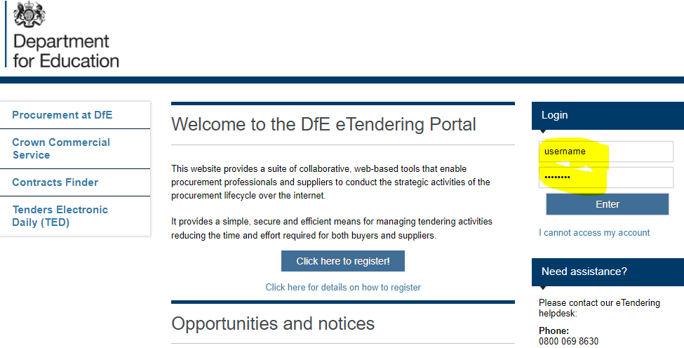
- Once logged in - go to “My PQQs”
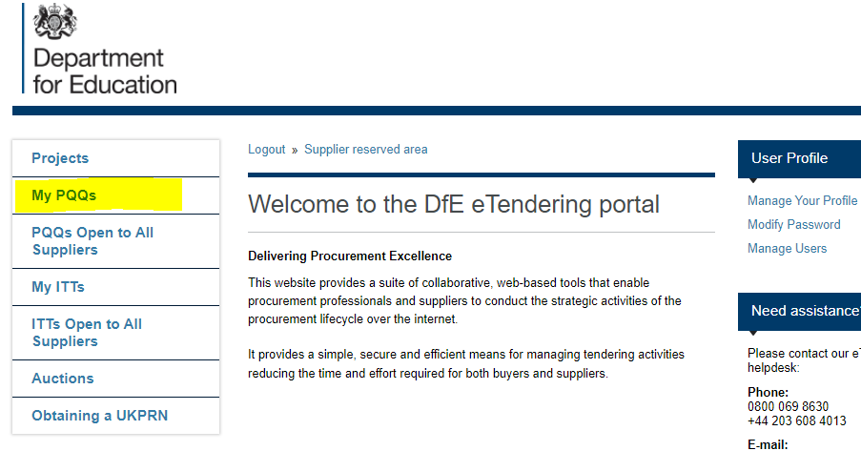
- Locate ssq_221 and open it (double click)
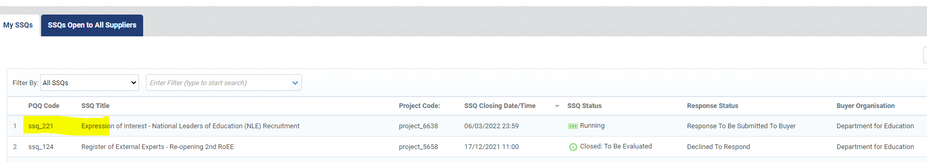
- This will take you to the screen below:
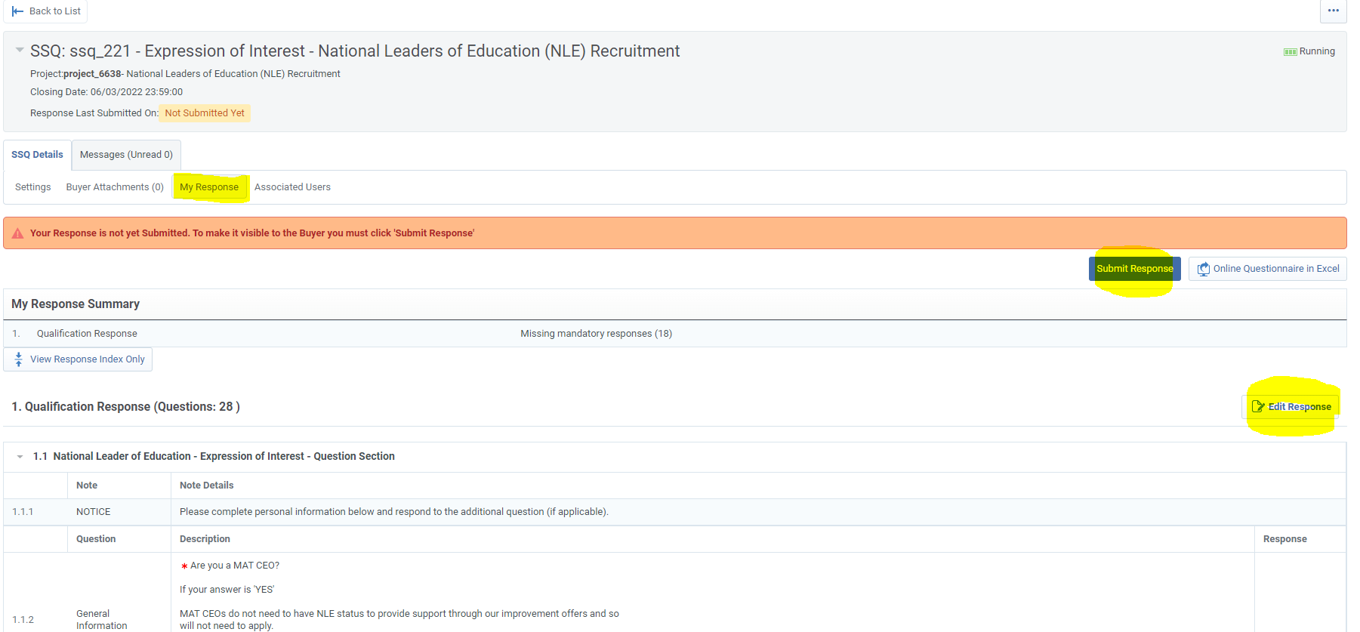
- In order to express your interest in the NLE recruitment you need to complete “My Response” tab providing relevant information.
To input your response, go to 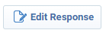and complete the relevant information.
- Once your response form is completed, please submit it using button.
At this stage1 – there is nothing else you have to do.
No additional evidence is required.
Please make sure you submit your response by 6th March 2022 23:59

