
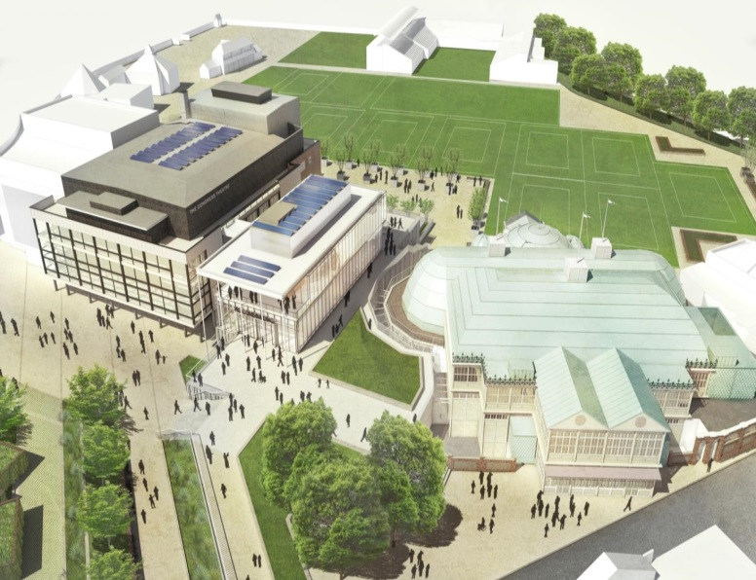
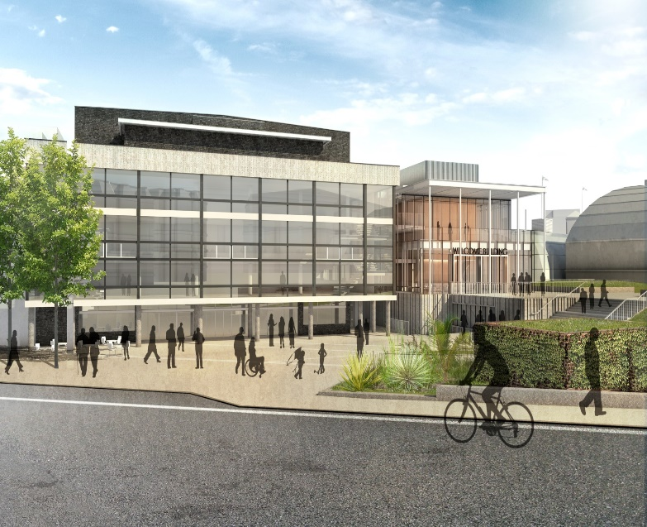
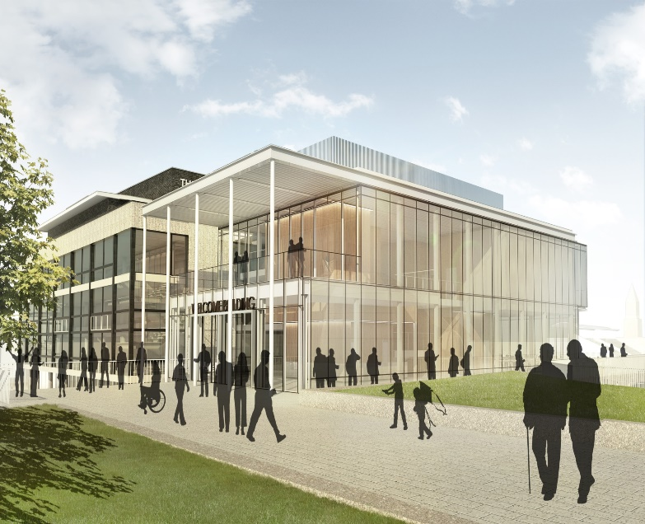
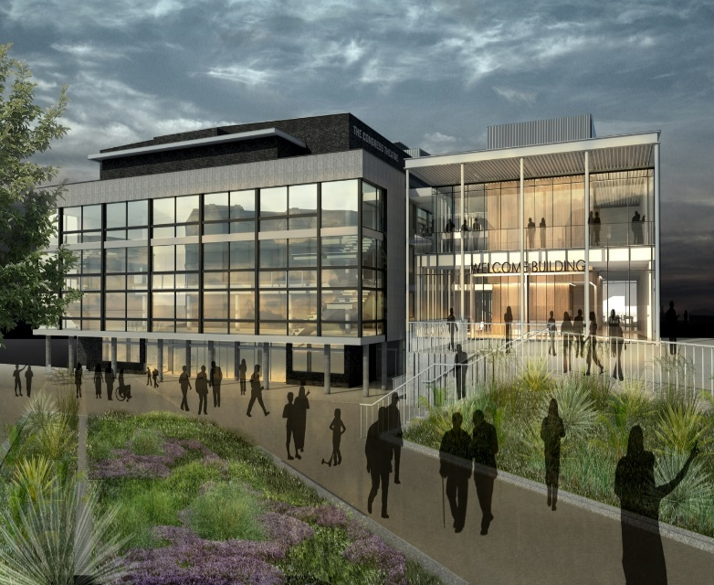

Eastbourne
Borough Council
Devonshire Park Re-Development

Southern Buildings Contract
Memorandum of Information
Competitive Procedure with Negotiation

January 2016

Foreword

Eastbourne Borough Council has a clear vision to create a key cultural destination at Devonshire Park and for it to be one of the most talked about locations in the South East. To achieve this we have wide support for the scheme, planning permission and listed building consent is in place and we have agreed the necessary budget.
We are now about to appoint a contractor who has the skills and experience to deliver our vision. This is an exciting and varied project that will call on the broadest set of skills of a highly competent contractor. Encompassing restoration and repair works to a 20th Century Grade II* listed theatre, a 19th Century Grade II listed Winter Garden and the construction of a new build 4 storey welcome building connecting the two, plus the associated landscaping and public realm works, this is a unique opportunity for a contractor to bring together conservation and new build specialisms.
If you believe you can match our needs please take up this tremendous opportunity.

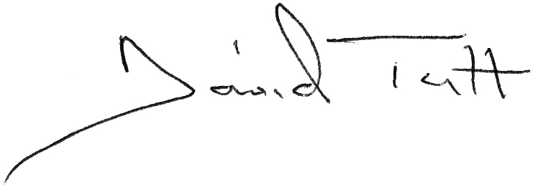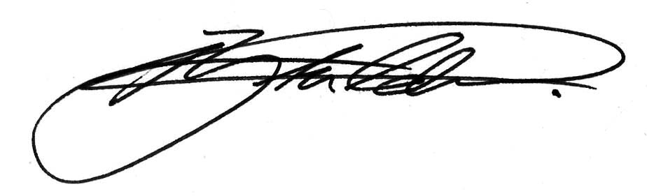
David Tutt Robert Cottrill
Leader Chief Executive

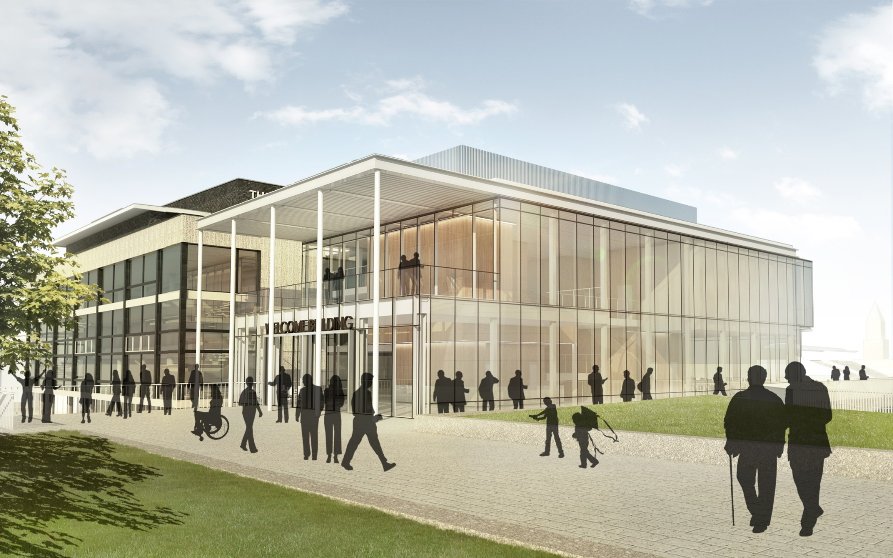
Contents

- Background 1

- Overview of the Opportunity 1

- The Procurement Process 8

- Enquiries and Responses 9

- Important Notices 11

- Details of Advisors 14

- Project Documents at this Stage 14

- Background

The purpose of this Memorandum of Information (MOI) is to provide background information for potential Suppliers to assist them in deciding whether to express an interest.
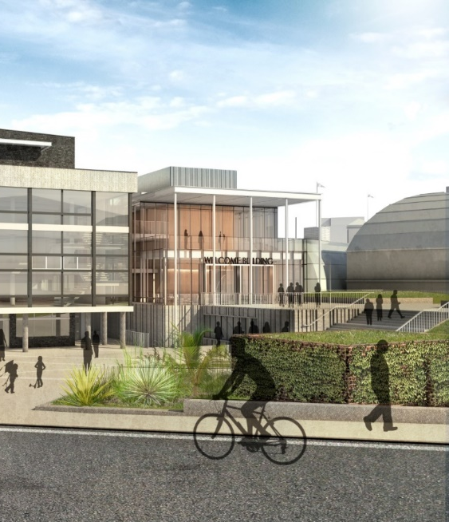
This MOI sets out:

- An overview of the opportunity;
- The procurement process which will be followed; and
- The response requirements and selection process.

This MOI should be read in conjunction with the Pre-Qualification Questionnaire (PQQ) for this opportunity which sets out in detail the information required and the basis on which potential Suppliers will be invited to participate in the procurement process.

Any queries or additional information required in relation to this opportunity should be requested in accordance with the Enquiries and Responses Section of this document.

Those wishing to express an interest in participating in this procurement and be considered for selection as a potential Supplier must return the completed PQQ and supporting documentation in accordance with the information in the PQQ document by Midnight on 5th February 2016 by uploading to the InTend portal at https://www.sesharedservices.org.uk/esourcing

- Overview of The Opportunity

2.1 Project Description, Aims and Objectives

Vision statement:

‘The transformed Devonshire Park will be one of the UK’s most distinctive and talked-about cultural places. It will celebrate and care for its unique heritage. Through its relationships with diverse performing and visual arts audiences and its partnerships with artists and fellow-producers it will enrich lives. Through its mission to entertain through everything from theatre to tennis, it will welcome hundreds of thousands of people every year. This cultural vitality and visibility will make Devonshire Park a natural place for people to gather and to meet – whether for a major conference or for exceptional hospitality – bringing new people to Eastbourne, to culture and to support the sustainability of the Park for future generations.’

‘To transform Devonshire Park into a distinctive, thriving, diverse cultural and tennis destination and amenity with an economically and environmentally sustainable long term future that can be enjoyed by the local community and international visitors alike.’

Objectives:

- To celebrate its past and embrace its future.
- To sensitively transform and renew its key heritage buildings to create a quality experience.
- To make efficient use of these existing buildings ensuring that they are flexible for traditional and new uses.
- To create carefully judged new facilities that make a dramatic statement of confidence in the future.
- To ensure that new and existing facilities work together as an efficient and coherent whole.
- The creation of a new public realm that improves the setting of the listed buildings and opens the Park to a wider audience for enjoyment throughout the year.
- To improve the connection and visibility between the Town Centre, Park and the Seafront.

Overview

The Devonshire Park Complex in Eastbourne consists of a number of theatres, arts and cultural venues; including theatres, galleries, several buildings providing offices for external professionals, staffing and storage, several car parks, conference facilities and the International Lawn Tennis Centre, which hosts six major tennis tournaments each year, from the AEGON International ladies and men’s tennis, to junior and veteran events.

The site also accommodates many of the Tourism and Leisure Staff at various locations throughout the site who, in addition to the services above, also deliver major events and conferencing services.

It is a key development site in Eastbourne Borough Council’s ambitious renewal strategy for the Town. Consequently, the project has cross party support with both parties having membership on the Project Board that steers the development. The Park was a key element of the town planning of Eastbourne, undertaken by the Duke of Devonshire and his architect Henry Currey, as a public amenity combining sports and arts, starting with the Winter Garden in 1875 and followed by the Devonshire Park Theatre. Since then buildings have been added, haphazardly, over time, with no overall master plan, and existing listed buildings have become tired and altered, sometimes unsympathetically, without any co-ordination.

The existing buildings all have their own separate and different orientations. The Park contains a number of buildings which are of historical, heritage and architectural significance including the Devonshire Park Theatre and the Winter Garden which are Grade II and the Congress Theatre which is Grade II*.

The original catalyst for the Project was dilapidations affecting the façade of the Congress Theatre which suffers from significant concrete corrosion issues; the careful replacement of the facade of this II* listed facility was completed in summer 2015. Works have now commenced on the next phase of the site, the essential repairs to Devonshire Park Theatre. Please see the supporting documents for the Stage 3 report which describes in detail the full Devonshire Park Redevelopment project.

The scope of this Southern Buildings Contract is the greatest portion of the work and will deal with restoration and repair works to the 20th Century Grade II* listed Congress Theatre, the 19th Century Grade II listed Winter Garden and the construction of a new build 4 storey welcome building connecting the two and including conference facilities, plus the associated landscaping and public realm works, the works must be completed January 2017 – April 2019.

2.2 Funding

At the Cabinet Meeting on 9th December 2015 approval was given to the full £44m required to deliver the Devonshire Park Redevelopment project. The Southern Buildings Contract forms part of this.

2.3 Planning

At the Planning Committee Meeting on 17th November 2015 conditioned planning permission and listed building consent was granted for the full project including the Southern Buildings. Please refer to the supporting documents for details of the planning permission.

2.4 Site Description and Location

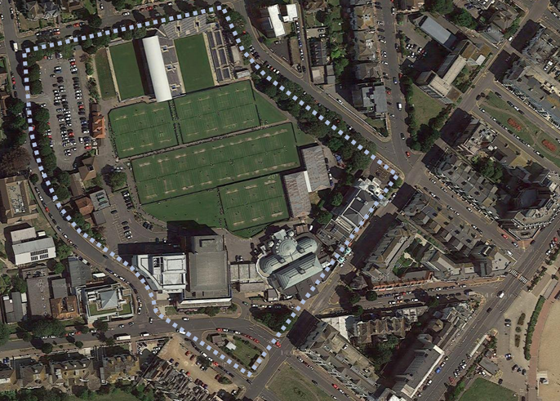
The site lies between the railway station, retail centre, seafront and residential/hotel district. The Project seeks to reinforce connections between the Park, its public buildings and the town. The site is bounded by Blackwater Road to the north, Hardwick Road to the east, Compton Street/Wilmington Gardens to the south and College Road to the west. It is a self-contained, walled site that the Project seeks to open up providing stronger links to the seafront and a sense of arrival – a true destination.

The site is wholly owned by Eastbourne Borough Council with the exception of the Buccaneer. The Towner Gallery is on a lease to a Trust. Neither the Buccaneer nor Towner Gallery form part of the project but both are key neighbours and therefore stakeholders in the project.

The site is generally operated, managed and maintained by Eastbourne Borough Council.

Key uses of the site run by Eastbourne Borough Council are as follows:

Conferences
- The Congress Theatre is the primary conference venue and the Winter Garden and exhibition halls serve as exhibition space and break out facilities.

Catering
- Devonshire Park Catering based in Devonshire Park; offices in the Winter Garden and a commercial kitchen attached to the Congress Suite.
- Deliver catering services for Council facilities and additionally a commercial arm for outside catering, functions etc. Until recently this was contracted out however now delivered in-house.
- No actual dedicated restaurant on site at present.

Theatres
- Congress Theatre; Capacity 1690; Grade II* listed venue for larger shows/musicals etc and also the primary venue for conference business which was part of its original purpose. The replacement of the façade is expected to be completed by spring 2015 to coincide with the submission of the RIBA Stage 2 concept design for the whole site.
- Winter Garden; two rooms, the Floral Hall and the Gold Room; Grade II listed large and versatile Victorian pavilion for functions, exhibitions, festivals, shows etc with 2 rooms. The ground floor Floral Hall is linked to large ‘temporary’ exhibition halls in the Park
- Devonshire Park Theatre; capacity 600; Grade II listed Victorian theatre used for plays, musicals etc.

Public Realm
- Site visits are destination or event driven
- Site comes alive when tennis events are on although still unwelcoming to the casual (non tennis) visitor.

T&L Offices, Events
- The Tourism and Leisure services (theatres, Conferencing etc) are based in the Winter Garden offices (including the Catering Department – Devonshire Park Catering)
- The Events team are based in the Pavilion building adjacent to College Road Car Park.

Tennis
- Devonshire Park hosts a major pre-Wimbledon Tennis Tournament in June each year attracting players from across the world including several of the world’s top twenty players. The tournament is currently sponsored by AEGON.
- In addition, the Devonshire Park site also hosts a number of regional and international tennis tournaments due to the high standard of its grass courts.

Note that the Tennis is run in partnership with the Lawn Tennis Association and therefore they are a key stakeholder in the Project. The AEGON International Tennis Tournament must continue throughout the course of the project.

The following is run independently:

Towner
- Recently constructed (2010) contemporary Art Gallery with exhibition and collection galleries.
- Managed by an independent Trust.

2.5 Scope of this Contract

Please read the following in conjunction with the Stage 3 Report included as a supporting document for further detail.

Landscape / Public Realm
The landscape proposal integrates the site seamlessly with the surrounding context, enhances the setting of the listed buildings and maximises the project’s contribution to the regeneration of Eastbourne. The proposed plaza comprises high quality public realm with a rich mix of planting, space for seating, steps, ramps and lighting.

The tennis field is reconfigured to accommodate various tournament layouts, retain parking to northern car park and allow for servicing the buildings from the north.

Congress Theatre
Proposals for the nationally significant 1963 Grade II* listed Congress Theatre seek to improve its setting, reinstate lost elements and restore its original interior design, improve accessibility, and improve comfort and facilities for audiences and performers.

The contemporary Congress Banqueting Suite is of unremarkable design and much altered internally; the Conservation Management Plan of October 2014 allocates it low significance. The proposals include its demolition to provide the site for the Welcome Building.

Winter Garden
Originally built in 1874 for uses including roller skating and concerts, proposals for the Grade II listed Winter Garden seek to enhance the historic character of its exterior and interior, improve accessibility throughout, reduce overheating in the venues, improve facilities for all users and increase revenue generation.

Welcome Building
The Welcome Building is located on the site of the Congress Banqueting Suite. The proposals place the large volume conference spaces at semi-basement level with the intention of mitigating their impact on the east elevation of the Congress Theatre.

Glazed façades to the new building enable the elevation of the Congress Theatre to remain legible.

The building resolves vertical circulation for the Congress Theatre, provides an effective link towards the Winter Garden, accommodates two fit-for-purpose conference halls (the existing Devonshire Park Halls are to be demolished to enable extension of the tennis field), two breakout/hospitality spaces, tourist information, provides central box office/ registration, and a public coffee/wine bar.

Racquet Court
Owing to its location on the eastern side of the Floral Hall, the Racquet Court is not well integrated with the other venues. It is therefore proposed to continue its use as essential support and storage space. The Winter Garden boilers are currently located in the Racquet Court and they are to be consolidated within the Congress Theatre.

Tennis Field

The focus for change is on the provision of better playing and support facilities for the International Event (currently sponsored by Aegon). The preferred new court layout contains a new show court and increased footprints for individual match courts. Setting out the new larger courts within the existing tennis field with adequate interstitial space leads to a reduction from 13 to 12 courts for the International Event. However, the required minimum number of courts for County Week can be accommodated and further capability at Meads Lawn offers further flexibility for both events.

Catering

A single cost effective and efficient production kitchen is proposed, located in the former Floral Bistro with good delivery access from the north. This location has excellent access for supplying banquets and dinners in the principal dining spaces of the Floral Hall and Gold Room above. From here catering services will be distributed daily or as required to a reheat kitchen in the new café / bar serving ‘light bites’ at Congress Theatre entrance level; a snack/prep space for the smart new podium coffee bar in the Welcome Building; pantries in conference hall 1, the lower conference foyer and the upper floor breakout/hospitality rooms; and to bars and cellars in the Congress Theatre and Winter Garden. This contract will provide the shell and services; the actual fit out of the kitchen will be by others.

2.6 Works to be Completed by Others

Devonshire Park Theatre
This project intends to complete the essential repairs and back-log maintenance in order to safeguard this Grade II listed playhouse, and improve access arrangements for disabled people. The essential structural and external repairs are currently being carried out by Eastbourne Borough Council.

Tennis Players Accommodation
Two options continue to be discussed between Eastbourne Borough Council and the Lawn Tennis Association:
Refurbishment: provision of separate male and female accommodation by converting the existing fitness centre and office building. This option has been submitted for planning consent.
New/modular: replacement of the fitness building with a new build purpose-designed facility with separate male and female accommodation.

Other Buildings and Spaces
Owing to low heritage benefit, low contribution to the business case and budget constraints, the following other projects are not included in the proposals: Wilmington Garden landscape enhancements, integration of the Buccaneer, improvements to the Towner ground floor exhibition halls, refurbishment of WCs and stores in the park, additional permanent tennis stands and repairs to the park entry booths. However, essential repairs are proposed for the Tennis Pavilion, International Tennis Centre and the Grade II listed Telephone Box in the Devonshire Park Theatre forecourt.
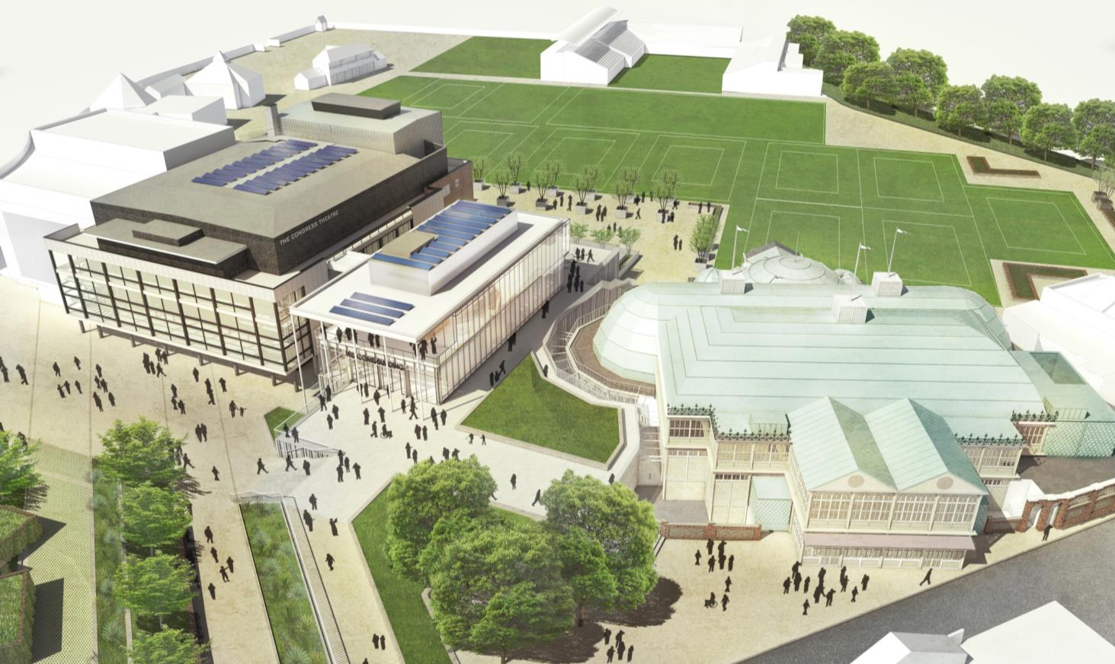
Catering
Fit out of the production kitchen.

Tennis Courts
Preparation groundworks will be within the Southern Buildings Contract but the completion works of the courts themselves will be undertaken through a separate contract with a specialist contractor.

2.7 Sub-Contracting

Due to the specialist nature of much of the works included within the Southern Buildings Contract, we fully anticipate there to be a wide range of subcontractors required to complete the Contract. Such sub-contractors will need to be appropriately skilled and competent in the necessary works and where undertaking design will be required to complete appropriate sub-contractor warranties.

Suppliers will be expected to have identified all major or significant sub-contractors for approval and evaluation at final tender. In particular this will apply to the sub-contractors for Mechanical and Electrical Engineering works, Highways Works and Theatre Fit Out. Where sub-contractors have not been approved as part of the selection or tendering process, but may be appointed under the terms of the contract, then the Council will, as part of this, require a contractual right to approve the appointment of sub-contractors working on the project.

The Suppliers attention is drawn to the provisions in the PQQ in relation to the provision of information concerning sub-contractors and the declarations required from sub-contractors. Whilst Suppliers are entitled to rely on the capacities of other entities to meet the selection criteria the Council reserves the right to require the Supplier to provide evidence of the commitment from the entity to provide those resources. The Council may require a Supplier to replace a sub-contractor at any stage if verification has shown that there are mandatory or discretionary grounds for exclusion.

2.8 Contractual Terms

A single stage JCT Standard Form of Contract is anticipated to be used for this procurement. In addition the Supplier will be responsible for undertaking works for the Council which arise under a section 278 Highways Act 1980 agreement between the Council and East Sussex County Council. The entity undertaking these works will need to be approved by the County Council for this purpose.

2.9 Social Value

The Supplier will be required to actively participate in the achievement of social objectives if appointed and contract performance conditions may relate in particular to such considerations. Further information will be set out in the Invitation to Tender, but Suppliers attention is drawn to the terms of the section 106 Town and Country Planning Act 1990 conditions in relation to these and the Councils internal policy for this sort of contract.

3.0 The Procurement Process

3.1 The Process

The Council is following the Competitive Procedure with Negotiation process for this procurement in accordance with the Public Contract Regulations 2015.

It is envisaged that the procurement process will be undertaken in distinct Stages. The Council reserves the right to reduce the number of tenders after the initial tender stage but is not obliged to do so. The basis on which tenders (and therefore the number of Suppliers competing) will be reduced will be set out in the Invitation to Tender which will be issued after Stage 1.

Procurement Stage |  | Anticipated Number of Participants at the end of Stage
Stage 1 | Selection | 3 - 4
Stage 2 | Initial Tender | 3 - 4
Stage 3 | Negotiations | 2 - 4
Stage 4 | Final Tenders | 2 - 4

Stage 1 – Selection
This stage is to enable the Council to select potential Suppliers to invite to participate in the tender and negotiation stages.

The Council (with the assistance of its external advisors) will carry out the selection process by evaluating Suppliers responses to the PQQ.

Details of how this selection process will operate and the criteria being applied are set out in the PQQ which accompanies this MOI.

Stage 2 – Initial Tender Stage
Selected Suppliers will receive an Invitation to Tender. This will set out in detail the process that will be followed during the procurement and the criteria for the award of the contract.

The Invitation will also specify the needs and requirements of the Council in more detail and any minimum requirements that all tenders must meet. It will contain the draft contract terms.

It is anticipated that elements of the information required to provide final pricing may not be available in full at this stage in which case the Invitation to Tender will set out how Suppliers are to address the provisional pricing for certain elements – notably the Mechanical and Electrical Engineering works.

The Council reserves the right to award the contract on the basis of the initial tenders without negotiation, however at the current time it is anticipated that this will not be the case.

The Council reserves the right to reduce the number of tenders after the initial tender by applying the award criteria to the tenders but is not obliged to do so. The Council will wish to ensure that there are sufficient participants to ensure genuine competition in so far as there are enough tenderers to do so.

Stage 3 – Negotiation Stage
The Council may negotiate with those Suppliers who submitted Initial Tenders (and who have not been de-selected) with the purpose of improving their content.

Any minimum requirements previously stated and the award criteria will not be subject to negotiation.
The detailed process for the negotiation stage will be set out in the Invitation to Tender. The Council reserves the right to undertake the negotiation in successive stages with the possible reduction of the number of tenders at each stage.

It is anticipated that additional information will be provided to Suppliers during the negotiation stage to enable in so far as possible full pricing. Where this is not possible review clauses will be provided to cover any necessary modifications, options and price revision.

Stage 4 – Final Tenders
At the conclusion of the Negotiation Stage, the Council intends to request the remaining Suppliers to submit a final tender based on the initial tenders and the proposals developed during the Negotiation Stage. These will be evaluated against the contract award criteria and the Council then intends to select the Supplier to whom the contract will be awarded.

Timetable
The indicative timetable for the key stages of procurement is outlined below. Whilst the Council has a strong desire to ensure that this timetable is adhered to, Suppliers should note that it may be subject to change and further detail will be provided at to those organisations selected to tender.

Step | Milestone | Date / Deadline
1 | Place Contract notice / Issue PQQ and MOI | 31st December 2015
2 | Contractor PQQ Deadline | 5th February 2016
3 | Complete PQQ assessment and identify tender shortlist | 4th March 2016
4 | Notify Shortlisted Tenderers and de-selected applicants | 18th March 2016
5 | Issue Invitation for Initial Tender | 1st April 2016
6 | Deadline for Initial Tender Returns | 27th May 2016
7 | Complete Initial Tender Assessment | 24th June 2016
8 | Commence First Round Negotiations | 24th June 2016
9 | Commence Second Round Negotiations | 8th July 2016
10 | Complete Contractor Negotiations | 5th August 2016
11 | Issue Invitation for Final Tender | 5th August 2016
12 | Deadline for Final Tenders | 19th August 2016
13 | Complete Final Assessment | 16th September 2016
14 | Identify Preferred Contractor | 16th September 2016
15 | Commence Standstill Period | 16th September 2016
16 | Complete Standstill Period | 26th September 2016
16 | Confirm Appointment of Contractor | 30th September 2016
18 | Contracts in Place | Mid October 2016
19 | Mobilisation and finalisation of designs | 23rd December 2016
20 | Start on Site Congress Theatre | 2nd January 2017
21 | Start on Site Welcome Building | 2nd January 2017
22 | Start on Site Winter Garden | 8th January 2018
23 | Completion Congress Theatre | 25th May 2018
24 | Completion Welcome Building | 24th August 2018
25 | Completion Winter Garden | 26th April 2019
26 | Practical Completion | 26th April 2019

4.0 Enquiries and Responses

4.1 Enquiries

Any enquiries in relation to this project or this documentation must be submitted to the InTend portal https://www.sesharedservices.org.uk/esourcing PLEASE NOTE that applicants must log in to the system in order to take part in the electronic tender process.

Please note that the Council does not intend at this stage to enter into detailed discussion of the services with any individual Supplier. Suppliers should not make any contact with any employee of the Council or the Advisors or other interested authority or statutory body without the Council's prior written consent.

Please note that any responses given will be via the InTend portal and therefore may be circulated to all potential Suppliers.

Where a Supplier considers that an enquiry or response will relate to commercially confidential information relevant only to itself and that it should not be circulated to other Suppliers, it must include in the enquiry submission heading "In Commercial Confidence – Not to be circulated to other Suppliers" and set out its reasons in the body of the submission.

If the Council considers that, in the interests of a fair and open competition, it cannot respond to the enquiry on a confidential basis, it will notify the Supplier and treat the enquiry as withdrawn. It will then be for the Supplier to resubmit the enquiry without the requirement for confidentiality if it requires an answer.

If the Council considers that the request for a confidential response is justified, then it will provide a response which is not circulated to other Suppliers.

  - Freedom of Information Act 2000

The Council is subject to the requirements of the Freedom of Information Act 2000 and the Environmental Regulations 2004. Accordingly, all information submitted to it may need to be disclosed by the Council in response to a request under the Act or Regulations.

In making any submission during this procurement process, each Supplier acknowledges and accepts that information contained therein may be disclosed under the Act or Regulations without consulting the Supplier, or following consultation with the Supplier and having considered its views.

If Suppliers consider that any of the information included in their PQQ response is commercially sensitive, please identify it and explain (in broad terms) what harm may result from disclosure if a request is received, and the time period applicable to that sensitivity. It should be noted that, even where it is indicated that information is commercially sensitive, the Council may be required to disclose it under the Act or Regulations if a request is received. Please also note that the receipt of any material marked ‘confidential’ or equivalent by the Council should not be taken to mean that it accepts any duty of confidence by virtue of that marking. If a request is received, the Council may also be required to disclose details of unsuccessful Suppliers’ responses.
- Important Notices

  - The attention of Suppliers is drawn to the fact that by issuing this request to quote the Council is in no way committed to awarding any contract and reserves the right to cancel the appointment process at any point. The Council is not liable for any costs resulting from any cancellation of this appointment process nor for any other costs incurred by those expressing an interest in or making a submission for this opportunity.

  - The Council reserves the right to vary or change all or any part of the basis of the procedures for the process at any time or not to proceed with the proposed appointment at all. The Council reserve the right at any time:

- to issue amendments or modifications to the documentation;
- to alter the timetable to selection;
- and/or not to select a service provider and to withdraw from this process.

  - All Suppliers are solely responsible for their costs and expenses incurred in connection with their participation in this procurement process. Under no circumstances will any of the Council team be liable for any costs or expenses borne by the bidder or any of its supply chain partners or advisors in this process.

  - Suppliers should note that no submission or offer is deemed accepted until the relevant contractual documents have been duly signed on behalf of the Council and all other relevant parties and declared unconditional. No negotiation or communication with the Council whether prior to, during or subsequent to the selection process (including any notification of a successful submission) imply acceptance of any offer or constitute an indication that the Supplier will be awarded the position of service provider. Only the express terms of any written contract which is finally agreed and signed for and on behalf of the relevant parties and which is duly declared unconditional shall have any contractual effect.

  - The Council and their advisors will not be held liable to any party for any direct or indirect losses, financial or otherwise, associated with any contents of this invitation, associated documents or any research or analysis completed to date which is referenced in this document. The documents do not purport to be all inclusive, to contain all of the information that a prospective service provider may require, or to have been independently verified. The documents should not be considered as an investment recommendation made by the Council. Any person considering making a decision to enter into contractual relationships with the Council or any other person on the basis of the information provided should make their own investigations and form their own opinion.

  - No disclaimer in this document is intended to exclude liability for fraud or fraudulent misrepresentation.

  - Non-Collusion

The Council reserves the right to disqualify (without prejudice to any other civil remedies available to the Council and without prejudice to any criminal liability which such conduct by a Supplier may attract) any Supplier who, in connection with this process:

- fixes or adjusts the amount of its submission by or in accordance with any agreement or arrangement with any other Supplier (other than a member of its own consortium or supply chain);

b) enters into any agreement or arrangement with any other Supplier to the effect that they shall refrain from making a submission or as to the amount of any submission to be submitted;
c) causes or induces any person to enter such agreement as is mentioned in either paragraph a) or b) or to inform the Supplier of the amount or approximate amount of any rival submission;
d) offers or agrees to pay or give or does pay or give any sum of money, inducement or valuable consideration directly or indirectly to any person for doing or having done or causing or having caused to be done any act or omission in relation to any other submission or proposed submission for this process; or
e) communicates to any person other than the Council the amount or approximate amount of his proposed submission (except where such disclosure is made in good faith in order to obtain quotations necessary for the preparation of a submission).

  - The Council also reserves the right to disqualify (without prejudice to any other civil remedies available to the Council and without prejudice to any criminal liability which such conduct by a organisation) any Supplier who, in connection with this opportunity:

- offers any inducement, fee or reward to any member or officer of the Council or any person acting as an adviser for the Council in connection with this process;
- does anything which would constitute a breach of the Bribery Act 2010 or under Section 117 of the Local Government Act 1972;
c) canvasses any officer or member of the Council in connection with this process.

Information

  - The Council may disclose detailed information relating to submissions to the Council's members, directors, officers, employees, agents or advisors and the Council may make the key documents available for private inspection by the Council's members, directors, officers, employees, agents or advisors.

  - The Council also reserve the right to disseminate clarifications and information that is materially relevant to the opportunity to all Suppliers, even if the clarification or information has only been requested by one bidder. The Council will act reasonably as regards the protection of commercially sensitive information relating to Suppliers in the light of the latest published guidance on this area.

General Matters

  - The Council reserves the right, in their sole discretion, to reject any submission.

  - Suppliers should note that the information given at any stage may be subject to verification at any time during the procurement process. If any error, omission, false statement or misrepresentation is discovered, the Council reserves the right to disqualify the organisation, without regard to what stage the selection process has reached when the error, omission, false statement or misrepresentation is discovered.

  - Suppliers should note that the Council reserves the right to terminate any ensuing contract with the organisation at any time if it is discovered that the organisation has made any false statement or material misrepresentation in any document submitted as part of this process.

  - The Council will rely upon the representations in response to this invitation in selecting those Suppliers to become the appointed contractor and may seek its wasted costs from a Supplier if any representations are materially untrue or incorrect (or later become untrue or materially incorrect in the absence of immediate notification by the Supplier to the Council).

  - The Council reserve the right to reject or disqualify an organisation where any submission is submitted late, is completed incorrectly, is incomplete or fails to meet any other submission requirements which have been notified to the organisations.

  - This invitation and subsequent information will be provided on the same basis to all Suppliers, however the Council reserves the right to seek clarification on submissions from particular Suppliers during the selection process.

  - The Council is concerned to avoid conflicts of interest. Suppliers should note that, the Council reserves the right to disqualify Suppliers where there is an actual or potential conflict of interest. Suppliers are encouraged to seek to clarify the Council's view on actual or potential conflicts at the earliest opportunity before submission.

  - The laws of England shall apply to this process and any resulting contract.

6.0 Details of Advisors

Project Manager Focus Consultants
Principle Designer Levitt Bernstein, Lead of MDDT
Conservation Architect Levitt Bernstein, Lead of MDDT
New Build Architect Levitt Bernstein, Part of MDDT
Tennis Facilities Architect TrioPlus, Part of MDDT
Landscape Architect Levitt Bernstein, Part of MDDT
Structural Engineer Edge Structures, Part of MDDT
M&E Engineer Max Fordham, Part of MDDT
Fire Engineer Exova Warrington, Part of MDDT
Transport Planner Project Centre, Part of MDDT
Access Consultant All Clear Design, Part of MDDT
Quantity Surveyor Huntley Cartwright
Theatre Consultant Neill Woodger Associates
Business Planner David Clarke Associates
Conference Consultant Venues Advisor
Catering Consultant Kendrick Hobbs
Retail Consultant Quince Retail
Building Control Wealden District Council
Planning Consultant Parker Dann
Legal Dentons UKMEA LLP

7.0 List of Project Documents Available at this Stage

Cabinet Report
http://democracy.eastbourne.gov.uk/ieListDocuments.aspx?CId=125&MId=1357&Ver=4

Stage 3 Design: Available via InTend portal only due to size restrictions https://www.sesharedservices.org.uk/esourcing

Planning Committee Report http://democracy.eastbourne.gov.uk/ieListDocuments.aspx?CId=144&MId=1372&Ver=4

EBC Policy on Employment and Training (ETP) Technical Guidance Note (attached)

EBC section 106 Conditions on Social Added Value (DRAFT attached)

