**Children’s Palliative Care and End of Life Pathway**

**for East Berkshire CCG**

**Background**

NHS East Berkshire Clinical Commissioning Group (the CCG) is planning to contract with Alexander Devine Children’s Hospice Service in Maidenhead, Berkshire (Alexander Devine) for the provision of a Children’s Palliative Care and End of Life Pathway under a Single Tender Waiver (STW).

The commissioning of Children’s Palliative Care and End of Life Pathway in East Berkshire is the responsibility of the CCG. It must commission high quality personalised care for children and young people, ensuring that they prioritise children’s palliative care in their strategic planning with providers to ensure that services can work together seamlessly and advance care planning can be shared and acted upon.

Life-limiting conditions (LLC) in children and young people can be defined as conditions for which there is no reasonable hope of cure and from which children or young people will die. Life-threatening conditions are those for which curative treatment may be feasible but can fail, such as cancer.

In Oct 2011, the University of Leeds completed a prevalence study for Children’s hospice charities that identified a 32% rate per 10,000 Children with LLC. Berkshire was found to be slightly higher at 32.9 per 10,000.

Noting that there has been a population uplift since 2011 in 0-19 year olds, a potential projection for East Berkshire has been estimated below at 33.2%:

|  |  |  |  |
| --- | --- | --- | --- |
| **Where** | **Projected number LLC** | **Population size u18s (ONS 2019 projections)** | **Increase in LLC** |
| Berkshire East | 360 | 108508 | 52 |

The CCG worked with providers once it became clear that there was no clear pathway or clinical model of care in place for children and young people at the end of their life, which made providing an offer to families difficult to discuss.

A series of provider/CCG workshops took place to co-produce an integrated model of care. This work resulted in Alexander Devine being awarded a short-term contract to develop and provide the service, working in close collaboration with other Integrated Care System (ICS) partners including the Royal Berkshire NHS Foundation Trust (RBFT), Frimley Health NHS Foundation Trust (FHFT) and Berkshire Healthcare NHS Foundation Trust (BHFT).

The interim arrangement is due to end on the 31st July 2021. A long term solution is now sought.

**The Vision**

The service provides a family centred pathway and recognises that children with life-limiting conditions have complex needs involving multiple care interventions by a range of professionals. The service model is an integrated one for the delivery of care as depicted in the diagram below.

The success of the pathway is predicated on partnerships and integration and working across clinical boundaries. In order to achieve this, the principles of integration, co-operation, trust and partnerships had to be revisited. Out of this work, the integrated model of service delivery was born which is led by Alexander Devine, piloted on a short-term contract with oversight of the partnership being led by the CCG. A new, longer duration contract will allow the service provision to be further honed and investment to take place.

Based locally, Alexander Devine is an organisation that has developed a strong reputation for delivering specialist palliative and end of life care for children and young people through providing, in collaboration with partners, respite care, specialist play, symptom management, family support and eventually, support in bereavement.

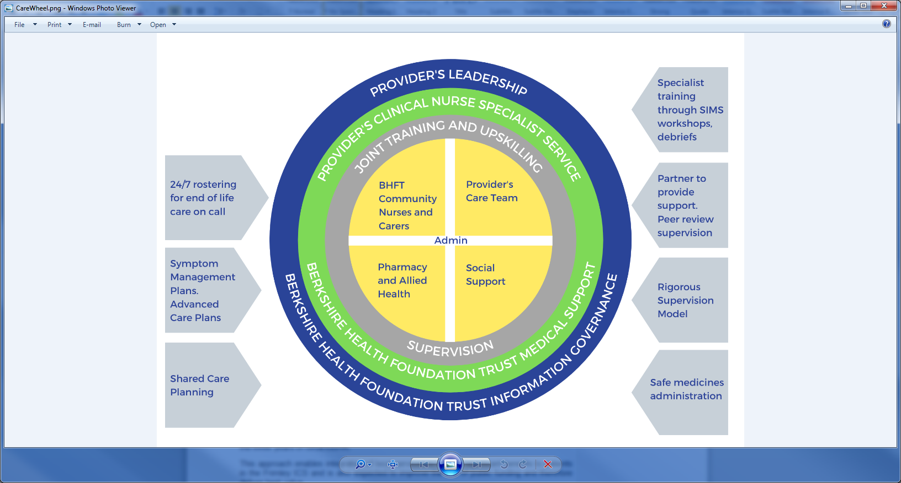

**The Proposed Contract**

The optimum long-term solution is to draw on the strengths from across the Integrated Care System (ICS). This includes expertise not only from Alexander Devine but also other ICS partners including RBFT, BHFT and FHFT.

Geographic proximity to the system providers is imperative to create strong working partnerships. Children with LLC and their parents are often under significant pressure when managing their needs. This pressure is significantly heightened when parents are required to travel for long periods at a time to get the support they need.

Given the existing strong existing relationships, knowledge and experience coupled with a robust clinical pathway model, Alexander Devine have been identified as the only reasonable option for delivering the service locally.

Building on the relationship and expertise that has developed prior to and since the inception of the short-term contract, the CCG now wish to utilise these services, led by Alexander Devine, to provide a long term solution for a period of 3 years from the 1st August 2021.

The indicative value of the service is circa £177K per annum with a total contract value for the three years of circa £531K.

This approach enables integration of local services to release significant benefits to patients in the Frimley ICS and is also expected to improve the use of public funding and therefore deliver best value.

For the avoidance of doubt this contract does not fall under the Public Contract Regulations 2015.

**Scope of Service**

The scope of the service to be provided by Alexander Devine and its partners includes:

**Service objective:**

* To provide advanced symptom management for children and young people
* To improve communication and information sharing specific to the end of life pathway
* To facilitate advance care planning conversations
* Coordinates work across providers; with families and carers to enable them to meet the child’s (and their families) needs as they move through the End of Life pathway.
* To signpost to services who may be able to offer families further support and liaison with other services involved in the care of the child
* To provide a coordinated/ integrated professional network for children with palliative and end of life care needs and their families
* To manage death and dying for children and support families and other professionals.
* To facilitate and provide information, training and advice to health and care professionals to enable them to meet the needs of Children that are in the End of Life Pathway.

**Deliverables of the integrated service are:**

1. To lead and provide a specialist palliative care service for children and young people.
2. Lead the provision of specialist assessment so that care is provided at the right time and in the right place in the child’s journey.
3. Provide symptom management advice and support to meet the child’s needs – that leads to a symptom management plan where necessary.
4. Lead the management of and co-ordination of multi-disciplinary teams for this group of children and young people, ensure there is regular communication and review of care
5. Create and manage a register of all children and young people who are diagnosed with a life limiting/threatening condition to ensure care is co-ordinated and integrated.
6. Facilitate and enable anticipatory care plan creation and development (ACP) so there is clarity about what the child/young person and their significant carers want.
7. Monitor and know who at is at risk and likely to move into end of life phase.
8. Annual quality assurance and regular learning processes on the use and impact of children and families experience of the end of life pathway – leading to improvement plans for both individual organisations as well as multi-agency where applicable.
9. Offering and facilitating de-briefs, learning events and audits.
10. Offer training opportunities both as a regular opportunity as well as bespoke to a child (e.g. to their GP or their school).

**Population covered**

Children and Young people registered with a Berkshire East GP

Children and Young People aged 0 – 18 year olds (up to 364 days) including antenatal palliative and end of life care

For the reasons set out above NHS East Berkshire CCG believe Alexander Devine to be the only capable provider locally and intends to proceed with a direct award. However, prior to proceeding with the award the CCG would be willing to hear from other potentially capable providers who believe they would be able to meet the above requirements. Expressions of interest should be sent in writing within 30 days of this notice to [akilham@nhs.net](mailto:akilham@nhs.net)