**Croydon Dermatology Service**

**Memorandum of Information (MOI)**

**NHS Croydon**

**Clinical Commissioning Group (CCG)**

**Contents**

|  |  |  |
| --- | --- | --- |
| 1. | Purpose | 3 |
| 2. | Definition | 3 |
| 3. | Strategic Context | 3 |
| 4. | The Commissioning Organisation | 5 |
| 5. | The Proposed Dermatology Service | 7 |
| 6. | Service Mobilisation | 8 |
| 7. | Governance and Administration | 8 |

1. **Purpose**

The purpose of this Memorandum of Information (MOI) is to support a market testing exercise being undertaken by NHS Croydon CCG (CCCG). The market testing exercise is intended to inform future commissioning plans with respect to the potential future procurement of a Croydon Dermatology Service.

The MOI is intended only as a preliminary background explanation for the procurement of the service. It is in no way intended to form the basis of any decision on the terms upon which CCCG will enter in to any contractual relationship.

**2. Definition**

CCCG wishes to inform the potential future commissioning of a dermatology service for Croydon residents. The service is intended to deliver safe, high quality and innovative dermatology services in line with the CCG’s strategic vision.

**3. Strategic Context**

3.1 National context

CCCG has taken into consideration national, regional and local strategies and frameworks in the development of initial commissioning plans for dermatology. There are strong and robust strategic drivers for change and key related strategies have been highlighted in this section of the MOI.

Over recent years, the NHS has been increasing its focus on improving the provision, access and quality of care provided outside of an acute hospital setting. The White Paper ‘Our Health, Our Care, Our Say’ outlined the ambition to create a fundamental shift of care from hospitals to more community-based settings and this was reiterated by Lord Darzi in ‘Our NHS, Our Future with the principle to ‘localise where possible, centralise where necessary’.

The NHS Five Year Forward View further emphasised the need to break down barriers in how care is provided; with far more care delivered locally, supported by specialist centres for more complex needs. The provision of more dermatology services outside of hospital settings is a step towards meeting this objective of care closer to patients and primary care. This has significant benefits; providing a more convenient service to patients and helping to relieve the pressure on secondary care services, focusing the most complex Dermatology diagnostics and treatment in secondary care. Patient feedback from other similar community services indicates high satisfaction by patients for community alternatives to hospital outpatient care.

The Kings Fund recommend that dermatology care should be delivered by individuals with the right skills, in the right setting, the first time. The way in which services are provided to people depends on factors including local needs, the demography of the area, facilities available and the availability of staff with the required knowledge and skills.

British Association of Dermatology (BAD) recommends that people with skin conditions should have their care managed at a level appropriate to the severity and complexity of their condition, acknowledging that this may vary over time. The principles of care are therefore described in relation to the level of care required:

• Self-care (Level 1)

• Generalist care (Level 2)

• Specialist care (Level 3)

• Supra-specialist care (Level 4)

BAD recommends that people with skin conditions who manage their conditions themselves (Level 1 care) should be supported with high-quality patient information and input from suitably trained nurses, patient support groups and community pharmacists. People with skin conditions needing generalist (Level 2) care are managed initially through self-referral to their GP. Level 2 care should also include access to input from suitably trained nurses. Any patient whose skin condition cannot be managed by a generalist will need to be referred for specialist care (Level 3) and/or supra-specialist services (Level 4).

This guidance encourages the sharing of care across organisational boundaries and improvements to integration and collaboration between primary and secondary care. Service redesign of this nature would achieve for health economies the avoidance of unnecessary patient attendances and elective admissions.

NHS England’s publication; ‘London: A Call to Action’, reported that London’s diverse population has resulted in a broad and growing range of health needs and that there had been a failure to close the inequalities gap. It considered that the pattern of healthcare provision with its emphasis on hospital services would not address this problem in the future and that much more should be done to support people to live healthier, independent lives through services provided in community settings that are more accessible to patients. The publication recommended that care needs to move away from traditional hospital-centred delivery and that local community based health services are developed to address the type and severity of local needs and to raise the health and wellbeing of those who are the least healthy to be in line with the healthiest. The report recognises that doing nothing is not an option and that bold transformational change is needed to the way in which services are currently delivered.

3.2 Local context

### 3.2.1 CCCG’s vision and strategy

CCCG’s vision, strategic objectives and values are as follows:

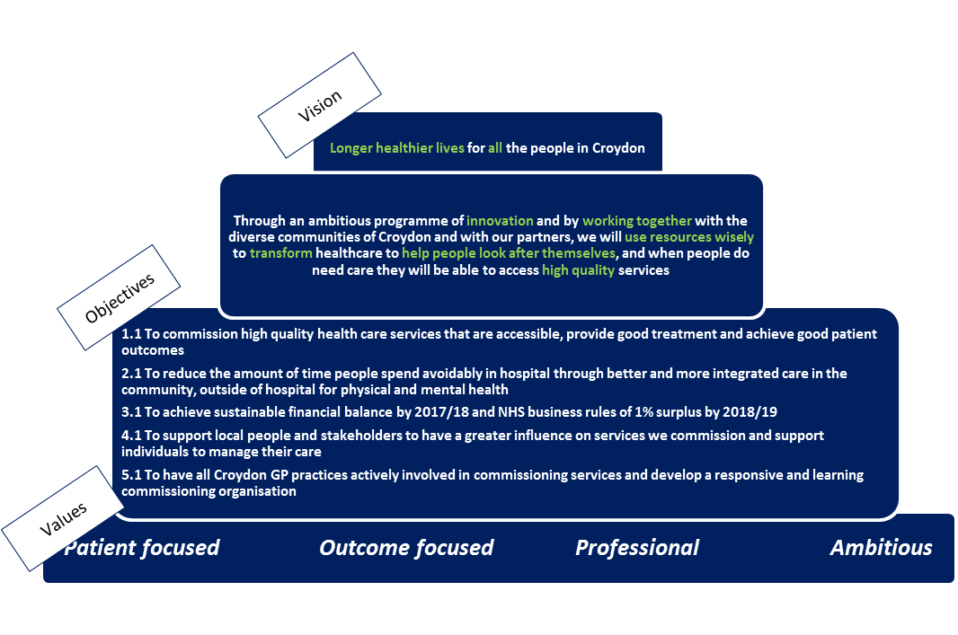

3.2.2 Historic model of care and future vision

The historic model of care and CCCG’s future vision for Croydon patients is as follows:

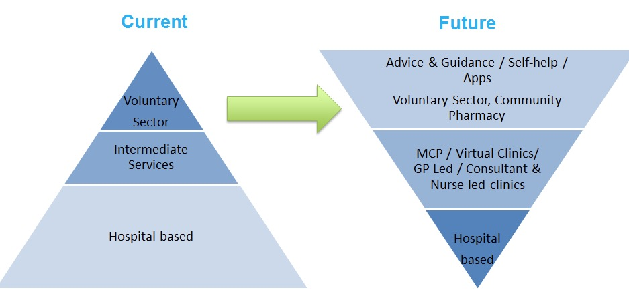

3.2.3 CCCG’s new model of care

CCCG has developed the “rainbow approach” to describe the components that will underpin the new Planned Care model of care. These components, shown in the figure below, are:

1. 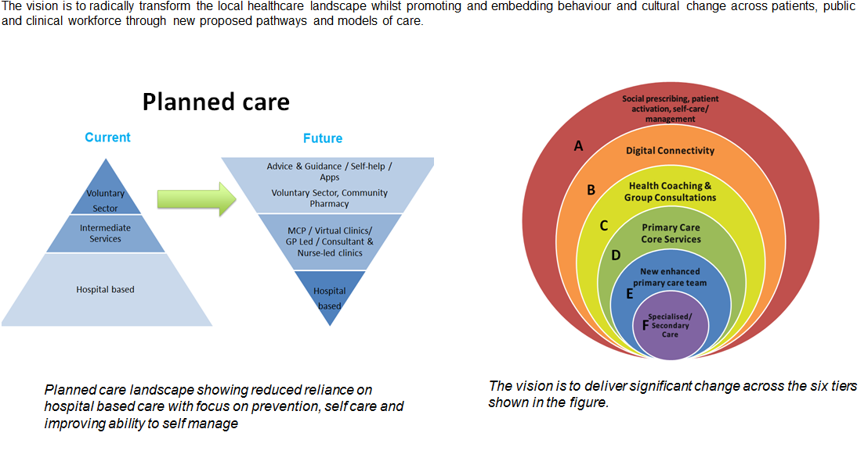Social prescribing, patient activation, self-care/management
2. Digital Connectivity
3. Health Coaching & Group Consultations
4. Primary Care Core Services
5. New enhanced primary care team
6. Specialised/secondary care

3.2.4 The vision for Dermatology care

CCCG’s vision for Dermatology care is that it is more closely aligned to and enhances primary care. The following diagram shows how CCCG envisages Dermatology care being delivered in Croydon:

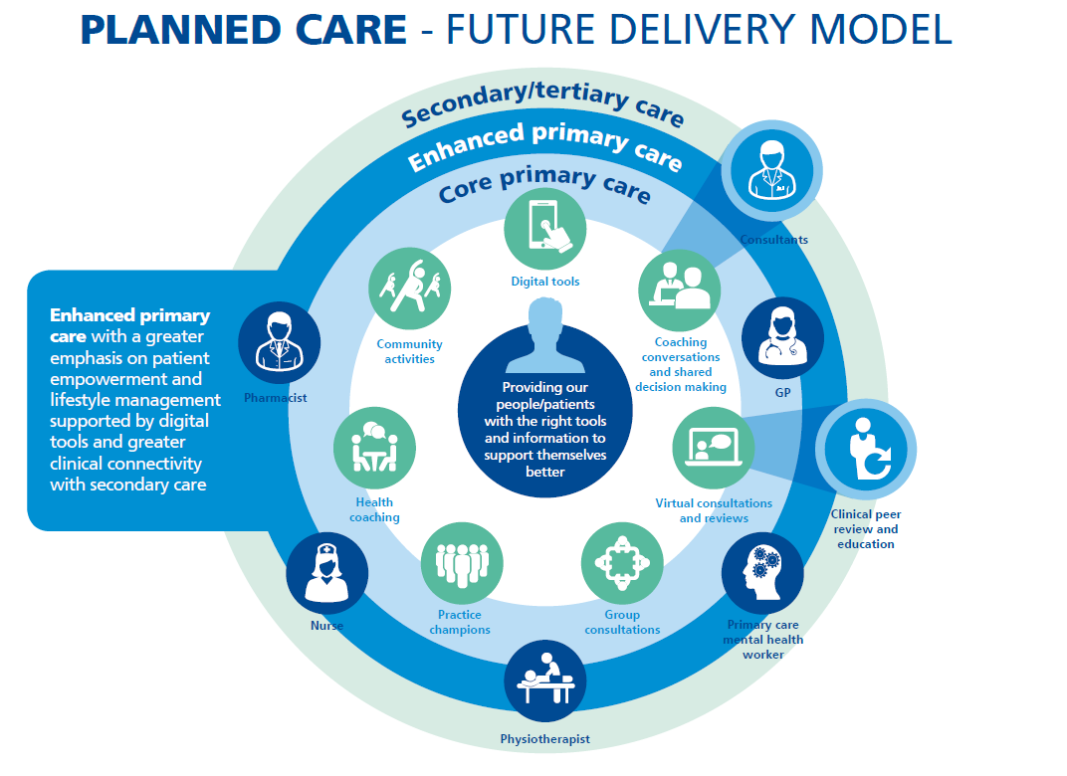

**4. The Commissioning Organisation**

4.1 Croydon CCG

CCCG is a membership organisation made up of all 56 GP practices in the borough of Croydon.​​ CCCG was established in April 2011 as a shadow organisation and received authorisation from the NHS Commissioning Board (now NHS England) in March 2013.  On 1 April 2013, CCCG became legally responsible for commissioning health services for the residents of Croydon.

CCCG manages local healthcare budgets in excess of £465 million and commission a range of Croydon health services on patients’ behalf.  These include hospital, community and mental health services.

Details of CCCG’s member practices can be found at <http://www.croydonccg.nhs.uk/about-us/clinical-networks/Pages/GP-Practices.aspx>.

4.2 Population

Croydon’s population (382,304) is the second largest of London’s 32 boroughs after Bexley. Source: ONS 2016 Population Estimate.

4.2.1 Age

The age distribution of Croydon’s population is as follows:

|  |  |  |
| --- | --- | --- |
| **Age (years)** | **Numbers** | **Percentage** |
| 0-4 years | 28,621 | 7.5% |
| 5-10 years | 32,859 | 8.6% |
| 11-17 years | 32,955 | 8.6% |
| 18-64 years | 237,663 | 62.2% |
| 65+ years | 50,206 | 13.1% |
| Total Population | 382,304 |  |

**Source: ONS, Mid-Year Population Estimates, 2016**

4.2.2 Disability

The 2011 Census identified that there were 53,113 people in Croydon who considered their day to day activities were limited a little or a lot by a disability or long term illness, 65% of whom were aged 50 and over:

|  |  |  |
| --- | --- | --- |
| **Disability category** | **Numbers** | **Percentage** |
| Day-to-day activities limited a lot | 24,380 | 6.7% |
| Day-to-day activities limited a little | 28,733 | 7.9% |
| Day-to-day activities not limited | 310,265 | 85.4% |
| Total of all categories. | 363,378 | 100.0% |

**Source: ONS, Census 2011, Table QS303UK**

4.2.3 Ethnicity

Croydon is an ethnically diverse borough with 55.1% of residents identifying as White and 45.9% identifying as from BME groups (20.1% Black, 16.4% Asian, 6.6% Mixed Ethnicity and 1.8% Other); Source: GLA 2015 Round of Demographic Projections - long-term migration scenario.

4.2.4 Gender

Croydon’s population pyramid shows a fairly even distribution of males (48.6%) and females (51.4%).

4.2.5 Language

82.6% of households in Croydon have English as their main language whilst English is not the main language in 7.9% of households. Source: ONS Census 2011.

4.2.6 Religion

The religion of Croydon residents is reported as follows:

|  |  |  |
| --- | --- | --- |
| **Faith** | **Number** | **Percentage** |
| Christian | 205,022 | 56.4% |
| Buddhist | 2,381 | 0.7% |
| Hindu | 21,739 | 6% |
| Jewish | 709 | 0.2% |
| Muslim | 29,513 | 8.1% |
| Sikh | 1,450 | 0.4% |
| Other Religion | 2,153 | 0.6% |
| No Religion | 72,654 | 20% |
| No Response | 27,757 | 7.6% |

**Source: ONS Census 2011**

**5. The Current Dermatology Service**

5.1 Current Dermatology service in Croydon

Dermatology services in Croydon are currently structured in a two-tier system: intermediate and secondary care. The intermediate service is provided by Communitas/CGPC with the Secondary Care Service provided by Croydon Health Services NHS Trust (CHS) and its purpose is to support, manage and coordinate the needs and conditions of Croydon Dermatology patients through an integrated model across primary, community and secondary care.

5.2 The Current Dermatology service pathway in Croydon



**Figure 4: Current Dermatology Pathway**

### Description of the Pathway

|  |  |
| --- | --- |
| **Routine / Urgent Pathway** | **Suspected Cancer Pathway** |
| 1. Routine appointments are sent to the Intermediate Provider via e Referral Service (this changed from CReSS in January 2017). 2. Referrals are triaged by the Intermediate Service via eReferral Service. 3. If the patient is for onward referral the patient is referred back to the GP. 4. Patients are booked into the service by Communitas if this is indicated via triage. | 1. All suspected cancer referrals are sent to the Cancer Office at CHS or other provider of Acute Dermatology Services (King’s College Hospital, St. George’s University Hospital). 2. Referrals are not triaged for appropriateness. 3. The referral letter is scanned into the Trust Document Sharing Information System. 4. Patients are contacted to confirm a suitable appointment time and booked to be seen within 14 Days at the Acute provider. 5. If cancer is confirmed the patient will be treated at CHS. |

**5.3 Scope of Proposed Service**

The scope of the service will be developed by CCCG in response to the needs of the local community. Other than the type of locations of service detailed in the draft service specification, CCCG has not currently mandated the scope or the method for delivering the service, and encourages providers to take account of CCCG’s vision set out above and consider how they would innovate to deliver the specification.

The new dermatology model will be delivered through an integrated approach using any setting, namely Primary Care, Enhanced Primary Care or Secondary Care Clinics through a balanced approach to aid training and development of GPs. Ensuring Providers work together with a particular focus on improving self-care and learning and development within primary care. The role of the enhanced primary team will be to provide an alternative treatment option including (minor operations) to patients as an alternative to being referred to secondary care. Referrals will be received directly from secondary care dermatology consultants following review. Within the new model, enhanced primary care teams will have a significant focus on training and development within primary care setting.

The Commissioning aims for dermatology are the following:

1. Improve patient access to care and patient journey
2. Promote ownership and self-management of care
3. Patient care managed predominantly in Primary Care and Community setting
4. Promote seamless care across the system
5. Consistent with national/regional goals
6. Facilitating Patient Enablement (social prescribing) through:
   1. Promoting behaviour change
   2. Cultural shift across the clinical workforce
7. Enhancing Clinical and Digital Connectivity
8. Reducing hospital based care
9. Incentivising, innovation and management across the care pathway.

Model of Care from the Provider needs to demonstrate provision as per the “Rainbow Approach” as outlined in Section 3.2.3 above.

**5.3 Anticipated activity & contract value**

5.3.1 The **anticipated** activity for the service is as follows:

Anticipated patient contacts per annum is **24 - 25k attendances**

The current service appointment types are first appointments face-to-face (10% of all contacts), follow-up appointments face-to-face (26% of all contacts), procedures (19% minor operations) and outpatient appointments (45% of all contacts). Again, CCCG does not mandate this method for delivering the service, and encourages providers to innovate to deliver the specification.

5.3.2 The **anticipated** contract value for the service is as follows:

The anticipated contract value per annum is **£2.1 – £2.2m**

**5.4 Expected service deliverables**

It is anticipated that commissioning a new Dermatology service will result in the following:

1. Reduction in secondary care activity by reducing inappropriate referrals to secondary care services, and by facilitating early discharge back to a community setting
2. Promotion of prevention, self-care and self-management among patients and the public as the first port of call wherever appropriate
3. Optimal clinical outcomes, safety and patient satisfaction and experience with high levels of shared decision making
4. Regular quarterly auditing of the dermatology service with evidence of feedback and service delivery
5. Provide Dermatology Learning & Development (L&D) Training to GPs and increase number of GPwERs with a formal Evaluation Process
6. Increased knowledge within general practice regarding Dermatology conditions and treatment options
7. Standardised educational tools and resources for GPs and patients, and a robust education programme for primary car
8. Innovative use of technology to access clinical advice and to improve diagnosis and treatment of skin conditions.
9. Equitable access and treatment of dermatology patients within different levels of deprivation and other socio economic factors.
10. Improved communication and collaboration between primary and secondary care
11. Increased levels of confidence in managing skin conditions in GPs and reduced variation in primary care
12. Improve patient choice ensuring patients are aware and supported in making the right decision for themselves
13. Better access for patients through improved waiting time and availability of services in primary care, closer to home
14. Effective demand management leading to an overall financially sustainable model

**5.5 Anticipated contract model**

The **anticipated** contract model for the service is a **2 part model** made up of a block funding element and a funding element dependent up delivery of agreed quality requirements.

The incentive element may take the form of a ‘reward for success’ scheme – assuming all operational standards and quality requirements are met. If the providing organisation fails to gain all the available reward within the Incentive payment scheme, money will be withheld by CCCG. The provider may bid for part or whole of this withheld sum via a proposal which would need to detail a cogent plan to recover performance against missed targets.

As such we are keen that proposals received describe how risk will be managed and that governance and sub-contracting arrangements are robust.

**5.6 Procurement Timeline**

The procurement timeline is outlined below:

|  |  |
| --- | --- |
| **Date** | **Activity** |
| May 2018 | Open Market Engagement |
| May 2018 (2 Weeks) | Close Market Engagement |
| May 2018 | SMT Sign Off – Dermatology Procurement Documents |
| May 2018 | ITT to be sent out |
| Late June 2018 | Close ITT |
| Late June 2018 | Evaluation of ITT |
| July 2018 | Interviews of shortlisted bids |
| Early July 2018 | Evaluation of ITT Closed |
| Late July 2018 | SMT Paper Submitted for Dermatology Procurement |
| July/August 2018 | Governing Body/ Finance Committee Approval to award tender |
| August - September 2018 | Mobilisation |
| October 2018 | New Provider ‘Goes Live’ |

**6. Service Mobilisation**

Once the contract has been awarded, a detailed mobilisation plan will be developed by the provider and agreed by CCCG – this will need to be a pre-requisite before contract signature so that the CCG and the provider have a shared confidence that the services will commence within the intended timelines.

It is envisaged that in order to support the effective set up, mobilisation and implementation for the new service, there will be a provider-side resource with the knowledge, skills and experience to achieve and deliver the service specification.

**7. Governance and Administration**

Further details on the requirements for the Dermatology Service are provided separately in the draft service specification.

Disclaimer

The information contained in this MOI is presented in good faith but is subject to change and further development in preparation for the intended procurement process.

This MOI is intended only as a preliminary background explanation of CCCG’s activities and plans and is not intended to form the basis of any decision on whether to enter into any contractual relationship.

Nothing in this MOI or any other pre-contractual documentation shall constitute the basis of an express or implied contract that may be concluded in relation to the Procurement, nor shall such documentation/information be used in construing any such contract. Each bidder must rely on the terms and conditions contained in any contract when, and if, finally executed, subject to such limitations and restrictions that may be specified in such contract. No such contract will contain any representation or warranty in respect of the MOI or other pre-contract documentation.

In this section, references to this MOI include all information contained in it and any other information (whether written, oral or in machine-readable form) or opinions made available by or on behalf of the Commissioner, or any of their advisers or consultants in connection with this MOI or any other pre-contract documentation.