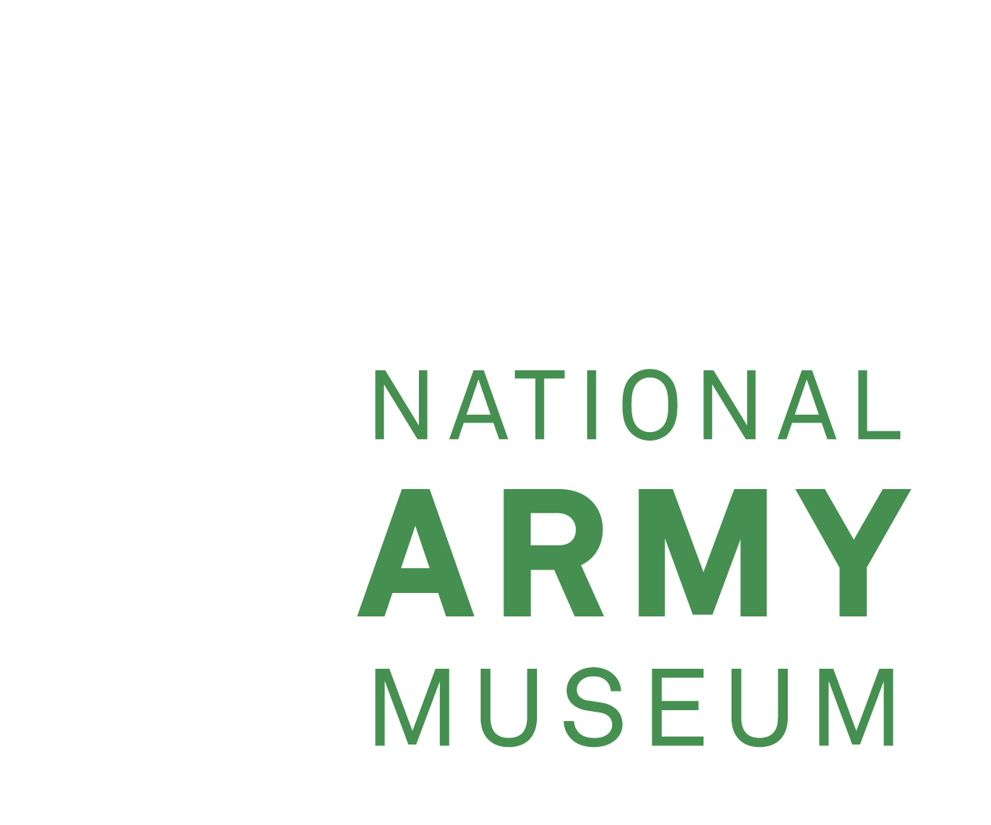

**APPOINTMENT OF DIRECTOR GENERAL**

**1. Background**

Transformed through a £23.75 million investment at its site in Chelsea, the National Army Museum’s (NAM’s) mission is to provide a museum experience that meets the widest range of public need and connects the British public with its Army.

Our purpose is to gather, maintain and make known the story of the British Army and its role in world history, and through five new galleries, the public can explore what it’s like to be a soldier, why we fought in conflicts – past and present, and explore British society’s relationship with its army.

The Museum holds world-class collections relating to the British Army over the last 400 years and is supported by a well-developed Collections facility at Stevenage and on line/digital resources including the online collection, exhibitions, and content – one of the most important ways of reaching and engaging with our existing and potentially new audiences.

The Museum has a dedicated Learning and Outreach remit, and full programme of taught sessions for primary and secondary schools, which launches in September 2017. Our galleries support a wide range of curricular areas to complement classroom learning, and we have a dedicated study centre and regular public programme, which supports higher education and those with a general interest in accessing the Museum’s archive collection.

We continue to develop both our national and international academic partnerships; our staff deliver lectures in the UK and abroad, and the Museum also provides pastoral care to Regimental Museums.

The Museum is a Royal Charter Body and a Registered Charity (No 237902). It is also an Executive NDPB (Non-Departmental Public Body), with the Ministry of Defence as its Government Sponsor Department, through which it receives annual grant-in-aid. There is an annual operating budget in the region of £7.1 million of which £6 million is Grant in Aid. The Museum’s governing body is the Council of the National Army Museum, whose non-executive Members carry out the functions of Charity Trustees.

The Museum’s external (statutory) auditor is the National Audit Office.

The Museum is accredited by the Arts Council England (ACE) and received Accreditation status in 2009.

Around 100 staff are employed directly by the Museum, supported by a team of volunteers and contracted staff in security, cleaning and catering, in a range of permanent and contract posts.

**2. NAM’s Purpose, Mission and Brand Values**

Purpose

To gather, maintain and make known the story of the British Army and its role in world history.

Vision

To be the leading authority on the history of the British Army and a first-class museum that moves, inspires, challenges, educates and entertains.

Brand Values

Real -

We are grounded in reality. We express humanity as it really is about real events and the Army’s role in society without sensationalising or manipulating.

Sharing -

We share stories, thoughts and ideas, not just ‘things’. We have a duty to make known the story of the British Army.

Conversational -

We spark conversations and encourage people to join in and continue the conversation for themselves.

Insightful -

We have a unique insight into the British Army and are confident in our accurate and deep understanding.

Relevant -

We always seek to communicate in unique ways that different audiences will engage with.

Stimulating -

We stimulate people’s minds, senses and emotions. We challenge people in a way that encourages them to think about things in different ways.

**3. Job Role**

**Accountability**

* To the Museum Council for the operation of the Museum and on matters of policy.
* To the Permanent Under-Secretary of State at the MOD in respect of financial regularity and propriety of grant in aid expenditure; (the Director General is the Museum Accounting Officer and is answerable to Parliament for the proper stewardship of public funds).

**Responsibility**

* For all persons working at the Museum on a permanent or term contract basis, including employees, volunteers and contractors; all of the Museum’s premises, assets and moveable property - including the collections.

**Line Management Responsibility**

Direct Reports:

There is a Senior Management Team, which supports the Director General in the discharging of his/her duties:

* Museum Director (Operations)
* Assistant Director (Collections)
* Assistant Director (Commercial and Visitor Experience)
* Assistant Director (Development)
* Assistant Director (Human Resources)
* Assistant Director (Public Programmes)
* Senior Personal Secretary
* Committee Clerk

**Director General’s Main Duties and Responsibilities**

* To work with the Council on strategy, direction and development of the Museum.
* To provide creative and professional leadership, with clearly defined objectives cascading through the Management Team to all levels of management, oversight and service to the public, in accordance with Government legislation and best practice in the museums and galleries sector.
* As NAM Accounting Officer, conduct the business (including NAM Trading Limited [NAMTL]) to the highest achievable standards of propriety, regulatory and good practice as laid down by the National Audit Office (NAO), the Charity Commission, Arts Council England (ACE), Companies House and other external authorities.
* To build and develop effective relationships and to enhance the Museum’s reputation with key stakeholders, including the Chairman and Members of Council, the MoD, other museum and cultural service providers and potential funders/sponsors.
* To develop the Museum’s capability to deliver its vision and strategy.
* To oversee the continuing management of change at the Museum, having regard to value for money, good communications, the fair and open application of all the Museum’s procedures, and the skills, career development, performance assessment and reward of the staff.
* To provide full access (physical, intellectual and virtual) to the NAM’s collections to as diverse an audience as possible.
* To co-ordinate and manage fundraising initiatives.
* To maximise commercial opportunities through NAM Trading Limited (NAMTL).

**Governance**

* To safeguard the Museum’s public reputation.
* To safeguard the Museum’s assets, including its people, collections, money and buildings.
* To co-ordinate and service an effective cycle of meetings of Council and Council’s various sub-committees, providing reports for the Chairman and Council Members, key stakeholders and potential funders/sponsors, as appropriate, in particular, to report to Council, in a timely manner, any risks or other matters currently or likely to affect the Museum, its performance and reputation.
* To advise the Council on governance arrangements, and/or to seek appropriate advice on their behalf.

**Financial and Administrative Management**

* To ensure proper accounting systems, processes and controls are in place to meet statutory obligations, charity law, high standards of risk management and audit (external and internal) especially to satisfy Government accounting requirements and good practice.
* To oversee the maintenance of the Museum’s risk matrix and to ensure that appropriate contingency, emergency and disaster recovery plans are in place.

**Business Development**

* To identify opportunities and take the necessary action to develop income-generating activities and income streams from commercial activities, sponsorship and earned income.
* To identify key service delivery, operational and capacity challenges for the NAM and develop business plans to secure medium and long-term sustainability.
* To oversee community and public relations and ensure that programmes, products and services are consistently presented in a strong, positive manner to relevant stakeholders.

**Advocacy and Partnerships**

* To maintain and develop effective contacts and active relationships with a wide range of decision-makers, stakeholders, organisations and communities and media.
* The Director General will be an advocate and an ambassador for NAM internationally. (The Museum is a member of the International Council of Museums [ICOM] and its sub-committee, International Committee for Museums of Arms and Military History [ICOMAM], with special links to museums of arms and military history worldwide).
* The Director General represents the Museum at the National Museum Directors’ Council (NMDC) - an association of directors and chief executives of the UK's museums, galleries, libraries and archives, which lobbies Government and other public stakeholders on museums & galleries issues.

## **Collections Management**

* To secure the future of the Museum’s collections and increase public access to them.
* To ensure high quality care, documentation, storage and conservation of the collections to ensure their long term future.
* To rationalize the collections either where duplication exists or other issues pertain, in line with NAM’s Policy on Acquisitions & Disposals and the Accreditation protocols laid down from time to time by ACE.

**General Responsibilities**

* Compliance with the Data Protection Act 1998 and Information Governance:-

The post-holder is not entitled to use for their own benefit or gain, or to divulge to any persons, or other organisation whatsoever, any confidential information belonging to the NAM or relating to the NAM’s affairs or dealings that may come into their knowledge during employment.

* Compliance with the Health & Safety at Work Act 1974:

The overall responsibility for the health, safety and welfare at work of all personnel in the NAM is vested in the Director General. The post-holder is required to fulfil a proactive role towards the management of risk in all their actions. This entails the risk assessment of all situations, the taking of appropriate actions and reporting of all incidents, near misses and hazards. There is a statutory duty of care for their own personal safety and that of others who may be affected by their acts or omissions.

* Maintain awareness and ensure compliance with all Museum policies, including health and safety, security, data protection and the Staff Code of Conduct.
* The post-holder will be accountable for carrying out all duties and responsibilities with due regard to the NAM’s Equal Opportunities Policy.

**4. Person Specification**

**Essential**

* Excellent leadership and people management skills.
* Outward facing with the ability to promote the Museum at all levels.
* A strategic thinker and decision-maker with an eye for detail.
* A proven high level of personal integrity with strong business, commercial and financial acumen.
* Financial competence and the capability to discharge the role of NAM Accounting Officer.
* A demonstrably successful track record over time in leading a complex organisation in a competitive, customer-focused and changing environment, including experience of leading significant culture change and business improvement.
* Excellent communication and inter-personal skills; comfortable with all aspects of media relations.
* The ability to prepare clear and comprehensive reports for Council, key stakeholders and potential funders/sponsors.
* An understanding of/empathy with the British Army and/or a subject bearing on (or related to) at least one of the core subject areas of the Museum.

**Desirable**

* A demonstrable track record of successful management of a leading museum/gallery, or management in the wider heritage, cultural, academic or corporate sectors.
* A demonstrable understanding of the principles of public service and the principles of public life.
* A track record of delivering on fundraising and commercial activities, including catering, events, retail and donations.

**5. Remuneration and Benefits**

**Salary**

Competitive salary reviewed annually, plus performance related pay.

**Pension**

NAM operates a Joint Contributory Pension Scheme (under N.E.S.T).

**Holiday Entitlement**

Annual leave of 30 days, plus public and privilege holidays.

**6. Terms and Conditions of Employment**

**Appointment**

The appointment is a full-time and permanent position, based at the NAM’s premises in Chelsea.

**Hours of Work**

Hours of work are based on a 42-hour week, inclusive of breaks, and working 5/7 days. The post-holder will be required to work such hours as may be reasonably necessary, including attendance at evening and weekend meetings, to meet the requirements of the post.

**Probation**

Employment is subject to satisfactory references, a medical assessment and the satisfactory completion of a six-month probationary period.

**Notice Period**

Your notice period should you wish to resign, will be six months.

**Security Clearance**

The appointment is subject to a satisfactory security clearance through Disclosure Scotland.

7.The National Army Museum is an equal opportunities employer.

General Sir Richard Shirreff June 2017

Chairman, NAM Council National Army Museum