Request for Information (RFI)

Provision of Customer Insight Platform
Ref: 7F-2023-I167

Commercial in Confidence

DATE RESPONSE REQUIRED: Monday 15th July by 12:00 (noon)

All responses should be sent via the Atamis portal.
Responses via any other method will not be accepted.

Contents
1 Contents 2
2 Disclaimer 3
3 RFI Introduction 4

3.1 | INTRODUCTION
3.2 | OBJECTIVES
3.3 | INTRODUCTION TO 7FORCES COMMERCIAL SERVICES
3.4 | LEARNING & DEVELOPMENT
3.5 | OUR AIMS
3.6 | WHAT WE ARE LOOKING FOR
3.7 | QUESTIONS
3.8 | TIMESCALES
3.9 | POINT OF CONTACT

Disclaimer
The information contained within this document is the property of 7Forces Commercial Services (7Forces) and is issued in confidence and must not be reproduced in whole or in part or used in tendering or manufacturing purposes or given or communicated to any third party without the prior written consent of 7Forces.
7Forces does not accept any responsibility for the information contained in this document or for its fairness, accuracy, or completeness. Advice given, or statements or recommendations made shall not in any circumstances constitute or be deemed to constitute a warranty by 7Forces as to the accuracy of such advice, statements, or recommendations.
7Forces will not be liable for any loss or damage (other than in respect of fraudulent misrepresentation) arising because of reliance on such information or any subsequent communication. Only the express terms of any written contract relating to the subject matter of this document as and when it is executed shall have any contractual effect in connection with the matters to which it relates. English law will govern any such contract.
Nothing contained within this document, or in any other communication made between 7Forces and any other party, shall be taken as constituting a contract, agreement, or representation between 7Forces & any other party (excluding a formal award of contract made by 7Forces or any formal express legal agreement).
This RFI is not an offer to enter into an agreement with any party; rather it is a request to receive information from Potential Providers interested in providing the goods & services specified herein.
7Forces offers no warranty that a procurement exercise will be undertaken pursuant to the issues of this RFI, responses to which will be used to inform a wider options appraisal. As such the procurement process to be followed is yet to be defined. An expression of interest will not automatically entitle your involvement in any future procurement exercise. Any procurement conducted because of this exercise will be advertised separately and all organisations wanting to participate will need to respond to the procurement advertisement as and when it is published.
7Forces expect that all responses to this RFI will be provided by Potential Providers in good faith to the best of their ability considering information available at the time of their response.
No information provided by a Potential Provider in response to this RFI will be carried forward, used or acknowledged in any way for the purpose of evaluating the Potential Provider, in any subsequent formal procurement process.
Any and all costs associated with the production of such a response to an RFI must be borne by the Potential Provider. We will not contribute in any way to meeting production costs of any response.

RFI Introduction

INTRODUCTION
We would like to notify you of an upcoming requirement, and by doing so we are keen to understand where the market stands in terms of our requirement.

This document has been prepared to provide suppliers with initial material to aid them in understanding the requirement for Hertfordshire Constabulary regarding a Customer Insight Platform that captures the Voice of the Customer (VoC) and Voice of the Employee (VoE). The platform will enable Hertfordshire Constabulary to gain insights from anybody who lives, works, studies or travels through Hertfordshire. The platform is also required to obtain the Voice of the Employee and insights from partner agencies. The platform will support and inform local and national statutory requirements and, organisational strategic drivers such as Local Policing Priority Setting, Safeguarding and Public Contact.

OBJECTIVES
The objective of this RFI is gauge market interest and gather additional supplier options. Hertfordshire Constabulary is exploring the options for the procurement of a Customer Insight Platform.
The objective of this exercise is to obtain up-to-date information and feedback from the market to understand market capabilities and solutions in relation to the functionality required; and provide Hertfordshire Constabulary with indicative costs associated with the implementation and on-going support of a suitable solution.

INTRODUCTION TO 7 FORCES COMMERCIAL SERVICES
7 Forces Commercial Services is a shared procurement service for the seven Eastern Region Policing Bodies (Bedfordshire; Cambridgeshire; Essex; Hertfordshire; Kent; Norfolk and Suffolk)
Our Vision
By working together our vision is to enable the delivery of an effective Police service and provide support for victims of crime in the Eastern Region by procuring and managing a high-quality value for money supply chain.

Current Position
[In 2019, we procured and went live with a supplier who provided the Constabulary with a VoC and VoE platform to deliver insights at scale and, with automated sentiment and analytical capabilities.
We have since reflected on our position. We aspire to create a new vision and further develop our capability of soliciting and analysing customer feedback – going beyond basic level sentiment analysis.

Since 2019 we have learned (and do not require help to understand):
- What standard industry generated insights are (based on topics or emotion)
- How to construct and phrase SMS feedback invites.
- How to use feedback dashboards
- What triggers are (low scoring or trigger words)

3.5 OUR AIMS – WHAT WE WANT TO ACHIEVE

a) To improve the customer experience by increasing feedback touch points across the journey.
b) To work towards building trust and confidence in policing in Hertfordshire.

Service Users:

We offer many different services; these could be a one-off interaction with Herts police or many interactions over days/week/months. For both the service provider and the user, the customer effort must be low and the customer experience meaningful.

To monitor this desired approach, we must be able to track interactions, outcomes and sentiment.

Basic aims - We want to be able to break down the service user end to end journey and easily show what was good and what was bad from the service user (even the service provider too where possible). With advanced sentiment analysis at the core to show what drives things like, Trust and confidence, Engagement including Attrition rates, but also more traditional as well things like satisfaction or effort scores.

Residents:
Listen to the voice of our residents and learn from their feedback to build trust and confidence.

Ensure easy access to be able to engage with Herts Police in a way that meets their needs.

Voice of Employee:

To enable our staff and officers to have access to insights / Learn and act based on insights / community engagement.
To listen, learn and work towards a better working environment for all staff and officers.
Mutual benefit - to meet the need of staff and officers as well as victims and residents.

Advanced aims – since 2019 we have established some patterns and themes to feedback. We have hypothesized that there are some feedback models or filters which we would like to test and apply to service user or victim sentiment. Using these to develop strategy and performance for the service user is critical going forward.

The “echo Way” Mission Statement:

Insight is a Decision to act upon Information to change an Experience.

‘The echo Way’ as Service, Engagement and Trust (Get SET!)
- The Purpose of ‘The echo Way’ is Service, where we use Insight to go Beyond Understanding to Better
- The Aim of ‘The echo Way’ is Engagement, where we use Insight to seek A Better Experience for All
- The Vision of ‘The echo Way’ is Trust, where we use Insight to make Every Touchpoint a Trust point (Thankyou, Dept of Homeland Security!)

The echo Way | Is about | Excellence | Using Insight to …
Purpose: | Service | From Understanding to Better (4 words) | Build better Service
Aim: | Engagement | A Better Experience for All (5 words) | Improve Engagement and reduce Attrition
Vision: | Trust | Every Touchpoint a Trust point (5 words) | Earn Trust, Confidence and Satisfaction

Long-term Vision:

We are looking to incorporate the ‘Get SET!’ as part of the branding solution as we develop CX.

3.6 WHAT WE ARE LOOKING FOR

A relationship and partnership with a vendor that enables the Customer Insights Team to manage, analyse, and improve all aspects of caller, victim, resident and employee interaction. Functionalities may cover data management, analytics, and customer journey mapping, providing Hertfordshire Constabulary with a holistic view of a single or multiple customer journey. The insights derived allow Herts to tailor its processes, services, and interactions to meet customer expectations.
Our core requirements are shown in the table below.

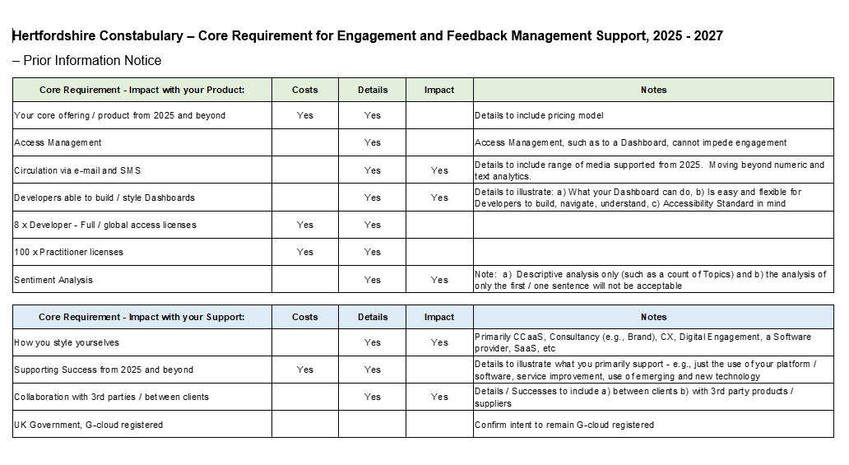
The full log of requirements is detailed within the document embedded below within this RFI (can also be found in a separate document appended to this RFI)

Please note that:
limited/no experience in the Public Sector in the UK should not deter expressions of interest.
Organisational Experience in Customer Experience (CX) is highly desirable.
Impact’ – to include examples / case studies, where possible.
3.7 QUESTIONS for Potential Providers
Suppliers are requested to complete the relevant questions below.

3.7.1 COMPANY INFORMATION
Please provide information about your company and product by completing the pro forma below.
Company name:
Business nature:
Address:
Product Names and Versions:
Contact person: |  | Position:
Telephone no: |  | Email:

3.7.2 QUESTIONS & REQUIREMENTS
No. | Question | Response  Please provide an answer to the below questions, in no more than 250 words. Feel free to provide answers in a separate document. If you are attaching supporting evidence, please attach each document separately and clearly reference them to reflect the question number and criteria.
1 | Are you a UX/CX/XM focused provider? Or do you suggest another overarching approach to achieve success?
2 | What is your USP?
3 | Can we see a case study where you achieved success and what was the mutual benefit?
4 | Can we see how you analyse free text, from individual topics up to an overall summary?
5 | Can we see how once free text is analysed, what are the suggestions for service improvement?
6 | We will be looking to on board our new supplier by February 2025. Assuming we want a seamless transition between providers, how long do you need to implement?
7 | What initial training and ongoing support will you offer and maintain.
8 | Please describe (with examples, where possible) your planned product and service development over the next 2-5 years.

Responses to the questions above and those included on the attached Requirements Catalog document below must be submitted via the Atamis web portal by Monday 15th July 2024.

Please indicate if each requirement is part of your solution and give a brief response as to what is provided as part of your offering. Please also respond to the specific questions above

3.7.2 INDICATIVE COSTS

Costing Assumptions
- Prices should be at 1st October 2024 base price.
- Prices should be expressed in GBP Pound Sterling excluding VAT.
- Indicative total costs for implementation and support should be provided as well as day rates; and
- While you will not be held accountable for the prices 7Forces are keen to get a realistic representation of costs so please provide prudent pricing information based on the information provided and your past experience.

Pricing Templates

The pricing templates are detailed in the following pages

National License
Price Item | One off | Year 1 | Year 2 | Year 3 | Assumptions
1 Software Licence
Please indicate a price per User Licence
Please also indicate a price per Concurrent User Licence
Please also provide any other Licensing model that your organisation provides and the rationale on which the licence cost is based be that Licence on a one-off payment basis or an Annual Revenue basis

Any Other Costs:
Price Item |  | One off | Year 1 | Year 2 | Year 3 | Assumptions
1) Implementation
 | Project Management
 | Configuration
 | Software Development
 | Implementation Support
 | Design
 | Integration/Interface Development (e.g., cost per unique interface)
 | Training
 | Testing
 | Other (specify)
2) Support
 | General Support
 | Hosting
 | Other (specify)
3. Additional Services
 | Training (day rate)
 | Project management (day rate)
 | Consultancy (day rate)
 | Other (specify)

3.8 TIMESCALES
DATE | ACTIVITY
Monday 24th June 2024 | Publication of the Request for Information
Monday 15th July 2024 | Deadline for submission of a RFI Response
Thursday 18th July 2024 | Analysis of RFI responses
Friday 19th July 2024 | Confirm next steps to RFI Respondents

RFI Leads
Name | Amanda Calvert - Insight Manager
 | Ope Ore - 7F IT Procurement Specialist – Procurement Lead

3.9 GENERAL CONTACT POINT FOR THIS RFI
Please direct any questions relating to this RFI via the Atamis Portal. Be advised that where such enquiries have been made, responses will be distributed to all expressions of interest with anonymity preserved.

