Invitation to Tender for Architectural Services: Park Lane Workshop & Allotments:
Background:
Corsham Town Council wishes to employ an experienced Architectural practice to help deliver a new workshop for its grounds staff as well as allotment plots for local residents.
The Town Council’s responsibilities are likely to increase over the next few years, due in part to Wiltshire Council’s Service Delegation and Asset Transfer policy (devolving services and assets to towns and parishes). Corsham Town Council’s current workshop, located behind the Tourist Information Centre (31 High Street) is too small to adequately accommodate the needs of a larger workforce undertaking a wider variety of tasks.
The Town Council has acquired land off Park Lane, Corsham, between the Hartham Park Quarry and Groundstone Way, on which it proposes to construct the new workshop and allotments.
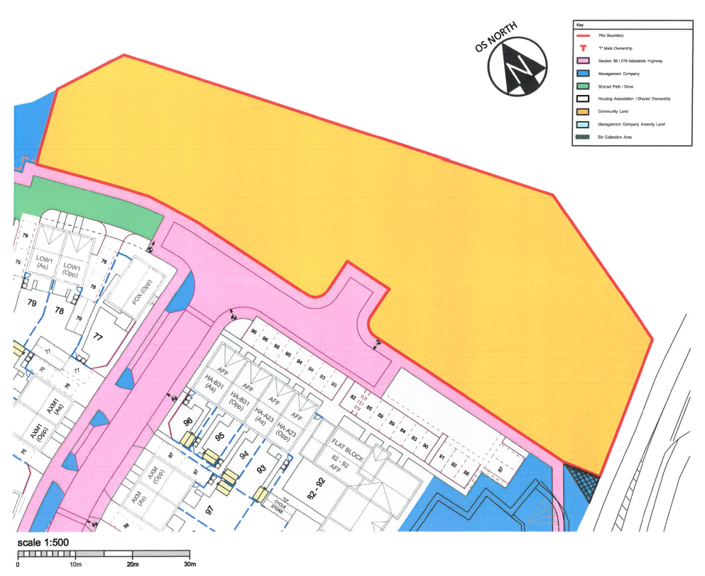
Corsham Town Council wishes to construct a workshop which will accommodate up to eight grounds staff and enable them to carry out their duties in an efficient and orderly manner.
The Town Council would also like the workshop to perform very well from an environmental point of view (both in terms of operational energy and embodied energy). We are committed to becoming net carbon neutral by 2030 and would like the building to both help us achieve this goal and to provide an example to other organisations in the area.
Development on the site is somewhat constrained by the presence of a 200mm watermain, which requires a 10 metre easement (Wessex Water have indicated that if the ground level was dropped by 1 metre, they would consider allowing us to build within 7 metres of this pipe).
The Town Council had been working with a local architect to develop plans. Unfortunately, he has had to withdraw from the project for personal reasons. He had developed some initial designs for the building and allotments (which took account of the constraints caused by the water pipe) which the Town Council were reasonably happy with. A copy of the elevations and Layout is attached along with a specification/list of ideas drawn up with our grounds staff of elements they would like included in the workshop design. The Town Council is not necessarily committed to pursuing these plans exactly as they are, but they do indicate the type of facility we are trying to develop.
After receiving the initial designs, the Town Council employed Hoare Lea for environmental consultancy work. Hoare Lea have produced a Part L2A Assessment based on the designs and were due to carry out an Energy Strategy and a Life-cycle Carbon Assessment. This work is now on hold following the withdrawal from the project of our architect.

Site Visits:
Prospective companies are encouraged to undertake a site visit before submitting a tender. Please contact James Whittleton (Head of Technical Services) to arrange a time/date: jwhittleton@corsham.gov.uk 07879 256215.

Tenders:
Corsham Town Council wishes to select an architect to develop the designs and to construct the new workshop and allotments; essentially following stages 1-6 of the RIBA Plan of Work.
We would like tenders to include the following:
- A quote for the completion of a full architectural service; RIBA stages 1-6, with a fee breakdown by stage.

- A quote for Principal Designer service; RIBA stages 1-6, with a fee breakdown by stage.

Quotes are to be based on a traditional form of procurement and project cost (inclusive of all fees, but exclusive of VAT).

We would require the architect to be the Contract Administrator, to run the building contract, issue instruction to the contractor and certificates for payment etc.

We would be open to exploring other forms of procurement (Design & Build) once the appointment has been made.

Fees should be based on an estimated contract value of £350,000.
The Town Council would also like tenderers to submit the following additional information:
- Please describe your previous experience of delivering similar projects to that required by Corsham Town Council (maximum 300 words).

- Please provide details of three recent relevant projects of a similar size and complexity – preferably completed in the last five years (maximum 200 words per example). Can you also provide contact details, so that we can take up references for these projects.

- Please provide details of how the project would be resourced within your practice (maximum 300 words).

- Please describe your approach to the management of engagement of the key stakeholders and the wider community (maximum 500 words).

- Please describe your practice’s approach to the design and delivery of sustainable (preferably carbon neutral) design (maximum 300 words).

- Please provide hour rates and day rates charged for members of your team who would be working on the proposal.

Submission of Tenders:
Tenders sent by post or delivered by hand should be in an envelope clearly labelled ‘Tender – Park Lane Workshop’, addressed to:
Mr David Martin – Chief Executive
Corsham Town Hall
High Street
Corsham
Wiltshire, SN13 0EZ

Tenders submitted electronically should be sent to dmartin@corsham.gov.uk and should have the following title: ‘TENDER – PARK LANE WORKSHOP’.
Tenders submitted electronically should have a maximum attachment limit of 10mb.
Tenders should be received no later than 12.00 noon on Friday 11th June 2021.

Interviews:
Following receipt of tenders, Corsham Town Council will invite up to three companies to attend an interview.
We would like these interviews to take place c.3 weeks following the submission of tenders.

Evaluation:
The Town Council will assess tenders on a 60:40 quality:cost basis.
Evaluation Criteria:
 | Overall Weighting | Category | Category Weighting
Price | 40% | Cost/Competitiveness | 40%
Quality | 60% | Environment – commitment/ability to achieve excellent environmental performance | 20%
 |  | Technical – capability & resources | 15%
 |  | Service Delivery – flexibility, communication, reaction to problems, innovation and added value | 15%
 |  | Quality – customer care, quality of service, continuous improvement | 10%

Timescales:
We would like to complete the project in 18 months from awarding the contract.

