SPECIFICATION OF REQUIREMENTS FOR THE DOWN’S SYNDROME SCREENING QUALITY ASSURANCE SUPPORT SERVICE (DQASS)

Revision Date | Summary of Changes | New Version No
07/03/2024 | New draft specification | V0.1 DRAFT
19/03/2024 | Revised draft incorporating comments from Claire Burns, Kevin Dunbar, Rebecca Till, Rhiannon Marr and Teresa Lardner | V0.2 DRAFT
11/04/2024 | Link to UK NSC consultation on T18 added | V0.3 DRAFT

TABLE OF CONTENTS

SPECIFICATION OF REQUIREMENTS TEMPLATE 1
Specification of Requirements 2
1. Background to the requirements 2
2. Scope of the Procurement 6
3. Requirements 8

Specification of Requirements

Background to the requirements
1.1 The Vaccination and Screening directorate (V&S) is part of NHS England and exists to protect and improve the nation’s health and wellbeing and reduce health inequalities. This is achieved through world-leading science, knowledge and intelligence, advocacy, partnerships, and the delivery of specialist public health services.

1.2 NHS England V&S leads on the NHS Fetal Anomaly Screening Programme (NHS FASP). The NHS FASP aims to:
- offer screening to all eligible women in England to assess the chance of their baby having Down’s syndrome (T21), Edwards’ syndrome (T18) or Patau’s syndrome (T13)
- ensure there is a high-quality accessible screening programme throughout England
- facilitate a personal informed choice in screening, diagnostic testing, and pregnancy management.

1.3 The main expected health outcomes of the NHS FASP are:
- equitable access to the T21/T18/T13 screening programme
- a personal informed choice for women about participating in screening and how they respond to the chance calculation given
- easily accessible diagnostic and follow-on care services.

1.4 The NHS FASP is delivered by a range of services working together. The offer of the screening test, provision of support and information is primarily delivered by maternity services. Various components of the screening and diagnostics tests are performed by biochemistry and genomics laboratories and ultrasound services.

1.5 Women with higher chance results may be referred to fetal medicine services for further information and tests including diagnostic tests.

1.6 There are at least 145 maternity services, 20 biochemistry laboratories, three genomic laboratory hubs and over 2,500 ultrasound practitioners across England delivering the screening programme.

1.7 All eligible pregnant women in England are offered screening to assess the chance of having a baby with T21, T18 and T13. Screening is offered to both singleton and twin pregnancies.

1.8 The recommended method of screening for those wishing to have screening is first trimester combined screening, combining maternal age, two biochemistry markers [free beta human chorionic gonadotropin (bhCG) and pregnancy associated plasma protein-A (PAPP-A)] and ultrasound measurement of crown rump length (CRL) and nuchal translucency (NT) to provide the pregnant woman with her chance of having a baby with T21, T18/T13.

1.9 Second trimester biochemical screening; the quadruple test using four biochemistry markers [alpha-fetoprotein (AFP), human chorionic gonadotropin (hCG) or free bhCG, inhibin-A and unconjugated oestriol (uE3)] is available for women who are too late to have the combined test or in cases where it is not possible to measure the NT. The quadruple test provides the woman with her chance of having a baby with T21.

1.10 Women who receive a higher chance screening result are offered further information and have the following options:
- no further testing
- non-invasive prenatal testing (NIPT)
- prenatal diagnosis (PND).

1.11 The decision to have PND can be a difficult decision for pregnant women as one out of every 200 women (0.5%) who have a diagnostic test will miscarry because of the diagnostic test procedure.

1.12 Due to context and nature of the tests, a screening quality assurance service is required to support the quality, effectiveness and consistency of the screening tests, and the results women receive.

2. Current arrangements / context
2.1 The Down’s Syndrome Screening Quality Assurance Support Service (DQASS) supports the quality, effectiveness and consistency of the screening tests, and the results women receive for T21, T18 and T13 for both the combined and quadruple screening strategies. It is essentially a statistical service that provides independent clinical audit data and feedback to screening laboratories and ultrasound practitioners to provide quality assurance and drive continuous improvement of the screening programme. Without a quality assurance service there would be variation in how laboratories manage the adjustments needed for the biochemical markers which would lead to variation in the screening result a woman receives. Similarly for ultrasound measurements there would be a lack of consistency in how the ultrasound measurements are performed without a DQASS.

2.2 For England, the DQASS looks at approximately 485,000 screening tests per year, 88% of these are combined tests and 12% are quadruple tests. Approximately three percent of these will have higher chance results. They also provide statistical analyses on approximately 425,000 ultrasound scans (CRL/NT) from more than 2,500 ultrasound practitioners each year.

2.3 The context in which the NHS FASP operates is complex. There are ethical sensitives with screening for T21, T18 and T13 and there is an inherent risk of miscarriage with PND for women who receive a higher chance result.
There are various biochemical, ultrasound markers and different reagents and software suppliers of the test.

2.4 In addition, there are also other factors like maternal weight, ethnicity, diabetes status, method of conception and smoking that can impact on the results a woman receives. The DQASS produces meta-analyses to enable screening laboratories and software suppliers to adjust biochemical markers multiple of mediums (MoM) to improve screening performance.

2.5 The analyses provided by the DQASS are used by the Screening Quality Assurance Service (SQAS) and NHS FASP in collaboration with professional clinical advisors (PCA) working for NHS England to improve the screening programme through feedback on specific properties of the test to laboratories, ultrasound departments and commercial suppliers.

2.6 The DQASS produces six different types of reports from these analyses that are used by screening laboratories, individual ultrasound practitioners, ultrasound screening leads called Screening Support Sonographers (SSSs), the SQAS, NHS FASP and screening commissioners.
Down’s syndrome screening quality assurance support service: report types - GOV.UK (www.gov.uk)

2.7 The current level of service delivery should be maintained but the supplier is expected to respond to changes in a timely manner as requested by NHS England. The supplier is expected to continually work towards improving and making the service more efficient. For example, implementing more automated processes where these are possible to reduce manual ones.

3. Scope of the procurement

3.1 Aims and objectives
3.1.1 NHS England (V&S) directorate is seeking to procure a Down’s Syndrome Screening Quality Assurance Support Service (DQASS). The service will be a clinical statistical support service to support the Down’s syndrome (T21) Edwards’ syndrome (T18) and Patau’s syndrome (T13) screening programme by providing independent audits of screening laboratory and ultrasound data in a standardised and statistically valid format. The service will be led by and include staff who are statisticians and are experts, experienced and knowledgeable in the complexity of screening for these conditions.

3.1.2 The main outputs of the service will be:
- six monthly reporting to the screening laboratories, ultrasound departments and individual ultrasound practitioners
- six monthly reports to SQAS
- attendance at monthly calls with SQAS, NHS FASP and PCAs to discuss the laboratory reports
- attendance at three monthly meetings to discuss ongoing quality improvement work
- attendance at monthly contract meetings
- supporting education and training events.

3.2 Inclusion and exclusion criteria
3.2.1 All screening laboratories and ultrasound practitioners are required to participate in the DQASS as specified in NHS England Section 7a service specification no.16 (schedule 2), therefore all labs are mandated to securely send data to the DQASS supplier to enable the requirements of this contract. https://future.nhs.uk/vaccsandscreening/view?objectId=184625157

3.2.2 All NHS screening laboratories in England are required to securely submit their data according to the schedule specified by the supplier. The data specification and schedule can be found at Down’s syndrome screening quality assurance support service - GOV.UK (www.gov.uk)

3.2.3 In addition to providing a service for England, the supplier is also required to include a service for Scotland and Wales. Separate reports will be provided for Scotland and Wales and the supplier will need to agree a communication process directly with Scotland and Wales.
The current activity for Scotland is 34,000 screening tests per year and 400 ultrasound practitioners.
For Wales current activity is 24,000 tests and 170 ultrasound practitioners.

3.2.4 In cases where an NHS maternity service subcontracts ultrasound services to a private provider /any qualified provider the supplier will include the private provider in the DQASS service if they are providing NHS screening.

3.2.5 Private screening test and any screening strategy that does not meet the NHS FASP specification are excluded from the DQASS.

3.3 Constraints and Dependencies

3.3.1 The supplier is required to work in close collaboration with the Screening Quality Assurance Service (SQAS), NHS FASP and PCAs working for NHS England to improve the screening programme.

4. Requirements

4.1 Mandatory and minimum requirements
4.1.1 The supplier will produce the following reports. For all reports the supplier must have in place a standard operating procedure (SoP) that clearly defines how the reports will be produced and communicated to the defined groups. The SoP should also detail the statistical analysis methodology and quality checks.

4.1.2 The supplier will inform SQAS of any delays or problems encountered with producing the reports on time, as early as possible.

4.1.3 The supplier will demonstrate a move from manual communication processes for example from emails or data submission spread sheets to more automated processes for example use of a web portal or equivalent.

4.1.4 The supplier is expected to support the SQAS in communicating messages to screening laboratories, SSSs and deputies on request.

4.2 Reports
Reporting on screening performance of laboratories
Two types of laboratory reports will be produced. Two reports are required for each laboratory every six months: a detailed laboratory/network report and a summary laboratory/network report.
In addition, one detailed laboratory report and one summary laboratory will be produced for Scotland and for Wales each year.

Report 1
Report 1 is a detailed report for the screening laboratory and contains information on:
- summary statistics on the demographic information of the population screened
- estimated standardised screen positive rates (SPR) for each test provided
- details of each biochemical marker used by the laboratory
- a summary of the ultrasound data from the ultrasound department(s) that the laboratory provides a service for
- parameter estimates for log Multiple of Medians (MoM) values from samples.

Report 2
Report 2 is a summary report which outlines the following:
- screening test(s) provided
- software and equipment used for each screening strategy
- laboratory/network throughput for each screening strategy
- estimated annual number of pregnancies screened with each test
- modelled screening performance - detection rate(s) and SPRs
- standardised laboratory SPR for each test for the current cycle and the last three previous cycles
- an agreed list of recommendations and actions
- compliance of sonographer identity codes
- list of providers the laboratory is serving.

The supplier will ensure the following processes are in place to enable the production of timely reports:

4.2.1 A specification, schedule, and submission process for data collection from the screening laboratories. The supplier will have processes in place to deal with non-submissions, late submissions, and incomplete data. The supplier will adhere to the Data Protection Act 1998.

4.2.2 The supplier will have a process for pooling data for all laboratories that are part of a laboratory network and ensure these reports are communicated to an identified laboratory network lead.
4.2.3 The supplier will work with NHS England PCAs to arrange a feedback call with the identified laboratory lead for each laboratory or network. The purpose of this feedback call is to give advice and support in relation to changes which are expected to lead to improvements in the chance calculation results. The content of the laboratory summary report is also agreed at this call. The supplier will maintain a log of discussions and progress of actions and report progress at monthly reviews with the SQAS.

4.2.4 The supplier should agree the process for reports directly with contacts in Scotland and Wales.

4.2.5 The supplier will have processes in place to provide customised reports for Scotland and for Wales.

4.3 Reporting on screening performance of NT/CRL paired measurements
Two types of ultrasound reports will be produced. Every six months each ultrasound practitioner undertaking NHS Screening will receive an individual feedback plot and each ultrasound department will receive a summary ultrasound report.

The supplier will provide individual CRL/NT feedback plots for each ultrasound practitioner and ultrasound summary reports for Scotland and Wales.

Report 3
This is a report for each ultrasound practitioner performing screening measurements called an individual feedback plot. The individual feedback plots provide ultrasound practitioners with information on throughput and their individual paired NT and CRL distributions (bias and spread) in relation to the Fetal Medicine Foundation (FMF) reference curve.
An example of an individual feedback plot is shown below. Down’s syndrome screening quality assurance support service report types - GOV.UK (www.gov.uk)
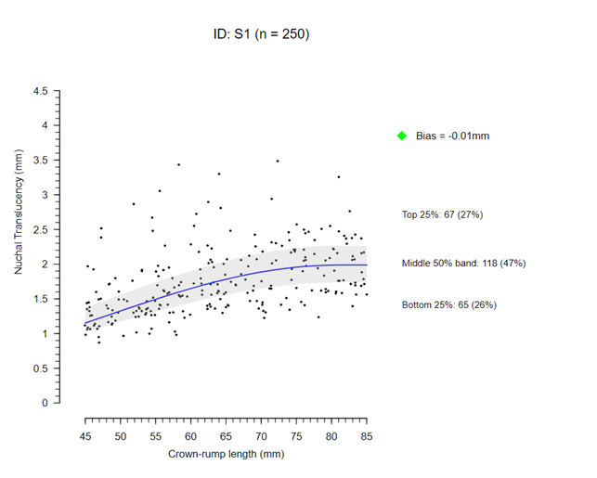
Individual feedback plots are assigned a flag for bias, spread and throughput using the following criteria:
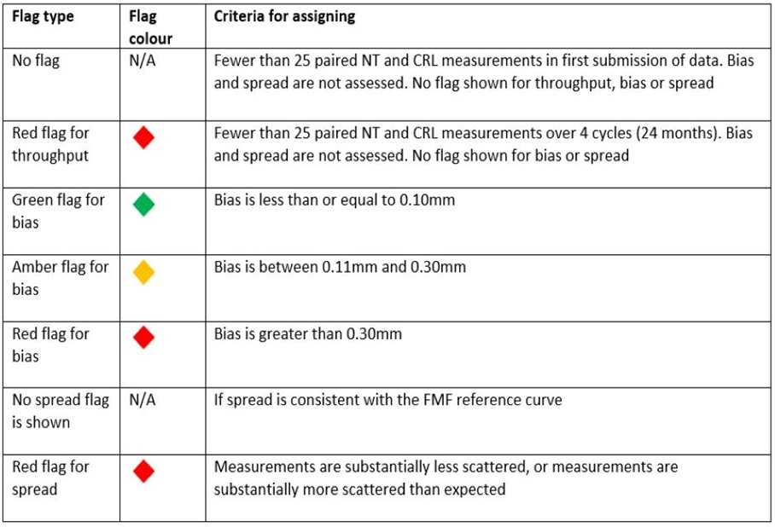

Report 4
Summary ultrasound reports contains information on:
- the screening laboratory used, and period covered by report
- for each practitioner – identity code, number of scans, median NT, median CRL, estimated bias and flag status
- flag status allocated in the previous cycle
- a plot of the estimated bias for each practitioner with 95% confidence intervals.
The supplier will ensure the following processes are in place to enable the production of timely reports:

4.3.1 A data specification for the screening laboratories contains the specific data fields on paired NT and CRL for each individual ultrasound practitioner.

4.3.2 An accurate list of ultrasound practitioners providing NHS screening with associated identity codes mapped to all sites where the practitioner works. Movement of practitioners across organisations is common and the supplier will have a process in place to manage this and continuously update the list. This should include a process for trainee ultrasound practitioners, and trainees should be distinguishable from trained practitioners.

4.3.3 The supplier will maintain an accurate and up to date list of SSSs and deputies to feedback reports to and specifically to provide feedback on data sets that are assigned red flags.

4.3.4 The supplier will have a process in place for communicating individual feedback plots and summary reports to SSSs and deputies.

4.3.5 The supplier will have a process in place for communicating summary reports and red flags to the SQAS.

4.3.6 The supplier should agree the process for reports directly with contacts in Scotland and Wales.

4.3.7 The supplier will have processes in place to provide customised reports for Scotland and for Wales.

4.4 Reporting national cycle reports
Two types of reports will be produced.

4.4.1 The supplier will produce national reports twice a year, two months after the cycle has ended (end of May and end of November).

4.4.2 The supplier will produce one ultrasound cycle report each for Scotland and for Wales.

4.5 Laboratory/network cycle report (report 5)
The laboratory end-of-cycle report includes aggregated results for all laboratories and allows comparison of performance cycle on cycle. This can be seen for individual markers and for the overall screening programme. These reports also provide summary statistics for the distribution of biochemical markers, including effects of factors such as ethnicity and smoking status.
No laboratory cycle reports are produced from Scotland or Wales.

4.5.1 The supplier will have a process in place for communicating the laboratory/network cycle report to SQAS.

4.6 Ultrasound cycle report (report 6)
The ultrasound end-of-cycle report includes aggregated results for all ultrasound practitioners and gives feedback on the overall performance of ultrasound over time. The plots give the mean level of bias in NT measurements relative to the NT reference curve nationally.

4.6.1 The supplier will have a process in place for communicating the ultrasound end of cycle report to SSSs and deputies.

4.6.2 The supplier will have a process in place for communicating the ultrasound end of cycle report to the SQAS.
4.7 Supporting screening laboratories and ultrasound departments in between reporting cycles

4.7.1 The supplier will respond to requests from screening laboratories, SSS and the SQAS outside of the cycle reporting schedule.

For example, additional analyses may be performed outside of the six-month schedule to provide the laboratory with feedback on request after a problem is identified or following implementation of a biochemical median update.

For example, to provide feedback on request on measurements of a sonographer who has had a break in clinical practice or following concerns raised from an ultrasound image review.

4.8 Providing and supporting education and training

4.8.1 The supplier will contribute to education and training events at the request of NHS England. This maybe in the form of but not limited to data to develop a slide set or a presentation or supporting a workshop. As a minimum the supplier will support:
- an annual biochemistry network meeting
- SSSs workshops
- SQAS updates
- Support development of e-Learning content.

4.8.2 Any requests directly to the supplier must be discussed and agreed with the SQAS prior to acceptance. Any presentations and training materials must be appropriately branded i.e. NHS England logo must not be used for any work without prior agreement and approvals.

4.9 Contributing to development and quality improvement work

4.9.1 The supplier will respond to requests from NHS England to support specific quality improvement or policy change work streams, queries from providers or data/information to support managing a screening safety incident. For example, data held by DQASS was used to set a threshold for laboratory throughput and give practice advice on the use of nicotine replacement therapy and the effects these have on biochemical markers. For example, NHS England may be asked to modify the screening programme by adding screening for Edwards’ syndrome to the quadruple test pending the UK National Screening Committee’s recommendation (pending) Addition of quadruple test to Edwards' syndrome screening pathway - GOV.UK (www.gov.uk)

4.9.2 The supplier will work with NHS England PCAs to support the review and update of the software specification. The supplier will also provide support in communicating changes and updates to software suppliers providing technical and statistical expertise as required.

4.9.3 The supplier will contribute to specific task and finish groups on request from NHS England where their specific expertise is required and adds value.

4.9.4 The supplier will provide NHS England with data on the screen positive rate of the screening tests and other data needed for screening reports such as the Screening in England report.

4.9.5 The supplier will respond to requests to share the quality assurance model, learning experience and processes with other national screening programmes or other directorates in NHS England.

4.10 Timescales and implementation

To familiarise the supplier with requirements, up to 6 months will be allocated for

mobilisation and on-boarding (before contract start date on the 1 of April 2025).
4.10.1 The supplier will develop a mobilisation work plan with dates for deliverables starting with kick off planning meeting with NHS England. The plan should provide clarity on check in points with NHS England during the life of the mobilisation period.

4.10.2 The supplier will agree the final design and processes with NHS England.

4.10.3 The mobilisation work plan will include but not limited to:
- collating contact list for the various stakeholders and users
- engaging with stakeholders and users
- development and testing of statistical model and processes in collaboration with NHS England PCAs
- setting up any IT interfaces and back-up systems
- producing example reports of all types as described in the specification
- agreeing and testing communication processes to screening laboratories, SSSs and the SQAS
- development and agreement of reporting SoPs and schedules
- agreeing specific outputs for Scotland and for Wales.

4.11 Location
4.11.1 The supplier is not expected to travel but on exception NHS England may ask the supplier to travel for face-to-face meetings or training events in England. Travel expenses will be met by the supplier.

4.12 Roles and responsibilities

4.12.1 The supplier – roles and responsibilities as outlined in this specification.

4.12.2 The SQAS will:
- communicate details about the DQASS contract with screening laboratories and ultrasound services to ensure continued interface
- arrange meetings as outlined in this specification including monthly contract meetings with the supplier
- communicate red flags and laboratory and ultrasound summary reports with screening commissioners
- develop guidance as outlined here Down’s syndrome screening quality assurance support service - GOV.UK (www.gov.uk)
- follow up supportive action plans for red flags with the SSS/deputies
- set up training events as required.

4.12.3 Screening laboratories will:
- participate in the DQASS
- identify a lead
- send complete data to the supplier on time as per agreed schedule
- work with the supplier and NHS England PCAs to arrange and participate in a feedback call to discuss the detailed laboratory report and agree the summary report
- complete actions as per report
- work with software suppliers
- work with the SSSs and deputies to make sure identity codes are accurate and up to date.

4.12.4 SSSs and deputies will:
- make sure identity codes are used and documented on the screening request forms that are used by the laboratory
- keep the supplier up to date with a list of ultrasound practitioners and their identity codes
- request new identity codes and trainee codes as necessary
- share individual feedback plots with individual ultrasound practitioners
- take laboratory summary reports and ultrasound summary reports to programme boards
- manage red flags supportive action plans.

5.0 Communication
5.1 The supplier is expected to have robust communication links with each screening laboratory/network, SSSs and deputies, the SQAS and NHS England PCAs as outlined in this specification.

5.2 In cases where the supplier has difficulties communicating with laboratories, SSSs or deputies, the supplier will inform the SQAS.

6.0 Management information and governance

6.1 Management

6.1.1 The supplier is expected to attend:
- monthly calls with the SQAS and PCAs to discuss reports
- three monthly meetings to discuss ongoing quality improvement work
- monthly contract meetings
- education and training events as requested by NHS England.

6.2 Governance
The overall accountability of the service sits with NHS England SQAS. The SQAS is responsible for overseeing the overall quality, sustainability, and accessibility of the DQASS service.

6.2.1 The SQAS ensures effective monitoring by:
- monthly reviews to monitor progress of laboratory actions and to capture any wider learning or actions required
- quarterly strategy and operation huddles to ensure the DQASS is functioning as specified. This provides a forum to discuss and agree any changes that are currently emerging from practice, and monitor progress on laboratory reports and red flags assigned to NT/CRL measurements
- reviewing queries coming through the screening system and agreeing responses.

6.2.2 The supplier should raise concerns about local screening programmes with the SQAS. In cases where there are safety concerns about a provider the supplier will inform the SQAS as soon as possible.

6.3 Data and information management

6.3.1 The supplier will maintain a comprehensive, accurate and up to date databases of all laboratory data submissions, ultrasound practitioner information, reports, action logs and contacts in line with Data Protection Act 1998 and contractual agreement. Information and data are shared with NHS England SQAS as outlined in this specification and on request.

6.3.2 The supplier will have a process in place so at the point of registration with DQASS, each screening laboratory/network is allocated a unique code to enable anonymised reporting of results where necessary. The codes are assigned and kept by the supplier.

6.3.3 The supplier will also maintain a database of ultrasound practitioners and their identity codes to enable anonymised reporting of results.

6.3.4 The supplier will have a process in place for receiving, processing, and storing the data in a suitable manner which is secure and adequately backed up. These processes must meet the requirements of the Data Protection Act 1998 and prevent any loss of data.

6.3.5 The supplier will ensure all processes are secure and have a process in place for managing and destroying any identifiable data that may be sent to them erroneously.

6.3.6 The supplier is responsible for maintaining and storing information as per agreed data retention period which is a minimum of 25 years.

6.3.7 All intellectual property relating to this service will be owned by NHS England. The supplier will at NHS England’s request, provide copies of all such databases, logs etc.

6.3.8 DQASS is not a research study but is based on the principles of quality assurance and audit and aims to enable continuous quality improvement of the service. However, DQASS is well placed to contribute to the body of research in the field of screening and quality assurance. Data sharing is mandated by NHS England and requests to use DQASS data for peer review publications must be agreed and approved by NHS England. Additionally, request for use of the DQASS data for research purposes must be submitted to Research, Innovation and Development Advisory Committee (RIDAC). In cases where RIDAC gives approval, secure data release must be facilitated by the supplier. The supplier should maintain a central log of release and usage of the DQASS data.

6.3.9 The supplier will comply with the Freedom of Information (FOI) Act 2000. In the event of a FOI request, these should be sent to england.foi@nhs.net and the supplier should inform the SQAS senior responsible officer for the DQASS service.

6.4 Performance and measurements
The following key performance indicators (KPIs) will be used to monitor performance of the supplier and the contract.

6.4.1 The supplier is expected to achieve between 95% and 98% compliance for each KPI. These KPIs will be monitored by the SQAS.

- Six monthly reports to screening laboratories are produced and communicated to laboratories as per schedule.
- Six monthly reports to ultrasound departments (this includes feedback plots for individual practitioners and summary reports for the department) are produced and communicated to the screening support sonographers/deputies as per schedule.
- End of cycle reports are produced on time (end of May and end of November) each year.
- Attendance at monthly calls to discuss screening laboratory reports.
- Attendance at monthly contract meetings.
- Attendance at quarterly quality improvement meetings.
- Support to the annual biochemistry network meeting.

6.4.2 Each year NHS England will agree a minimum of one area of development with the supplier. For example, for 2024/25 the supplier will make laboratory summary reports available to SSSs/deputies via a web reporting portal instead of by email.

6.5 Contract Term

The contract term will run for 24 months; however, the contract will have an option to extend up to a further period of an additional 12 months (36 months in total) subject to performance review, budgetary approval, and business planning.

6.6 Exit strategy
6.6.1 NHS England will work with the supplier to develop an exit strategy which will include but not limited to:
- a notice period of no less than three months
- transfer of data and reports
- communication to users and stakeholders
- sharing the standard operating model and analytical methodologies
- meetings with a new supplier to ensure there is safe transfer of the service.

