**Peak District Dales SAC Protected Site Strategies Pilot- Effectiveness of agri-environment scheme (AES) in delivering condition on the dales: Part 2-Field monitoring (Peak 2g2).**

**Appendix 2: NVC maps (for relevant units)**

These do not show unit boundaries and will need to be compared to unit maps in Annex 1

Coombs Dale

Long Dale and Gratton Dale

Long Dale, Hartington

Topley Pike and Deep Dale

The Wye Valley

Via Gellia Woodlands

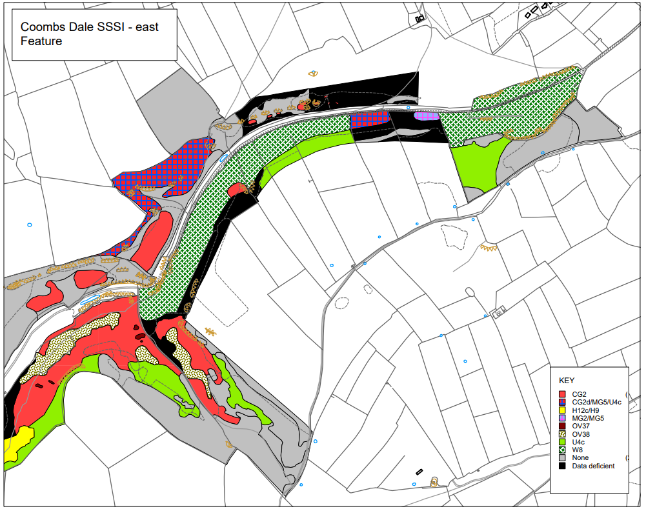`

Long Dale and Gratton Dale (west)

Long Dale, Hartington (north)

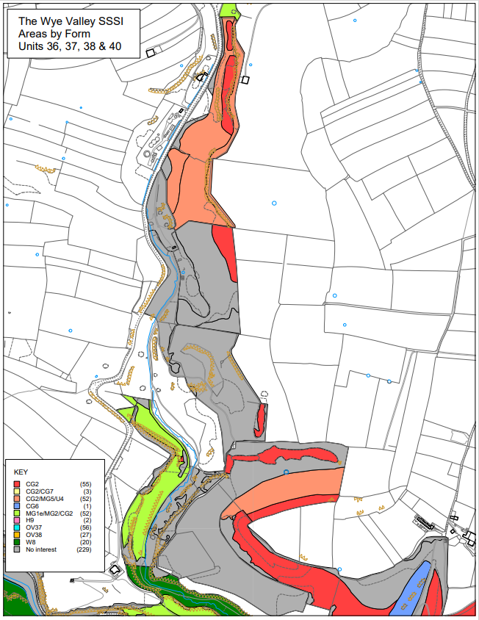

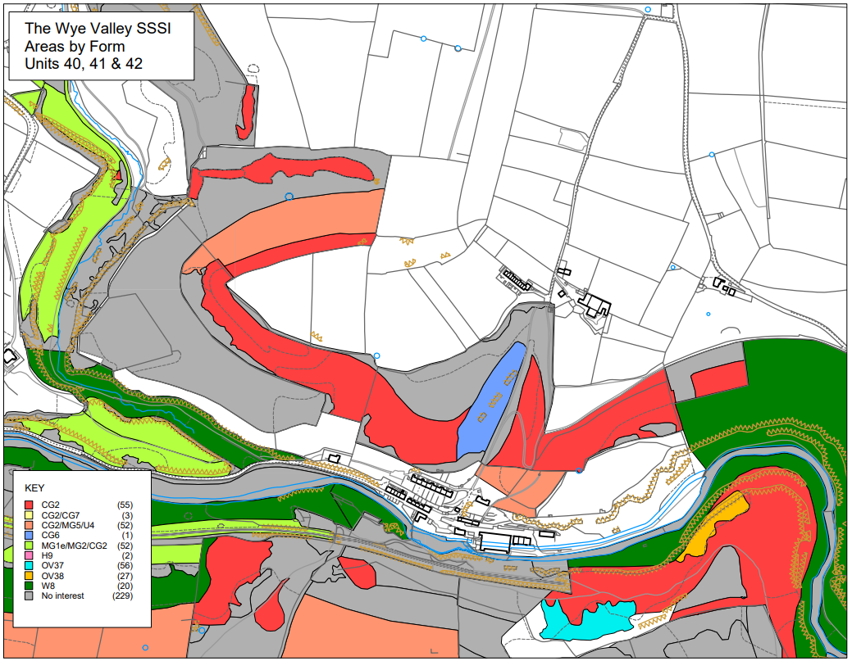

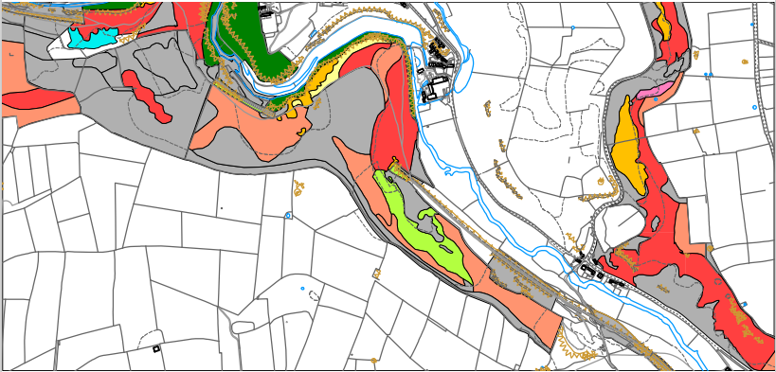

The Wye Valley: Units 46, 48, 50



