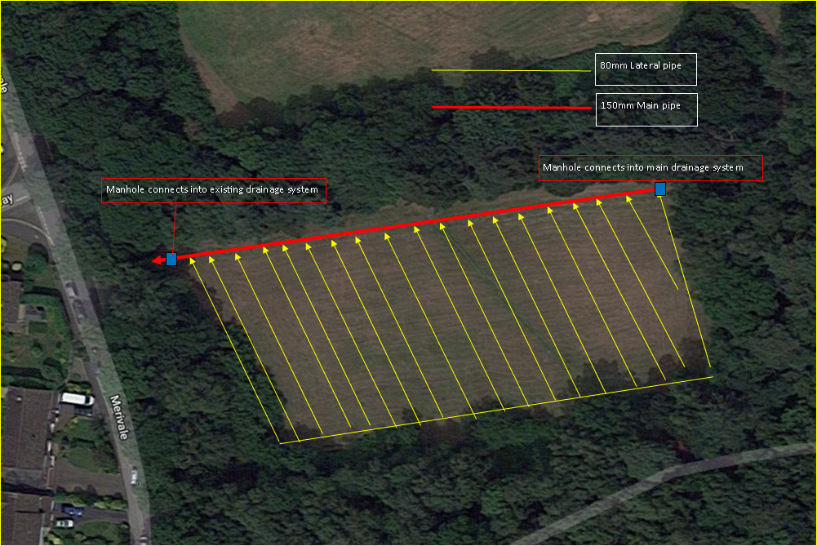
Drawing 2. Current Drainage System (indicative)

