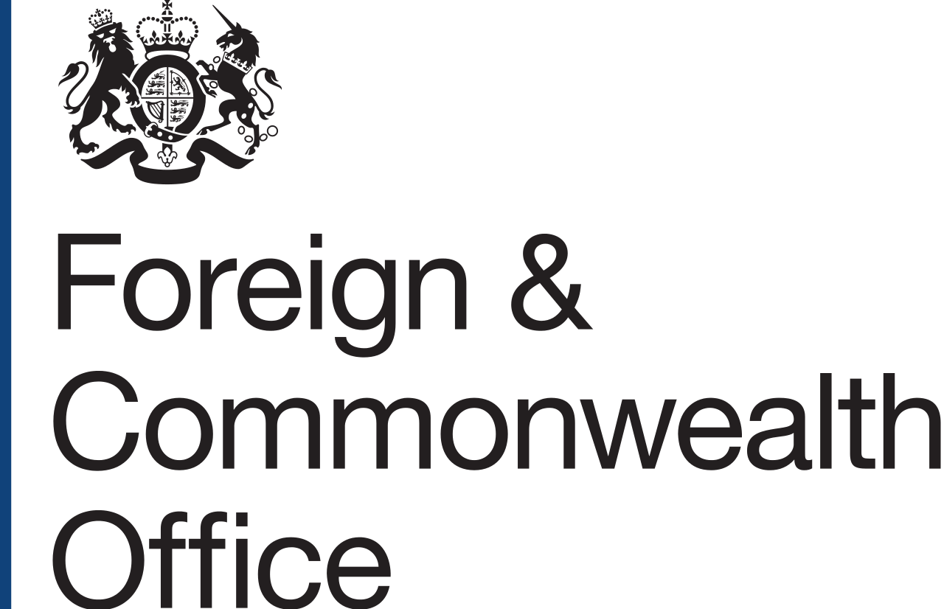

UK Prosperity Fund
South East Asia Economic Reform Programme
Supplier Conference Call
28 November 2017

ATTENDEES
Coller IP, GovRisk, ICAEW, IP Academy, IPO, Ipsos MORI, NdB, Ordnance Survey, Oxentia, PraxisAuril, Rouse, British High Commission Singapore: Jonathan Turner – SE Asia Regional Director, Economic and Trade Policy, Jane Ellaway – Head of Prosperity Programmes SE Asia, Aya Engracia – Regional Programme Officer, Prosperity Fund SE Asia

APOLOGIES
IDEAS, Oliver Wyman, The Asia Foundation, The London Institute of Banking and Finance, TheCityUK, Tilleke & Gibbins, UK-ASEAN Business Council

CONFERENCE CALL started at 16:00H (GMT+8).

MEETING NOTES
UK Prosperity Fund and the South East Asia Economic Reform Programme
The UK Prosperity Fund (PF) is a UK cross-government fund that aims to promote inclusive economic growth and development and the further enhancement of UK’s bilateral trade and investment.
The objective of the call was to give an overview of the in South East Asia Economic Reform Programme being developed under the Prosperity Fund. This will run to the end of March 2021. The call outlined parts of the programme that will be tendered and the procurement process.

Procurement
The PF Framework
The two elements of the SE Asia Economic Reform Programme will be procured under the Prosperity Framework Agreement. This Framework shall enable the appointment of specialist suppliers with the right capabilities to meet the requirements of programmes and assist in the delivery of long term programme objectives. It was launched under the Open Procedure in July 2017.
The lead implementer
The procurement team in London is currently assessing received bids* to identify a shortlist of preferred suppliers that are then able to bid for the Prosperity Fund programmes. Lead implementers will have to bid, and will be assessed, in accordance with the Terms of Reference and the evaluation criteria that form the Invitation to Tender for each individual programme. The list of preferred suppliers/lead implementers is expected to be released once the Framework goes live early next year. Note: these may include consortia. Suppliers will be divided into sub-lots within the Framework, based on their original bids.
*To note: the window to bid as a potential lead implementer has already closed.
Sub-implementers
Potential lead implementers can also bring in sub-implementing partners that have additional expertise and local knowledge required to deliver the programmes. Note: There is no exclusivity requirement on sub-implementers to work with one lead implementer and can appear in several bids.
The Programme does not have any requirements that potential implementers and/or subcontractors are from certain countries. However, bids will take into account the in-country delivery structure of bids.

Proposed key programme interventions
There are two main parts of the SE Asia Economic Reform Programme that will be procured – Intellectual Property (IP) and Financial Services. The Programme is particularly looking for expertise on IP and Financial Services as well as country and regional knowledge of SE Asia.
Intellectual Property
On Intellectual Property, procurement will cover enforcement and non-enforcement issues.
The aim on IP enforcement is to enhance institutional linkages between UK and four SEA countries namely Burma, Indonesia, the Philippines and Vietnam. Planned activities include sharing of UK experience and best practices to improve enforcement systems, better coordination between enforcement agencies, further development of IP enforcement law to strengthen monitoring and advocacy work on IP regulations, and supporting the development and launch of a comprehensive legal framework including revised IP law and processes.
The non-enforcement component intends to educate and enable stakeholders to understand, manage and protect IP regional innovation by providing access to tools and resources. Planned activities include building capacity and sharing knowledge to identify gaps and monitor the development of tools and curriculums that will increase IP-based collaboration.
Financial Services
The Programme Team will be looking for consolidated bids that cover the financial services element identified as priorities for the Programme --capital market development, accounting standards development, and Financial Technology (FinTech) regulatory development. Another strand on financial crime and Anti-Money Laundering may potentially be included in this list.
Capital Market Development involves the countries of Vietnam, Burma, Malaysia and possibly Indonesia.
- In Vietnam, the objective will be to support development of a well-functioning corporate bond market;
- In Burma the objective will be to support capital market development, diversifying sources of funding for government and business
- In Malaysia and Indonesia (TBC), the objective will be to promotethe deepening and broadening of Islamic capital markets through the simplification of processes and standardisation of frameworks.
FinTech Regulatory Development will support SE Asian governments as they develop the regulatory environment for FinTech and further encourage industry development. Priority countries are Burma, Malaysia, Thailand, the Philippines, Vietnam and possibly Indonesia.
The Programme also intends to assist selected SE Asian countries in bringing their accounting standards in line with international commitments and best practice in order to support these countries’ further integration into global capital markets. The target countries include Indonesia, Malaysia, the Philippines, Thailand, and Vietnam. This intervention might as well be considered for Burma and at ASEAN level.
A Financial Crime and Anti-Money Laundering strand may also be included targeted to help the governments of Burma and Thailand to build capacity and exchange of knowledge in order to create a dynamic and effective AML/CFT environment.

AOB
The names and contact details of participants in the call will be circulated, unless participants indicated up to 48 hours after the call that they did not wish to be included.
Another supplier day will be held early next year to continue engaging with the market and provide opportunities to build relationships between potential lead implementers and sub-implementers. Further details will be provided once the timings are confirmed.

CONFERENCE CALL ended at 16:35H (GMT+8).

