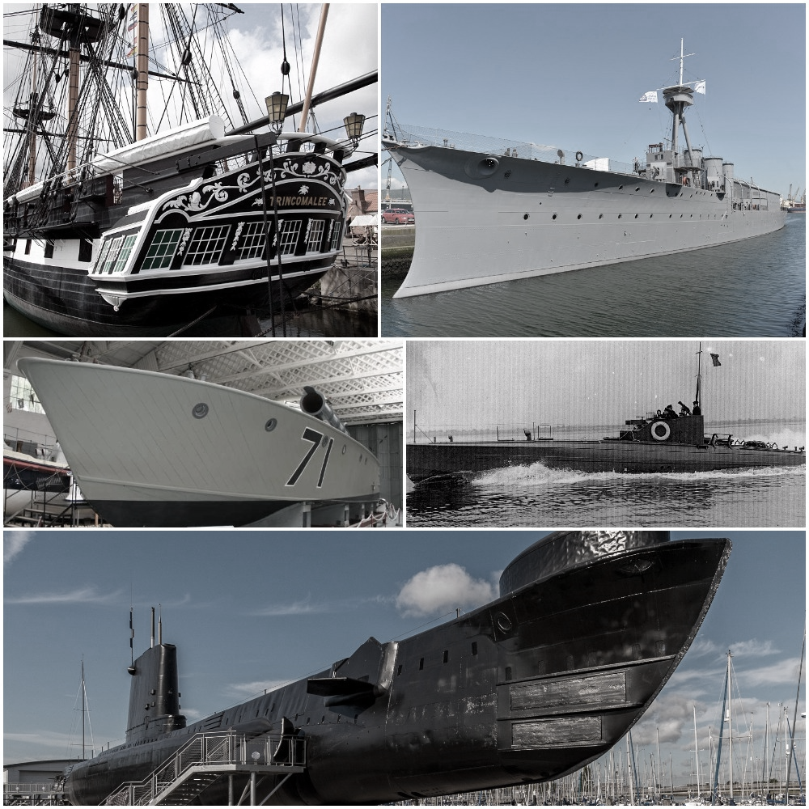
Invitation to Tender (ITT)
Refurbishment of the Head Platform and Figurehead to HMS Warrior, Portsmouth

First Issued: 12 June 2018

Contents

Summary Instructions and Details of Contract
1. Project Introduction
2. Scope of Work
3. Additional Requirements
4. Further Information
5. Supplier Response
Annex 1 – Evaluation Criteria
Annex 2 – Terms and Conditions of Contract
Annex 3 – Head Platform drawings (8)
Annex 4 – Pricing Document
Annex 5 - NMRN GDPR Notice

Summary Instructions and Details of Contract

SUBJECT | DETAILS
Contract Description | The National Museum of the Royal Navy (NMRN) wishes to appoint an experienced contractor to work under the guidance of the Museum’s Historic Ships Team for the purposes of carrying out Refurbishment works to the Head Platform and Figurehead of HMS Warrior.
Programme | From September 2018
NMRN Contact during tender period | Clarifications and enquiries during the tender process can be sent to HST.procurement@nmrn.org.uk. Please note that this email address is different to the submission email.
Date of Tender Return | Friday 13th July 2018,12:00  Tender’s must be submitted to tenders@nmrn.org.uk
Content for Submission | Content requirements for tender returns are listed in Annex 2 of this ITT.
Last date for Clarifications | Tuesday 3rd July 2018, 12:00

Invitation to Tender for the Refurbishment of the Head Platform and Figurehead to HMS Warrior, Portsmouth.

June 2018

- Introduction
  - HMS Warrior is based in Portsmouth and is under the ownership of the National Museum of the Royal Navy.
  - Based on high-level visual inspection the Head Platform and Figurehead are in need of refurbishment and repair.
  - The extent of the work needs to be confirmed by survey and inspection. However, for the purposes of tender the works are as set out in Section 2 below.
  - As the ship is alongside a tidal jetty, the ship will move fore, aft and in and out from the jetty, this should be taken into account for the purposes of designing scaffolding, working platforms and undertaking the work.
  - This ITT requests for companies to quote for the work required for completion from September 2018.
  - Contractors should take into account that the ship and jetty will be open to the public and staff throughout the works.

- Scope of Work
  - The enclosed drawings show in detail the form of the Head Platform and associated components including guard rail, stanchions and Head Box.
  - In order to tender for this work Contractors are required to attend site and inspect the areas of work for themselves.
  - The contractor is required to allow to undertake the following work on HMS Warrior:
Ref. | Location | Action
1. | Head Platform | Fully refurbish the Head Platform including:  - Replace side cladding (timber battens)  - Assess condition and repair/replace the timber cross beams as the condition merits. Allow for replacement for the purposes of pricing.  - Replace main rail and mould  - Replace lower rail and mould  - Replace centre cladding  - Remove, shot blast and paint gratings  - Assess condition and repair/replace the aft head timber, mid head timber and fore head timber as condition merits. Allow for replacement for the purposes of pricing.  - HP FW wash 3000psi minimum, clean down all areas to be repaired or coated to remove all dirt, grease, oil, salts and other contamination.  - Prepare corroded areas by use of hand or power tools to achieve a minimum St3 standard as per ISO 8501-1:2007. The edges of sound surrounding coatings should be feathered back by 50mm Spot prime as necessary with International Paints Interseal 670HS aluminium thickness 125um to spot-primed areas.  - Abrade existing paint work to provide a key, remove all dust and debris.  - Apply 1 full coat of International Paints Interseal 670HS colour RAL 9005 Black, thickness 125um.  - Top Coat 1 full coat of International Paints Interthane 870 colour RAL 9005 Black, thickness 75um.
2. | Head Box | - Inspect and assess condition of the steel and timber elements  - Recommend repair as appropriate  For the purposes of pricing at this stage assume the following to be allowed allow for:  - Steel plate and inserted grating bar: HP Fresh Water wash 3000psi minimum, clean down all areas to be repaired or coated to remove all dirt, grease, oil, salts and other contamination. Prepare corroded areas by use of hand or power tools to achieve a minimum St3 standard as per ISO 8501-1:2007.  - Timber: Abrade existing paint work to provide a key, remove all dust and debris.  - Apply 1 full coat of International Paints Interseal 670HS colour RAL 9005 Black, thickness 125um.  - Top Coat 1 full coat of International Paints Interthane 870 colour RAL 9005 Black, thickness 75um.
3. | Guard rail | - Remove canvas covers and replace with new  - Remove Guard rail (handrail and stanchions), shot blast back to bare metal and a holding coat applied.  - Apply 1 full coat of International Paints Interseal 670HS colour RAL 9005 Black, thickness 125um.  - Top Coat 1 full coat of International Paints Interthane 870 colour RAL 9005 Black, thickness 75um.  - Reinstate guard rail and canvas covers
4. | Beak Top | For the purposes of pricing at this stage assume the following to be allowed allow for:  - HP Fresh Water wash 3000psi minimum, clean down all areas to be repaired or coated to remove all dirt, grease, oil, salts and other contamination. Blast steelwork to achieve a minimum Sa 2.5 standard as per ISO 8501-1:2007.  - Apply 1 full coat of International Paints Interseal 670HS colour RAL 9005 Black, thickness 125um.  - Top Coat 1 full coat of International Paints Interthane 870 colour RAL 9005 Black, thickness 75um.
5. | Figurehead | The Figurehead is showing signs of deterioration especially around the areas where water sits within crevices and folds. The scope of the repair to the Figurehead needs to be agreed with the NMRN once access is secured. The aim of the work will be to consolidate the condition of the structure and make minor amendments to prevent ongoing water damage and penetration. All repairs to be in yellow pine.  For pricing purposes please allow for a full repaint and re-gild.  Please also state the applicable day-rate for a carver or similar to undertake the repairs required.
6. | Preliminaries | Within your tender please allow for the following:  6.1 Within 5 days of commencement of works and following completion of all access installations (scaffolding) INSPECT all areas of the works and record the results on an inspection report.  6.2 Inspection report to be shared with the NMRN and any amendments to the scope of works to be priced and agreed accordingly. All works to be priced within 5 days.  6.3 In the interests of Health & Safety compliance it is assumed that a scaffolded and shrink wrapped enclosure is required for the execution of the works. Any blast cleaning and painting process will take place within the enclosure.  6.4 The access structure should be designed and installed in such a way as to avoid any fixings into the historic fabric of the vessel.  6.5 All displaced shrouds and stays need to be temporarily and safely secured as required but the NMRN will provide the in-house expertise to assist with this.  6.6 The NMRN Historic Ships Team Representative is to be given full access at all times to the work in progress and to all drawings, models, samples, and articles or items of any kind appertaining to the work.  6.7 The NMRN Historic Ships Team Representative shall have the right to reject any workmanship, article, or material which does not meet the relevant specified standard or is not considered fit for purpose. This includes sub-contracted work.  6.8 The NMRN Historic Ships Team Representative has the right to view all subcontracted costs submitted to the main contractor. All subcontract costs / material costs etc. must be made available a minimum of three days prior to completion.  6.9 The work required by this specification includes the following and all related costs are the contractor’s responsibility :  a) REMOVAL and subsequent RE-INSTATEMENT of any parts, equipment and fittings etc. required to discharge the work. i.e. all work in way. Where possible work in way has been detailed, however this is only indicative and the contractor must satisfy their self that they include in their costings all work in way to fully discharge the work and the successful setting to work of the equipment / system on completion.  b) RENEWAL or REPLACEMENT of all missing, damaged, broken or excessively worn nuts, bolts, studs, screws, keys, split pins, washers, shims and parts of a similar nature removed in course of any work or observed during an INSPECTION.  c) Ensuring that all replacement parts used, conform to the original design specification and that the quality is equal to or greater than that of the original design specification. Certification is to be provided with new equipment, including where appropriate class approval, or test / calibration certificates.  d) REPRESERVATION and painting of all equipment and fittings, machinery systems, all signage etc. and the repair of any damaged paintwork arising from any of the work undertaken.  e) Correct reassembly, alignment and setting to work in accordance with the manufacturers most up to date specification of all equipment and systems fitted, refitted, repaired or opened up for INSPECTION and OVERHAUL and for the subsequent successful operation of complete systems.  f) INSTALLATION of any parts, equipment and fittings etc. required to discharge the work. i.e. all work in way. Where possible work in way has been detailed, however this is only indicative and the contractor must satisfy their self that they include in their costings all work in way to fully discharge the work and the successful setting to work of the equipment / system on completion.

2.4 All quantities are at the contractor’s risk to estimate.

- Additional Requirements

  - Materials and equipment supplied by the Contractor
    - The contractor is required to provide:
- All materials, tools and access equipment necessary to perform the work to a high standard and in a safe manner.
- Rope access teams, if required, should be in possession of the relevant qualifications and be in date.
- Ships fittings, rigging, structural members and the bowsprit are to be protected during throughout the works and every effort should be taken to ensure that no damage is caused by ropes, access equipment or scaffolding.
    - THE NMRN can provide barriers for exclusion zones as required.
    - The supplier must organise their own disposal of any hazardous substances.
    - No materials, debris or waste should be allowed to fall into the Harbour.

  - Condition Statement
    - On completion of the work, the contractor is required to provide evidence of paint thicknesses taken at regular intervals. Photographs documenting before and after work is complete would prove a valuable record of the condition and actions taken.
  - Health & Safety
    - All materials and equipment used by the contractor or their subcontractors must comply with IOSH and COSHH best practice.
    - Work can only commence when Risk Assessments and Method Statements provided by the contractor have been provided and signed off by the NMRN’s Historic Ships Team.

  - Quotations
3.4.1 A fixed price lump sum (Excl. VAT) is required for this task.
3.4.2. The cost should account for down time that may be incurred due to bad weather. The supplier will not be able to charge the NMRN further costs during the contract due to bad weather.
3.4.4. The supplier is also required to supply daily rates of all contractors and sub-contractors, including daily travel, subsistence and accommodation costs.
3.4.4 All quotes should be sufficiently detailed to enable identification of the applicable cost for all components of the work (as set out in Section2 Scope of Works).

3.5 Guarantees
3.5.1 The contractor is to provide a 10 year guarantee for paintwork or state offer.
3.5.2 The contractor is responsible for recording manufacturer, type, batch numbers, temperature, humidity and wet film thickness of the paint system applied.
3.6 Defects
3.6.1 Defects Liability Period 12 months. The Contractor shall be liable for and shall make good all defects occurring before the expiration of the defects liability period.
- Further Information

  - Emergent Works
    - Both during and/or on completion of the work as specified within this Brief, there is potential for the supplier to highlight immediate or longer term emergent works.
    - Any emergent work should be reported to the NMRN on site and in writing.
    - Tenderers are invited to supply option prices for emergent work.

  - Heritage Best-Practice
    - The NMRN require all contractors and sub-contractors as part of this work to be aware of and comply with heritage best-practise when working on and around the Ships. Guidance on heritage best-practise can be found at https://historicengland.org.uk/images-books/publications/conservation-principles-sustainable-management-historic-environment/ (Historic England 2008). Specific best-practise on historic vessels is set out by National Historic Ships in Conserving Historic Vessels (2010).

  - Other Work on HMS Warrior
    - At the time of the works HMS Warrior is likely to be in the later stages of a ships’ side repainting programme. It is unlikely that this programme will impact on the proposed Head Platform project but the presence of another contractor on both the ship and the adjacent jetty should be noted. A degree of coordination and joint working may be required (as identified by the Historic Ships Team at the time of appointment).
    - Aloft work on the rigging will also be undertaken over the contract period. This will require exclusion zones onto the deck which could, without appropriate scheduling, impact on other works.
    - The timing of the above programmes are in the process of being finalised. Prior to appointment and finalisation of contracts the contractor may be required to consider the different projects occurring on HMS Warrior and offer a schedule of work which will work for the NMRN and the various contractors on-site.

  - Sub-Contracted Work
    - In line with recent 2018 changes to the public procurement regulations, the NMRN will require the supplier to provide information on any sub-contracted work and their costs.
    - If the supplier will not know sub-contractor costs until they have been awarded the contract, they are required to provide information on the sub-contracted work in line with Clause 7.1 on the NMRN’s T&Cs.

- Supplier Response

  - Clarifications
    - Please contact hst.procurement@nmrn.org.uk for clarifications during the tender process.

  - Response
    - Please provide the following to tenders@nmrn.org.uk by 12.00 13th July 2018. Any tender submissions sent to the hst.procurement@nmrn.org.uk email will not be valid submissions and will be excluded from the evaluation process.

5.3 Statement of Understanding
In preparing your tender, and based on visual observations during your visit, you should set out at the beginning of your submission a statement on the condition of the following:
  - Side cladding (timber battens) to Head Platform
  - Timber cross beams
  - Main rail and mould
  - Lower rail and mould
  - Head Platform gratings
  - Head Box
  - Guard rails
  - Beak Top

Ref | Content | Ref | Detail
1 | CVs & Qualifications | 1.1 | The professional skills and qualifications of people involved in the project, including the names and CV’s of proposed team members, their specific responsibilities and any arrangements for subcontracting.
2 | Methods | 2.1 | Specify the detailed set up, execution and completion of the works set out in the scope of works
3 | H & S | 3.1 | Specify how the contractor aims to comply with H&S IOSH standards.
3 | H & S | 3.2 | For any use of substances hazardous to health, specify how the contractor will comply with COSHH standards of substance use and storage
4 | Heritage Best-Practise | 4.1 | Demonstrate how the potential supplier will exercise conservation best practise (NHS; 2010, Historic England; 2008)
5 | Scheduled Work Programme | 5.1 | Scheduled work programme (in days) for all stages of the work with milestones and dates, including but not limited to;  RAMS & Consultations
 | Scheduled Work Programme | 5.2 | Site set-up and scaffolding
 | Scheduled Work Programme | 5.3 | Initial survey and condition report
 | Scheduled Work Programme | 5.4 | Exclusion Zones (as applicable)
 | Scheduled Work Programme | 5.5 | The Works (all components as set out in Section 2 of the Brief)
 | Scheduled Work Programme | 5.6 | Demobilisation
 | Scheduled Work Programme | 5.7 | Final Consultation
6 | Costs - Complete Pricing Document at Appendix 4 in full | 6.1 | A breakdown of costs for the work and materials, including subcontracting work – Please refer to the PRICING DOCUMENT
 | Costs - Complete Pricing Document at Appendix 4 in full | 6.2 | Any travel, subsistence and accommodation costs for the work proposed
 | Costs - Complete Pricing Document at Appendix 4 in full | 6.3 | Schedule of hourly rates for the proposed labour, including sub-contractors
 |  | 6.4 | Scaffolding and containment costs to be separately identified
7 | Insurance |  | Full extent of professional insurance or indemnity cover

