
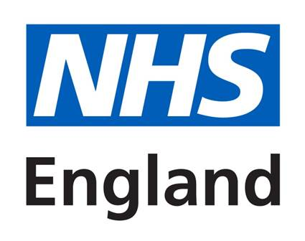

Market Sounding Questionnaire

NHS England and NHS Improvement South East (Wessex)

Mandatory Dental Services (MDS) in Portsmouth, Alton and Tadley (PAT)

Project reference: PR003624

October 2019
This questionnaire is an information gathering exercise by the Commissioner(s) to inform the procurement process for Mandatory Dental Services in Portsmouth, Alton and Tadley.

Respondents Information
Potential bidder(s) name:
Trading Status | Public limited company ☐  Limited company ☐  Limited liability partnership ☐  Third or voluntary sector ☐  NHS organisation ☐  Other (please specify) ☐
Address:
Contact name:
Telephone:
E-mail:
Website address:

Q1. Please provide a brief summary/introduction about your organisation, outlining the services you currently deliver and any previous experience of delivering mandatory dental services.

Q2. Please confirm which location(s) you might be interested in:
Alton ☐
Tadley ☐
Portsmouth ☐

Q3a. Please confirm which UDA(s) you would be interested in bidding for:
Alton:
3,500 ☐
7,000 ☐
21,000 ☐

Tadley:
3,500 ☐
7,000 ☐
21,000 ☐

Portsmouth:
3,500 ☐
7,000 ☐
21,000 ☐
Q3b. Please indicate the UDA rate that would allow the services to be sustainable, and why you think you require this rate.
£

Why:

Q4a. Please indicate how likely you would be to bid for services if the contract offered was:
Please choose one of the following: ‘Not at all, Unlikely, Likely, Very Likely’

Up to and including 5 years:

Minimum of 5 years and maximum of 7 years including extension periods:

Minimum of 7 years and maximum of 10 years including extensions:

Q4b. Please confirm why you would prefer this contract length.

Q5. For each of the UDA volumes selected above, please confirm how long you will require for mobilisation and the reasons why.
3,500:

7,000:

21,000:

Q6. What are the risks or challenges, as a provider you face / or believe you might face when delivering these services and why?

Q7. What are the key factors which would allow you to bid for these services? These can be service related (e.g. Requirements / delivery model) and/or procurement related (e.g. Financial / contract length)

Q8. What are the key factors which would prevent you from bidding for these services? These can be service related (e.g. Requirements / delivery model) and/or procurement related (e.g. Financial / contract length) and/or other such as recruitment and premises.

Please complete this questionnaire and return it via email to scwcsu.procurement@nhs.net by 12:00pm on 5th November 2019 with the subject ‘Market Sounding Questionnaire – MDS PAT’

THANK YOU

