Wayfinding Specification and KPIs

- INTRODUCTION AND BACKGROUND

  - Thurrock Council (“the Council”) is seeking a partner (“the Partner”) to assist in the implementation of a Wayfinding scheme across different towns within the borough, to promote walking and cycling by displaying an estimated time and distance to places of interest by the appropriate mode through safe routes.

  - As part of this scheme the Partner will design, supply and install a Wayfinding signage system that includes monoliths/totems, wall mounted signage, fingerposts, as well as any relevant signage as necessary, with relevant information including direction, distance and walking/cycling times to places of interest within the vicinity of the scheme.

  - The Wayfinding scheme will cover initially the towns of Stanford-le-Hope & Corringham (Core Phase). Beyond, the Council will explore the provision of additional infrastructure within Stanford-le-Hope & Corringham and in other key urban areas within Thurrock such as Purfleet, Grays, South Ockendon & Aveley, and East Tilbury, subject to funding.

- CONTRACT TERM

  - The Contract period is to be a minimum of three years with the option to extend by a further two years. Thurrock Council holds the right to review the contract at the end of the installation of the first project and any subsequently delivered project.

- CORE REQUIREMENTS

  - The Partner will present a design layout including artwork, font type and size, colour scheme, logos and imagery to be used across the signage system of monoliths/totems, wall mounted signage and fingerposts.

  - The Partner will carry out all preparatory works, manufacture and/or supply fixtures, signs and appropriate printing and finalisation required, to install the Wayfinding Infrastructure proposals making good use of the public realm/highway. All works will be carried out in accordance with the latest legislation and best practise.

  - The Partner will be able to comply with the following specification for the Wayfinding Infrastructure: non-electrified monoliths/totems of minimum 1800 mm high x 600 mm wide and maximum 2500 mm high x 1000 mm wide, preferably made with appropriate recycled materials with ease to be recycled after its use and anti-vandalism protection, containing a map of the location, a list of places of interest and key facilities and walking and cycling distances; a suitably robust wall sign (preferably made of aluminium or other suitable metal/ material) of minimum 300 mm high x 600 mm wide and maximum 600 mm high x 800 mm wide with anti-vandalism protection containing walking and cycling distances; and fingerposts indicating direction and walking/cycling time to places of interest with minimum clearance of 2.1 meters.

Stanford-le-Hope Core scheme

  - The Partner will deliver the Core Phase of the scheme consisting of 3 monoliths located at Stanford-le-Hope train station, Kings Street (junction with London Road) and The Green (in front of St Margaret's Church entrance), 1 wall mounted sign located at Hardie Park (entrance of the tunnel crossing the A1014) and 9 fingerposts on distinct street crossings through the town. The locations of the Core Phase is specified in the Appendix 2A and 2B.

  - The Partner must be able to deliver the Stanford Le Hope Core Phase before the end of the current financial year (March 2020).

  - The Partner will use its expertise to identify points for additional totems/monoliths and fingerposts and contrast them with the Wayfinding Proposal Phase Two shown in Appendix 2A and 2C. The locations of the infrastructure must be agreed with the Council prior to any installation being carried out.

  - The Council will work together with the Partner to identify main locations suitable to install monoliths and fingerposts in future schemes within Thurrock. The locations of the infrastructure must be agreed with the Council prior to any installation being carried out.

  - The Partner will attend meetings as necessary with the Council and stakeholders to plan and implement the planning, design and delivery of the scheme. Cost for attending meetings should be specified (see Table in point 3.6)

- COUNCIL RESPONSIBILITIES

  - As part of the Contract, the Council will:
- provide the area on the footpath or public space required
- prepare all appropriate Traffic Regulation Orders (TROs)
- Prepare any Stats searches.

- INSTALLATION DETAILS

  - The partner will provide details related to installation works, including timescales and alterations to the public space/highway network. In no way must the delivery of the works extend further than March 2020.

- REPLACING AND/OR REFRESHING ITEMS

  - The Partner will provide details of the replacement process of the items of the Wayfinding Scheme including the timescale of the works. These replacing works can be required either after a faulty/damaged item is detected or when a content refresh/update is needed.

  - The Partner will be held responsible for any problem related to faulty equipment, inadequate installation or misinformation reported within one year after the installation works. The Partner will carry out all works required to replace any installed item under these conditions at no additional cost. After one year, any replacement work required will adjust to the cost displayed on the table shown in point 3.6.

  - The Partner will carry out all works required to refresh/update any installed item when the Council requires these works at the cost stated on the table shown in the point 3.6.

- KEY PERFORMANCE INDICATORS (KPIs)

  - The Partner will be responsible for ensuring the wayfinding infrastructure is delivered to the specification tendered by the Council without defect or causing hazard to the public during installation and will provide the data to evidence its quality against the KPIs.

  - These KPIs are set for the first year of the contract and will be used by the Council in monitoring the Partner’s performance. KPI data shall be submitted to the Council to the schedule as set out in the “Reporting Frequency” column.

  - At any time during the Contract term the Council and the Partner may work together to add or amend KPIs and targets to better demonstrate performance.

  - If a KPI is not met during the period of the assessment then the Council may require the Partner to put together an action plan to address the issues within a timescale to be defined by the Council.

No | Item | Measure | Calculation | Target | Report Frequency
1 | Time scale deliverability | Ability to deliver Stanford-le-Hope Core Phase before the end of the funding period (March 2020) | Pass / Fail | Pass | After delivering the scheme
2 | Item compliance | Compliance of the items with the specification requested (design, destination, times, distances, etc.) | Number of items without variations from agreed content divided by total number of items installed | 100% | After delivering the scheme
3 | Defect-proof equipment | Equipment reported to present visible defect within one year after the installation works | Number of equipment reported to present visible defect within one year after the installation works. | Max 1 item | Annually
4 | Replace/refresh response | Response time between a replacement/ refresh is required | Maximum time taken between a replacement / refresh is requested and when is carried out | Max 45 days | Annually
5 | Partnership development | % of agreed meetings attended | Number of meetings attended divided by total number of meetings agreed and organized | 100% | Annually
6 | Health & safety during works | Health & safety conditions in the working area during the installation – no breaches reported | Pass / Fail  Works in line with Health & safety regulations | Pass | After delivering the scheme

- SOCIAL VALUE

  - The Council has considered the implications of the Social Value Act 2012 within the remit of this Service. The Social Value Act requires public authorities to have due regard for economic, social and environmental wellbeing in connection with public service contracts.

  - The Council’s Social Value framework is set out here:
https://www.thurrock.gov.uk/Council-procedures-and-thresholds/social-values.

  - The Partner will deliver additional ‘added’ social value that benefits the community and the people who live within it.

  - Tenderers will make proposals around these as part of their tender submission and once agreed by the Council, will become a contractual obligation for the Partner.

APPENDIX 2A – MAP OF WAYFINDING CORE PHASE FEATURES

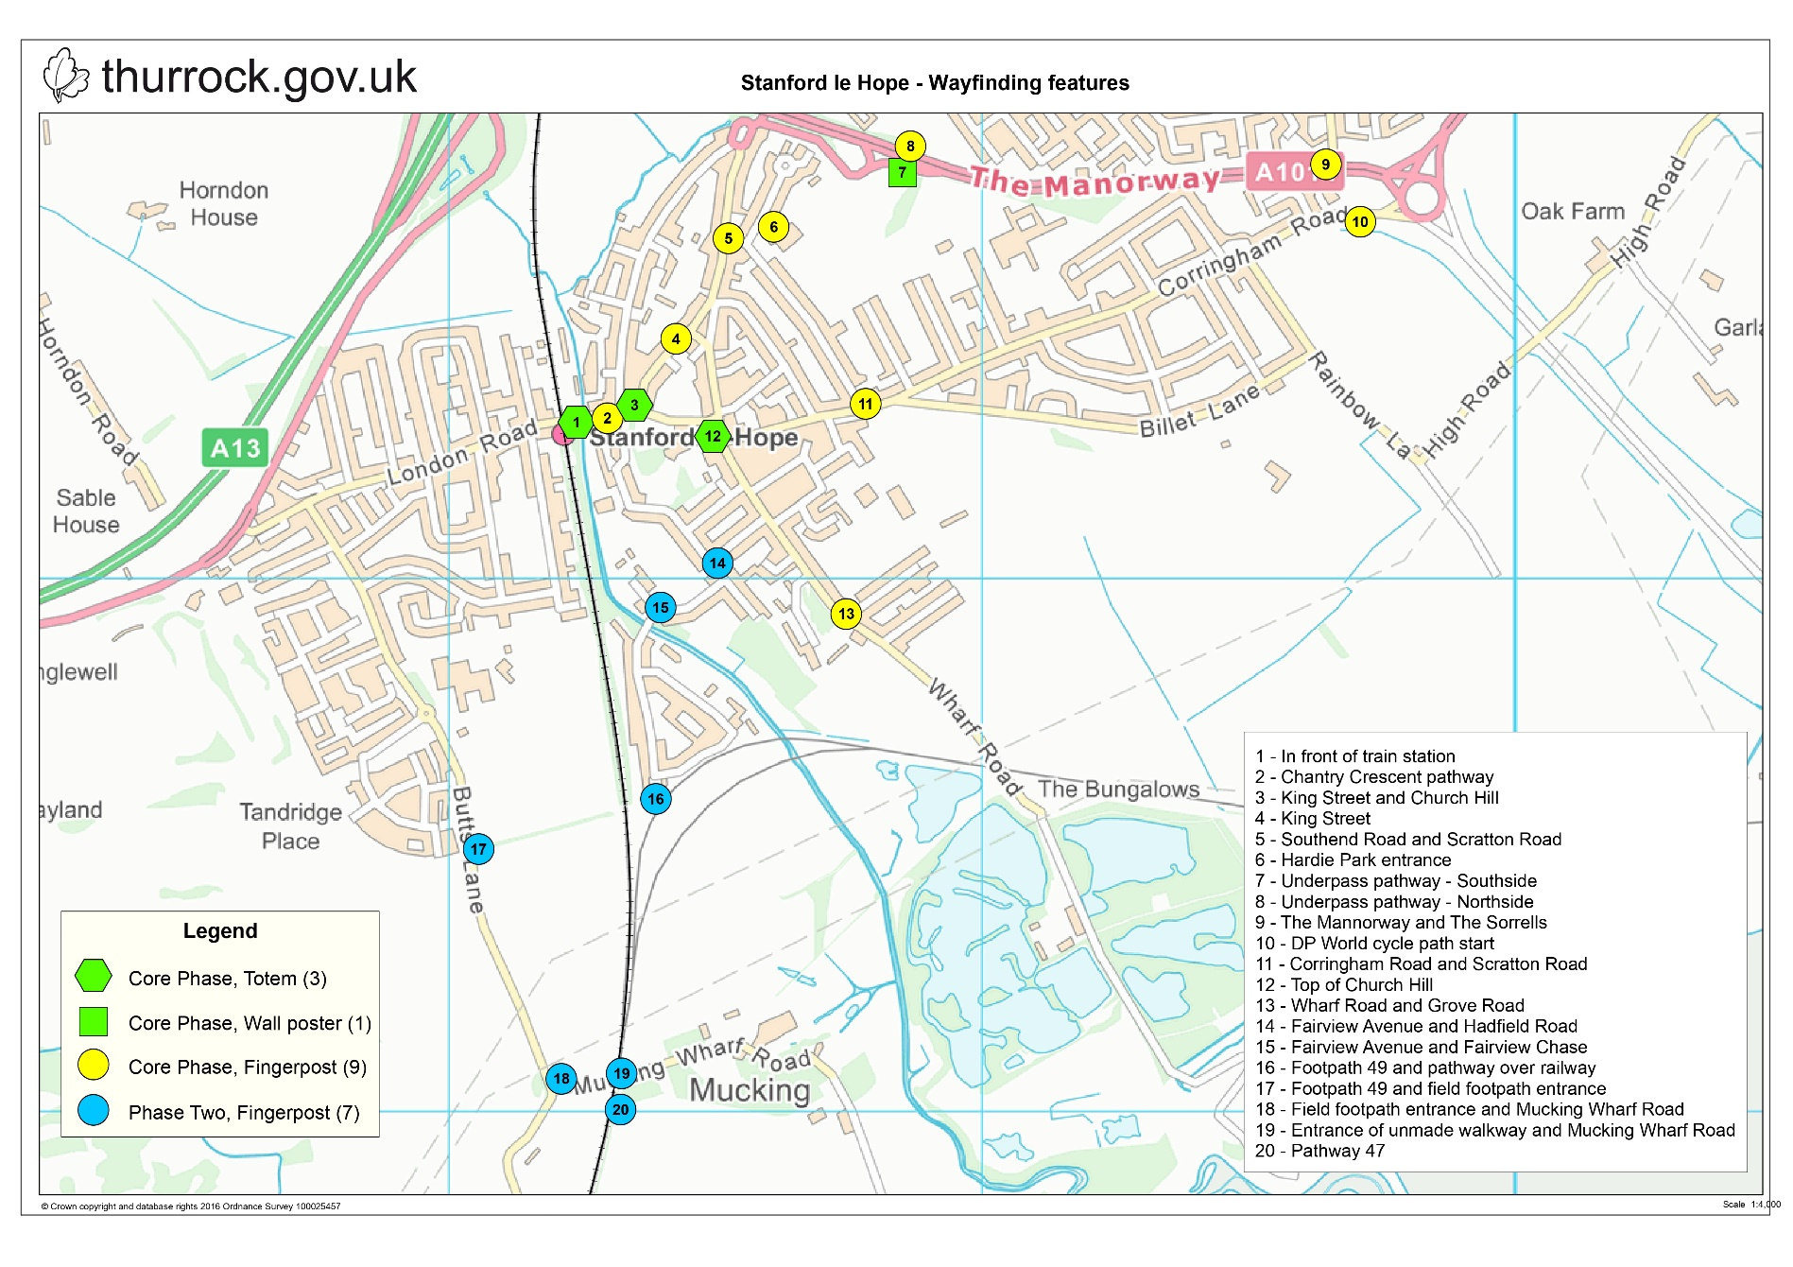

APPENDIX 2B – DESCRIPTION OF WAYFINDING CORE PHASE

Number | Location | Type | Signs and Directions
1 | Map outside the front of the train station | Totem | Map showing the whole of Stanford Le Hope highlighting the listed places of interest, distances and times for walking and cycling plus ‘you are here’
2 | Sited on the pathway linking Chantry Crescent at the bottom of Church Hill | Post | North East: Hardie Park  0.4 miles 3 mins 0.4 miles 9 mins  North East: London Gateway (cycling)  2.2 miles 13 mins  East: Recreational Ground  0.4 miles 3 mins 0.4 miles 9 mins  East: London Gateway (walking)  2.0 miles 40 mins  East: St Margaret’s Church  0.2 miles 1 min 0.2 miles 4mins  South: Nature Reserve  2.1 miles 12 mins 2.1 miles 40 mins  West: Train Station  0.1 miles 1 min 0.1 miles 1 min
3 | Junction of King Street and Church Hill | Totem | Map showing the whole of Stanford Le Hope highlighting the listed places of interest, distances and times for walking and cycling plus ‘you are here’
4 | Kings Street between the shops and The Old Court House Public House | Post | North East: London Gateway (cycling)  2.1 miles 12 mins  North East: Hardie Park  0.3 miles 2 mins 0.3 miles 5 mins  East: London Gateway (walking)  2.0 miles 39 mins  East: Town Centre  0.4 miles 3 mins 0.1 miles 2 mins  South West: Recreation Ground (cycling)  0.4 miles 2 mins  North East: Recreational Ground (walking)  0.4 miles 7 mins  South West: Train Station  0.2 miles 1 min 0.2 miles 4 mins
5 | Corner of High Southend Road and Scratton Road | Post | North East: Hardie Park  0.1 mile 1 min 0.1 mile 3 mins  North East: London Gateway (cycling)  1.9 miles 10 mins  South East: London Gateway (walking)  1.8 miles 38 mins  South East: Recreation Ground  0.2 miles 1 min 0.2 miles 5 mins  South: Town Centre  0.1 mile 1 min 0.1 mile 3 mins  South: St Margaret’s Church  0.2 mile 1 min 0.2 miles 4 mins  South West: Train Station  0.3 mile 2 mins 0.3 miles 7 mins
6 | The entrance of Hardie Park | Post | North East: London Gateway (cycling)  1.6 miles 9 mins  South East: London Gateway (walking)  1.8 miles 38 mins  South East: Recreational Ground  0.3 miles 2 mins 0.3 miles 7 mins  South West: Train Station  0.4 miles 3 mins 0.4 miles 9 mins  South West: Town Centre  0.1 mile 1 min 0.1 mile 3 mins
7 | In Hardie Park at the entrance of the underpass pathway (south side) | Post/Wall sign | Pointing through the underpass highlighting the direction to the London Gateway cycling route
8 | At the entrance of the underpass pathway (north side) | Post | East: London Gateway (cycling)  1.5 miles 8 mins  South: Town Centre  0.2 miles 1 min 0.2 miles 4mins  South: Train Station  0.6 miles 4 mins 0.6 miles 12 mins
9 | End of the cycle path near the pelican crossing to cross over The Mannorway towards Corringham Road | Post | South: London Gateway  1.1 miles 5 mins 1.1 miles 22 mins  West: Hardie Park  0.7 miles 4 mins 0.7 miles 15 mins  West: Town Centre  1.0 miles 5 mins 1.0 miles 18 mins  West: Train Station  1.1 miles 6 mins 1.1 miles 22 mins
10 | Top of the Corringham Road at the start of the DP World access road cycle path | Post | North: Hardie Park  0.5 miles 3 mins  North: Town Centre  0.7 miles 4 mins  North: Train Station  1.2 miles 6 mins  East: London Gateway  1.0 miles 5 mins 1.0 miles 18 mins  West: Train Station  1.2 miles 25 mins  West: Town Centre  1.1 miles 22 mins  West: Hardie Park  1.1 miles 22 mins  West: Recreational Ground  0.7 miles 15 mins
11 | Junction of Corringham Road and Scratton Road | Post | North: Hardie Park  0.3 miles 2 mins 0.3 miles 7 mins  East: London Gateway  1.5 miles 9 mins 1.5 miles 33 mins  South: Recreation Ground  0.1 miles 1 min  West: Town Centre  0.3 miles 2 mins 0.3 miles 7 mins  West: Train Station  0.4 miles 3 mins 0.4 miles 8 mins
12 | Top of Church Hill near the bus stop on the junction of the High Street | Totem | Map showing the whole of Stanford Le Hope highlighting the listed places of interest, distances and times for walking and cycling plus ‘you are here’
13 | Junction of Wharf Road and Grove Road | Post | North East: London Gateway (walking)  2.1 miles 45 mins  North East: Recreation Ground  0.2 miles 1 min 0.2 miles 4 mins  North West: Train Station  0.5 miles 5 mins 0.4 miles 8 mins  North West: Town Centre  0.4 miles 3 mins 0.4 miles 8 mins  North West: St Margaret’s Church  0.3 miles 2 mins 0.3 miles 6 mins  North West: Hardie Park  0.6 miles 2 mins 0.6 miles 12 mins

APPENDIX 2C – DESCRIPTION OF WAYFINDING PHASE TWO

Number | Location | Type | Signs and Directions
14 | junction of Fairview Avenue and Hadfield Road | Post | North East: London Gateway (walking)  1.8 miles 39 mins  North East: Recreational Ground  0.4 miles 3 mins 0.4 miles 8 mins  South West: Nature Reserve  1.8 miles 10 mins 1.8 miles 38 mins  North West: Train Station  0.3 miles 2 mins 0.3 miles 6 mins  North West: Town Centre  0.3 miles 2 mins 0.3 miles 6 mins
15 | Bottom of the walkway between Fairview Avenue and Fairview Chase | Post | North East: Train Station  0.4 miles 3 mins 0.4 miles 8 mins  North East: Town Centre  0.4 miles 3 mins 0.4 miles 8 mins  South West: Nature Reserve  1.8 miles 10 mins 1.8 miles 37 mins
16 | On footpath 49 that connects St Margarets Avenue and the pathway over the railway line | Post | North East: Train Station  0.6 miles 3 mins 0.6 miles 12 mins  North East: Town Centre  0.6 miles 3 mins 0.6 miles 12 mins  West: Nature Reserve  1.3 miles 7 mins 1.3 miles 27 mins
17 | Positioned on footpath 49 at the entrance to the field footpath (New Bridal Way to be built) running south parallel to Butts Lane on the field side of the hedge | Post | East: Train Station  0.8 miles 5 mins 0.8 miles 14 mins  East: Town Centre  0.8 miles 5 mins 0.8 miles 14 mins  South: Nature Reserve  1.1 miles 6 mins 1.1 miles 22 mins
18 | bottom entrance of the field entering Mucking Wharf Road on the Junction of Butts Lane | Post | North: Train Station  1.2 miles 6 mins 1.2 miles 24 mins  North: Town Centre  1.2 miles 6 mins 1.2 miles 24 mins  East: Nature Reserve  0.7 miles 4 mins 0.7 miles 13 mins
19 | Positioned at the entrance of an unmade walkway to the east side of the Railway Line on Mucking Wharf Road. As previously mentioned above, this pathway will need to be built to link up with the existing footpaths 47 and 38 plus made suitable for bike usage | Post | South: Nature Reserve  0.7 miles 4 mins 0.7 miles 12 mins  West: Train station  1.2 miles 6 miles 1.2 miles 25 mins  West: Town Centre  1.2 miles 6 mins 1.2 miles 25 mins
20 | Post to be sited on existing pathway 47 | Post | North: Train Station  1.3 miles 7 mins 1.3 miles 27 mins  North: Town Centre  1.3 miles 7 mins 1.3 miles 27 mins  East: Nature Reserve  0.6 miles 4 mins 0.6 miles 12 mins  South West: Pathway 47/Tilbury

