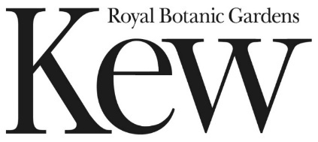

Part 2: Specification

Contract Reference: RBGKEW

Creative Campaign for Nature Based Solutions at a Landscape Scale

This document is for information

Creative Brief - Nature Based Solutions on a Landscape Scale
- Introduction to project
  - What are Nature Based Solutions
  - Nature Based Solutions for Climate at a Landscape Scale
- Partners and internal stakeholders
- Campaign objective and needs
- Look & feel guidance
- Deliverables and project management
- Other campaign references
- Appendices

- What are Nature Based Solutions?
Nature-based solutions harness the power of nature to boost natural ecosystems, biodiversity and human wellbeing to address major societal issues, including climate change.
These solutions cover a broad range of actions to protect, restore or sustainably manage landscapes, seascapes, watersheds and urban areas so they can tackle challenges such as food and water security, climate change, disaster risks and human health. Examples include restoring wetlands to buffer local communities from flood waters, or conserving mangrove forests that provide nurseries for fish and protect nearby homes against storm damage. From protecting salt marshes to restoring forest habitats, nature-based solutions are already in operation across the world.
Indigenous peoples and local communities have used nature-based solutions for millennia. It is crucial that all solutions are people-centred, led by communities and draw from traditional and local knowledge. Nature-based solutions must be inclusive, transparent, developed with respect to land rights and respect to local people’s views and the benefits should be equally distributed.
Nature-based Solutions (NbS) tackle societal problems, such as climate change, in ways that benefit both biodiversity and people. There is a great focus, both financially and scientifically on reducing greenhouse emissions and promoting carbon sequestration by creating or restoring semi-natural habitats using an adaptive management approach.

But to fully understand how NbS can be used for carbon offsetting or towards the carbon emission balance for the UK, we need to know in detail how much carbon can NbS store.

Examples:
- Beavers on the River Otter, Devon https://welcometopickering.co.uk/about-pickering/about-the-town/slowing-the-flow/
- The LIFE Recreation ReMEDIES partnership led by Natural England, is already underway. Over 1.5 hectares of seagrass have been planted, and the project aims to plant a total of 8 hectares by 2023: https://www.gov.uk/government/news/england-s-largest-seagrass-restoration-continues-in-plymouth-sound
- Peat for carbon capture and flow management for flood prevention
- Marram grass to protect sand dunes for flood defence
- Riparian tree planting to improve water quality – cooling of the water uses trees to shade streams and prevent some of the warming that happens on hot sunny days, reducing the impact on trout and salmon and other species.
- Weald to Waves initiative https://www.theguardian.com/environment/2022/jul/22/sussex-farmers-plan-to-create-wildlife-rich-green-corridor-to-the-sea

Nature Based Solutions for Climate Change at a Landscape Scale
Nature-based Solutions for Climate Change at the Landscape Scale: a new £12.5m pilot programme - Natural England (blog.gov.uk)
A new Defra - BEIS project supported by the Treasury’s Shared Outcomes Fund and led by Natural England, Environment Agency, RBG Kew and the Forestry Commission. The Shared Outcomes Fund funds pilot projects to test innovative ways of working across the public sector with an emphasis on thorough evaluation.
These government bodies are working collaboratively to develop nature-based solutions for climate change. We are researching how carbon accumulates or is released from different habitats in different circumstances. This research has started at Wakehurst, Kew’s wild botanic garden in Sussex, as its biodiverse 535 acre site forms a microcosm of UK habitats allowing Kew scientists to undertake expert research across woodlands, grasslands and wetlands all in one place. We have launched a grant scheme to fund this research at a small number of pilot sites across the country – this ensures our work covers a broad range of landscapes to strengthen our data.
With the findings of this new research, we can inform government on how they may best achieve carbon net zero goals. With increased interest from private business to support green initiatives, this project also seeks to establish ways that we can combine public and private investment to ensure continued support for our landscapes.
2. Partners and stakeholders
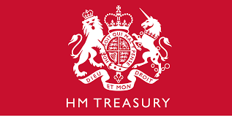
HM Treasury
Role: Funding the project via Shared Outcomes Fund

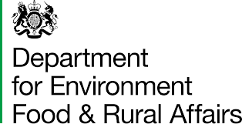
Dept for Environment, Food and Rural Affairs
DEFRA is a ministerial department, supported by 32 agencies and public bodies.
Responsible for improving and protecting the environment. Aim to grow a green economy and sustain thriving rural communities. Supports our world-leading food, farming and fishing industries. The broad remit means they play a major role in people’s day-to-day life, from the food we eat, and the air we breathe, to the water we drink. Here to make our air purer, our water cleaner, our land greener and our food more sustainable. Our mission is to restore and enhance the environment for the next generation, leaving it in a better state than we found it.
Role: Project sponsors
Natural England
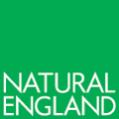
We're the government’s adviser for the natural environment in England. We help to protect and restore our natural world.
Our purpose is to help conserve, enhance and manage the natural environment for the benefit of present and future generations, thereby contributing to sustainable development. Our vision is ‘Thriving Nature for people and planet’. We aim to achieve this through our mission ‘Building partnerships for Nature’s recovery’.
Featuring high up among their list of priorities: Nature-based solutions contributing fully to tackling the climate change challenge and wider environmental hazards and threats.
Role: Natural England will manage the project, appoint the pilot sites, establish relationships with local partners and learn how best to support them in delivering NbS. NE will also carry out the research to compare carbon storage and uptake across different habitats of different ages and in different parts of the country.
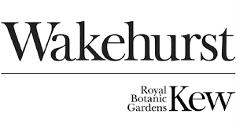
Royal Botanic Gardens, Kew – Wakehurst
The Royal Botanic Gardens, Kew is a world-famous scientific organisation, internationally respected for its outstanding collections as well as its scientific expertise in plant and fungal diversity, conservation, and sustainable development in the UK and around the world. Kew Gardens is a major international and a top London visitor attraction. Kew Gardens’ 132 hectares of landscaped gardens, and Wakehurst, Kew’s wild botanic garden in Sussex, attract over 2.5 million visits every year. Kew Gardens was made a UNESCO World Heritage Site in July 2003 and celebrated its 260th anniversary in 2019.
Wakehurst is Kew’s wild botanic garden in the Sussex High Weald. Its ancient and beautiful landscapes span 535 acres and are a place for escape, exploration, tranquillity and wonder. Its diverse collection of plants from Britain and around the globe thrive within a tapestry of innovative gardens, temperate woodlands, meadows and wetlands. Wakehurst is a centre for UK biodiversity and global conservation, seed research and ecosystem science. At its heart is Kew’s Millennium Seed Bank, the world’s largest store of seeds from wild plant species.
Role: Producing the science for DEFRA and BEIS to better inform policy decisions. Kew will undertake high resolution research into the ability of biodiverse habitats to sequester carbon at its Wakehurst site in Sussex. Focussing on arable grassland to meadow to ancient woodland, Kew will combine a range of scientific expertise from remote sensing (the use of drones to measure plant health), gas flux (the flow of greenhouse gases in and out of the landscape) and belowground mycology.
Most recent report findings from carbon findings for different habitats has given an indicative measure of carbon store at Wakehurst. A very conservative estimate that is approximately 9,000 tonnes of carbon in the soils and 10,000 in the above ground vegetation. As the project progresses these estimates will tighten and most likely increase.
Environment Agency
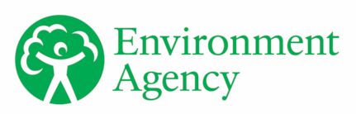
We work to create better places for people and wildlife, and support sustainable development. EA is an executive non-departmental public body, sponsored by the DEFRA, supported by 1 public body.
Among other responsibilities, we’re responsible for managing the risk of flooding from main rivers, reservoirs, estuaries and the sea. This includes restoring peatland.
Role: The Environment Agency will work with the pilot areas to develop a toolkit providing methodology for implementing a systems-approach for recovery of landscapes, incorporating combined private and public funding, and ensuring new markets help achieve the multiple outcomes we want from our natural assets.
Forestry Commission
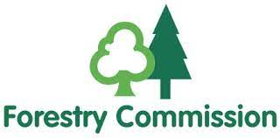
FC is a non-ministerial government department, providing expertise in advising Ministers on forestry matters and implementing forestry policy through a combination of guidance, advice, regulation of sustainable forest management and woodland creation, and the delivery of forestry grants. The FC increases the value of woodlands to society and the environment. Responsible for protecting, expanding and promoting the sustainable management of woodlands. Nature of Climate fund is their biggest priority.
Role: FC will contribute its expertise in developing robust carbon standards, based on more than ten years of experience in developing and running the Woodland Carbon Code. FC will also facilitate and advise on woodland creation grant proposals in the pilot areas.
Dept for Business, Energy and Industrial Strategy
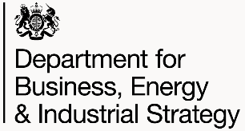
BEIS is the leading economy-wide transformation by backing enterprise and long-term growth, generating cheaper, cleaner, homegrown energy and unleashing the UK as a science superpower through innovation.
Objectives among others are to tackle climate change: reduce UK greenhouse gas emissions to net zero by 2050 and unleash innovation and accelerate science and technology throughout the country to increase productivity and UK global influence
Role: co funder
3. What is the conundrum we are trying to solve with this campaign – campaign objective
DEFRA, BEIS, Natural England, Environment Agency, Forestry Commission, Kew and Wakehurst are working together to promote better use of land for the future of our planet.
We want to positioning NbS at the heart of making the planet a better place for us all. But crucially, anyone can do that, what we have is the high-definition science and research to evidence how do deliver NbS well.
Though this subject is highly contested, and we are in a volatile climate both politically and environmentally. Greenwashing is contentious. Plus there are many projects like this one getting money – what makes us different?
We need a punchy campaign which can be used by all partners on a number of channels to help articulate our work, approach and partnerships, how we are working towards the greater good together and promoting why nature-based solutions are imperative to fighting climate change.
The nexus is how we deliver net zero (BEIS’s priority) and biodiversity and species abundance (DEFRA’s priority) together – these are two parallel policies. This work, is where they and we come together.
The campaign must
- Stand out from a noisy environmental campaign marketplace
- Normalises nature-based solutions as a mainstream concept
- Evidence that biodiversity can mitigate climate change
- Translate government jargon into something filled with passion and purpose.
- Be future proof for when we get statistics and research findings
- Be a campaign all partners (including major landowners) can get on board with and use
We have articulated the project objectives in the SCOPING SHEET (see attached) which articulates the following
- Strategy/Objectives
- Challenges and Risks
- Internal Stakeholders and dependencies
- Target Audience
- Key messages
- Story lines
- Relevance to audiences
- Existing Assets
- Channels
- Success measures
We need your help to hone this information into succinct messaging and call to action alongside compelling visuals and storytelling for priority audiences.
4. Tone, look & feel guidance
Needs to be
Solutions based, positive possibilities, encouraging, passionate, purposeful, good energy and momentum, easy to digest, straight forward, achievable, honest, inviting citizens and big business to make positive change, tender and careful towards the prevailing political conditions in the country
Must not be
Catastrophic, doom gloom, activist, expensive looking, exclusive, complicated, clinical, jargonistic, or
Sensitivities
that nature isn’t the only option or final answer – emission reductions need to happen
That farmers will lose land and this will threaten farming industry and stability, food security https://www.dailymail.co.uk/news/article-11087995/How-Britains-farms-devastated-corporate-giants.html
Cost of living crisis, sense that green stuff is not necessary - we can provide counterfactuals (NE)
We are part of the government and therefore cannot be seen to lobby, our campaign must be research and evidence based. However, we can use what we call a ‘participant’ voice which can raise awareness to educate or involve the public by mobilising their support on a particular issue, or to influence or change public attitudes. This voice is;
  - Authoritative/trusted
  - Debate shaping/convenor
  - Evidential/insightful
  - Emotional/personable
  - Informs/engages/empowers
  - Advocate/educator/influencer/partner
5. Deliverables – project management and assets
Stakeholder workshops with key parties are required to fully agree direction and priorities for the key messages, audiences and campaign outcomes.
Core Deliverables
Discovery consultation and engagement with project leads
Campaign concept with a call to action
Campaign name
Visual identity
Video explainer
Variety of social assets
Toolkit for partners to use
Desirable
Copy writing for key asset needs (e.g. Web page/press release/ad copy)
Possibly a digital home, though Kew can host
Campaign ideas to engage action – once partner sites are confirmed and research findings delivered
Budget £50k approximately, shared across all partners
Key dates and timeframes
This campaign will need to start ideally in December for Biodiversity COP, though as this will have a longer legacy and continue until March 2024, we can be flexible. We need to consider and future cast what might be poignant in that time. For eg. Winter flooding, summer heat waves and fires. Election May 2024.
Contract Management
Your key contact will
Marilena Reina – Head of Marketing and Strategic Comms
Frances – Strategic Comms Manager at Wakehurst
To manage the campaign outputs and billing
Christine Robertson – Shared Outcomes Fund Project lead – contract signatory and responsible for setting up wider group meetings with government parties.
Other parties will need to agree with all stages and approvals.
Success measures
For the campaign output, these are outlined in the Scoping Sheet
For the project itself ;
- Meeting deadlines
- Flexibility of dates
- Responding to the brief
- Creative ideas generated
- Flexibility in ideas
- Other campaigns references
Nature Unlocked | Kew: Major research programme launched May 2021. Wakehurst’s rich landscape became a ‘living laboratory’ where Kew scientists research nature-based solutions to environmental and social challenges. Four key research streams, multiple internal and external stakeholders. Original title Landscape Ecology Programme formed barrier for non-science audiences, so we developed new title/identity March 2022. See appendices for activity.
https://www.kew.org/wakehurst/nature-unlocked
Nature Unlocked print DL (May 2022).PDF
Wakehurst Nature Unlocked slidedeck (May 2022).pdf

RBG Kew, Our Future is Botanic Campaign
https://www.lbbonline.com/news/kew-gardens-says-our-future-is-botanic-in-cop26-campaign-from-vccp
Stand at COP26
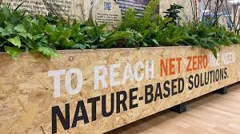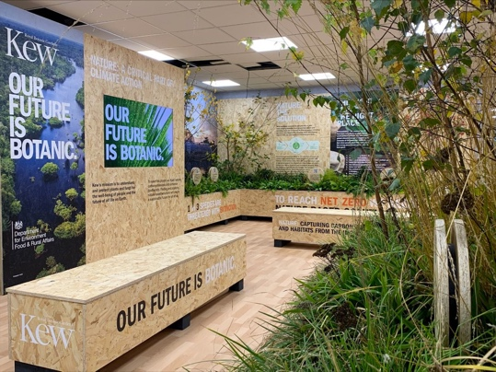
Our Future Is Botanic ads produced which weave into the Nature Unlocked campaign here – Wellbeing, Pollinators and still working on the right image for the Fungi one!
14205 Our Future is Botanic – Wakehurst_A1_V4.pdf

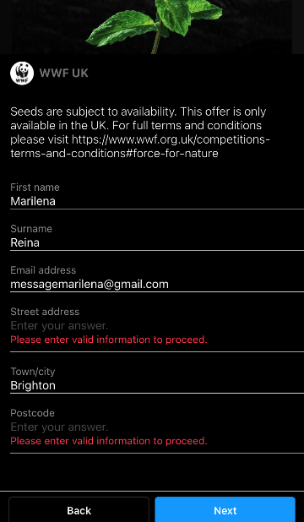
WWF – People’s Plan for Nature
Have your say on the nature crisis | National Trust

WWF – Be a Force for Nature
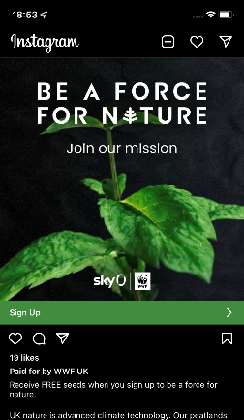
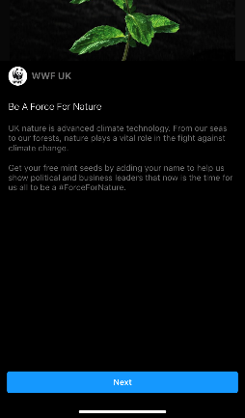

Restor https://restor.eco/
National Trust 100 things to do before your 12.5 50 things to do before you're 11¾ | National Trust What's '50 things' all about? | National Trust (used The People and Nature Survey - GOV.UK (www.gov.uk) to inform direction)
Interesting visuals and links
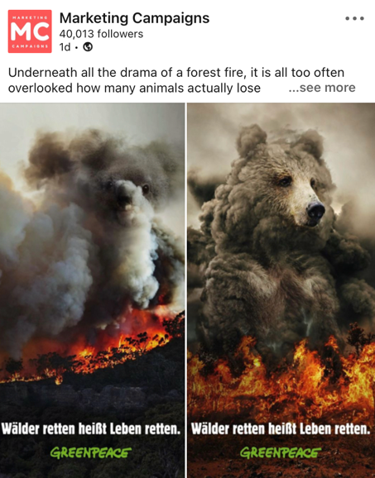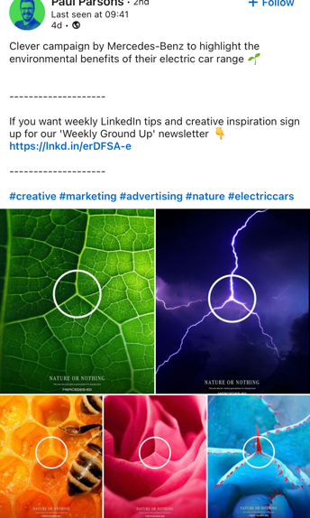

https://www.greenhouse.agency/blog/top-10-climate-action-campaigns-of-2019/
https://www.thedrum.com/news/2022/02/07/5-the-most-awarded-environmental-campaigns-2021
https://www.greenhouse.agency/blog/our-top-12-environmental-campaigns-of-2020/
Appendices
Scoping sheet

