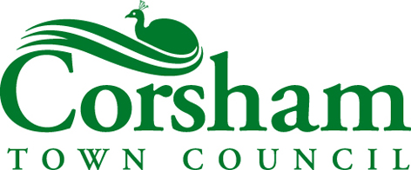 | 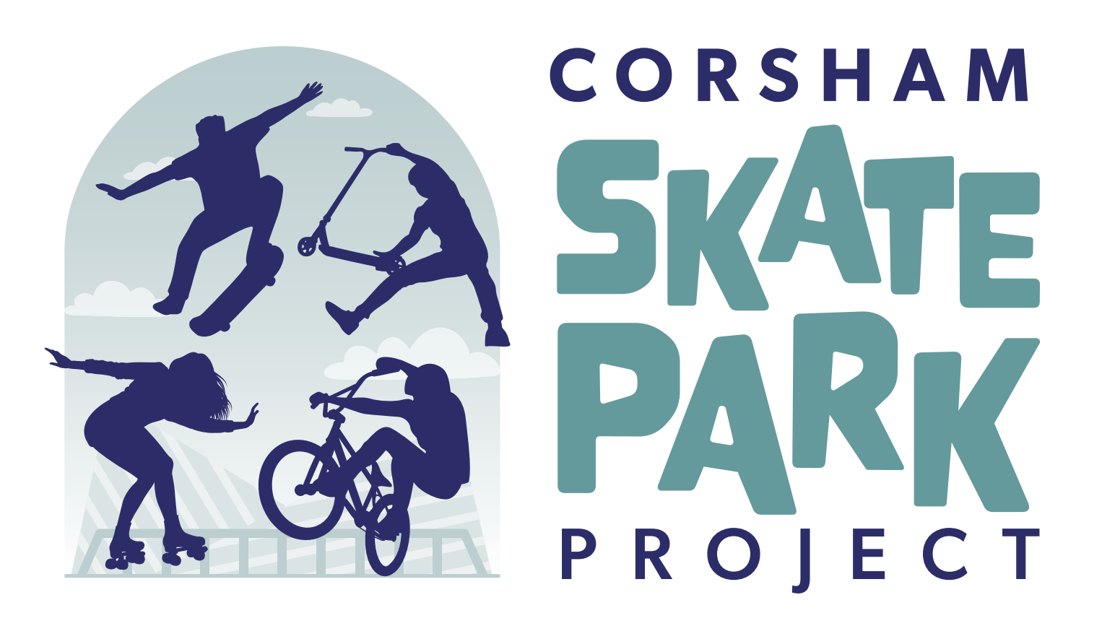

Designing and Constructing a New Skatepark at Springfield, Corsham

Summary:
Corsham Town Council is seeking to appoint an experienced specialist skatepark company to design and construct a new skatepark at Springfield Recreation Ground. The successful company will be expected to work closely with the Town Council and the Corsham Skatepark Project Group; to design a new skatepark; to support efforts to access grants from national organisations (and to support the Corsham Skatepark Project Group in its efforts to raise funds locally); to manage the planning process for the new skatepark and ultimately, to construct and deliver a fantastic new facility for skaters in Corsham.
Whilst the Town Council has earmarked a substantial sum towards the project and the Corsham Skatepark Project Group has started to raise funds from the local community, not all the funding is in place yet. As such, the contractor will be initially appointed as a speculative partner. Once a design has been agreed, planning permission has been secured and the necessary funding is in place, the contractor will be asked to enter into a JCT contract with Corsham Town Council to construct the new skatepark.
The new skatepark is to be constructed on the site of the existing 400m2 facility, though there is scope, and the aspiration amongst local skaters, to expand the footprint if funding and the eventual design permits. Any expansion in the size of facility should not however be at the expense of quality. Corsham Town Council expects the total cost of the project to be around £350,000 +VAT.
This document sets out how Corsham Town Council will appoint a contractor to take the project forward and how companies can submit tenders.

Background:
The current skatepark in Corsham is located at Springfield Rec. It was built in 2006, upgraded in 2013 and lighting was installed in 2016. The skatepark is approximately 400m2 and is constructed in concrete (sections of rough concrete rather than the smooth sprayed concrete which feature in modern designs). The skatepark is starting to show its age, with damage/wear to the parts where the concrete sections join. Furthermore, there are issues with the layout of the skatepark – it tends to funnel skaters towards the middle of the park and prevents more than a few skaters using the facility at any one time. Often experienced skaters are prevented from using the park when less proficient riders are skating.
In 2022, the Town Council became aware of dissatisfaction with the current facility and aspiration for a larger, modern skatepark following discussions on site with local skaters. After considering their comments, the Town Council told the skaters that if they wanted the Council to invest the necessary time and resources to provide a new skatepark, they would first have to demonstrate that there was a genuine and sizeable demand for such an initiative within the community. In November 2022 the Town Council received a petition, signed by 388 local skaters, asking for a new skatepark, as well as a large number of accompanying emails and letters.
In July 2023, a group of local skaters came together (with the Town Council’s support and backing) to form the Corsham Skatepark Project Group. This group, which now has its own governing document and bank account, is working to raise funds for a new skate facility in the town. In recent months, the group has generated real momentum in its fundraising activities and has organised a raffle with prizes donated by local businesses, organised (with Route One) a well-attended ‘skate jam’, set up a GoFundMe page, placed collection boxes in town centre shops/pubs/cafes and participated in a number of events. So far, the group has raised £2,442 and has plans for bigger and better fundraising activities in 2025. When a specialist contractor is appointed, this group will be charged by the Town Council to work with the contractor to develop a design for the skatepark.
Whilst the local skaters were busy putting their group together and starting their fundraising efforts, the Town Council considered the funding and siting of a new skatepark. The Council’s Strategic Planning Working Group anticipated that the Town Council would contribute half of the £350,000 estimated cost of the project. Accordingly, £175,000 has been allocated across the Town Council’s draft 2025/6 and 2026/27 budgets for this purpose. In addition, the Council’s Property and Amenities Committee gave consideration to the siting of a new facility and, in September 2024, approved expanding on the existing footprint to construct a new skatepark of up to 800m2 (the exact size would depend on costs and the design).
Both the Corsham Skatepark Project Group and Corsham Town Council now feel that the time is right to appoint a specialist skatepark company to build on the work done thus far and push the project forward.

Requirement:
Corsham Town Council is looking to appoint an experienced specialist skatepark company to:
- Work with the Corsham Skatepark Project Group and Corsham Town Council to draw up a high-quality design for a new skatepark, on the site of the existing facility at Springfield Rec.
- Work with the Corsham Skatepark Project Group and Corsham Town Council to identify funding opportunities, to assist with/support applications and secure sufficient funding to bring the project to fruition.
- Work with the Corsham Skatepark Project Group and Corsham Town Council to properly consult with all stakeholders, including the wider skating community, to ensure that the design meets the needs of all potential skaters. Neighbouring residents should also be consulted to assure them that the new designs will not negatively affect their quality of life.
- Manage/negotiate the planning process and obtain planning consent to construct the new facility.
- Enter into a JCT contract with Corsham Town Council and construct the new skatepark.
*Important Note: Until 1-4 (above) have been completed, the contractor is expected to work as a speculative partner – with no guarantee of remuneration. Once planning permission has been obtained (Corsham Town Council will pay the planning fee and any surveys undertaken during the planning process), sufficient funding secured and a design produced that the Corsham Skatepark Project Group, Corsham Town Council and the wider skating community are happy with, the contractor will be invited to enter into a JCT contract with Corsham Town Council to remove and properly dispose of redundant material from the old facility and to construct the new facility in accordance with the agreed design.

What We Want to Deliver:
Corsham Town Council and the Corsham Skatepark Project Group want to deliver a modern skatepark that caters for all forms of wheeled sports including skateboarding (the majority of users), BMX, scooters, roller-skating - both inline and traditional - and WCMX. The design should also cater for all abilities, providing a place for beginners to learn and gain confidence as well as providing a challenge and maintaining an interest for skilled skaters. The layout should also provide for a mix of riding styles: street, transition and flow. Ultimately, we would like to create a facility that local skaters value, feel proud of and have a sense of ownership towards.
The skatepark should be constructed from the best, most modern materials (sprayed concrete) and be designed and constructed to be as durable as possible, so as to provide a facility for a generation of skaters. It should feature carefully directed lighting, so that it can be used by skaters in the evenings yet not be a source of undue light pollution for nearby residents (secure adjustable timers will need to be provided so that any lighting conditions contained in a planning consent can be adhered to). The design should also feature some kind of acoustic barrier – a wall to prevent sound travelling in the direction of nearby houses or earth mounds so that the facility appears to be contained within the ground.
We would like a design that is unique to Corsham, perhaps even reflecting the town in some way. The new skatepark should sit well within the site and provide an attractive architectural feature that is of interest to skaters and non-skaters alike. We would like to develop a design that has additional features beyond just skating. We think the skatepark should have safe places to sit, to rest and to observe – places for non-skaters to come along and socialise. Providing shade from the sun and shelter from the elements would be a good feature. We want to provide an open space that welcomes and encourages people to take part, but not hidden areas where anti-social behaviour might take place.
The current skatepark on the site is approximately 400m2. However, there is scope and the aspiration amongst local skaters to construct a larger facility – the Town Council’s Property & Amenities Committee has set a maximum footprint of 800m2. The exact size will depend on the design drawn up, the funds raised and any planning constraints. However, any increase in the footprint should not be at the expense of quality.

The Tender Process:
There will be a two-stage process to select a contractor:

Stage 1

This stage will be open to any company. Interested companies are required to:
- Complete the Selection Questionnaire appended to this document.
- Supply copies of any documents/additional information asked for in the Selection Questionnaire.
- Provide details of three skatepark projects that the company has successfully completed in the past five years (detailed requirements are set out in the Selection Questionnaire).

Following receipt of this information, three companies will be selected to progress to Stage 2 of the tender process.

Stage 2
This stage will only be open to the three companies selected following Stage 1. The three companies will be invited to:
- Submit a Method Statement outlining how they would work to successfully deliver the project. The Method Statement appendix at the rear of this document sets out all the information that should be included.
- Visit Corsham Town Hall and give a short presentation to representatives of Corsham Town Council and the Corsham Skatepark Project Group and to answer any questions. Presentations should feature a brief overview of the company, their experience delivering skatepark projects and how they would work to successfully deliver the new skatepark.

Note* We are not asking companies to submit proposed designs for the Springfield Skatepark as part of the tender process. The successful company will be asked to draw up a design with the Corsham Skatepark Project Group and Corsham Town Council during the project itself. Evaluation of tendering companies ability to produce a high quality design will be based on the three examples they submit in Stage 1.

Evaluation:
Stage 1
Submissions in Stage 1 will be evaluated equally against the following criteria:
- Assurance – An assessment of the company’s responses to questions 4-8 contained in the Selection Questionnaire.
- Collaborative Working – The extent to which the three examples provided by the company show the ability to successfully work in collaboration with other stakeholders.
- Quality of Work – The design and build quality of the three skatepark projects that the company puts forward as examples of its recent work. Corsham Town Council will gauge the opinion of the Corsham Skatepark Project Group when scoring this element.

Stage 2

The three companies selected to take part in Stage 2 will be assessed by scoring their Method Statements and Presentation (with equal weighting given to each element). When considering scores, Corsham Town Council will consider the quality of the company’s previous projects, the company’s approach to collaborative working, knowledge of funding opportunities and the ability to bring projects to fruition on time and in budget.

Timetable:
Specification published: | 2 December 2024
Return date for Selection Questionnaire and additional information: | 13 January 2025
Corsham Town Council decision on which three companies to take forward to Stage 2: | 27 January 2025
Method Statement to be returned by: | 10 March 2025
Presentation: | w/c 17 March 2025
Contractor appointed: | 24 March 2025

Site Visits:
Prospective contractors who wish to undertake a site visit should contact James Whittleton (Head of Technical Services) to arrange a time/date: jwhittleton@corsham.gov.uk 07879 256215.

Submission of Tenders:
Tenders are to be sent by post or delivered by hand in an envelope clearly labelled “Tender – Springfield Skatepark”, addressed to:

David Martin – Chief Executive
Corsham Town Hall
High Street
Corsham
Wiltshire, SN13 0EZ

Alternatively, tenders can be sent via email to dmartin@corsham.gov.uk AND mjones@corsham.gov.uk with “Tender – Springfield Skatepark” in the title bar.

Tenders for Stage 1 should be received no later than 12noon on Monday 13th January 2025.

Selection Questionnaire – Stage 1
- General Information:

Name of Company

Registered address

Company/charity number
Name of parent company (if applicable)

- Contact Details:

Name (main contact)

Postal address

Phone number

Mobile number

Email address

- Bidding Model:

Please tick in the relevant box below to indicate whether you are:
a – Bidding as a prime contractor and will deliver 100% of the contract yourself.
b – Bidding as a prime contractor and will use third parties to deliver some elements of the skatepark.

If you have ticked this box, please provide details of your proposed bidding model – the names of all sub-contractors, which elements they would be responsible for and the percentage of work being carried out by each sub-contractor.
c – Bidding as a prime contractor but will operate as a managing agent and will use third parties to deliver all elements of the skatepark.

If you have ticked this box, please provide details of your proposed bidding model – the names of all sub-contractors, which elements they would be responsible for and the percentage of work being carried out by each sub-contractor.
d – Bidding as a consortium.

If you have ticked this box please provide details of all consortium members, indicate who is the lead member, provide full details of the bidding model and state whether a Special Purpose Vehicle is to be formed.

- Registration with a Professional Body:

Is your business registered with a relevant trade or professional register?
If so, please provide details (including registration number and date of registration) in the adjoining box.

- Insurance:

Please tick to confirm that you have (or can commit to obtain prior to the commencement of the contract) the following levels of insurance cover:
Employer’s (compulsory) Liability Insurance - £10,000,000.
Public Liability Insurance - £10,000,000.
Professional Indemnity Insurance - £2,000,000.

- Environmental Management:

Environmental Credentials:
Please give details of any environmental credentials that your company possesses.
Please indicate whether your company has an environmental policy which it follows when carrying out work by ticking (or leaving blank) the adjoining box.
If you have ticked this box, please provide a copy of your environmental policy.

 | Yes | No
Has your company been convicted of breaching environmental legislation, or had any notice served upon it in the last five years by any environmental regulator or authority?
If you ticked the ‘Yes’ box for the answer above, please provide details on a separate sheet of the conviction or notice and any details of any remedial action or changes you have made as a result.

- Health & Safety

Please indicate whether your company has a Health & Safety Policy that complies with current legislative requirements by ticking (or leaving blank) the adjoining box.
If you have ticked this box, please provide a copy of your Health & Safety Policy.

 | Yes | No
Has your company or any of its directors or executive officers been in receipt of enforcement/remedial orders in relation to the Health & Safety Executive (or equivalent body) in the last five years?

If your answer to this question was ‘Yes’, please provide details on a separate sheet of any enforcement/remedial orders served and give details of any remedial action or changes to procedures you have made as a result.

If you use sub-contractors, do you have processes in place to check whether any of the circumstances apply to these other organisations?
Please tick the adjoining box if you do have such processes in place.

- Quality

 | Yes | No
Does your company hold a quality certificate such as ISO9001 (or equivalent) or a policy that attests to your organisation’s approach to quality management?
If you use sub-contractors, do you have processes in place to check whether any of the above circumstances apply to these other organisations?

- Technical and Professional Ability
On a separate sheet, please provide details of three skatepark projects that your company has successfully delivered during the last five years.
In each case, please provide:
- The name of the customer organisation.
- A contact within that organisation along with an email address or other contact details.
- The start date, completion date and contract value.
- A short narrative (less than 500 words for each example) outlining the work that you undertook to deliver the project, the skills/expertise that you demonstrated, people you worked with, funding, planning etc.
- Images – especially of the finished skatepark.

Declaration:

I declare that to the best of my knowledge the answers submitted to these questions are correct. I understand that the information will be used to assess my organisation’s suitability to be invited to participate further in this procurement, and I am signing on behalf of:

…………………………………………………………………(insert name of company)

I understand that Corsham Town Council may reject my submission if there is a failure to answer all relevant questions fully or if I provide false/misleading information. I have provided a full list of any additional sheets used to provide additional information in response to questions.
Additional Sheets:

I also declare that there is no conflict of interest in relation to the Town Council’s requirement.

Selection Questionnaire completed by:
Name

Role in organisation

Date

Signed

Method Statement – Stage 2
The Method Statement should contain the following:
- An outline of your overall approach – how you would plan, manage and deliver the project (max 500 words).

- A short statement of how you would work with the Corsham Skatepark Project Group and the wider skating community to ensure that the design was of the highest quality and met the needs of all skaters (max 300 words).

- How you would communicate with Corsham Town Council, the Corsham Skatepark Project Group, the wider skating community and other stakeholders throughout the life of the contract (max 200 words).

- How you would ensure that quality of the completed skatepark (both the design and the construction) was as good as it could be (max 300 words).

- How would your company support the Corsham Skatepark Project Group to access funding from national organisations and conduct local fundraising (max 300 words).

- Your approach to managing the planning process and successfully obtaining planning permission for a new skatepark (max 300 words).

- An outline project timeline – featuring potential dates/timescales and key milestones e.g. completing the design, sourcing funding, obtaining planning consent, construction etc.

- An outline of what support you could give Corsham Town Council to maintain the skatepark after it has been constructed.

- A rough breakdown of costs for each activity you are likely to be required to carry out as part of the project, including design and consultation. It would also be useful to have an approximate cost per square metre of skatepark.

