Tender Pack
Martello Toilets Facility
INTRODUCTION
Seaford Town Council is inviting invitations to tender for the refurbishment of the Martello Toilets Block, Esplanade, Seaford, BN25 1JH.
As well as completely updating the interior, it will also enable the space to include a refreshments facility and storage.

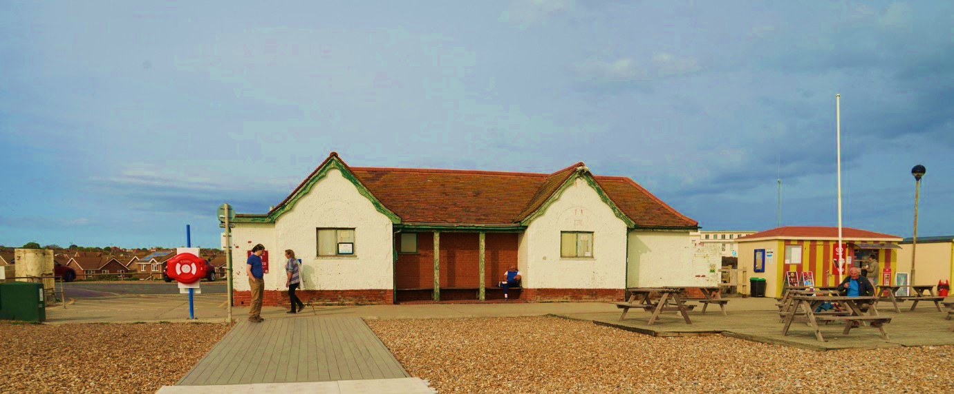
Tender closing date: 18th September 2023
Queries to: projects@seafordtowncouncil.gov.uk
Submissions to: tenders@seafordtowncouncil.gov.uk

CONTENTS
- Conditions
- Insurance/Health and Safety
- Scoring and Evaluation Criteria
- Timescale
- Submissions

CONDITIONS
- This Tender Document is issued for and on behalf of Seaford Town Council, 37 Church Street, Seaford, East Sussex, BN25 1HG.
- All contractors tendering will demonstrate relevant qualifications and experience.
- All tenders must be signed by a company director or the named sole trader or partnership, dated and returned by email to the stated address or hand delivered to the postal address.
- The deadline for completion is 12 o’clock midday on 18th September 2023.
- This tender should be read in conjunction with the specification and accompanying plans/drawings and other documents, including the structural calculations and plan, Building Control conditions, Planning decision and Asbestos survey. Please note that a drain survey report is to follow in early September.
- The contractor will be deemed to have made all necessary allowances in the Tender Price for access, storage, arising, disposal etc.
- Prospective contractors are prohibited from contacting councillors or staff to encourage or support their tender outside of the prescribed process.
- The Contract will be monitored by the Town Council.
- Following inspection by the Town Council, any work deemed not to have been carried out, or not to have been carried out satisfactorily, will be reported to the contractor. They will be given the opportunity to promptly rectify the work. If the work is not rectified during the agreed timescale, payment for the work may not be made.
- The Contractor will ensure that all relevant legislation pertaining to the Health and Safety at Work Act 1974 and Control of Substances Hazardous to Health (COSHH) Regulations 1989 are adhered to.

INSURANCE AND HEALTH AND SAFETY
All bidders must provide the following with the tender:
- Evidence of Public Liability Insurance no less than £5million
- The company’s health and safety policy.
For the successful applicant, we will require the following documentation upon notification of being successful:
- Risk Assessment
- Method statement (safe working method) sometimes called RAMS (risk assessment method statement).
- COSHH document

SCORING AND EVALUATION CRITERIA
The key assessment criteria for submitted tenders will be:
- Service Delivery Quality (Compliance with Specification)
- Local Business/Connections
- Experience, Capability and Sustainability of Company
- Price/Value for Money
Please provide a response to each of these criteria in your tender submission document.

TIMESCALE
Published Date | 11th August 2023
Tender Returns | 12 o’clock midday 18th September 2023
Preferred Bidder Announcement | Week commencing 16th October 2023
Build Timetable | Bidders to include proposed timetable in the submission – to be agreed with Seaford Town Council

SUBMISSIONS
Clarifications and queries must be addressed by email to: projects@safordtowncouncil.co.uk
The tender closing date is 12 o’clock midday on 18th September 2023
Bid tender returns must be emailed to:
tenders@seafordtowncouncil.gov.uk
or submitted in writing in a sealed marked envelope to:
Town Clerk, Seaford Town Council, 37 Church Street, Seaford, BN25 1HG
Bidders must provide a suitable Point of Contact (PoC) for clarification questions.

