19/3/24
Q. Could you please confirm the specific building within your company where you intend to install the equipment?
A. 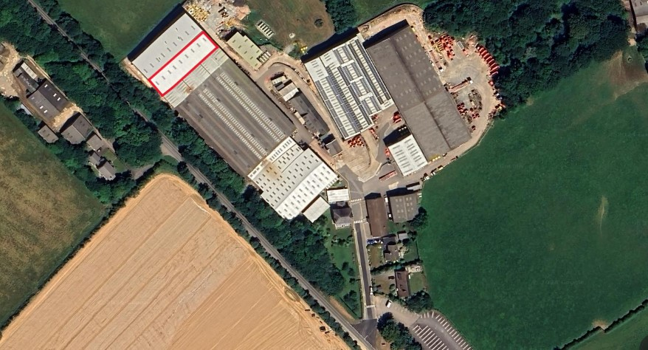
Q. the subject header for submission states "Solar Panel and Storage Batteries" while the specific requirement states at 3.2.4 No battery storage, please advice if the batteries are required.

A. This is an error, subject header should be Solar Panels only - batteries are not required

Q. Is there an export limitation required as the export stated is 80W, in such a case the batteries will be extremely good and will assist in 85-90 % saving in your region. Or if the figure is in 80kw also advice on if there is a DNO approval already obtained or need to be obtained.

A. 80kW relates to the maximum output capacity of the inverters. DNO approval will need to be obtained.

Q. In case DNO approval need to be obtained please advice on the current capacity/availability of the supply. Usage peak or 1/2 hourly data from the supply.

A. We currently have 300kW of solar panels installed and a DNO imposed export limit of 150kW. As part of the DNO application we would like to find out if the export limit can be removed which would enable us to export up to 700KVA (agreed import capacity).

Q. Is there a calculation of the current structure available.?

A. Structural drawings of the building are available on request

Q. As you advice the 300KWp panels are installed, what is the capacity and model of the previous installed Inverter to assess and understand the current network.
A. Existing 6 installation are:

50kW with 4 x Fronius Inverters
50kW with 2 x Power One Aurora Trio / ABB Trio Inverters
50kW with 3 x Solar Max Inverters
50kW with 3 x SolarEdge Inverters
50kW with 2 x SolarEdge Inverters
50kW with 2 x SolarEdge Inverters

All SolarEdge Inverters are linked to export limiting system that ramps them down when we approach the site export limit of 150kW.

