

www.gov.uk/naturalengland

Request for Quotation

## 

## Request for Quotation

## Natural England is the government’s advisor on the natural environment. We provide practical advice, grounded in science, on how best to safeguard England’s natural wealth for the benefit of everyone.

## Our remit is to ensure sustainable stewardship of the land and sea so that people and nature can thrive. It is our responsibility to see that England’s rich natural environment can adapt and survive intact for future generations to enjoy.

## NERC Act

## Natural England was formally established on 01 October 2006 following the successful passage of the Natural Environment and Rural Communities (NERC) Act 2006 through Parliament. We are an independent statutory Non-Departmental Public Body.

## The NERC Act sets out Natural England's purpose: to ensure that the natural environment is conserved, enhanced and managed for the benefit of present and future generations, thereby contributing to sustainable development.

## The Act states that this purpose includes:

## ​​​​​​​promoting nature conservation and protecting biodiversity

## conserving and enhancing the landscape

## securing the provision and improvement of facilities for the study, understanding and enjoyment of the natural environment

## promoting access to the countryside, open spaces and encouraging open air recreation

## contributing in other ways to social and economic wellbeing through management of the natural environment

## You can read more about what we do on [GOV.UK](https://www.gov.uk/government/organisations/natural-england/about).

**Pond slubbing at Woodwalton Fen National Nature Reserve (NNR)**

You are invited to submit a quotation for the requirement described in the specification below.

Please confirm at your earliest convenience, by email, receipt of these documents and whether you intend to submit a quote.

After confirming receipt, your final quotation response should be returned to [Tristan.Colaco@naturalengland.org.uk](mailto:Tristan.Colaco@naturalengland.org.uk) by: 09:00 on 25/06/2023 Ensure you state the request name and ‘Final Submission’ in the subject field when submitting your quote to make it clear that it is your response.

**Contact Details and Timeline**

Tristan Colaço will be your contact for any questions linked to the content of the quote pack or the process. Please submit any questions by email and note that, unless commercially sensitive, both the question and the response will be circulated to all tenderers.

|  |  |
| --- | --- |
| Action | Date |
| Date of issue of RFQ | 09/05/2023 |
| Deadline for clarifications questions | 18/06/2023 at 15:00 |
| Deadline for receipt of Quotation | 25/06/2023 at 09:00 |

### Glossary

Unless the context otherwise requires the following words and expressions used within this Request for Quotation shall have the following meanings (to be interpreted in the singular or plural as the context requires):

|  |  |
| --- | --- |
| “Authority” | Means the Department for Environment, Food and Rural Affairs acting as part of Natural England |
| “RFQ” | Means this Request for Quotation and all related documents published by the Authority and made available to suppliers |
| “Contract” | Means the contract to be entered into by the Authority and the successful supplier. |

### 

### Conditions applying to the RFQ

You should examine your response to the RFQ and related documents ensuring it is complete prior to submitting your completed quotation.

Your quotation must contain sufficient information to enable the Authority to evaluate it fairly and effectively. You should ensure that you have prepared your quotation fully and accurately and that prices quoted are arithmetically correct for the units stated.

The supplier by submitting a quotation is deemed to accept the terms and conditions in the RFQ. Failure to comply with the instructions set out in the RFQ may result in the supplier’s exclusion from this procurement.

### Acceptance of Quotations

By issuing this RFQ the Authority does not bind itself to accept any quotation and reserves the right not to award a contract to any supplier who submits a quotation.

#### Costs

The Authority will not reimburse you for any costs and expenses which you incur preparing and submitting your quotation, even if the Authority amends or terminates the procurement process.

#### Mandatory Requirements

The RFQ includes mandatory requirements and, if you do not comply with them, your quotation will not be evaluated.

#### Clarifications

The Authority reserves the right to discuss, confidentially, any aspect of your quotation with you prior to any award of Contract to clarify matters.

#### Amendments

The Authority may amend the RFQ at any time prior to the deadline for receipt. If it amends the RFQ the Authority will notify you in writing and may extend the deadline for receipt in order to give you a reasonable time in which to take the amendment into account.

#### Conditions of Contract

The terms and conditions found here: [www.gov.uk/government/organisations/natural-england/about/procurement](http://www.gov.uk/government/organisations/natural-england/about/procurement) will be included in any contract awarded as a result of this RFQ process. The Authority will not accept any material changes to these terms and conditions proposed by a supplier.

**Prices**

Prices must be submitted in £ sterling, inclusive of VAT. Please itemised the quote per area as outlined above

**Quotation Submission**

We will award this contract in line with the most economically advantageous tender (MEAT) as set out in the following award criteria:

Price – 50%

Quality – 50%

|  |  |  |
| --- | --- | --- |
| **Criteria** | Weighting | **To include:** |
| **Experience of similar works** | 40 | To include:   * Examples of relevant work |
| **Proposed methodology** | 40 | To include:   * How you will work to allow for the sensitive ground conditions and habitat * Availability/timings |
| **Health and Safety** | 20 | * Ability to provide RAMS, work plans etc. |

|  |  |
| --- | --- |
| **Score** | **Justification** |
| For a score of hundred (100): | Excellent - Response is completely relevant and excellent overall.  The response is comprehensive, unambiguous and demonstrates a thorough understanding of the requirement and provides details of how the requirement will be met in full. |
| For a score of seventy (70): | Good - Response is relevant and good.  The response demonstrates a good understanding and provides details on how the requirements will be fulfilled. |
| For a score of fifty (50): | Acceptable - Response is relevant and acceptable.  The response provides sufficient evidence to fulfil basic requirements. |
| For a score of twenty (20): | Poor - Response is partially relevant and/or poor.  The response addresses some elements of the requirements but contains insufficient / limited detail or explanation to demonstrate how the requirement will be fulfilled. |
| For a score of zero (0): | Unacceptable - Nil or inadequate response.  Fails to demonstrate an ability to meet the requirement. |

**Bid format**

If possible, as well as providing an itemised quote for all works outlined below, please also provide a day-rate for slubbing work. The reason for this being that, depending on costs relative to our budgets, we may be able to undertake more or less work than that outlined above.

**Contract Management**

This contract shall be managed on behalf of the Authority by Tristan Colaço through regular contact and occasional site meetings with Tristan and other NE staff.

We will raise purchase orders to cover the cost of the services and will issue to the awarded supplier following contract award. We envisage that we will be invoiced after works have been completed.

### Disclosure

All Central Government Departments, their Executive Agencies and Non Departmental Public Bodies are subject to control and reporting within Government. In particular, they report to the Cabinet Office and HM Treasury for all expenditure. Further the Cabinet Office has a cross-Government role delivering overall Government policy on public procurement, including ensuring value for money and related aspects of good procurement practice.

For these purposes, the Authority may disclose within Government any details contained in your quotation. The information will not be disclosed outside Government during the procurement.

In addition, the Authority is subject to the Freedom of Information Act 2000 and the Environmental Information Regulations 2004, which provide a public right of access to information held by public bodies. In accordance with these two statutes, the Authority may be required to disclose information contained in your quotation to any person who submits a request for information pursuant to those statutes.

By submitting a quotation you consent to these terms as part of the procurement.

### Disclaimers

Whilst the information in this RFQ and any supporting information referred to herein or provided to you by the Authority have been prepared in good faith the Authority does not warrant that this information is comprehensive or that it has been independently verified.

The Authority does not:

* make any representation or warranty (express or implied) as to the accuracy, reasonableness or completeness of the RFQ;
* accept any liability for the information contained in the RFQ or for the fairness, accuracy or completeness of that information; or
* accept any liability for any loss or damage (other than in respect of fraudulent misrepresentation or any other liability which cannot lawfully be excluded) arising as a result of reliance on such information or any subsequent communication.

Any supplier considering entering into contractual relationships with the Authority following receipt of the RFQ should make its own investigations and independent assessment of the Authority and its requirements for the goods and/or services and should seek its own professional financial and legal advice.

**Protection of Personal Data**

In order to comply with the General Data Protection Regulations 2018 the contractor must agree to the following:

* You must only process any personal data in strict accordance with instructions from the Authority
* You must ensure that all the personal data that we disclose to you or you collect on our behalf under this agreement are kept confidential.
* You must take reasonable steps to ensure the reliability of employees who have access to personal data.
* Only employees who may be required to assist in meeting the obligations under this agreement may have access to the personal data.
* Any disclosure of personal data must be made in confidence and extend only so far as that which is specifically necessary for the purposes of this agreement.
* You must ensure that there are appropriate security measures in place to safeguard against any unauthorised access or unlawful processing or accidental loss, destruction or damage or disclosure of the personal data.
* On termination of this agreement, for whatever reason, the personal data must be returned to us promptly and safely, together with all copies in your possession or control.

**General Data Protection Regulations 2018**

For the purposes of the Regulations the Authority is the data processor.

The personal information that we have asked you provide on individuals (data subjects) that will be working for you on this contract will be used in compiling the tender list and in assessing your offer. If you are unsuccessful the information will be **held and destroyed within two years** of the award of contracts. If you are awarded a contract it will be retained for the duration of the contract and destroyed within **seven years** of the contract’s expiry.

We may monitor the performance of the individuals during the execution of the contract, and the results of our monitoring, together with the information that you have provided, will be used in determining what work is allocated under the contract, and in any renewal of the contract or in the award of future contracts of a similar nature. The information will not be disclosed to anyone outside the Authority without the consent of the data subject, unless the Authority is required by law to make such disclosures.

Equality, Diversity & Inclusion (EDI)

The Client is striving to create a diverse and inclusive working environment where every individual has equality of opportunity to progress and to apply their unique insights to making the UK a great place for living. The Service Provider is expected to respect this commitment in all dealings with Natural England staff and service users.

Suppliers are expected to;

* support Defra group to achieve its Public Sector Equality Duty as defined by the Equality Act 2010, and to support delivery of [Defra group’s Equality & Diversity Strategy](https://www.gov.uk/government/publications/defra-group-equality-diversity-and-inclusion-strategy-2020-to-2024/defra-group-equality-diversity-and-inclusion-strategy-2020-to-2024).
* meet the standards set out in the [Government’s Supplier Code of Conduct](https://www.gov.uk/government/publications/supplier-code-of-conduct)
* work with Defra group to ensure equality, diversity and inclusion impacts are addressed (positive and negative) in the goods, services and works we procure, barriers are removed and opportunities realised.

Sustainable Procurement

Addressing global sustainability impacts and realising additional community benefits within commercial activity is core to Defra group’s approach, working with its supply chain is key to achieving sustainable outcomes. In addition to supporting Defra group to meet its outcomes we look to understand and reduce negative sustainability impacts associated with our commercial activity and realise benefits.

The Client encourages its suppliers to share these values, work to address negative impacts and realise opportunities, measure performance and success.

Suppliers are expected to have an understanding of the Sustainable Development Goals, the interconnections between them and the relevance to the Goods, Services and works procured on the Client’s behalf

Conflicts of Interest

The concept of a conflict of interest includes but is not limited to any situation where an Involved Person or Relevant Body has directly or indirectly, a financial, economic or other personal interest which might be perceived to compromise their impartiality and independence in the context of the procurement procedure and/or affect the integrity of the contract award.

We expect suppliers to mitigate appropriately against any real or perceived conflict of interest through their work with government. A supplier with a position of influence gained through a contract should not use that position to unfairly disadvantage any other supplier or reduce the potential for future competition

Where the supplier is aware of any circumstances giving rise to a conflict of interest or has any indication that a conflict of interest exists or may arise you should inform the Authority of this as soon as possible (whether before or after they have submitted a quotation). Tenderers should remain alert to the possibility of conflicts of interest arising at all stages of the procurement and should update the Authority if any new circumstances or information arises, or there are any changes to information already provided to the Authority. Failure to do so, and/or to properly manage any conflicts of interest may result in a quotation being rejected.

Provided that it has been carried out in an open, fair and transparent manner, routine pre-market engagement carried out by the Authority should not represent a conflict of interest for the supplier.

#### Specification

The Authority is Natural England. The Authority’s priorities are to secure a healthy natural environment; a sustainable, low-carbon economy; a thriving farming sector and a sustainable, healthy and secure food supply. Further information about the Authority can be found at: [Natural England](http://www.naturalengland.org.uk/)

Woodwalton Fen NNR is one of the oldest nature reserves in the UK and is of national importance to nature conservation. The ditches and water bodies on site are valuable habitats in their own right, containing a variety of rare plants and animals. The ditches are also integral to water level management- careful water level management being vital for the maintenance of other habitats on site. Ditches vary between 1.5-2.5m across and 1-2m deep.

**Specification**

Natural England are seeking to restore an overgrown/silted up pond/small mere at Woodwalton Fen National Nature Reserve

The pond is well choked with reed.

The site is a SSSI and the ground is peat so low ground pressure equipment needs to be used and care taken not to excessively damage the ground. Access to the work site from reserve entrance is approx. 700 m along a relatively firm boundary earth track (during drier times of year), the ground within the work area is very soft peat; we anticipate that works will need to be completed by very low ground pressure equipment (e.g. using bog mats etc.), with measures taken to minimise tracking across site (e.g. long reach diggers).

The pond is approx. 670m2, the bank is approx. 70m long and 3-4m wide.

The low spoil bank is approx. 50 m away.

Spoil to be moved either by wide tracked dumper or by handballing with the excavating digger.

Once piled onto spoil bank, to be shaped as best as possible and left to reduce in size.

Ideally, we would like works carried out in September or October; after bird breeding season is finished but before the site gets too wet over the autumn.

Further information

Nearest post code for Woodwalton Fen: PE26 2RS

Site location map:

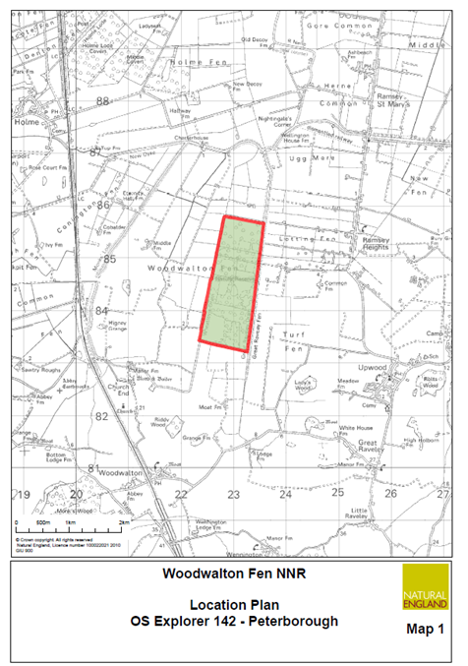

site layout maps:

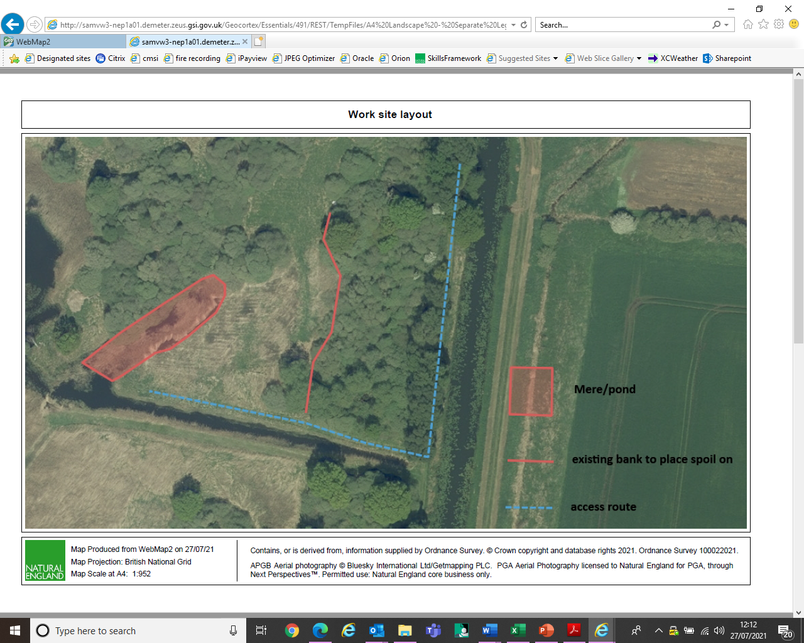

We would welcome a price for the whole job, but also a day rate price. Depending on the amount of material generated the receiving bank may or may not accommodate all the slubbings. If not, then the work may need to be split over 2 years, in which case working on a day rate may be our preferred option.

We would also welcome options to remove the spoil from site altogether.

Other information

Woodwalton Fen is a wetland and a SSSI. As such the ground is very sensitive to damage and can be extremely soft.

Work sites are accessed via a network of non-surfaced grass visitor/access paths and across bridges, some of which are narrow (<3m).

Standard 4x4 vehicle access to the work sites is not possible at any time of year.

Any machinery used on site must be low ground pressure – e.g. wide tracked diggers, ATV.

There is good access for standard vehicles and 4x4s into the reserve work base, which is a secure locked yard suitable for storing equipment and materials.

Please outline in your bid how your equipment and work methods will minimise ground disturbance.

The water body being de-silted is a valuable habitat, home to rare plants and animals. The other habitats on site are also home to a number of important species. Please ensure that your bid outlines your environmental credentials and how your methodology will minimise risk to the natural environment.

Due to the site’s biodiversity importance, we will require you to ensure that all equipment is properly cleaned before coming onto site to reduce the risk of spread of invasive species, disease etc. Please factor this into your quote.

The site is open to the public, so safety of visitors must be taken into consideration; please outline in your bid how visitor safety will be managed

Ideally this work would be done during October and November- though this is weather dependant.

Before undertaking any work, we would be required to see risk assessments, work plans, competency certification etc. to ensure we are satisfied it is safe for works to be carried out.

**We would strongly recommend a site visit prior to submitting a quote.**

It is anticipated that this contract will end no later than 31/11/23. Prices will remain fixed for the duration of the contract award period. We may at our sole discretion extend this contract to include related or further work. Any extension shall be agreed in advance of any work commencing and may be subject to further competition.

For any questions or to arrange a site visit to obtain a better understanding of the project please contact Tristan Colaço on [Tristan.Colaco@naturalengland.org.uk](mailto:Tristan.Colaco@naturalengland.org.uk) or 07880145755.

Yours faithfully,

Tristan Colaço

Natural England Reserve Manager, West Anglia

Annex 1 Mandatory Requirements

Part 1 Potential Supplier Information

Please answer the following self-declaration questions in full and include this Annex in your quotation response.

Part 1.1 Potential Supplier Information:

|  |  |  |
| --- | --- | --- |
| Question no. | Question | Response |
| 1.1(a) | Full name of the potential supplier submitting the information |  |
| 1.1(b) | Registered office address (if applicable) |  |
| 1.1(c) | Company registration number (if applicable) |  |
| 1.1(d) | Charity registration number (if applicable) |  |
| 1.1(e) | Head office DUNS number (if applicable) |  |
| 1.1(f) | Registered VAT number |  |
| 1.1(g) | Are you a Small, Medium or Micro Enterprise (SME)? | (Yes / No) |

Note: See EU definition of SME <https://ec.europa.eu/growth/smes/business-friendly-environment/sme-definition_en>

Part 1.2 Contact details and declaration

By submitting a quotation to this RFQ I declare that to the best of my knowledge the answers submitted and information contained in this document are correct and accurate.

I declare that, upon request and without delay you will provide the certificates or documentary evidence referred to in this document.

I understand that the information will be used in the selection process to assess my organisation’s suitability to be invited to participate further in this procurement.

I understand that the authority may reject this submission in its entirety if there is a failure to answer all the relevant questions fully, or if false/misleading information or content is provided in any section.

I am aware of the consequences of serious misrepresentation.

|  |  |  |
| --- | --- | --- |
| Question no. | Question | Response |
| 1.2(a) | Contact name |  |
| 1.2(b) | Name of organisation |  |
| 1.2(c) | Role in organisation |  |
| 1.2(d) | Phone number |  |
| 1.2(e) | E-mail address |  |
| 1.2(f) | Postal address |  |
| 1.2(g) | Signature (electronic is acceptable) |  |
| 1.2(h) | Date |  |

Part 2 Exclusion Grounds

Part 2.1 Grounds for mandatory exclusion

|  |  |  |
| --- | --- | --- |
| Question no. | Question | Response |
| 2.1(a) | Please indicate if, within the past five years you, your organisation or any other person who has powers of representation, decision or control in the organisation been convicted anywhere in the world of any of the offences within the summary below. | |
|  | Participation in a criminal organisation. | (Yes / No)  If yes please provide details at 2.1 (b) |
|  | Corruption. | ((Yes / No)  If yes please provide details at 2.1 (b) |
|  | Fraud. | (Yes / No)  If yes please provide details at 2.1 (b) |
|  | Terrorist offences or offences linked to terrorist activities | (Yes / No)  If yes please provide details at 2.1 (b) |
|  | Money laundering or terrorist financing | (Yes / No)  If yes please provide details at 2.1 (b) |
|  | Child labour and other forms of trafficking in human beings | (Yes / No)  If yes please provide details at 2.1 (b) |
| 2.1(b) | If you have answered yes to question 2.1(a), please provide further details.  Date of conviction, specify which of the grounds listed the conviction was for, and the reasons for conviction.  Identity of who has been convicted  If the relevant documentation is available electronically please provide the web address, issuing authority, precise reference of the documents. |  |
| 2.1 (c) | If you have answered Yes to any of the points above have measures been taken to demonstrate the reliability of the organisation despite the existence of a relevant ground for exclusion? (i.e. Self-Cleaning) | (Yes / No) |
| 2.1(d) | Has it been established, for your organisation by a judicial or administrative decision having final and binding effect in accordance with the legal provisions of any part of the United Kingdom or the legal provisions of the country in which the organisation is established (if outside the UK), that the organisation is in breach of obligations related to the payment of tax or social security contributions? | (Yes / No) |
| 2.1(e) | If you have answered yes to question 2.3(a), please provide further details. Please also confirm you have paid or have entered into a binding arrangement with a view to paying, the outstanding sum including where applicable any accrued interest and/or fines. |  |

Part 2.2 Grounds for discretionary exclusion

|  |  |  |
| --- | --- | --- |
| Question no. | Question | Response |
| 2.2(a) | The detailed grounds for discretionary exclusion of an organisation are set out on this [webpage](https://www.gov.uk/government/uploads/system/uploads/attachment_data/file/551130/List_of_Mandatory_and_Discretionary_Exclusions.pdf), which should be referred to before completing these questions.  Please indicate if, within the past three years, anywhere in the world any of the following situations have applied to you, your organisation or any other person who has powers of representation, decision or control in the organisation | |
| 2.2(b) | Breach of environmental obligations? | (Yes / No)  If yes please provide details at 2.2 (f) |
| 2.2(c) | Breach of social obligations? | (Yes / No)  If yes please provide details at 2.2 (f) |
| 2.2(d) | Breach of labour law obligations? | (Yes / No)  If yes please provide details at 2.2 (f) |
| 2.2(e) | Shown significant or persistent deficiencies in the performance of a substantive requirement under a prior public contract, a prior contract with a contracting entity, or a prior concession contract, which led to early termination of that prior contract, damages or other comparable sanctions? | (Yes / No)  If yes please provide details at 2.2 (f) |
| 2.2 (f) | If you have answered Yes to any of the above, explain what measures been taken to demonstrate the reliability of the organisation despite the existence of a relevant ground for exclusion? (Self Cleaning) |  |

Annex 2 Acceptance of Terms and Conditions

I/We accept in full the terms and conditions appended to this Request for Quote document.

Company ____________________________________________________

Signature ____________________________________________________

Print Name ____________________________________________________

Position ____________________________________________________

Date ____________________________________________________