

www.gov.uk/naturalengland

**Request for Quotation**

**Margate and Long Sands SAC subtidal surveys**

**21/09/2023**

**Request for Quotation**

**Margate and Long Sands SAC subtidal surveys**

You are invited to submit a quotation for the requirement described in the specification, Section 2.

Please confirm by email, receipt of these documents and whether you intend to submit a quote or not.

Your response should be returned to the following email address by:

Email: **becca.turley@naturalengland.org.uk**

Date: **03/11/2023**

Time: **18:00**

Ensure you include the name of the quotation and ‘Final Submission’ in the subject field to make it clear that it is your response.

**Contact Details and Timetable**

**Becca Turley** will be your contact for any questions linked to the content of the quote or the process. Please submit any clarification questions via email and note that, unless commercially sensitive, both the question and the response will be circulated to all tenderers.

|  |  |
| --- | --- |
| Action | Date |
| Date of issue of RFQ | **22/09/2023** at **10:00** |
| Deadline for clarifications questions | **20/10/2023** at **18:00** |
| Deadline for receipt of Quotation | **03/11/2023** at **18:00** |
| Intended date of Contract Award | **03/12/2023** |
| Intended Contract Start Date | **08/01/2024** |
| Intended Delivery Date / Contract Duration | **31/08/2026** |

**Section 1: General Information**

**Glossary**

Unless the context otherwise requires, the following words and expressions used within this Request for Quotation shall have the following meanings (to be interpreted in the singular or plural as the context requires):

|  |  |
| --- | --- |
|  |  |
| “Authority” | means NATURAL ENGLAND who is the Contracting Authority. |
| “Contract” | means the contract to be entered into by the Authority and the successful supplier. |
| “Response” | means the information submitted by a supplier in response to the RFQ. |
| “RFQ” | means this Request for Quotation and all related documents published by the Authority and made available to suppliers. |

**Conditions applying to the RFQ**

You should examine your Response and related documents ensuring it is complete and in accordance with the stated instructions prior to submission.

Your Response must contain sufficient information to enable the Authority to evaluate it fairly and effectively. You should ensure that you have prepared your Response fully and accurately and that prices quoted are arithmetically correct for the units stated.

By submitting a Response, you, the supplier, are deemed to accept the terms and conditions provided in the RFQ. Confirmation of this is required in Annex 2.

Failure to comply with the instructions set out in the RFQ may result in the supplier’s exclusion from this quotation process.

**Acceptance of Quotations**

By issuing this RFQ the Authority does not bind itself to accept any quotation and reserves the right not to award a contract to any supplier who submits a quotation.

**Costs**

The Authority will not reimburse you for any costs and expenses which you incur preparing and submitting your quotation, even if the Authority amends or terminates the procurement process.

**Self-Declaration and Mandatory Requirements**

The RFQ includes a self-declaration response (Annex 1) which covers basic information about the supplier, as well as any grounds for exclusion. If you do not comply with them, your quotation will not be evaluated.

Any mandatory requirements will be set out in Section 2, Specification of Requirements and, if you do not comply with them, your quotation will not be evaluated.

**Clarifications**

Any request for clarification regarding the RFQ and supporting documentation must be submitted via email no later than the deadline for clarifications set out in the Timetable. The Authority shall be under no obligation to respond to queries raised after the clarification deadline.

The Authority will respond to all reasonable clarifications as soon as possible but cannot guarantee a minimum response time. The Authority will publish all clarifications and its responses to all suppliers via email unless deemed commercially sensitive.

If a supplier believes that a request for clarification is commercially sensitive, it should clearly state this when submitting the clarification request. However, if the Authority considers either that:

the clarification and response are not commercially sensitive; and

all suppliers may benefit from its disclosure,

then the Authority will notify the supplier (via email), and the supplier will have an opportunity to withdraw the request for clarification by sending a further message requesting the withdrawal of the clarification request. If not withdrawn by the supplier within 2 working days of the Authority’s notification, the Authority may publish the clarification request and its response to all suppliers and the Authority shall not be liable to the supplier for any consequences of such publication.

The Authority reserves the right to seek clarification of any aspect of a quotation and/or provide additional information during the evaluation phase to carry out a fair evaluation. Where the Authority seeks clarification on any aspect of the quotation, the supplier must respond within the timeframe requested by the Authority.

**Amendments**

The Authority may amend the RFQ at any time prior to the deadline for receipt. If it amends the RFQ the Authority will notify you via email.

Suppliers may modify their quotation prior to the deadline for Responses. No Responses may be modified after the deadline for Responses.

Suppliers may withdraw their quotations at any time by submitting a notice via the email to the named contact.

**Conditions of Contract**

The Authority’s standard **[insert name of the conditions of contract to be used]** provided as part of the RFQ will be included in any contract awarded as a result of this quotation process. The Authority will not accept any changes to these terms and conditions proposed by a supplier.

Suppliers should note that the quotation provided by the successful bidder will form part of the Contract.

**Prices**

Prices must be submitted in £ sterling, **exclusive** of VAT.

**Disclosure**

All Central Government Departments, their Executive Agencies and Non Departmental Public Bodies are subject to control and reporting within Government. In particular, they report to the Cabinet Office and HM Treasury for all expenditure. Further the Cabinet Office has a cross-Government role delivering overall Government policy on public procurement, including ensuring value for money and related aspects of good procurement practice. For these purposes, the Authority may disclose within Government any details contained in your quotation. The information will not be disclosed outside Government during the procurement.

In addition, the Authority is subject to the Freedom of Information Act 2000 and the Environmental Information Regulations 2004, which provide a public right of access to information held by public bodies. In accordance with these two statutes, the Authority may be required to disclose information contained in your quotation to any person who submits a request for information pursuant to those statutes.

Further to the Government’s transparency agenda, all UK Government organisations must advertise on Contract Finder in accordance with the following publication thresholds:

Central Contracting Authority’s: £12,000

Sub Central Contracting Authority’s and NHS Trusts: £30,000

For the purpose of this RFQ the Authority is classified as a **'Central Contracting Authority'** with a publication threshold of **'£12,000'** inclusive of VAT.

If this opportunity is advertised via Contracts Finder, we are obliged to publish details of the awarded contract including who has won the contract, the contract value, and indicate whether the winning supplier is a small and medium-sized enterprise (“SMEs”) or voluntary organisation or charity. A copy of the contract must also be published with confidential information redacted.

By submitting a Response, you consent to these terms as part of the procurement.

**Disclaimers**

Whilst the information in this RFQ and any supporting information referred to herein or provided to you by the Authority have been prepared in good faith the Authority does not warrant that this information is comprehensive or that it has been independently verified.

The Authority does not:

make any representation or warranty (express or implied) as to the accuracy, reasonableness or completeness of the RFQ;

accept any liability for the information contained in the RFQ or for the fairness, accuracy or completeness of that information; or

accept any liability for any loss or damage (other than in respect of fraudulent misrepresentation or any other liability which cannot lawfully be excluded) arising as a result of reliance on such information or any subsequent communication.

Any supplier considering entering into contractual relationships with the Authority following receipt of the RFQ should make its own investigations and independent assessment of the Authority and its requirements for the goods and/or services and should seek its own professional financial and legal advice.

**Protection of Personal Data**

In order to comply with the General Data Protection Regulations 2018 the supplier must agree to the following:

You must only process any personal data in strict accordance with instructions from the Authority.

You must ensure that all the personal data that we disclose to you or you collect on our behalf under this agreement are kept confidential.

You must take reasonable steps to ensure the reliability of employees who have access to personal data.

Only employees who may be required to assist in meeting the obligations under this agreement may have access to the personal data.

Any disclosure of personal data must be made in confidence and extend only so far as that which is specifically necessary for the purposes of this agreement.

You must ensure that there are appropriate security measures in place to safeguard against any unauthorised access or unlawful processing or accidental loss, destruction or damage or disclosure of the personal data.

On termination of this agreement, for whatever reason, the personal data must be returned to us promptly and safely, together with all copies in your possession or control.

**General Data Protection Regulations 2018**

For the purposes of the Regulations the Authority is the data processor.

The personal information that we have asked you provide on individuals (data subjects) that will be working for you on this contract will be used in compiling the tender list and in assessing your offer. If you are unsuccessful the information will be held and destroyed within two years of the award of contracts. If you are awarded a contract it will be retained for the duration of the contract and destroyed within seven years of the contract’s expiry.

We may monitor the performance of the individuals during the execution of the contract, and the results of our monitoring, together with the information that you have provided, will be used in determining what work is allocated under the contract, and in any renewal of the contract or in the award of future contracts of a similar nature. The information will not be disclosed to anyone outside the Authority without the consent of the data subject, unless the Authority is required by law to make such disclosures.

**Equality, Diversity & Inclusion (EDI)**

The Client is striving to create a diverse and inclusive working environment where every individual has equality of opportunity to progress and to apply their unique insights to making the UK a great place for living. The Service Provider is expected to respect this commitment in all dealings with **NATURAL ENGLAND** staff and service users.

Suppliers are expected to;

support Defra group to achieve its Public Sector Equality Duty as defined by the Equality Act 2010, and to support delivery of [Defra group’s Equality & Diversity Strategy](https://www.gov.uk/government/publications/defra-group-equality-diversity-and-inclusion-strategy-2020-to-2024/defra-group-equality-diversity-and-inclusion-strategy-2020-to-2024).

meet the standards set out in the [Government’s Supplier Code of Conduct](https://www.gov.uk/government/publications/supplier-code-of-conduct)

work with Defra group to ensure equality, diversity and inclusion impacts are addressed (positive and negative) in the goods, services and works we procure, barriers are removed and opportunities realised.

**Sustainable Procurement**

Addressing global sustainability impacts and realising additional community benefits within commercial activity is core to Defra group’s approach, working with its supply chain is key to achieving sustainable outcomes. In addition to supporting Defra group to meet its outcomes we look to understand and reduce negative sustainability impacts associated with our commercial activity and realise benefits.

The Client encourages its suppliers to share these values, work to address negative impacts and realise opportunities, measure performance and success.

Suppliers are expected to have an understanding of the Sustainable Development Goals, the interconnections between them and the relevance to the Goods, Services and works procured on the Client’s behalf

**Conflicts of Interest**

The concept of a conflict of interest includes but is not limited to any situation where an Involved Person or Relevant Body has directly or indirectly, a financial, economic or other personal interest which might be perceived to compromise their impartiality and independence in the context of the procurement procedure and/or affect the integrity of the contract award.

We expect suppliers to mitigate appropriately against any real or perceived conflict of interest through their work with government. A supplier with a position of influence gained through a contract should not use that position to unfairly disadvantage any other supplier or reduce the potential for future competition.

Where the supplier is aware of any circumstances giving rise to a conflict of interest or has any indication that a conflict of interest exists or may arise you should inform the Authority of this as soon as possible (whether before or after they have submitted a quotation). Tenderers should remain alert to the possibility of conflicts of interest arising at all stages of the procurement and should update the Authority if any new circumstances or information arises, or there are any changes to information already provided to the Authority. Failure to do so, and/or to properly manage any conflicts of interest may result in a quotation being rejected.

Provided that it has been carried out in an open, fair and transparent manner, routine pre-market engagement carried out by the Authority should not represent a conflict of interest for the supplier.

**Section 2: The Invitation**

**Specification of Requirements**

**Introduction**

**Background to survey including reasons and desired outcomes:**

Margate and Long Sands was originally designated as a Site of Community Importance (SCI) on 20th August 2010. Starting from north of the Thanet coast of Kent,and proceeding in a north-easterly direction to the outer reaches of the Thames Estuary, the site covers an area of 64914 ha. (Figure 1). The site’s status changed to a Special Area of Conservation (SAC) on 29th September 2017, Specifically, for the Annex I habitat: ‘sandbanks which are slightly covered by seawater at all times’ and is one of the best areas of sandbanks in the United Kingdom ([Marine site detail (naturalengland.org.uk)](https://designatedsites.naturalengland.org.uk/Marine/MarineSiteDetail.aspx?SiteCode=UK0030371&SiteName=Margate+and+Long+Sands&SiteNameDisplay=Margate+and+Long+Sands+SAC&countyCode=&responsiblePerson=&SeaArea=&IFCAArea=&NumMarineSeasonality=&HasCA=1#sitemaps)).

The sandbanks are composed of well-sorted sandy sediments, with muddier and more gravelly sediments in the troughs between banks, with the upper crests of some of the larger banks drying out at low tide. The boundary of the site has been drawn to include the flanks of the banks and the intervening troughs, which are important for the structure and function of the sandbanks and support notable faunal communities.

Margate and Long Sands SAC is under increasing pressure from competing industries, including offshore wind and fisheries, and there is growing concern over the exacerbated deterioration of the site. It also contains between 2-15% of the national Annex I sandbank resource and 2 areas closed to fishing by bottom-towed gear within the MMO jurisdiction (Margate and Long Sands Area A and B) and 3 closed areas in the Kent and Essex IFCA jurisdiction (East Margate Sands, Pan Sand Hole, Knob Channel) [View all Restrictions (kingfisherrestrictions.org)](https://kingfisherrestrictions.org/fishing-restriction-map?types=1&types=11&types=12&types=13&types=4&types=5&types=18&types=19&types=20&types=21&types=22&types=23&types=24&types=25&types=2&types=3&types=14&types=15&types=16&types=17) (Figure 1). These closed areas have no current data and are also at risk of development by proposed interconnector cables.

This survey will gather bathymetric and environmental information about the seabed within the SAC to improve our understanding of the coverage, scale, and ecological quality of its features. The data gathered will allow an evidence-based assessment of the impacts of activities and the recoverability of benthic features, which will contribute to resilient management of pressures within the site.

**Figure 1 shows the location of Margate and Long Sands SAC with IFCA and MMO fishing byelaw areas**

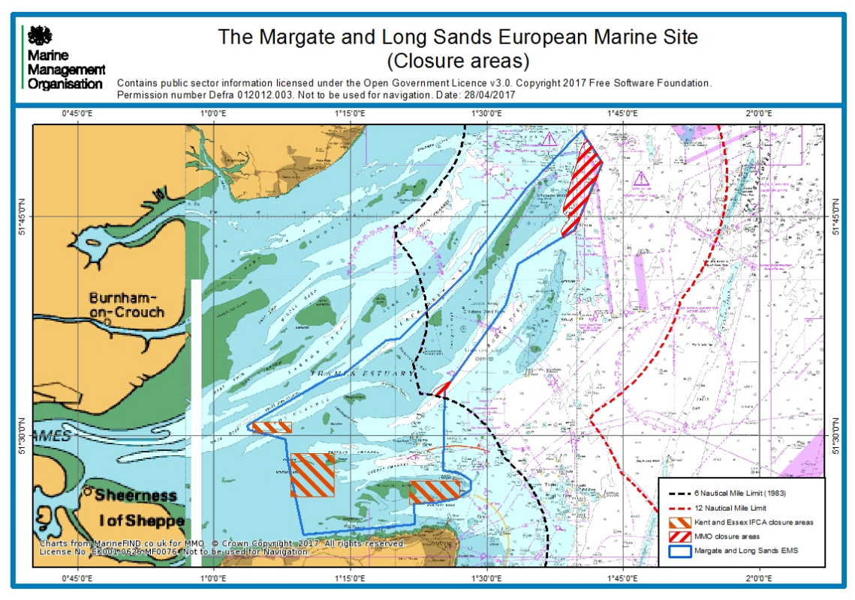

**Survey area**

Margate and Longs Sands SAC complements the UK’s suite of International and SSSI sites and overall MPA network.

The sub features of the ‘Sandbanks which are slightly covered by sea water all the time’ are:

* Subtidal coarse sediments
* Subtidal mixed sediments
* Subtidal sand

There are also other features of conservation interest within the SAC, such as ross worm (*Sabellaria spinulosa*) reefs and various associated communities that are reliant on the above subfeatures. The extent of Margate and Long Sands SAC and previously mapped features and biotopes are shown in Figure 2 and 3 below.

**Figure 2: Margate and Long Sands SAC Feature Map**

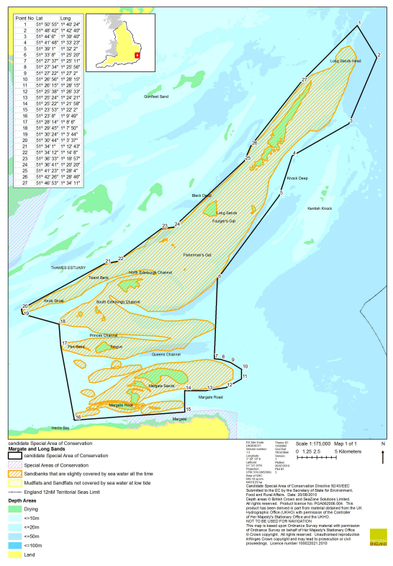

**Figure 3 shows the biotope classification within Margate and Long Sands SAC**

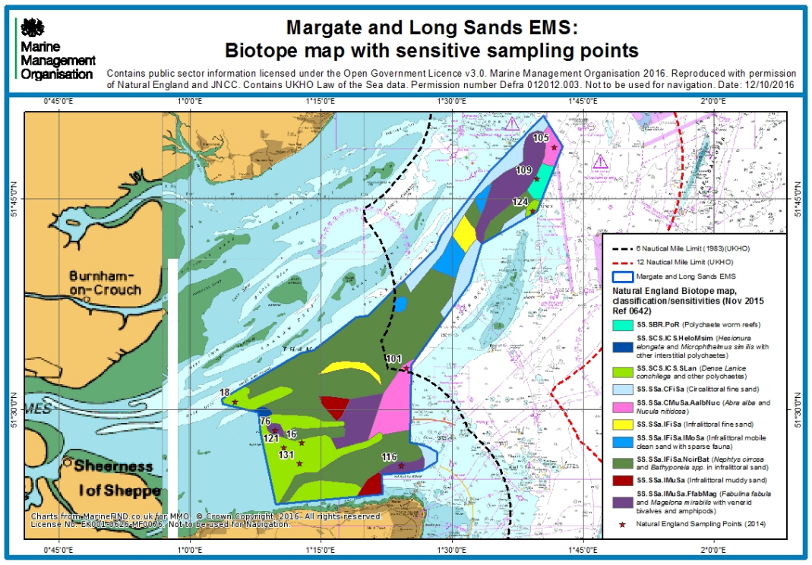

Full site details are available on the NE designated sites webpage so please see [Margate and Long Sands cSAC - UK0030371A (naturalengland.org.uk)](http://publications.naturalengland.org.uk/publication/3251957) ([[[Marine site detail (naturalengland.org.uk)](https://designatedsites.naturalengland.org.uk/Marine/MarineSiteDetail.aspx?SiteCode=UK0030371&SiteName=Margate+and+Long+Sands&SiteNameDisplay=Margate+and+Long+Sands+SAC&countyCode=&responsiblePerson=&SeaArea=&IFCAArea=&NumMarineSeasonality=&HasCA=1#sitemaps)](https://designatedsites.naturalengland.org.uk/Marine/MarineSiteDetail.aspx?SiteCode=UK0030371&SiteName=Margate+and+Long+Sands&SiteNameDisplay=Margate+and+Long+Sands+SAC&countyCode=&responsiblePerson=&SeaArea=&IFCAArea=&NumMarineSeasonality=&HasCA=1#sitemaps)](https://designatedsites.naturalengland.org.uk/Marine/MarineSiteDetail.aspx?SiteCode=UK0030371&SiteName=Margate+and+Long+Sands&SiteNameDisplay=Margate+and+Long+Sands+SAC&countyCode=&responsiblePerson=&SeaArea=&IFCAArea=&NumMarineSeasonality=&HasCA=1#sitemaps))

**Previous surveys**

Previous surveys undertaken within Margate and Long Sands SAC include:

* 1995 Mapping the distribution of benthic biotopes around the Thanet coast EC Life Project for English Nature (was M_00308 M_00059)
* 1995 MNCR Thanet sublittoral survey
* 1998 CEFAS Habitat Data
* 2002 London Gateway Benthic Monitoring Survey - (was M_00025)
* 2003 London Gateway Benthic Monitoring Survey - (was M_00025)
* 2005 London Gateway Benthic Monitoring Survey - (was M_00025)
* 2006 London Gateway Benthic Monitoring Survey - (was M_00025)
* 2007 London Gateway Benthic Monitoring Survey - (was M_00025)
* 2002 Thames gateway intertidal biology of Lower Thames - (was M_00025)
* 2004 Thames Array benthic grab survey (was M_00025)
* 2005 Outer Thames Estuary Sandbank Study
* 2007 Kentish flats data (was M_00025)
* 2008 Kent Seasearch Sublittoral Survey
* 2008 The Outer Thames Estuary Regional environmental characterisation (was M_00025)
* 2009 Outer Thames Estuary Regional Environmental Characterisation datasets
* 2014 Natural England Grab Sampling of Margate and Long Sands SAC
* 2014 RP1521 Margate & Long Sands SAC baseline survey of subtidal sandbanks IECS

A package from the Marine Evidence database can also be provided upon request to the successful contractor. Figure 2 and 3 shows existing mapped locations of subtidal features within the SAC.

Please note that, where possible, these datasets should be incorporated into the report provided for this project, however the methodology should not necessarily be followed, and the contractor is invited to suggest a survey plan.

The outputs of this survey may be used by NE for a number of different purposes, including Condition Assessment, the formulation of Conservation Advice and to improve our understanding of Ecosystem Assets pursuant to the Natural Capital approach. Therefore, ideally datasets must be comparable with historic data and methodologies to enable analyses, however different and novel approaches will be considered where a rationale is provided.

**Payment**

The Authority will raise purchase orders to cover the cost of the services and will issue to the awarded supplier following contract award.

The Authority’s preference is for all invoices to be sent electronically, quoting a valid Purchase Order number. Invoices can be submitted after project milestones with a final payments made once the work has been completed.

It is anticipated that this contract will be awarded for a period of **two years** to end no later than **August 2026**. Prices will remain fixed for the duration of the contract award period. We may at our sole discretion extend this contract to include related or further work. Any extension shall be agreed in writing in advance of any work commencing and may be subject to further competition.

**Evaluation Methodology**

A sampling design needs to be developed for this work. This should seek to build on any previous work listed and, where possible, enable temporal comparisons to be made with previous datasets.

In developing an appropriate sampling strategy contractors should not be bound to simply repeat the previous methodology undertaken; rather they should seek to implement an improved approach which enables a comparison with existing data but at the same time delivers Natural England’s requirements for a more statistically robust approach outlined above.

**Aims & Objectives**

**Aims**

The aims of this project in terms of priority are to:

1. Undertake a swathe bathymetric survey in the Margate and Long Sands SAC to help with identification of the extent and distribution of the designated features and sub features to enhance our understanding of the site.
2. Gather environmental data of the biological communities, sediment and species composition of the SAC sub features, using camera and grab surveys, to increase understanding of the quality of subtidal features.
3. Design a water sampling strategy to gather water quality data across the site, including dissolved oxygens, nutrients and turbidity.

**Methodologies to achieve each of the above aims should be outlined and priced *separately*:**

**i.e for:**

* **swathe bathymetric surveys**
* **camera surveys**
* **grab sampling, and**
* **water quality sampling.**

**We ask that costs for video analysis and sample analysis are also provided individually.**

**Natural England will consider quotations which can achieve all or individual aims of this project.**

**Please note we will also consider submissions where the site is split geographically into survey sections and welcome separate quotations accordingly. This can include sections surveyed individually e.g. the IFCA and MMO byelaw areas only.**

The information gathered must be of sufficient quality to provide a comparison with previous surveys (where possible) relating to subtidal habitats according to methodologies outlined in JNCC common standards guidance (JNCC, 2004).

In brief, Natural England are seeking potential contractors to pay particular attention to survey design so that quantitatively robust data is acquired which will permit rigorous statistical analysis and support robust condition assessment judgments.

**Objectives**

The specific objectives of this contract are to:

* In collaboration with Natural England, plan, undertake and report on subtidal benthic survey techniques to inform the condition of habitats within the Margate and Long Sands SAC.
* Undertake a cost-effective sampling strategy to gather up to date information on the benthic features and water quality of the site. The strategy should aim to cover the total seabed coverage of the site (potentially divided into sections individually costed) with inclusion of the closed bye-law areas highlighted in figure 1).

Overall outputs of the combined approach:

* Deliver a survey plan for the project using a desk-based exercise which identifies what work has already been conducted within the site.
* Identify and map the extent and approximate boundaries of subtidal benthic habitats across the full extent of the site.
* Using previous survey reports and the survey information gathered, provide a descriptive report of the site.
* Report on the quality of the benthic habitats within the site, including where cable installation activities have taken place.

Under this specification contractors must:

1. Develop, agree and implement, in collaboration with Natural England, a survey plan to collect data suitable for undertaking further camera assessment of the direction of change in seabed condition.
2. In agreement with Natural England, implement a statistically robust survey design to enable future collection of compatible data, permitting quantitative long-term analysis. This should seek to build on any previous work listed (please refer to section 1.2) and, where possible, enable temporal comparisons to be made with previous datasets. The overall objective is to provide an ecosystem asset map comprising the location and quality of subtidal habitats.
3. Provide fully detailed “standard operating protocols” for the work undertaken to ensure that methods can be repeated in the future.
4. Produce a concise, evidence-based technical report detailing the work undertaken, reporting the survey and analytical findings, discussing these in the light of any previous data.
5. Provide all data to the relevant standards set out in section 4.1.

**Pre-survey deskwork**

Before the survey is carried out the contractor will discuss any pre-survey work with the Nominated Officer, including:

1. Clarification of roles, responsibilities, and expectations
2. Acquisition and checking of sources of relevant information and gathering of local advice in preparation of a project plan
3. Review existing information provided by Natural England or any datasets known to the contractor.
4. Ways of working and close collaboration with Natural England in developing the project plan, particularly taking account of previous work, and finalising survey design and methodologies.
5. Ensure that up to date charts are used to position sample sites away from cables, pipelines, or any other coastal infrastructure. Should any coastal infrastructure exist within an area to be sampled then a buffer should be used to ensure that sampling activity does not cause damage, and this should be clearly displayed within the survey plan. Should coastal infrastructure be found during fieldwork then any sample sites should be relocated, and the Nominated Officer informed
6. Consider weather constraints and ensure there is expected to be a suitable weather window for data gathering to sufficient standards as required by the project.

**Provide detailed description of proposed survey methodology:**

NE will discuss the survey plan with the contractor to meet the survey aims and objectives stated above.

NE are interested in the presence and quality of the features across the whole site, including the presence and distribution of *Sabellaria spinulosa* reef.

We would expect the survey to be:

* Geographically spread throughout the site
* Representative of the range of sediments of interest
* Proportionate in their split to the overall coverage of the sediment of interest

Estimated timescales for the surveys and analysis should be stated where possible, with an estimate of what, if any, work is able to be completed by August 2026. However, potential contractors should provide contingency dates should the planned survey be affected e.g. by weather downtime.

Surveys will be carried out in accordance with the technical specification provided above. Alternative approaches will be considered if they meet the aims and objectives of the contract, demonstrate efficiencies, and are agreed with Natural England prior to survey commencing.

### Weather downtime & contingency

Survey windows should be allocated in accordance with the best tides available. Contractors will be expected to check weather regularly (daily) prior to agreed survey windows.  If contractors have 48 hours' notice of impending poor weather, then they will be expected to make alternative arrangements for the duration of the poor weather and reschedule survey work to be completed at a later date.  If contractors have not yet mobilised, then Natural England does not expect to be charged for any weather downtime.  It is the responsibility of the contractor to contact Natural England in the event that impending poor weather is putting the survey at risk.

In the event of uncertainty or other unforeseen events that impact upon the ability of the contractor to undertake the survey, the Natural England Nominated Officer should be contacted immediately.

**Reporting and analysis**

Draft reports should be provided in electronic MS Office Word *.DOCX format for comment. A template and guidance exist for writing Natural England commissioned reports and will be sent to the contractor upon award of the tender. All reports should retain a clear suggested citation stating that it is a ‘Report to Natural England’.

Data must be interpreted, analysed and presented in light of the overarching hypotheses stated above. Contractors should pay particular consideration to the data and GIS required formats for information compatibility (including MEDIN metadata standards and Marine Recorder provision if applicable).

All interpreted products following data analysis should accompany the draft report; these will include:

* All GIS datasets need to be provided in ESRI ArcGIS format compatible with ArcGIS 10.2 and have attached metadata.
* The GUI provided by Natural England for each survey will be used, and as much information as possible (e.g. survey name, originally assigned feature/habitat name etc.) from the original dataset, as well as any documentation provided (where available) should be included in the resulting datasets to maintain a useful audit trail. As specified in the [MESH DEF](http://www.emodnet-seabedhabitats.eu/default.aspx?page=2067), data files must be provided as ESRI Shapefiles or as a feature class data within a geodatabase using the WGS1984 geographic coordinate system and (lat/long coordinates. If not included in the GIS data layers listed above all sampling locations, vessels tracks, and links to data obtained should also be included as a single GI layer.
* Copies of the original data spreadsheets or databases are to be provided in the appropriate Microsoft Office format
* Stills photographs (if taken) to be provided in their raw format on CD/DVD or USB compliant external hard drives.

All sample data (e.g. grab sample analyses, video/still photography analyses, PSA analysis and biotope lists, biological taxon data), if taken, need to be entered into [Marine Recorder](https://www.esdm.co.uk/marine-recorder) NBN data and an exported snapshot file of the data should be provided for QA. Natural England will provide licence keys for Marine Recorder. Natural England will supply a ‘Marine Recorder guidance for contractors’ document to successful contractors.

The contractor must report any records of Invasive and Non-Native Species observed on site on Marine Recorder and to the Natural England project officer as part of the survey report. Any species currently listed as ‘alert’ species should be flagged immediately to the GB Non-Native Species Secretariat [Species alerts](http://www.nonnativespecies.org/alerts/index.cfm). More information and guidance including ID guides can be found at [GB non-native species secretariat](http://www.nonnativespecies.org/).

Copies of the original data spreadsheets or databases are to be provided in the appropriate Microsoft Office format.

All data products and electronic files must be appropriately named so they sufficiently describe the contents and are not purely a numerical value. All products should be named appropriately so that they can be clearly linked to the report/project.

Any species lists submitted will be compliant with current taxonomic names and synonyms (e.g. [Marine Species of the British Isles and Adjacent Seas (MSBIAS)](http://www.marinespecies.org/msbias/), World Register of Marine Species (WoRMS))

Video and still camera filenames must include the recording start date and time. Position data must be included within the overlay information.

We will raise purchase orders to cover the cost of the services and will issue to the awarded supplier following contract award. Upon completion of the Lot, the first payment will be made, and the final payment on completion of deliverables.

We will award this contract in line with the most economically advantageous tender (MEAT) as set out in the following award criteria:

Technical – **60**%

Commercial – **40**%

Evaluation criteria

Evaluation weightings are **60**% technical and 4**0**% commercial, the winning tenderer will be the highest scoring combined score.

|  |  |  |  |  |
| --- | --- | --- | --- | --- |
| Award Criteria | Weighting (%) | Evaluation Topic & Weighting | Sub-Criteria | Weighted Question |
| **Technical** | **60%** | **Service / Product Proposal** | **Methodology** | **2 Questions**  **Q1.1 (30% of technical score available)**  **Q1.2 (10% of technical score available)** |
| **Key personnel** | **1 Question**  **Q2 (10% of technical score available)** |
| **Quality Assurance measures** | **1 Question**  **Q3.1 (10% of technical score available)** |
| **Commercial** | **40%** | **Whole life cost of the proposed Contract** | **Commercial Model** | **1 Question**  **Q4 (40% of commercial score available)** |

**Technical (**60**%)**

Technical evaluations will be based on responses to specific questions covering key criteria which are outlined below. Scores for questions will be based on the following:

|  |  |  |
| --- | --- | --- |
| Description | Score | Definition |
| Very good | 100 | Addresses all the Authority’s requirements with all the relevant supporting information set out in the RFQ. There are no weaknesses and therefore the tender response gives the Authority complete confidence that all the requirements will be met to a high standard. |
| Good | 70 | Addresses all the Authority’s requirements with all the relevant supporting information set out in the RFQ. The response contains minor weaknesses and therefore the tender response gives the Authority confidence that all the requirements will be met to a good standard. |
| Moderate | 50 | Addresses most of the requirements with most of the relevant supporting information set out in the RFQ. The response contains moderate weaknesses and therefore the tender response gives the Authority confidence that most of the requirements will be met to a suitable standard. |
| Weak | 20 | Substantially addresses the requirements but not all and provides supporting information that is of limited or no relevance or a methodology containing significant weaknesses and therefore raises concerns for the Authority that the requirements may not all be met. |
| Unacceptable | 0 | No response or provides a response that gives the Authority no confidence that the requirement will be met. |

Technical evaluation is assessed using the evaluation topics and sub-criteria stated in the Evaluation Criteria section above.

Separate submissions for each technical question should be provided and will be evaluated in isolation. Tenderers should provide answers that meet the criteria of each technical question.

|  |  |
| --- | --- |
| **Methodology** | Detailed Evaluation Criteria |
| **Q1.1 Provide details of the methodology and approaches proposed to deliver the requirements of this project.**  **Responses should not exceed four sides of A4, and use Arial font, size 11.** | **Your response should:**  **1) Demonstrate a clear understanding of the nature of the requirements.**  **2) Be a clear, practical, achievable, and cost-effective methodology to deliver these requirements.**  **3) Have information in sufficient detail to allow a full appraisal of the suitability of the approach to deliver for the project.** |
| **Q1.2 Please supply a proposed schedule of work, stating the timescales you will be able to execute and deliver the product specified above.** | **Your response should:**   1. State what you are able to deliver from the Aims and Objectives of this document. 2. State the timescales that you would be able to work within for each deliverable. This can be displayed using a GANTT chart or similar |

|  |  |
| --- | --- |
| **Key Personnel** | Detailed Evaluation Criteria |
| **Q2.1 Demonstrate the appropriate skills for subtidal survey and/or analysis work** | **Your response should:**   1. Clearly specify the number and skillset of staff proposed to be involved in the project. 2. What experience do staff have to effectively deliver the project’s objectives |

|  |  |
| --- | --- |
| **Quality Assurance** | Detailed Evaluation Criteria |
| **Q3.1 Provide details of the Quality Assurance methods you will undertake for the survey methodology, data analysis and reporting** | **Your response should:**   1. State the steps you will use to ensure that the project has a robust level of quality assurance |

|  |  |
| --- | --- |
| **Commercial** | Detailed Evaluation Criteria |
| **Q4.1 Provide an estimated cost of the project deliverables** | **Your response should:**   1. Specify which outputs of the project you are able to deliver, referring to the Aims & Objectives section in this document. 2. Break down the project deliverables into separate costs |

**Commercial (**40**%)**

The Contract is to be awarded as a **schedule of rates** which will be paid according to the completion of the deliverables stated in the Specification of Requirements.

Suppliers are required to submit a total cost to provide the deliverables stated in the Specification of Requirements. In addition to this the Commercial Response template must be completed to provide a breakdown of the whole life costs against **each deliverable or objective** used in the delivery of this requirement.

Calculation Method

The method for calculating the weighted scores is as follows:

Commercial

Score = (Lowest Quotation Price / Supplier’s Quotation Price ) x **[40%]**  (Maximum available marks)

Technical

Score = (Bidder’s Total Technical Score / Highest Technical Score) x **[60%]**  (Maximum available marks)

The total score (weighted) (TWS) is then calculated by adding the total weighted commercial score (WC) to the total weighted technical score (WT): WC + WT = TWS.

**Information to be returned**

Please note, the following information requested must be provided. Incomplete tender submissions may be discounted.

Please complete and return the following information:

completed Commercial Response template

separate response submission for each technical question (in accordance with the response instructions)

completed Mandatory Requirements (Annex 1)

completed Acceptance of Terms and Conditions (Annex 2)

**Award**

Once the evaluation of the Response(s) is complete all suppliers will be notified of the outcome via email.

**The successful supplier will be issued the contract, incorporating their Response, for signature. The Authority will then counter sign.**

**Annex 1 Mandatory Requirements**

**Part 1 Potential Supplier Information**

Please answer the following self-declaration questions in full and include this Annex in your quotation response.

**Part 1.1 Potential Supplier Information:**

|  |  |  |
| --- | --- | --- |
| Question no. | Question | Response |
| 1.1(a) | Full name of the potential supplier submitting the information |  |
| 1.1(b) | Registered office address (if applicable) |  |
| 1.1(c) | Company registration number (if applicable) |  |
| 1.1(d) | Charity registration number (if applicable) |  |
| 1.1(e) | Head office DUNS number (if applicable) |  |
| 1.1(f) | Registered VAT number |  |
| 1.1(g) | Are you a Small, Medium or Micro Enterprise (SME)? | (Yes / No) |

Note: See EU definition of SME <https://ec.europa.eu/growth/smes/business-friendly-environment/sme-definition_en>

**Part 1.2 Contact details and declaration**

By submitting a quotation to this RFQ I declare that to the best of my knowledge the answers submitted and information contained in this document are correct and accurate.

I declare that, upon request and without delay you will provide the certificates or documentary evidence referred to in this document.

I understand that the information will be used in the selection process to assess my organisation’s suitability to be invited to participate further in this procurement.

I understand that the authority may reject this submission in its entirety if there is a failure to answer all the relevant questions fully, or if false/misleading information or content is provided in any section.

I am aware of the consequences of serious misrepresentation.

|  |  |  |
| --- | --- | --- |
| Question no. | Question | Response |
| 1.2(a) | Contact name |  |
| 1.2(b) | Name of organisation |  |
| 1.2(c) | Role in organisation |  |
| 1.2(d) | Phone number |  |
| 1.2(e) | E-mail address |  |
| 1.2(f) | Postal address |  |
| 1.2(g) | Signature (electronic is acceptable) |  |
| 1.2(h) | Date |  |

**Part 2 Exclusion Grounds**

**Part 2.1 Grounds for mandatory exclusion**

|  |  |  |
| --- | --- | --- |
| Question no. | Question | Response |
| 2.1(a) | Please indicate if, within the past five years you, your organisation or any other person who has powers of representation, decision or control in the organisation been convicted anywhere in the world of any of the offences within the summary below. | |
|  | Participation in a criminal organisation. | (Yes / No)  If yes please provide details at 2.1 (b) |
|  | Corruption. | ((Yes / No)  If yes please provide details at 2.1 (b) |
|  | Fraud. | (Yes / No)  If yes please provide details at 2.1 (b) |
|  | Terrorist offences or offences linked to terrorist activities | (Yes / No)  If yes please provide details at 2.1 (b) |
|  | Money laundering or terrorist financing | (Yes / No)  If yes please provide details at 2.1 (b) |
|  | Child labour and other forms of trafficking in human beings | (Yes / No)  If yes please provide details at 2.1 (b) |
| 2.1(b) | If you have answered yes to question 2.1(a), please provide further details.  Date of conviction, specify which of the grounds listed the conviction was for, and the reasons for conviction.  Identity of who has been convicted  If the relevant documentation is available electronically please provide the web address, issuing authority, precise reference of the documents. |  |
| 2.1 (c) | If you have answered Yes to any of the points above have measures been taken to demonstrate the reliability of the organisation despite the existence of a relevant ground for exclusion? (i.e. Self-Cleaning) | (Yes / No) |
| 2.1(d) | Has it been established, for your organisation by a judicial or administrative decision having final and binding effect in accordance with the legal provisions of any part of the United Kingdom or the legal provisions of the country in which the organisation is established (if outside the UK), that the organisation is in breach of obligations related to the payment of tax or social security contributions? | (Yes / No) |
| 2.1(e) | If you have answered yes to question 2.3(a), please provide further details. Please also confirm you have paid or have entered into a binding arrangement with a view to paying, the outstanding sum including where applicable any accrued interest and/or fines. |  |

**Part 2.2 Grounds for discretionary exclusion**

|  |  |  |
| --- | --- | --- |
| Question no. | Question | Response |
| 2.2(a) | The detailed grounds for discretionary exclusion of an organisation are set out on this [webpage](https://www.gov.uk/government/uploads/system/uploads/attachment_data/file/551130/List_of_Mandatory_and_Discretionary_Exclusions.pdf), which should be referred to before completing these questions.  Please indicate if, within the past three years, anywhere in the world any of the following situations have applied to you, your organisation or any other person who has powers of representation, decision or control in the organisation | |
| 2.2(b) | Breach of environmental obligations? | (Yes / No)  If yes please provide details at 2.2 (f) |
| 2.2(c) | Breach of social obligations? | (Yes / No)  If yes please provide details at 2.2 (f) |
| 2.2(d) | Breach of labour law obligations? | (Yes / No)  If yes please provide details at 2.2 (f) |
| 2.2(e) | Shown significant or persistent deficiencies in the performance of a substantive requirement under a prior public contract, a prior contract with a contracting entity, or a prior concession contract, which led to early termination of that prior contract, damages or other comparable sanctions? | (Yes / No)  If yes please provide details at 2.2 (f) |
| 2.2 (f) | If you have answered Yes to any of the above, explain what measures been taken to demonstrate the reliability of the organisation despite the existence of a relevant ground for exclusion? (Self Cleaning) |  |

**Annex 2 Acceptance of Terms and Conditions**

I/We accept in full the terms and conditions appended to this Request for Quote document.

Company ____________________________________________________

Signature ____________________________________________________

Print Name ____________________________________________________

Position ____________________________________________________

Date ____________________________________________________