

ICT
CANDIDATE INFORMATION
PACK

Message from Michael Brodie,
Executive Director, Finance & Commercial



Dear Prospective candidate,

I just wanted to say welcome and thank you for showing interest in our job opportunities here at Public Health England and in particular to the Finance and Commercial Directorate. I hope you will find this recruitment information pack of interest and that it encourages you to apply.

There’s always a lot to learn about a potential new job, not only about the role, but also about the organisation, its culture and ways of working. Our values are important to us. We aim to be a Directorate of talented, curious and smart people, who roll their sleeves up, work hard and follow through on what we promise to deliver.

We speak well of each other, even when times are hard, and we support each other to provide the best possible service to our customers and value to the taxpayer, we recognise each other’s differences and value the range of skills and experiences we can all bring to bear. None of us are as talented as all of us.

Effective ICT at PHE is key to the achievement of our objectives and fundamental to our success. We are on course to build a first-class technical capability, one that will enable us to ensure value for money for the taxpayer and great public health outcomes, whether that is in the provision of cutting edge High Performance Computing services, collaboration tools and flexible ways of working, consistent networking facilities or proactive data security.

I hope you want to find out more about how you could contribute to this next stage of PHE’s ICT transformation and that the information in this pack helps you make that decision - good luck with your application. If you would like to discuss any of the roles that we are recruiting to, do please contact XXXX XXXX on 020 XXXXXXXX. All conversation will be treated in complete confidence.

Michael Brodie
Executive Director
Finance & Commercial

Introduction to Public Health England

Public Health England (PHE) is an executive agency of the Department of Health and is a distinct delivery organisation with operational autonomy to advise and support central government, local authorities and the NHS in a professionally independent manner.
PHE was established in April 2013 and brought together over 100 separate organisations into one public health body. Its ambition is to lead nationaly, and enable locally, a transformation in the health expectations of all people in England, regardless of where they live and the circumstance of their birth. It will achieve this through the application of research, knowledge and skill.
PHE exists to protect and improve the public’s health and reduce health inequalities. We do this through advocacy, partnerships, world-class science, knowledge and intellingence, and the delivery of specialist public health services.
We have four core functions:
- Protecting the public’s health from infectious diseases and other hazards
- Improving the public’s health and wellbeing and reducing health inequalities
- Improving population health through sustainable health and care services
- Building the capability and capacity of the public health system
We have attached three infographics which give you some sense of the breadth and scale of what we do at PHE. More information is available at our web site at www.gov.uk/phe

Locations of Public Health England:
PHE operates from 54 sites across the country. Our headquarters are at Wellington House, Waterloo - Central London, we also have large sites at Porton near Salisbury, Chilton near Didcot in Oxfordshire and Colindale in North London

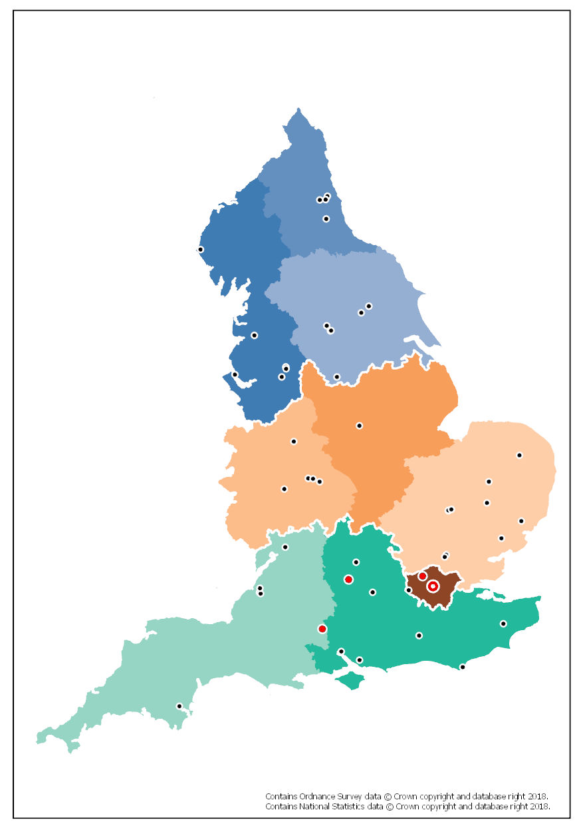

PHE Staff numbers, budgets & the services we provide:

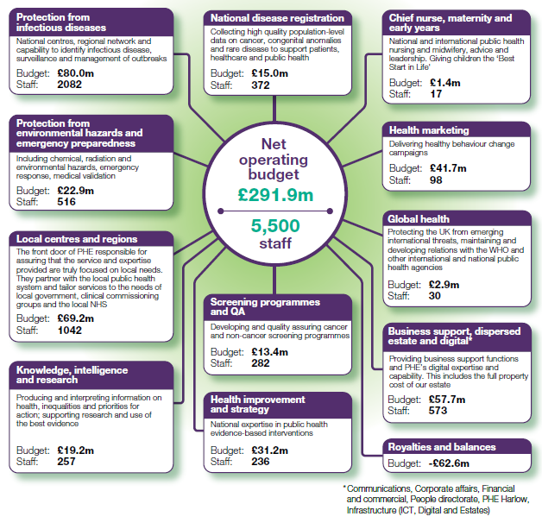

Introduction to the Finance and Commercial Directorate

The Finance and Commercial Directorate (FCD) has a fundamental role to play in the success of PHE, we provide a comprehensive portfolio of services which underpin all that PHE does:

● Our ICT Team manages our technical infrastructure and provides the technical foundations upon which our great science and information products are delivered.

● Our Digital Team manages our website, intranet and develops our other digital products.

● Our Procurement team ensures that we achieve taxpayer value when sourcing goods and services, maximising the resources available for front line public health.

● Our Estates and Facilities team maximises the efficient use of our properties by ensuring we operate from the right buildings in the right place to support the operational delivery of our services.

● Our Finance teams provide the strategic management and reporting that support business decision making and accountability. Our financial systems deliver the efficient transactional services that keeps PHE’s day to day financial operations running.

● Finally, our Business Development function works to maximise the resources available to PHE through the generation of external income and the management of our external customer base.

Our vision for the Finance and Commercial Directorate is:

“To provide great services which deliver value for money and help Public Health England achieve its mission to protect and improve the nation’s health and wellbeing and reduce health inequalities”.

Our vision is underpinned by the culture, values and behaviors which we share across PHE. We will:

▪ consistently spend our time on what we say we care about

▪ work together, not undermine each other

▪ speak well of each other, in public and in private

▪ behave well, especially when things go wrong

▪ keep our promises, small and large

▪ speak with candour and courage

Ensuring that we live these behaviors as part of our day to day business, and supporting a ‘One Team, One PHE’ approach is crucial to our success in delivering our business plan and transformation strategy.

ICT at PHE

Message from Sam Lloyd, Deputy Director - Technology

Welcome to our candidate information pack, I hope it gives you a good sense of our organisation, the Finance and Commercial Directorate and the ICT team.

PHE is a diverse and dynamic organisation and the service provided by ICT is critical to our success. Fully resourced, ICT will have 104 staff spread across PHE’s main and regional offices. We provide many technologies and services ranging from laptops, email and collaboration tools, cyber security and network infrastructure to high-performance computing; including petabytes of storage and a significant internal cloud infrastructure.

We are currently looking to fill a number of roles across the department to help us reach full capacity and push forward with out current projects and strategic aims. I hope the information in this pack will inspire you to express an interest in the roles and consider joining the team here at PHE.

ICT Strategy and Projects

Our current goals for this year are set out below:

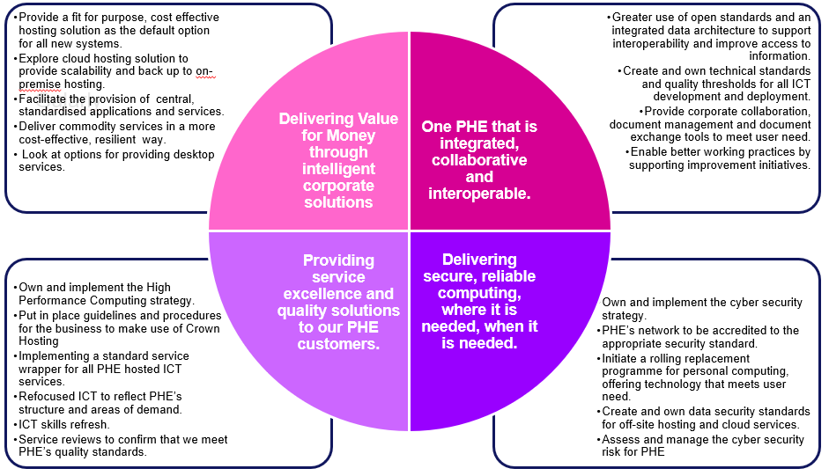

Key projects that we are currently working on include:

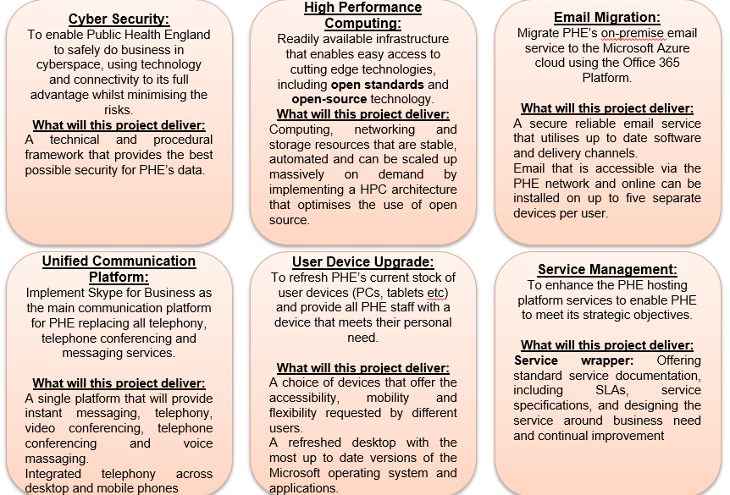

ICT Structure

The diagram below shows how the team is organised. We are looking to recruit within all areas and at all levels. We are a very flexible and diverse team and while these roles are advertised as full-time positions we would consider applications for condensed or reduced hours or other flexible arrangements.

PHE Staff Benefits

In addition to the satisfaction of knowing that you are working in an organisation that directly works to improve the health of the nation, you will receive a good annual leave entitlement and an excellent a civil service pension scheme. PHE is a family-friendly employer that promotes flexible working,

Further benefits include:
- Interest free season ticket loans
- Cycle to work scheme
- Childcare vouchers
- Mentoring Scheme
- Apprentiships up to Postgraduate level
- Civil Service Sport Council (CSSC)
- Health & Social Security Recreational Association (HASSRA)
- Civil Service Motoring Association (CSMA)

TRAINING AND DEVELOPMENT OPPORTUNITIES

As an employee of PHE, there are many learning and development opportunities available. These can be accessed through a variety of mediums and avenues including the Civil Service Learning (CSL) portal. Some training is designed for particular professions or for people at certain stages in their career, other courses are available to everyone.

Learning and professional development opportunities include:
- mandatory training
- induction training
- leadership programmes
- specialist learning opportunities
- Funded apprenticeships
- mentoring
We ensure fair and equitable access for all in line with our commitment to equality and diversity.

Civil Service Learning

The Civil Service Learning portal is available for you to access training for:
- core skills
- leadership and management
- working in the Civil Service

5 days learning
The Civil Service encourages all staff to engage in five days learning a year as part of the Civil Service Reform plan. This may include secondments, team working, stretch projects, conferences, deputising for managers, e-Learning and/or classroom-based learning.

ICT has a strong focus on learning and staff are encouraged to undertake training to update their own technical skills as well as develop their soft skills and encourage personal development.

Don't hold back your career; take your five a year!

