Terms of Reference

**Name of Project:**

**The Lever Report: Actions for Food service businesses and their clients to achieve Eating for Net Zero**

**Name of Programme Team: Advocacy & Campaigns-Food Transformation**

Background: 1

Project Aims: 2

Objectives and methodology: 2

Output and Deliverables: 2

Project Timeline: 3

Budget: 4

Roles and responsibilities: 4

Submission of Proposal: 4

Appendices 5

Background:

WWF is one of the world’s largest independent conservation organisations, active in nearly 100 countries, working to restore nature and to tackle the main causes of nature’s decline, particularly the food system and climate change.

WWF and Sodexo have been in a strategic partnership on the environmental impact of the Food Service industry since 2010, with a focus on sustainable diets over the last six years. This has led to support on the development of Sodexo’s sustainable eating strategy, sustainable eating campaigns (Finer Diner), plant-based alternatives report, [Food service sustainability report](http://assets.wwf.org.uk/downloads/wwf_catering_full_report.pdf?_ga=2.260765005.179122158.1561971478-1152898316.1561547209), alongside engaging in several advocacy pieces.

Sodexo UK&I recently announced a comprehensive roadmap to net zero and decarbonisation of their business in the United Kingdom and Ireland, with targets such as increasing the number of plant-based meals and recipes to 33% by 2025.   
Since then, Sodexo Group are developing their Net Zero strategy. In setting this strategy, Sodexo Group has also developed, tested, and are now scaling a [carbon trajectory tool](https://en.traace.co/case-studies/sodexo-reach-sbt-target-employee-engagement). This will act as a user guide to assist countries and segments to define their carbon reduction programme. However, further fixed actions, targets, and KPIs are still needed for the food element of the net zero strategy. The range of actions (levers) that are available to pull upon to achieve carbon reduction goals and helping to bend the curve on nature loss will require action not only from individual companies but wider multi-stakeholder collaboration between industry, government and third sector organisations.

Within Sodexo’s sustainable actions, there is a need to work closely with clients in different segments to ensure that there is an alignment in commitment and actions towards goals, so that impact is translated at the till-level (See Fig 1.). There are barriers and actions needed for this require exploration and identification.

**Figure 1: Levels of stakeholders involved in the delivery of Food Service. The outputs of this ‘Lever Report’ aim to identify the actions to support Food Service strategy and Food Service clients to deliver sustainable food choices to customers**

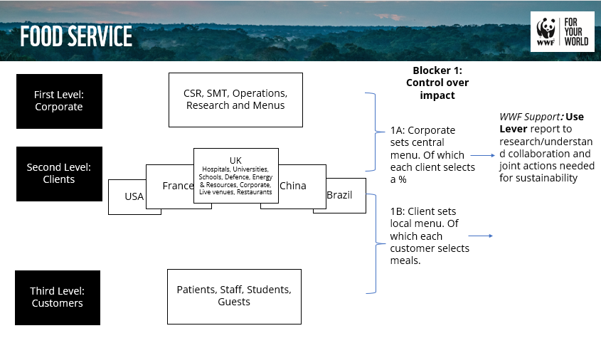

# Project Aims:

The primary aim of this project is to develop a report on the key collaborative actions (levers) that food service businesses (such as Sodexo) can take alongside their client segments (institutions of universities/hospitals, businesses in private and public sector) to support sustainable diet offers, across all areas of food but with a focus on a shift to more plant protein sales. This must be aligned with net zero trajectory and should cover Sodexo’s main global markets of UK, France, USA, and if within scope, also cover China and Brazil.

The report must primarily (1) be practicable and useful for food service and their clients, considering dynamics of this relationship, the barriers of each party and laying out actions to take (or levers to pull on) to support them.

In addition, the report will be used to create an (2) external facing client engagement tool, to be used by Sodexo staff as a blueprint for how to work with clients to engage and gain commitments on sustainable diets. This would ideally also act as an advocacy piece and encourage wide change across the food sector. Therefore, all work within (1) should bear this usage in mind.

# Objectives and methodology:

Development of the report should draw upon existing peer-reviewed, grey literature and should sit within planetary boundaries. This will ensure alignment with other work. A starting point of this work should be [WWF’s Planet-Based Diets](https://planetbaseddiets.panda.org/). This work covers a ‘scientific assessment of how dietary shifts in 147 countries can bend the curve on the negative impacts of the food system’, and therefore can act as a starting point to identify the specific actions that sit within food service and their clients.

In addition, this work should be based on and include the c[arbon trajectory tool by Sodexo](https://en.traace.co/case-studies/sodexo-reach-sbt-target-employee-engagement), used to identify measurable steps to achieve near and long-term science-based targets within food service. As well as [Sodexo’s Sustainable Eating Strategy](https://www.sodexo.com/home/corporate-responsibility/sustainability/sustainable-eating.html).

Other reports that could support research listed in Appendix I.

WWF welcomes suppliers to propose their own additional approach and methodology to achieve the aims and outputs, for example industry and client interviews.

# Output and Deliverables:

1. **Food service-facing report** on the key levers (actions) that food service businesses and their clients can undertake to improve the sustainable diet offer to customers, and business, and any other parties they would need to collaborate with to deliver these actions. To detail:
   1. WHAT levers are available for food service and their clients to work on? How do these actions interact or overlap to strengthen sustainability. Consider Sodexo’s Trajectory tool and Sustainable eating strategy:
      1. Joint commitments to meat:plant protein volume sales
      2. Data capture and reporting
      3. Suggested changes to canteen layout e.g. Default plant options, communications
      4. Suggested behaviours within stakeholders that need nudging and how
   2. HOW would the proposed lever(s) be implemented? (e.g. through collaboration with local authorities, universities and other organisations, and non-traditional partnership etc.)
   3. WHAT challenges or blockers could hinder implementation of proposed lever(s)? Consider:
      1. cultural diversity
      2. policy change implications
      3. supportive civil action needed
   4. WHO would be responsible for implementing proposed lever(s)?
   5. WHEN should the proposed lever(s) be implemented (timescales)?
   6. HOW impactful are the different levers on sustainability. Consider Sodexo’s Trajectory tool:
      1. Shift in meat: plant protein volume sales
      2. reduction in greenhouse gas emissions
      3. impact on wider environmental measures (water, land use, biodiversity, animal welfare)
      4. How does impact increase or decrease with overlap of levers.
   7. HOW can impact be monitored?
   8. WHAT are the additional benefits of any recommended levers e.g. improved cost / efficiencies / aligning with future market trends?
   9. WHAT are some best practice case studies on these levers?

See Appendix II for suggestions to illustrate the types of actions – these are illustrative only and the consultant can use to inform their proposal how they choose.

The report should resemble a detailed roadmap of actions, and corresponding milestones and KPIs to achieve an increase in sustainable consumption within a food service – client relationships.

The report must be in business-accessible language and content to ensure ease of access and adoption by the intended audiences, i.e.20-30 pages and slide deck of summary insights and recommendations.

# Project Timeline:

|  |  |  |
| --- | --- | --- |
| **Project Phase** | **Description** | **Timeline** |
| 1. Project management | Kick-off meeting to agree details of the project, timelines, milestones and communication | December 2022 |
| 1. Research | Desk research, interviews and workshop(s) according to agreed objectives | December 2022 /January 2023 |
| 1. Report draft | First draft of project work for WWF and Sodexo to feedback on. | February 2023 |
| 1. Final report ready for publish | Final analysis to be delivered as accessible reports for audiences | March 2023 |

# Budget:

£20,000 (including VAT)

# Roles and responsibilities:

WWF-UK is leading this piece of work, with close participation of Sodexo Group.

The supplier shall:

* Be under the direction of the WWF staff managing this project
* Commit to regular check-ins with WWF at agreed timepoints, and inform WWF if and when issues arise between check-ins
* Carry out agreed objectives to meet deliverables

WWF shall:

* Work closely with the selected supplier
* Provide feedback on draft versions of the report
* Provide resources as a starting point for research
* Provide final sign-off of report.

Sodexo Group shall:

* Consult on the assessment of proposals and selection of consultants
* Be informed of progress and consulted if issues arise
* Provide feedback on draft versions of the report
* Facilitate introductions with industry experts if agreed and required

# Submission of Proposal:

Proposals should include:

* Maximum 5 pages
* Brief overview of your organisations environmental and social activities
* Details of relevant experience
* Approach and method to meet Objectives and Outputs.
* A project plan detailing scope and timeframes for deliverables.
* A fee proposal including days and day rates for each member of staff who will work on the project, and any non-staff/travel/ancillary costs, including any applicable charity discounts
* Names and CVs of all staff who will work on the project, and proposed roles (can be beyond the 5 pages). To include safeguarding qualifications or checks if proposing work with specific vulnerable audiences. Agree to WWF’s Safeguarding Policy or submission of own.
* Indication of acceptance of WWF-UK’s standard terms and conditions (available on request), or submission of your own for review by our legal team.

WWF will assess proposals and appoint the successful supplier through a selection of criteria, to include:

* Quality of the submission and adherence to the brief
* Relevant organisational experience, expertise and skills of staff
* Cost and overall resource inputs
* Quality and effectiveness of the proposed methodology and ability to deliver the brief

Closing date to submit proposals: **Friday 9th December 2022, at 23.00 GMT.** Applications received after that will not be considered.

Delivery of final report: **March 2023** (Date TBD)

Guidance on budget available: £20,000 (inc VAT)

**Commissioned by:** WWF-UK, Living Planet Centre, Brewery Road, Woking, GU21 4LL

**Contact person:** Chiara Cadei, Partnership Manager, WWF-UK

Please email submission to: [CCadei@wwf.org.uk](mailto:CCadei@wwf.org.uk) Email subject: The Lever Report: Actions for Food service businesses and their clients to achieve Eating for Net Zero

**Alternative contact:** Procurement Team, [procurement@wwf.org.uk](mailto:procurement@wwf.org.uk)

# Appendices

**Appendix I**: List of industry reports that could support research into levers for Food Service and their Clients

[IPCC’s Special Report on Global Warming of 1.5 ºC](https://www.ipcc.ch/sr15/)

[WWF’s Livewell Plate,](https://www.wwf.org.uk/sites/default/files/2017-09/WWF_Livewell_Plates_Full_Report_Sept2017_Web.pdf)

[Food Made Good’s One Planet Plate](https://www.oneplanetplate.org/submit)

[WWF’s and Sodexo’s Food service sustainability report](http://assets.wwf.org.uk/downloads/wwf_catering_full_report.pdf?_ga=2.260765005.179122158.1561971478-1152898316.1561547209)

[One Planet: Communicating Food Sustainability to Consumers](https://www.oneplanetnetwork.org/programmes/consumer-information-scp/communicating-food-sustainability-to-consumers)

[WRI Playbook for Guiding Diner towards Plant Rich Foods in Food Service](https://files.wri.org/d8/s3fs-public/19_Report_Playbook_Plant-Rich_Diets_final.pdf)

[wbscd: Food Affordability - The role of the food industry in providing affordable, nutritious foods to support healthy and sustainable diets](https://www.wbcsd.org/Programs/Food-and-Nature/Food-Land-Use/FReSH/Resources/Food-Affordability-The-role-of-the-food-industry-in-providing-affordable-nutritious-foods-to-support-healthy-and-sustainable-diets)

WWF’s Potential for a Food Sector Protein Shift in the UK Report (to be available December 2022)

WWF’s Eating for Net Zero Report (to be available December 2022)

**Appendix II:** Examples of types of actions to improve sustainability within Food Service

1. Changing the serving layout of different food options:
   1. Level of impact (high/med/low)
      1. Predicted impact on environmental factors and monitoring
      2. Combined impact with other actions
   2. Ease of implementation (high/med/low)
   3. Collaboration required: universities, Local Authorities, hospitals etc
   4. Lead on implementation
   5. Timescale
   6. Dependencies or blockers
   7. Examples of impact elsewhere
2. Adding a poster on sustainability in the food serving areas
   1. Level of impact (high/med/low)
      1. Predicted impact on environmental factors and monitoring
      2. Combined impact with other actions
   2. Ease of implementation (high/med/low)
   3. Collaboration required: universities, Local Authorities, hospitals etc
   4. Lead on implementation
   5. Timescale
   6. Dependencies or blockers
   7. Examples of impact elsewhere
3. Altering composition of meal from 100% animal protein to 50/50% animal/plant split:
   1. Level of impact (high/med/low)
      1. Predicted impact on environmental factors and monitoring
      2. Combined impact with other actions
   2. Ease of implementation (high/med/low)
   3. Collaboration required: chefs, suppliers, clients
   4. Lead on implementation
   5. Timescale
   6. Dependencies or blockers
   7. Examples of impact elsewhere