Clarification Questions

 | Question | Answer
1. | Can you please clarify Question 6 of the ITQ, Part 4 in relation to assistance for the light switch on?  Question 6:  Please demonstrate how you are able to ensure the works are completed on time and how you are able to provide assistance for the light switch on. | Apologies but this was a typo.  The question should have read:  Please demonstrate how you are able to ensure the works are completed on time  Sorry for this and if you have any other queries please let me know. (Thanks)
2. | Do we need to prepare a quotation for 3, 4 or 5 locations, or prepare for 3/4 locations out of the 5 locations given (see image below).  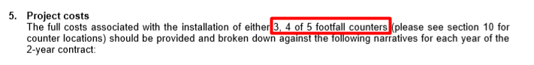 | Yes please, basically the costings to supply the system as per the spec but with pricing for 3 monitors in place, 4 monitors in place or the maximum of 5.
3. | What is the distance of the locations to their respective nearest access points? | In terms of access:  Spec 1- High Street. This is within the pedestrianised area but vehicular access is via automatic bollards  Spec 2 – Market Street. Just inside pedestrianised area accessed via automatic bollards for vehicles  Spec 3 – Marketplace. Not in pedestrianised area but access is available for vehicles by arrangement (KBC)  Spec 4 - Sheep Street. No access restrictions  Spec 5 – Sheep Street. This is within the pedestrianised area but vehicular access is via automatic bollards
4. | May I know what is the distance between the locations to the nearest router (internet connection) as we want to determine the network cabling structure. | I am afraid I do not have this information available.  Am assuming you would be looking at a hardwired solution for this rather than WIFI?  I am guessing it might need a conversation with the local telecoms infrastructure supplier to ascertain whether each location could be connected up to existing hardware such as the nearest cabinet that would supply the locations.

