**INVITATION TO TENDER**

DESIGN & CONSTRUCTION SERVICES FOR THE FLETCHER ROOM.

CLIENT, ACLE PARISH COUNCIL

REFERENCE NUMBER APC-FR-25

**PART B INVITATION TO TENDER (ITT) DOCUMENT**

**SERVICE DETAILS AND SPECIFICATION**

Part B is for information only and does not need to be returned with the Tender submission.

Contents of Part B

| 1. Background Information | 3 |
| --- | --- |
| 1. Conditions | 3 |
| 1. Project Details | 5 |
| 4. Sub-contractors | 8 |
| 5. Site Investigations and special reports | 9 |
| 6. Technical Standards | 9 |
| Appendix | 10 |

**1.0 Background Information**

Acle Parish Council are seeking a Contractor to carry out the works detailed below. We currently lease a section of land adjoining the local Primary Academy. On this land is a modular building which is reaching its end of life. The building currently houses the local Pre-School. The Council wishes to install a new larger building which will be suitable for the Preschool and other local community groups and individuals.

As the building is for a preschool, works need to be completed (within reason) out of term time. It is hoped works can be completed during Summer Holidays 2025.

1.1 Planning Permission

Planning permission has not been obtained yet. Once designs are agreed on, Acle Parish Council will apply for planning permission, with assistance from our planning consultant, from Broadland District Council.

1.2 Project Contacts

Kristina Smyth

Acle Parish Council

aclepcassistantclerk@gmail.com

07833916928

**2.0 Conditions**

2.1 General

These Main Contract Preliminaries are based upon the JCT Contract general conditions. All work must comply with Current Building Regulations, the Building Act, Codes of Practices, British Standards and all Health and Safety Requirements whether included, expressed or implied within the information provided within documents submitted as part of this Invitation to Tender.

The Contractor will accept responsibility for the coordination, supervision and administration of the Works, including subcontractors where applicable. Please be aware that the Contractor will be responsible for all CIS matters. The rectification period will be agreed as part of the Contract administration.

Unless otherwise specifically excluded in the Tender Pack, the Contractor shall provide and pay for all labour, materials, equipment, tools, construction equipment and machinery, insurance, taxes, water, heat, utilities, transportation, temporary site facilities, and other facilities and services necessary for the proper execution and completion of the Works, whether temporary or permanent.

The Contract will be subject to the Employer’s Requirements and satisfactory performance through continuous monitoring and performance review. Failure of satisfactory performance may result in the Contract being terminated.

The Contractor is to satisfy themselves during the tender process that all implications of the Employer’s Requirements have been considered with regard to Building Control and costs associated are included within the pricing document. This is to include any tests required.

2.2 Building Certification

At completion, the Contractor is to provide evidence that the Works have been executed in accordance with the conditions laid down by current Building Regulations, and obtain all necessary certificates from Environmental Health and all other appropriate bodies. Such evidence will be deemed to be a Completion Certificate issued by Development Control of the Local Authority, or equivalent body, at, or as soon as practical after, Practical Completion.

The Contractor is to satisfy themselves during the tender process that all implications of the Employer’s Requirements have been considered with regard to Building Control and costs associated are included within the pricing document. This is to include any tests required.

2.3 Construction and Design

The Tenderer is expected to design construction drawings. The contractor will be liable for ensuring these meet all relevant specifications and details. All details should be provided to the employer before purchase of materials or work commences.

The Tenderer must ensure conditions to the planning are met and will be imposed before commencement. The successful contractor will be responsible for ensuring that these are completed and approved. All liaison with the council should be completed directly from the contractor to discharge the conditions. The contractor will hold sole responsibility for ensuring the conditions are met before work commencement.

The tenderer shall be the principle contractor providing all services such as, design and build, CDM management.

Expectations for the construction work are detailed below;

* To demolish and remove the current modular building.
* To complete respective groundworks to level land to begin the project, and restorative landscaping should be included within the quotation submitted as part of this ITT. Details of current external landscaping can be found in Appendix B.
* To install a new larger 2 room modular building, inclusive of adult toilet, 4 children toilets, kitchenette and store room. The children toilets need to be directly attached to each room, or jack and jill between the two. The remaining areas can be accessible from the lobby. The 2 main rooms do not need to be the same size. Maximum dimensions are 18 metres by 11 metres given the land space
* Connect water supply and electricity services directly to mains connections (currently sub metered off neighbouring Academy).
* Moving or removing current large BT pole, used for giving height to cables for vehicular access to the neighbouring property.

If further contractors or consultants are deemed to be required by the Tenderer, then this should be noted in the Part C form to be returned as part of the Invitation to Tender.

2.4 Material Substitutions

Alternative products may be used where necessary to any specified or agreed with the employer. The Contractor must seek permission before ordering or confirming any products or materials that may differ to agreement or requirements. The Contractor should submit the relevant information on the new materials / product including the manufacturer and product reference, availability, relevant standards, performance and function, compatibility, proposed revisions to any drawings or specifications, appearance and warranty or guarantee.

**3.0 Project Details**

Acle Parish Council reserves the right to change any details provided where necessary. The below is general guidance on the project for the Tenderer to submit an accurate Tender Bid.

The work required is shown in drawings attached as part of the appendix to this Invitation to Tender.

Site commencement date: July 2025

Project Length: 8 weeks, 10 weeks maximum (to fit most of the work within school summer holidays)

Site Location: The Fletcher Room, Fletcher Way, Acle

Form of Contract: JCT Design & Build standard contract will be entered into by the employer and successful contractor. The employer and successful contractor will enter into administered details to discuss further contract details.

Construction Programme: The successful contractor will agree and provide a formal construction programme including, project commencement and key completion dates, deadlines for any information requested by the employer, any subcontractor commencement and completion dates.

3.1 Preparing for the Works

The Tenderer should ensure they have satisfied themselves with all access required and the site before submitting. All levels and dimensions must be checked and recorded upon commencement of the works to ensure accuracy and immediately report any discrepancies.

Site Facilities are to be set by the contractor as required for their work on site including site office, site welfare facilities. The site office must have record of all required documentation for the contractor, including but not limited to, risk assessments, health and safety policy, site drawings, accident book, sign in register etc.

Protection of the site must be undertaken by the contractor, including use of temporary signage, barriers and all necessary perimeter fencing, or other measures needed to ensure site safety. Advertisement may be permitted to be attached on the site perimeter fencing however, permission should be sought from the employer beforehand.

The contractor is responsible for ensuring safe and efficient removal of any waste from the site. All waste during the contract and at the site at time of contract commencement, is the responsibility of the contractor to remove safely and according to any relevant policies. A Site waste management plan must be provided and kept on record in the site office.

Site and weather conditions for the full term of contract are expected to be envisioned by the contractor and allowed for within the quotation. Further costs for work due to site condition will not be allowed.

3.2 The Site

The site is situated next to Acle Primary School. There is pedestrian access from the road/footway, vehicle and 3 car parking spaces in term time to utilise in the Primary School car park bordering the Fletcher Room land. The Primary School have provisionally agreed full access to their car park and field that surround the land through the summer holiday to enable works. Should significant works continue into term time full access to the car park is not available.

It is important all health and safety or other relevant protocols are adhered to through the contract duration. No public access to take place without prior notice.

The contractor should not obstruct any public pathways, roads or encroach on the surrounding school without prior permission.

**Site Etiquette**

Contractors are expected to adhere to all site health and safety requirements on site according to their risk assessment and associated policies, regulations or other. Personal Protective Equipment should be provided on site by the contractor for use by employers and visitors.

Protection of the site should be considered by the contractor and noise pollution, hazardous substances, waste, contamination, fire prevention, pollution should all be minimised where possible and appropriate management plans to mitigate against the above should be considered.

The structural integrity and site safety should be maintained at all stages by the contractor. Details on load capacity should be obtained by the contractor and overloading in areas should be prevented.

3.3 Expectations regarding progress

Successful bid will be expected to arrange meetings once weekly regarding updates and progress to the site or to discuss anything that may be required. Further meetings may be requested at the employer’s discretion if required.

A written progress report should be provided fortnightly. Should delay or any conditions arise that may postpone the progress of works then the contractor should without delay submit a proposal for how the delay will be minimised.

3.4 Services

The contractor shall be responsible for any cost associated with the infrastructure and utility of the site, including disconnecting and connecting. New and Existing utilities must comply with the Byelaws or Regulations of the relevant Statutory Authority.

**Water Regulations/Byelaws Notification**

The Contractor must notify the Water Undertaker of any work carried out to or which affects new or existing services and submit any required plans, diagrams and details. They must allow adequate time to receive the Undertaker's consent before starting work. The Contractor must inform the Employer immediately if the consent is withheld or is granted subject to significant conditions.

**Water Regulations/Byelaws Contractor's Certificate**

When the relevant work is completed, the certification must be provided as part of the Building Manual. A copy of the certification may also be required by the Water Undertaker.

The certificate must include:

* The address of the premises
* A brief description of the new installation and/or work carried out to an existing installation
* The Contractor's name and address
* A statement that the installation complies with the relevant Water Regulations or

Byelaws

* The name and signature of the individual responsible for checking compliance
* The date on which the installation was checked.

**Electrical Installation Certificate**

When the relevant electrical work is completed, the original certificate must be provided as part of the Building Manual.

**Gas, Oil and Solid Fuel Appliance Installation Certificate**

When the relevant work is completed, the certification must be provided as part of the Building Manual. The certificate must include:

* The address of the premises
* A brief description of the new installation and/or work carried out to an existing

installation

* Any special recommendations or instructions for the safe use and operation of

appliances and flues

* The Contractor's name and address
* A statement that the installation complies with the appropriate safety, installation and

use regulations

* The name, qualification and signature of the competent person responsible for

checking compliance

* The date on which the installation was checked
* Mechanical and Electrical Services

The Contractor must carry out the final tests and commissioning so that the services are in full working order at completion of the Works. A copy of the Building Regulations Completion Certificate must be provided as part of the Building Manual.

The Contractor shall liaise and coordinate with the utility supply company to ensure that the statutory undertakings are satisfied. The utility supplies must comply with the conditions and specifications of the relevant utility supply company for the area. The Contractor shall comply with the requirements of the utility supply company in providing the necessary installation and meter positions to the Site and residential units.

**Mechanical and Electrical Services Design**

The Mechanical and Electrical Services Installation must comply with the following general requirements:

* Designed in accordance with the latest Codes of Practice issued by the appropriate Statutory Authority or Body
* Installed to the highest standards
* Aesthetic in appearance
* Safe both in operation and use

All electrical installations shall be designed to comply with the following:

* Building Regulations
* Regulations of the Local Supply Authority(s)
* British Standards, whether applicable in part, or in whole
* Relevant British Standards Codes of Practice
* The latest edition of Regulations for Electrical Installations issued by the

Institute of Electrical Engineers

* The Health and Safety at Work Act
* The Electrical Equipment (Safety) Regulations
* The latest edition of the IEE Wiring Regulations for domestic installations

The Contractor should also note that the electrical installation design must take particular care with regard to earth leakage protection, overcurrent protection, the general use of accessories, and, in particular, MCB consumer units shall, as a minimum, be complete with RCD's. All mechanical installations, including sanitary and plumbing installations shall be designed to comply with the following:

* Building Regulations
* Regulations of the Local Supply/Water Authority(s)
* British Standards, whether applicable in part, or in whole; and of Relevant British Standards Codes of Practice.

3.3 Completion

Snagging will need to be addressed before completion of the contract. Snagging issues after build should be completed without delay to ensure that they do not create a delay in the overall completion time of the project.

Repairs necessary or arising from defect of materials or workmanship should be notified to the contractor on completion and should be reasonably attended to for the duration of the warranty, guarantee and liability period. Defects should be responded to in a reasonable time frame and repair completed within the required period. If the repair is not carried out satisfactorily or within a reasonable time period, another contractor may be sought and the reasonable cost for repair may be incurred against the contractor.

Building manual will need to be provided by the contractor prior to completion date. The manual should be a thorough document that provides an overview of the main design principles, describe key components and enable the safe operation and maintenance. Detailed information on services, fire ratings, construction, product details, diagrammatic, electrical and gas safety, health and safety etc. Details of the manual required can be discussed between the successful contractor and the employer if required.

In addition to the manual, the following documentation will be required to be passed by the contractor to the employer:

* Building Regulations certificate
* Electric Safety Certificates
* Smoke and Fire alarm details and manual
* Boiler details and manual (if required)
* Window and door details including guarantee and operation details
* Extraction fan details and manual
* Details of the meters locations for electricity and water
* Meter readings for the electricity and water
* Door keys – minimum of 3 per door
* Electric meter cupboard keys (if required)
* Window keys – 1 per window minimum
* Details on isolator switches, electricity box locations etc.
* Details of stop tap, internally and externally

**4.0 Sub-contractors**

Sub-contractors may be used by the contractor if deemed necessary to ensure completion of the project or skill set required. Sub-contractors will be employed directly by the successful contractor of this Invitation to Tender and not by the employer. Any work completed by a sub-contractor will be subject to the same terms as the successful contractor and all liability for sub-contractor works will be the contractors.

Sub-contractors should hold appropriate insurance, it is the responsibility of the contractor to ensure documentation and information is obtained on this. Sub-contractor works must be included as part of the warranty and guarantee and rectification of any problems or snags will be taken up with the contractor to fix. The contractor will be responsible for obtaining any warranty or collateral warranties required from sub-contracted work.

Sub-contractor work should comply with all Building Regulations, it is the responsibility of the contractor to oversee the work completed by any sub-contractors. Should any issues arise with work from a sub-contractor, the employer may seek compensation or financial rectification from the successful contractor directly.

Sub-contractor fees should be allowed within the Tenderers bid.

**5.0 Site Investigations and Special Reports**

SBEM calculations will be carried out by the contractor and refer back to the technical pack.

**6.0 Technical Standards**

Building regulations plan check approval is supplied by the contractor. The contractor will be responsible for obtaining full Building Regulations approvals and site inspections. Final Building Regulations sign off will be required and a certificate will need to be provided to the employer.

Any changes required to design, or current check approval should be sent to the employer to review changes alongside justification for the changes required. Should the changes be approved by the employer, it will be the responsibility of the contractor to ensure these changes meet building regulation requirements and pre-check approval is sought. Should the changes require further planning approval, the contractor will be responsible for ensuring the employer is made aware. Any associated costs or delays caused by changes requiring planning approval may be sought from the contractor, if the changes are deemed to be as a result of the contractor’s negligence or error.

Approvals or consents required to complete the works are the responsibility of the contractor and at the contractors own cost. This includes any council, contractor, service providers or building regulations approvals or consents.

Water meters must be located externally to the building(s) and be fully accessible. All meters will be labelled with the correct postal address.

The Contractor shall provide the MPAN and MPRN numbers and readings to each meter, prior to handover.

**APPENDIX DETAILS**

Appendix A: Current design

Appendix B: Current landscaping photographs

Appendix A: Current building original drawing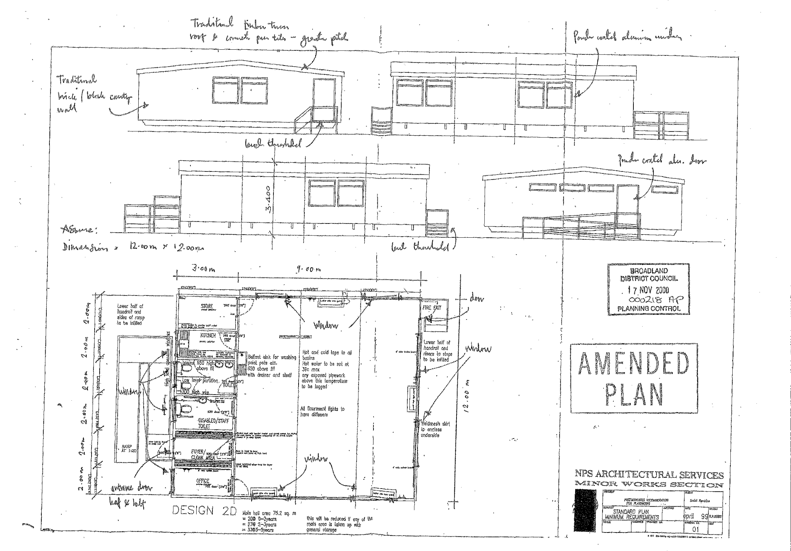

Appendix B: Landscaping

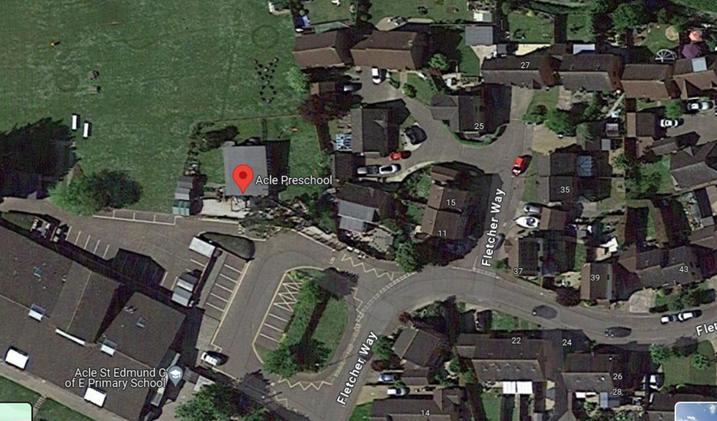

Location comparative to the Primary School & Fletcher Way

