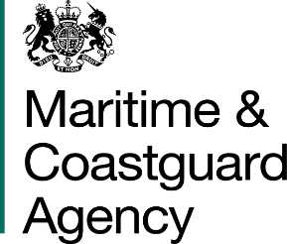 |  |  | Bay 3/21  Spring Place  105 Commercial Road  Southampton  SO15 1EG  United Kingdom
 | All Tenderers for the Provision of Surveyor Technical Training  Via Contracts Finder |  | Tel:  Fax:  E-mail: | +44 (0)23 80329275  +44 (0)23 80329388  contracts@mcga.gov.uk
 |  |  | Your ref:  Our ref: |  | TCA 3-7-968
 |  |  | 7th October 2015
Dear Sirs

PROVISION OF SURVEYOR TECHNICAL TRAINING

We have received some questions from a tenderer for the above-mentioned contract, and to ensure that all tenderers have access to the same information, we have copied the questions and our answers to you:

Question 1: How many of these courses are going to be needed?

Answer : Currently we are unsure of total numbers of courses that we are looking for, so have asked for a minimum and maximum number of trainees that you feel would make each course viable and a set price per student within these parameters. Where there is no minimum number of trainees to run a course a figure of zero (0) should be inserted on the pricing schedule. Currently we anticipate that there would be approximately 1-2 course per annum per requirement. There may be a possibility that this could be increased if required or a course may not run for a particular year because of insufficient numbers.

Question 2: Is there the potential to have the training delivered by online means or does it purely require to be face-to-face training?

Answer: Some elements of the requirement could possibly be delivered via online means and would not be discounted if identified as a possible solution.

I trust this answers the questions, but if you have any further queries please do not hesitate to get in touch.

Regards,

Richard Skeats MCIPS
Procurement Officer
Maritime and Coastguard Agency

