Did you know
You may be able to spread the cost of your payments or find reductions that you are eligible for. To find out more visit:
cheshireeast.gov.uk/counciltax
Direct Debit – our recommended payment method
- 80% of Cheshire East residents pay by Direct Debit
- choose to pay annually, half yearly or over 10 or 12 monthly instalments
- never miss a payment
- quick and easy to set up
- choose to pay on 1, 5, 10, 15, 22 or 27 of the month
cheshireeast.gov.uk/counciltax

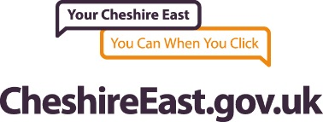
Always quote your Council Tax account number when making a payment
Important information
- contact the council at once to resolve any issues you may have regarding this reminder
- this reminder includes payments received by the Council up to the date of issue and does not include any amounts already subject to recovery action
- a maximum of 2 reminders will be sent in a financial year. If you are late a third time you may be sent a final notice, meaning you will have to pay the full balance straight away. You can avoid this by making sure all your payments are paid in full and by the due dates
- you must tell us of changes to your circumstances within 21 days or you may be fined £70
This notice is issued by Cheshire East Borough Council
Revenues Service, Cheshire East Council, PO Box 622,
Crewe, CW1 9JH
Tel: 0300 123 5013 (Telephone opening hours: Monday to Friday 8.30am – 5.00pm)

Why register?
- paperless billing
- never lose a bill
- check your account balance
- access your account 24/7
Plus, go online to:
- set up a direct debit
- tell us you’ve moved
- apply for or cancel a Single Person Discount
Registering for a Cheshire East online account is easy and only takes a couple of minutes. You can then manage your council services online. Just go to: cheshireeast.gov.uk/account
Register now for a Cheshire East online account

