**SUNNINGDALE FENCING REPLACEMENT**

* To supply and replace the existing chain link fencing with 2m high V mex mesh style anti climb panels at the perimeter of Sunningdale allotment site as detailed here:

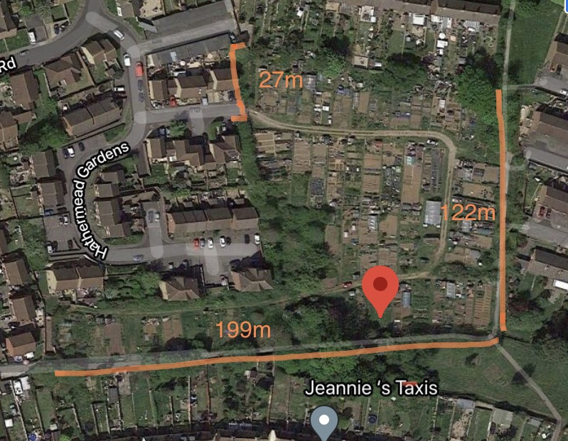(please quote **per metre**)

Sunningdale Allotment Site

Hathermead Gardens

Yeovil

BA21 5BX

* To supply and replace 2x double vehicle gates (V mex mesh style gates). Please quote per gate.
* To supply and replace 2x single pedestrian gates (V mex mexh style gates). Please quote per gate.
* To supply and install 5x badger access gates at locations along the fence line to be agreed. Please quote per gate.
* All waste materials to be removed and disposed of responsibly.
* Please quote ancillary costs separately.

The Council shall not be obliged to accept the lowest or any tender, quote or estimate.

For site visits, please contact sally.freemantle@yeovil .gov.uk, 01935 382424.