PART TWO

SPECIFICATION Gallery Library and Museum (GLaM) – Improvements and Transformation to RIBA Stage 3 (with the Option to progress to RIBA Stage 4 Technical Design)

Tender Value £60,000 to £75,000

Kettering benefits from having a cluster of heritage assets located within the town centre’s Cultural Quarter- Alfred East Art Gallery, Library and Manor House Museum (GLaM). A feasibility study conducted in 2019 identified two options to significantly improve and transform the physical assets within GLaM 1.Refreshment Option and 2. Transformational Option.
An expression of interest has been made via our Local Enterprise Partnership (SEMLEP) for GLaM (Option 2.Transformational) to be within the regional pipeline of projects for future funding opportunities. The Transformational option seeks to physically revitalise and extend GLaM to become a Creative and Cultural anchor for North Northamptonshire providing a blend of cultural amenities, commercial space and teaching facilities. The Project aims to be transformational, pay homage to the building’s historical character and dovetail with other cultural programmes across the town centre. The Project will create flexible work/exhibition space, augment the cultural/visitor offer, provide commercial and retail space and enable a programme of events to strengthen community links. Key to the project is maximising the assets and transforming them to become a visitor destination. The majority of the capital works will be focused on extending the rear of the Alfred East Art Gallery whilst refocusing the internal space of all three buildings.
A full copy of the feasibility study will be made available to interested parties e-mail collettelilley@kettering.gov.uk

The Basic Services
To be able to access funding opportunities, when they become available, The Client is commissioning a further piece of work to progress the Transformational Option 2 identified in the study, whereby at the end of RIBA Stage 3 (Developed Design) the Client will have sufficient detail to enable a full planning application to be submitted. Relevant works to be costed, within tender value, include architectural, associated services and surveys as detailed below:-

Architecture:-
Architect up to RIBA stage 3
Conservation Architect
Interior Designer
Landscape Architect
Other Consultants services:-
Quantity Surveyor
Mechanical and electrical Engineer
Structural Civil Engineer
Surveys:-
Buildings/Topology
Ecology
Arboricultural

The Additional Services

Option to progress to RIBA Stage 4 Technical Design

* These works are in addition to contract value stated above and need to be costed separately as they will only be progressed if and when additional funding becomes available.

In the event that the Client is able to secure additional funding, they are also seeking costings for relevant works including architectural and associated services to progress to the end of RIBA stage 4 Technical Design, we are also seeking costings for relevant works including architectural, associated services as detailed below:-

Architecture:-
Architect up to RIBA stage 4
Conservation Architect
Interior Designer
Landscape Architect
Other Consultants services:-
Quantity Surveyor
Mechanical and electrical Engineer
Structural Civil Engineer

Appendices

- Gallery and Library – Transformational (Option 2) site plan lower and upper floors*
- Museum- Proposed works and alterations

*Note: Proposed Option 2 site plans for Gallery and Library have been taken from the feasibility study

Appendix 1
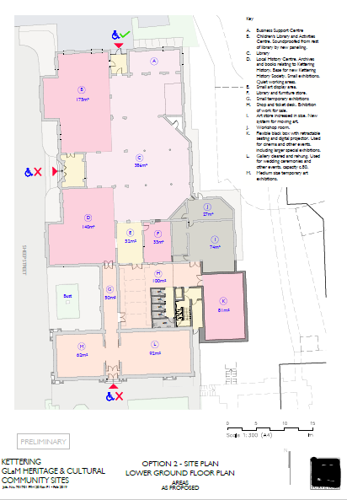

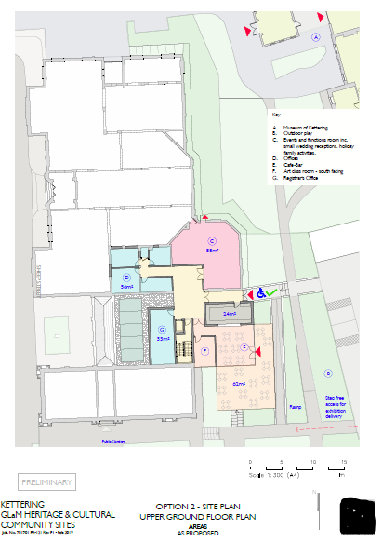

Appendix 2
Museum Improvements
- Creation of a more visible entrance
- Reconfiguration in internal floorspace to improve flow and enable quality temporary exhibitions, events and community/ educational usage (KBC initial sketches below)
