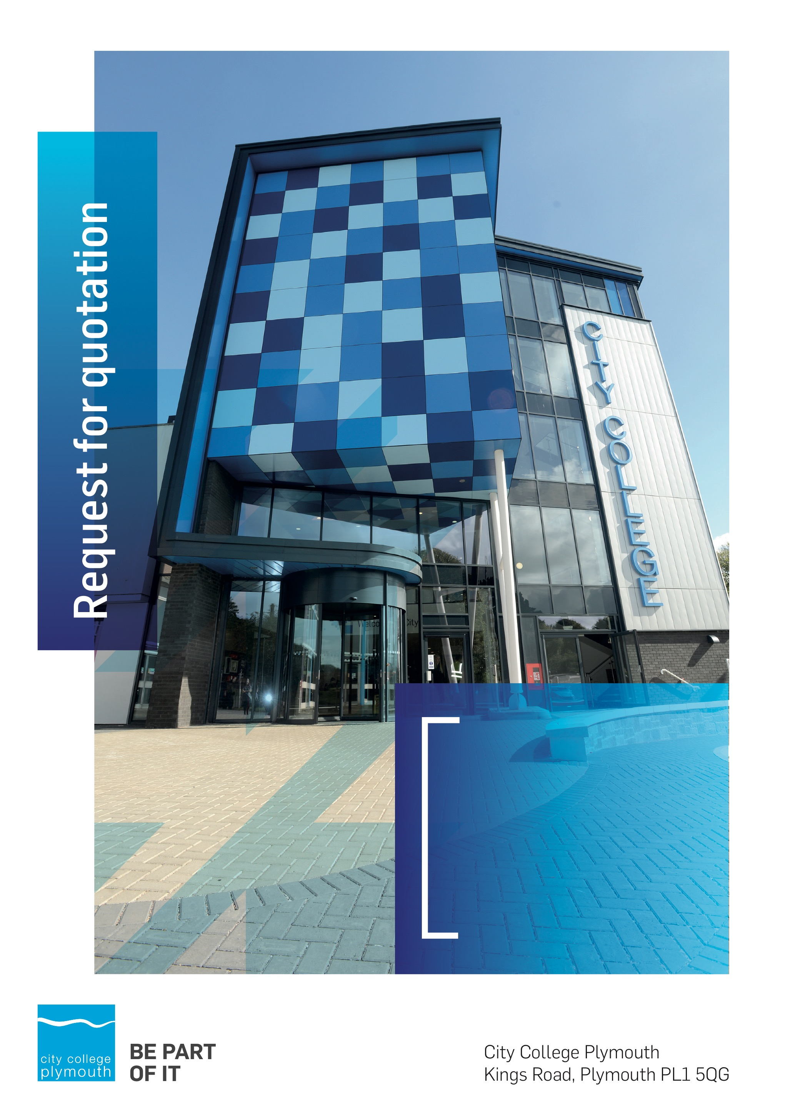

Request for Quotation
RFQ130
Paper
Issued 23rd April 2020

Table of Contents
Table of Contents 2
Confidentiality Statement 3
Open Procedure 3
Submission Details 3
Submission Deadlines 3
Submission Questions and Clarifications 4
Electronic Submissions 4
Introduction and Executive Summary 5
Business Overview & Background 5
Our Vision … is where our future lies 5
Our Mission … is what we focus on each and every day 5
Background 5
Detailed Requirement 6
Written Submission 6
Pricing 7
Timescales 7
Terms and Conditions 8
Validity 8
Selection Criteria 8
Award Price 9
Written submission 9
Assessment of Quotations 9
Freedom of Information Act 2000 10
General Data Protection Regulation (GDPR) 2018 10
Agreement Conditions Acceptance and Declaration 10
Supporting Documentation 10

Confidentiality Statement
This document, and any attachments thereto, regardless of form or medium, is intended only for use by the addressee(s) and may contain legally privileged and/or confidential, copyrighted, trademarked, patented or otherwise restricted information viewable by the intended recipient only. If you are not the intended recipient of this document (or the person responsible for delivering this document to the intended recipient), you are hereby notified that any dissemination, distribution, printing or copying of this document, and any attachment thereto, is strictly prohibited and violation of this condition may infringe upon copyright, trademark, patent, or other laws protecting proprietary and, or, intellectual property. In no event shall this document be delivered to anyone other than the intended recipient or original sender and violation may be considered a breach of law fully punishable by various domestic and international courts. If you have received this document in error, please respond to the originator of this message or email him/her at the address below and permanently delete and/or shred the original and any copies and any electronic form this document, and any attachments thereto and do not disseminate further.
Thank you for your consideration, City College Plymouth.
Where no notice is given, all information contained herein is Copyright 2020 City College Plymouth.

Open Procedure
The College fully adheres to the requirements of the Public Contracts Regulations 2015, including for opportunities which are under threshold amounts.
Any Contractor who directly or indirectly canvasses any Member or Officer of the Institution, or advisor concerning the award of the contract for the provision of the services, or who directly or indirectly obtains or attempts to obtain information from any such member or Officer concerning any Tender or proposed Tender for the service will be disqualified from having his/her Tender considered.

Submission Details

Submission Deadlines
All submissions for responding to this Request for Quote must be submitted via email as stated below, no later than:
Monday 18th May 2020
12:00 Noon
Any submissions received after this date will not be considered.

Submission Questions and Clarifications
You may contact the following person if you have any questions or require clarification on any topics covered in this Request for Quotation: by 12th May 2020
Carol Williams
Procurement Officer
Phone: 01752 856 809
Email: tenders@cityplym.ac.uk
All correspondence during the Tender should be channeled via the Procurement Officer using the above details only. Bidders found to have gained an unfair advantage shall be disqualified from the current opportunity and future opportunities with the College for a minimum of four (4) years.

Electronic Submissions
Electronic submissions in response to this Request for Quotation must meet the following criteria:
Sent via email to: tenders@cityplym.ac.uk
Document standards:
- Text must be in Microsoft Word format;
- Price tables must be in Microsoft Excel format (using pricing schedule in Appendix A);
- Supportive evidence may additionally be submitted in PDF format;
- Images, Designs, and other supporting evidence may be in either JPEG or PDF format
- Completed Appendix C Suitability Assessment & Selection Questionnaire (Including Mandatory & Discretionary Exclusions) Parts 1, 2 and 3. - Please note this suitability assessment will not be viewed unless you are the winning tenderer. Failure at this stage may prevent the contract from being awarded.
- Signed Agreement Acceptance and Declaration.

Please note that the College is able to accept submissions sent in a compressed or “.zip” file format, so long as the files contained meet the standards described above.

WARRANTY:
By submitting your tender bid, you are warrantying to the College that you have not breached our canvassing or soliciting clause.
If any successful tenderer awarded a contract is found to have provided an inaccurate warranty, then the College reserves the right to terminate the awarded contract with immediate effect and re-tender the contract from which the successful tenderer will be excluded from re-bidding and shall be disqualified from any future opportunities for a period of four years.

Introduction and Executive Summary
City College Plymouth is seeking to contract with a single supplier for the provision of paper across its two sites: Kings Road and Picquet Barracks. The purpose of this request is to establish an exclusive 1 year contract with a view to extend for a further year.
The anticipated value of the supply contract will exceed £25,000. Therefore, as per the Public Contracts Regulations 2015 the opportunity will be advertised on the government portal ‘Contracts Finder’.

Business Overview & Background
The College operates on two sites within the city, serving 12,533 students and employing over 500 staff. The College operates year round, with opening times from 0800-2100 on some days.

Our Vision … is where our future lies
We are a College with a national reputation for promoting enterprise, employability and science, technology, engineering and mathematics (STEM).

Our Mission … is what we focus on each and every day
To be the South West’s leading provider of innovative, technical, professional education and training by supporting partnerships for growth, raising aspirations and fostering wealth creation

Background
City College Plymouth is one of the largest providers of innovative, technical and professional, education in the South West with a national reputation for promoting enterprise, employability and science, technology, engineering and mathematics (STEM). The College plays a central role in the educational, cultural and economic life of the region and works with strategic partners to facilitate growth, raise aspirations and foster wealth creation.
The College was awarded the Teaching Excellence Framework Gold award for its university-level provision and its most recent Ofsted inspection confirmed that the College continues to be ‘Good’ with outstanding features. The College was rated first in the South West and second nationally for student satisfaction in the latest FE Choices student satisfaction survey.
City College supports the region’s employers with their award-winning Apprenticeship provision, as well as providing a range of courses and bespoke training programmes which enable employees to upskill or retrain to better support their business’ requirements. Their successful partnership working with the local business community resulted in a 99.5% satisfaction rate in the Government’s national ‘FE Choices employer satisfaction survey 2016 to 2017’ - placing them first in the country for general further education colleges.
City College Plymouth offers a wide range of academic and vocational courses in a variety of subjects. The total number of students supported by the College is 12,533 –comprising of: 3,569 full-time students, including 765 higher education students and 179 non EU students; 8,964 part-time students; and 1,599 apprentices. The College also employs over 500 staff.

Detailed Requirement
Approximate yearly spend is £27,000
The data in Appendix A provides a breakdown of the College’s requirements.
All products offered as part of this tender exercise will need to be compatible with the following College Printers. Please send paper sample packs to the College as part of your submission.
Colour Printer: Konica C1085
Mono Printer: Konica 1052
Multi-function devices – 60 Kyocera devices
Desktop colour printers – Hewlett Packard 3015
The ability to order online is essential. If you are unable to provide this service your submission will not be scored and your bid will be scored as a fail.

Written Submission
We require a written document which details your company offer with particular interest to the following areas:
- On-line ordering facility
- Price breaks for larger volumes, discounts available,
- Responsiveness, lead times, service.
- Innovative suggestions with regard a mutually beneficial arrangement following the initial one-year contract period,
- Sustainability,
- Potential partnering arrangements with regard to student work experience, apprenticeships and working partnerships.
This submitted document will be scored as per the table on page 8.

Pricing
Bidders should provide their pricing for each of the key products as listed in Appendix A.
It is expected that all bidders will provide prices for the items stipulated, or where an exact match is not available, a substitute that is as close as practicably possible, in which case you should make clear that this is a substitute. The data provided in Appendix A should not be considered a commitment to purchase, services will only be ordered on an ad-hoc basis, however the successful supplier will benefit exclusively from the College’s annual spend.
Prices should be firm and valid for at least the initial contract period (12 months) and not subject to increase or escalation of any kind throughout the contract.

Timescales

Action | Date
Tender Issued | 23/04/2020
Deadline for Queries | 12/05/2020
Tender Response Date | 18/05/2020
Award Date | 29/05/2020
Implementation Date | 21/06/2020

Terms and Conditions
The College’s normal business terms are 1-2 months from the date of invoice. Payment will become due subject to the above upon the College’s full acceptance of the goods/services. This Request for Quotation and any resulting purchase order will be subject to the College’s General Terms and Conditions of Purchase of Goods/Services – see Appendix B.

Validity
Bidder’s offers should be open and valid for acceptance for a period of no less than ninety [90] days from the date of submission.

Selection Criteria
The successful supplier will have provided the Most Economically Advantageous Tender (MEAT) to the college. It should be noted that the bidder with the lowest submitted prices will not necessarily be down-selected. All bidders will be notified via email of the results of the outcome no later than 90 days from the date of submission. The date of contract award will be provided within that email.
The marking criteria follows:
Category | Weight
Price, including price breaks for volume | 80%
Responsiveness, Lead Times, Service | 10%
Innovation | 5%
Sustainability, the Environment and Social Responsibility | 3%
Student Work Experience | 2%
Pass/Fail Criteria

On-line ordering facility | Pass/Fail

Please see table below for more details on the scoring method.

Award Price
Lowest quote price divided by quote price multiplied by 100

Written submission
Assessment | Score | Interpretation
Excellent | 4 | Comprehensive response supported by examples  Description fully supported by details that demonstrate the applicant’s ability to provide the required services.
Good | 3 | Broad response supported by relevant examples.  Description well supported by details that demonstrate the applicant’s ability to provide the required services.
Satisfactory | 2 | Reasonable response supported by some evidence.  Description adequately supported by details that demonstrate the applicant’s ability to provide the required services.
Poor | 1 | Limited response not well supported by evidence.  Description inadequately supported by details that demonstrate the applicant’s ability to provide the required services.
Unacceptable | 0 | No response or insufficient information provided.

Assessment of Quotations
Bidders must ensure that their quotation fully addresses all information requested within this RFQ document. Bidders must ensure that any quotation fully meets the specification required. The College reserves the right to discount any quotation which does not fully meet the specification.
The College reserves the right to seek clarification with bidders upon receipt of quotations.

Freedom of Information Act 2000
Under the Freedom of Information Act 2000 the College cannot guarantee that information provided by bidders during the course of this RFQ procedure or any resulting contract will be held a confidential. The College will not routinely release information to interested parties unless required to do so in order to meet our statutory obligations.

General Data Protection Regulation (GDPR) 2018
All bidders must comply with the General Data Protection Regulation (GDPR) 2018 in respect of using and processing personal information. Bidders must have in place technical and organisational safeguards to protect personal data from unauthorised use, disclosure or loss.
The College reserves the right to request a copy of your privacy statement if you are the successful bidder.

Agreement Conditions Acceptance and Declaration
Bidders are required to sign and return the attached Agreement Conditions Acceptance and Declaration. Appendix D

Supporting Documentation
Appendix A: Pricing Schedule
Appendix B: City College Plymouth Standard Terms & Conditions
Appendix C: Suitability Assessment & Selection Questionnaire
Appendix D: Agreement Conditions Acceptance and Declaration

