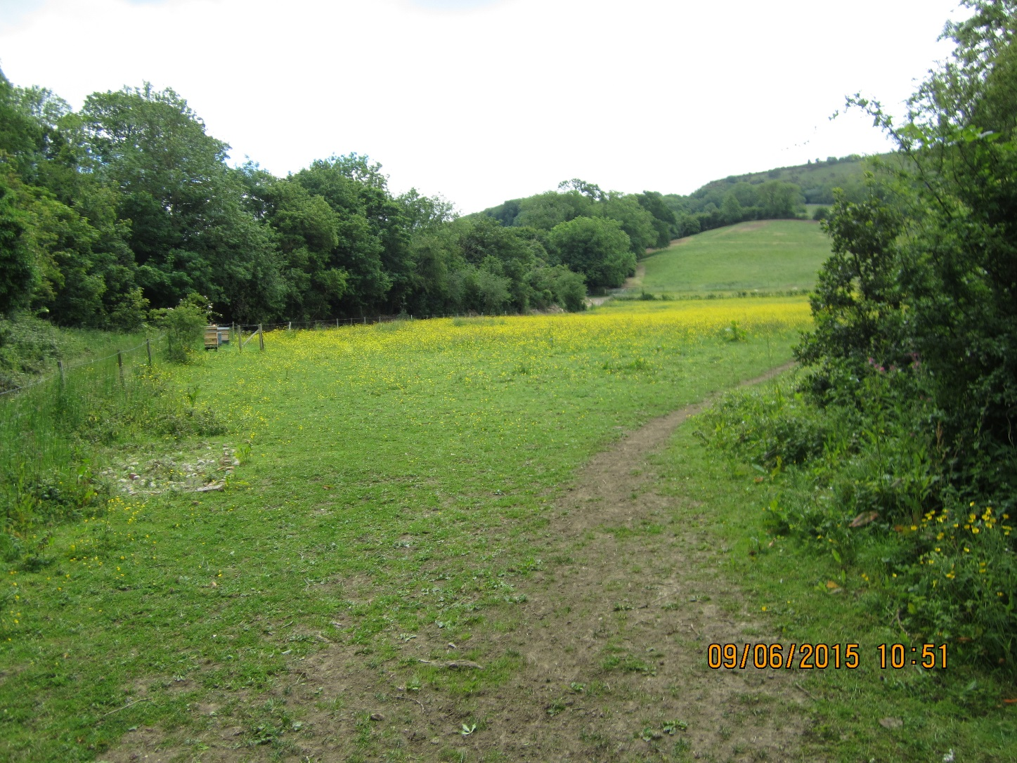
SOUTHFIELD BROOK FLOOD ALLEVIATION SCHEME
CDM Pre-construction Information
July 2016 – v1
Job Number: 204628.AL.01.00

Contents
1 Description of the Project 4
1.1 Project Description 4
1.2 Project Location 4
1.3 Application of the Workplace (Health, Safety & Welfare) Regulations 1992 4
1.4 Programme details 4
1.5 Project Team 5
1.6 Extent and location of existing records and plans 6
2 Client’s Considerations and Management Requirements 7
2.1 Planning for and managing the construction work 7
2.2 Health and safety goals 8
2.3 Proposed communication / liaison process 9
2.4 Site security 9
2.5 Welfare provision 9
2.6 Clients requirements relating to health and safety 9
3 Environmental Restrictions and Existing On-Site Risks 12
3.1 Safety Hazards 12
3.2 Health Hazards 12
4 Significant Design and Construction Hazards 14
4.1 Significant design assumptions and suggested work methods. 14
4.2 Arrangements for co-ordination of on-going design. 15
4.3 Information on significant risks identified during design. 15
4.4 Materials requiring particular precautions. 16
4.5 Information on significant environmental risks identified. 17
5 The Health and Safety File 18
5.1 Clients requirements 18
5.2 File arrangement 18

Document Control Sheet

 | Prepared by |  | Reviewed by |  | Approved by
ORIGINAL | ^{NAME} |  | ^{NAME} |  | ^{NAME}
ORIGINAL | ^{KC Howlett} |  | ^{SY Khan}
^{DATE} | ^{SIGNATURE} |  | ^{SIGNATURE} |  | ^{SIGNATURE}
^{July 2016}
REVISION |  | ^{NAME} |  | ^{NAME} |  | ^{NAME}
^{DATE} |  | ^{SIGNATURE} |  | ^{SIGNATURE} |  | ^{SIGNATURE}
REVISION |  | ^{NAME} |  | ^{NAME} |  | ^{NAME}
^{DATE} |  | ^{SIGNATURE} |  | ^{SIGNATURE} |  | ^{SIGNATURE}
REVISION |  | ^{NAME} |  | ^{NAME} |  | ^{NAME}
^{DATE} |  | ^{SIGNATURE} |  | ^{SIGNATURE} |  | ^{SIGNATURE}

Note to authors: As the preparation, review and authorisation of the document is a joint integrated team effort, please see the "preparation/review/authorisation" sections are completed by the "designer and project manager" respectively

Description of the Project

Project Description
The project consists of flood alleviation works at two locations in Southfield Manor Park, Cheltenham. These are identified as Location A and Location B on drawing 204628.001.
The works at Location A consist of a 210m length embankment with a maximum height of 1.8m, and a 94m length swale with a maximum depth of 1.6m. Works will also include a 3m width access track across the embankment, and the following precast concrete works. A 375mm diameter pipe beneath the south western end of the embankment with an upstream headwall and downstream manhole to connect into an existing culvert, and a 300mm diameter pipe beneath the north eastern end of the embankment also with an upstream headwall and downstream manhole.
The works at Location B consist of a 48m length ditch extension with a maximum depth of 0.23m, and a 68m length bund with a maximum height of 0.7m.
The proposed embankment fill material is to be sourced from the suitable excavated material from the swale or a local borrow pit.
Locations A and B are within fields adjacent to a residential area including schools, and site access will be along public highways. The Contractor must develop and maintain a traffic management plan for the duration of construction.
It is envisaged that the work will be undertaken during October to December 2016. It is assumed that the Principal Contractor will design any further temporary works considered necessary for access and undertaking the works, such as provision of trench support.

Project Location
The project is located in grazing land to the south of:
Southfield Manor Park, Sandy Lane, Cheltenham
O.S. Grid Reference SO 956 193

Application of the Workplace (Health, Safety & Welfare) Regulations 1992
The grazing land is envisaged to be classified as a workplace in accordance with the definitions contained in Workplace Health Safety and Welfare Regulations 1992.
All project designers for the structure shall ensure that they take suitable account of the Workplace Health Safety and Welfare Regulations 1992 in their design particularly in relation to the health and safety for the future use and maintenance of the structure.

Programme details
The current programme key milestone dates can be seen below:
Works Information approval date | 07/2016
Contract Award | 10/16
Planning, detailed design and contract finalisation | 05/16 to 07/16
Time allowed for Principal Contractor to mobilise | 4 weeks
Start Date on Site | TBC
Construction Phase Duration (weeks) | tenderer to advise
Completion Date on Site | tenderer to advise

Project Team
The project team is as follows:

Client
Name of organisation: | Cheltenham Borough Council
Address: | Municipal Offices, Promenade, Cheltenham GL50 9SA.
Tel: | 01242 774984
Mobile: | 07767 426097 (Tuesday to Friday only)
Contact Person | Geoff Beer (Project Manager)
Email Address | Geoff.Beer@cheltenham.gov.uk

Designers
Name of organisation: | CH2M
Address: | Burderop Park, Swindon SN4 0QD
Tel: | 01793 816 453
Mobile: | 07770 448319
Contact Person | Shauket Khan (Package Manager)
Email Address | Shauket.Khan@ch2m.com

Principal Designer
Not required

Principal Contractor
Name of organisation: | TBC
Address:
Tel:
Mobile:
Fax:
Contact Person
Email Address

Principal Landowners
The principal landowners on the site are:
- Southfield Manor Park Residents’ Association Limited, c/o 11 Southfield Manor Park, Sandy Lane, Cheltenham GL53 9DJ
- Pye Homes Limited, Langford Locks, Kidlington OX5 1HZ
Drawing number 204628 -001 showing the location of these is contained in the contract documents together with contact details.

Extent and location of existing records and plans
Any existing asset drawings and related documents available for the scheme are detailed on the table below.
None

Client’s Considerations and Management Requirements
Client’s arrangements for

Planning for and managing the construction work

Organisation Structure
Project Manager
Geoff Beer
Designer
Shauket Khan
CH2M
Principal Contractor
{Insert Name}
{Insert Organisation}

Construction Phase Plan
The Principal Contractor shall prepare a suitably detailed and site specific Construction Phase Plan (CPP) which is to be submitted to the Client as early as practical but at least a minimum of 10 working days prior to the planned start of any construction phase (including advanced works, Site investigation or other construction activities)
No works will be allowed to commence until the Construction Phase Plan is deemed compliant by the Client and an instruction is given by the Client for commencement.
The Principal Contractor must plan, manage and co-ordinate work during the construction phase taking account of the information contained in the PCI provided by the Client, and any other information provided by contractors.

Health and safety goals

The overall health & safety objectives for the project are:

A zero rate of accidents to any personnel or third parties resulting from the activities of the project

A zero rate of accidents or incidents that are classified as being reportable under the definition of the Reporting of Injuries Diseases and Dangerous Occurrences Regulations 2013 (RIDDOR)

A rate/frequency of minor injuries that is a minimum of 25% below the current national average for such events in comparable undertakings based on statistics from the HSE

To fully meet (as a minimum) the requirement of current health and safety legislation

Ensure the safe movement of vehicles and heavy equipment around the site.

Isolate and secure plant and equipment when the site is left unattended.

Exclude the public from the site during the works.

No noise disturbance complaints by local residence.

Ensure no lone working takes place without notification of whereabouts and arrangements for emergency communication.

Prevent the spread of any arisings around the sites and surrounding roads, including from the wheels of vehicles.

The contractor should undertake and record regular H&S safety audits including one during the first two weeks on site and submit all findings to the client.

Proposed communication / liaison process
The client’s representative will be periodically on site. A communication / liaison process will be agreed with the contractor to comply with the mutual QA procedures.
It is mandatory that the Client is informed of the following:
- Appointment of any designers by anyone (temporary works, specialists, etc.).
- Design changes where safety considerations are required for all permanent and temporary works.
- Proof that safety is considered for all design changes and variations.

Site security
Site security and preventing unauthorised persons entering the site area is paramount importance to achieve this, the client expects the minimum standard of security to include the following:
- Access to Southfield Manor Park is via Sandy Lane into the field immediately to the east of Southfield Manor that is Location A of the scheme; then across the field to the south and west of Southfield Manor to Location B of the scheme.
- Main compound fencing will be Heras security
- Compound gates will be lockable Heras security panels
- Main works area fencing Heras security
- Remote location security fencing Heras security
- Other security measures security guard

Welfare provision

The principal contractor shall make available adequate welfare facilities for each site, appropriate to the maximum number of people employed.

These facilities are to comply with Schedule 2 of the CDM 2015 regulations, shall be in place as the first items on site and last to leave site.

The client has identified a package of land for the site compound as shown on drawings 204628-001 and 002.

The Contractor will arrange for an electricity supply and any other services in accordance with the specification.
All welfare facilities shall be well maintained and readily available.

Clients requirements relating to health and safety

Site hoarding / fencing requirements
In addition to the general site security detailed above, the following is also required: TBC.

Site transport / vehicle movement restrictions
The vehicle access roads leading to Southfield Manor Park are through residential areas, which must be taken into account by the principal contractor when arranging deliveries to site.

Client permit to work system
The client do not have permit to work systems specific to this project.
The client expects the following activities to be fully and pro-actively managed by the Principal Contractor:
Ref | Activity | Permit Reference | Permit Owner
1 | Hot Works | Contractor own system
2 | Excavations | Contractor own system
3 | Confined Space Entry | Contractor own system
4 | Isolations (Mech/Elec) | Contractor own system
5 | Electrical Working | Contractor own system
6 | Asbestos Working | Contractor own system
7 | Lifting Operations | Contractor own system
The above list of client specific permits does not remove the contractors own requirements for permit operations where required through their own quality assurance system.

Fire precautions
The Client has no existing site fire risk assessments, plans and procedures.
The Principal Contractor shall carry out suitable fire risk assessments and arrange his own procedures and fire plan. Details must be included in the construction phase plan prior to commencement of work on site. It is expected that site specific plans are produced covering:
- Main compound area
- Fuel & Chemical storage facilities
- Other areas as assessed by the principal contractor

Emergency procedures / means of escape
The Client has no existing site emergency plans and procedures.
The nearest Accident and Emergency facility is located at:
Cheltenham General Hospital
Sandford Road, Cheltenham
GL53 7AN Telephone 0300 422 2222
The Principal Contractor shall carry out suitable assessment for emergency planning and arrange his own procedures. Details must be included in the construction phase plan prior to commencement of work on site. It is expected that site specific emergency plans are produced covering:
- Temporary works failure
- Construction of the swale in Location A
- Construction of the embankment in Location A
- Excavation of the ditch in location B
- Construction of the bund in Location B.

Details of “no-go” or authorisation requirements
The client has deemed the following as no-go areas:
Ref | Location | Location Owner/Contact
1 | Areas outside of the site not owned by the client
The client has deemed no areas require authorisation for access:

Designated confined spaces
None

Smoking restrictions
Smoking on the project is not permitted except as noted below.
- Smoking will not be permitted whilst operating mobile plant and equipment.
- No smoking in any enclosed or semi-enclosed areas or areas that are unsafe such as close to flammable and hazardous substances.
- Smoking will only be permitted in areas outside of the main site area that have been designated safe to do so.

Parking
All contractor personnel should park within the designated site compound area. Parking is not permitted in the streets around the site.
The Principal Contractor shall ensure that a traffic plan is produced. Details must be included in the construction phase plan prior to commencement of work on site. It is expected that traffic management plans are produced detailing the following as a minimum:
- Access to the site from the public highway
- Other users of the roads and walkways in the residential areas in the vicinity of the site
- Parking areas
- Storage areas

Environmental Restrictions and Existing On-Site Risks

Safety Hazards

Access to site
Site access / egress routes: Access to Southfield Manor Park is via Sandy Lane and other roads of the public highway in Cheltenham. The roads are through residential areas including schools, which must be taken into account by the principal contractor when arranging deliveries to site.
Dwellings are located close to the site.

Boundaries
Refer to drawing number: 204628 – 001.

Restrictions on deliveries and waste requirements
Waste as per SWMP.

Adjacent land use and known construction activity
There are public rights of way within Southfield Manor Park. These are used for pedestrian access primarily by walkers. The public right of way through the site at Location B will be closed for the duration of the works.
The surrounding land is grazing land. Currently horses are located in the field of site Location A. These will be separated from the works by electric fences to be erected by the tenants.

Existing storage of hazardous materials
None within the site boundary.

Existing services
Underground and overhead services information has been provided for the following:
- British Telecom
- Western Power Distribution
- Wales and West utilities
- Severn Trent Water
All available utility details found to-date have been marked up onto Drawings 204628 – 002 and 003. This does not remove the Principal Contractors requirement to carry out safe working practices in relation to overhead and underground services.

Ground conditions
A ground investigation was undertaken for Southfield Flood Alleviation Scheme by CC Ground Investigation and summarised in a Ground Investigation Report produced by CH2M dated February 2016. The main body of this report is included in the Works Information. The appendices may be requested if required.

Unexploded Ordnance
An unexploded ordnance search has not been carried out.

Existing structures
The following existing structure may be affected by the works is:
- The existing ditch in Location B of the scheme

Health Hazards

Asbestos, including results of surveys
The client is not aware of asbestos on site.
A management/demolition and refurbishment asbestos survey has not been carried out.

Existing storage of hazardous materials
None.

Contaminated land, including results of surveys
The client is not aware of any contaminated land.

Hazardous materials within structures etc
There are no known hazardous materials within the site.

Health risks from clients activities
None.

Schedule of Constraints

Significant design assumptions and suggested work methods.
It is assumed that the Principal Contractor will carefully consider the selection and location of construction plant with regard to the existing conditions.
It is assumed that the Principal Contractor will undertake any further investigations considered necessary for any temporary works design prior to undertaking the permanent works.
There are no existing electrical services to the site.
There are public rights of access across Southfield Manor Park. The drawings show the location of the site in relation to the adjacent residential areas and public highways. The Contractor is to develop an Employer approved traffic management plan for access including deliveries to the site to be adhered to for the duration of the construction period.
The suggested work method is as follows.
- Installation of any temporary works required to enable safe construction of the works and access between Locations A and B of the works.
- Construction of the swale in Location A.
- Installation of the precast concrete pipes, headwalls and manholes in Location A.
- Construction of the earth embankment in Location A including the access ramp across the embankment.
- Excavation of the existing ditch in Location B.
- Construction of the earthen bund in Location B.
- Demobilise and clear site.

Arrangements for co-ordination of on-going design.
The client’s representative will be periodically on site and will be responsible, in conjunction with the Designer for co-ordination. A communication / liaison process will be agreed with the contractor to comply with the mutual QA procedures.
It is essential that the Client is informed of the following:
- Appointment of any designers (piling, temporary works, etc.)
- Any design work still to be carried out
- Design changes where safety considerations are required for all permanent and temporary works.
- Proof that safety is considered for all design variations (however minor).

Information on significant risks identified during design.
The key significant issues identified by the designers are summarised on the following table. A copy of the Designer’s risk assessments may be requested if required.
DRA Ref. | Activity | Residual Hazards | Control
1 | Construction: Working adjacent to and within water | Leptospirosis. | Contractor to provide toolbox talks. Operatives to carry Leptospirosis cards at all times.
2 | Construction: Lifting plant, equipment and materials on and off vehicles for use in the works | Injury to workforce/members of the public/Cheltenham Borough Council (CBC) staff resulting from falling objects. | Weights of materials for use in the works are known. Contractor to identify and use a suitable location for lifting activities; provide and use appropriate lifting plant and trained banksman/slinger.
3 | Construction: Limited emergency services access to the site | Ineffective call to the emergency services. | The contractor and client are to agree the access routes and keep the access routes clear of obstructions at all times during the construction period.
4 | Construction: Visitors to the site | Injury to the public and/or CBC staff resulting from the contractor’s activities. | Drawings show the agreed site boundaries and access routes. The Contractor is to provide and erect appropriate signage and ensure that all visitors are accompanied by experienced site personnel.
5 | Construction: Interface with the public and / or CBC staff. | Injury to public and / or CBC staff resulting from the contractor’s operations. | Contractor to provide security fencing, develop road traffic management plan and adopt safe working practices. Client (CBC) to arrange any traffic / footpath closures / diversions for the duration of construction period. Client and Contractor to provide and erect appropriate signage.
6 | Construction: Undertaking the flood alleviation works. | Injury to workforce resulting from slips trips and falls, falls from height, falling objects, lifting operations, use of cement, dust and eye injury. | Weights of components can be readily determined from the drawings. The excavation and filling are the minimum required to meet the design requirements and the drawings advise the slopes of excavation and embankments based upon geotechnical information. The design minimises deliveries to the site by use of material taken from a borrow pit within the site boundary.
7 | Construction: Contact with services. | Injury from electrocution etc. | A site specific services search has been undertaken. The services information will be advised to the Contractor at Tender stage. Contractor to undertake CAT scan prior to any excavation work and adopt safe working practices.

Materials requiring particular precautions.
The designers have not identified any substances which will require health and safety precautions.

Information on significant environmental risks identified.
The specific environmental risks are detailed in the Ecological Appraisal which must be in place for all projects before any works commence on site (including site set-up).
The Ecological Appraisal has been produced for the project. The current version prepared by CH2M is dated May 2016. The report concludes the following:
“In summary, it is considered that subject to the implementation of the recommended measures set out above in relation to avoiding or mitigating for potential impacts to habitats and species, that the proposed development of the site could be implemented without significant adverse ecological impacts and be in accordance with relevant legislation.”
The full report is included in the Works Information.

The Health and Safety File

Clients requirements
A health and Safety File is to be prepared for the project and available for use by all those who will have a responsibility for the on-going maintenance of the structure or scheme.
The Principal Contractor, contractors and designers, shall, where applicable, provide the client with all relevant information for inclusion in the Health & Safety File. The Health & Safety File format and content is to be issued as a separate document.
The H&S File shall be substantially complete and available at project handover and to facilitate this all parties shall cooperate fully with the client in his duty to prepare this and meet agreed deadlines for preparing and submitting the requisite information requested by the client.

File arrangement
Principal Contractor, contractors and designers shall ensure that information is collated during the project and issued at the completion of the works.

