

**Met Office**

**Market Capability Assessment**

Wireless Modems for Land Observations Data Loggers

**September 2018**

**Return Date: 19th October 2018 at 17:30**

All correspondence and returns must be conducted on the Met Office’s eTendering system Pro-Contract

**1.1 - Overview:**

The Met Office currently operates an estate of over 300 remotely located automatic weather stations for the purpose of environmental monitoring as part of a wider system. The data loggers store digital representation of their sensor readings in preparation for communications transfer to the central servers based at the Met Office Exeter. This system covers sites with a variety of current connection methods, with 265 of the sites currently having connectivity via Circuit Switched Data over GSM or PSTN.

At regular time intervals, the site data logger is “polled” (interrogated) by the central server systems at Exeter through a variety of communication mechanisms and data is transferred over the communications link using a proprietary Campbell Scientific protocol (BMP5). The data transmitted from the data loggers consists of 1 minute table updates of averaged sensor data as a relatively short message on a site dependant basis of 1 minute, 10 minute, 30 minute or hourly.

The Met Office wishes to undertake a project to upgrade the connectivity of 245 of the sites which are currently on ‘dial up/circuit switched’ communications. The new solution will provide IP-capable connections over to/from the internet (Amazon Web Services) to the 245 sites and with corresponding bandwidth increase.

To mitigate the risk of the legacy telecommunication solutions becoming unsupported, in June 2018 the Met Office tested a number of mobile telecommunications devices and operators. Several core capabilities were tested to ascertain if they were able to meet our current and future needs, taking into consideration cost, security and effectiveness:

**1.2 - Specific Requirements to Meet Project Restrictions**

For technical reasons and to maintain compatibility with existing systems and platforms, the following requirements must be met or exceeded, in full.

* Modem must fit in existing data logger enclosure with a maximum space available of 120 mm x 35 mm x 95 mm.
* Modem will be powered by solar panel and 12VDC and up to 17Ah battery at most UK locations. The Modem’s power consumption must be minimal and controllable to avoid outages.
* Modem must have the ability to receive GSM Circuit Switched data calls.
* Modem must have the ability to connect to the internet (and/or Amazon Web Services) via the data logger (CR1000X) serial interface (CSIO and/or CPI RS-232) using PPP.
* Modem must have the ability to connect to the internet (and/or Amazon Web Services) via a LAN interface.
* Modem must have the ability to connect to a VPN.
* Modem must be compatible with a remote management platform that provides the minimum of the following features:
  + Communicate in a secure and cost efficient manner.
  + Centrally manage and perform firmware updates
  + Centrally manage and perform device configuration
  + Monitor and alert device connectivity
  + Monitor and alert data usage
* Modem radio technology must include 4G.
* Modem must have the ability to provide network diversity through dual SIM and dual aerials if required.
* Modem and associated data logger settings must be easy to setup and configure both locally and remotely.
* Modem must be compatible with UK mobile operators and respective frequencies.

**1.3 - Results**

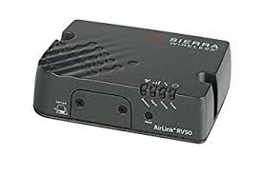Unfortunately, through testing and specification benchmarking of devices available on the market, it became apparent that no modem would be able to meet all of our current and future needs as a single device. Although the authority remains open to alternative options which adequately meet our project requirements, in testing, only one product proved to meet our needs with a mitigation for continued GSM CSD support.

The ***Sierra Wireless RV50*** excelled in all areas apart from the current MMS requirement of Circuit Switched Data compatibility which can be mitigated by continuing to use the data loggers existing modem in parallel (tested). It was also noted that the RV50 is the data logger manufacturer’s (Campbell Scientific) endorsed modem, ensuring ease of setup and its compatibility with the data logger into the future. Another important feature required for this project is a low and consistent power consumption figure, as the data loggers run on solar powered 12v 17Ah batteries. High power consumption will result in a loss of data and low reliability. The RV50’s power consumption is currently claimed as best in class and proved adequate by being controllable through power saving features and controllable standby.

Furthermore, the RV50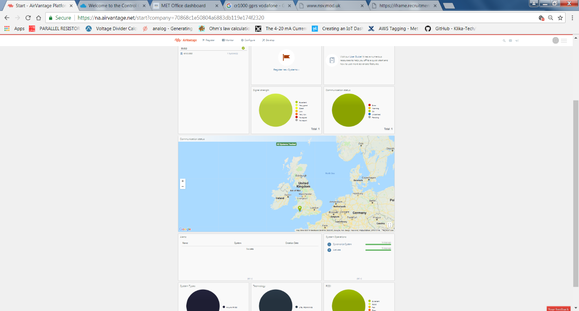 is compatible with the cloud hosted Sierra Wireless remote management platform (AirVantage), which allows for full remote management, configuration and updates of the modem. It also allows for a full overview of the health of the network which is exposed via an API. This could allow for complete integration with our systems network dashboards. As the RV50 uses open protocols (such as LWM2M), it may also be compatible with other management platforms employed by the Met Office.

**Before any purchase takes place the authority wishes to confirm the status of the RV50 as the only suitable product available to fully meet the requirements of this project.** Currently, the authority proposes to purchase the Sierra Wireless RV50 to enable the upgrade of its data logger communication network.

To facilitate the ultimate purchase of these modems **a mini competition will be issued** to the product’s resellers, to ensure value for money during the procurement process. The aim, therefore, of this Market Capability Assessment is to ascertain whether any suitable alternative products are available on the market. Bidders are therefore invited to submit proposals to prove the suitability of their proposed product.

**1.4 – Solution Overview**

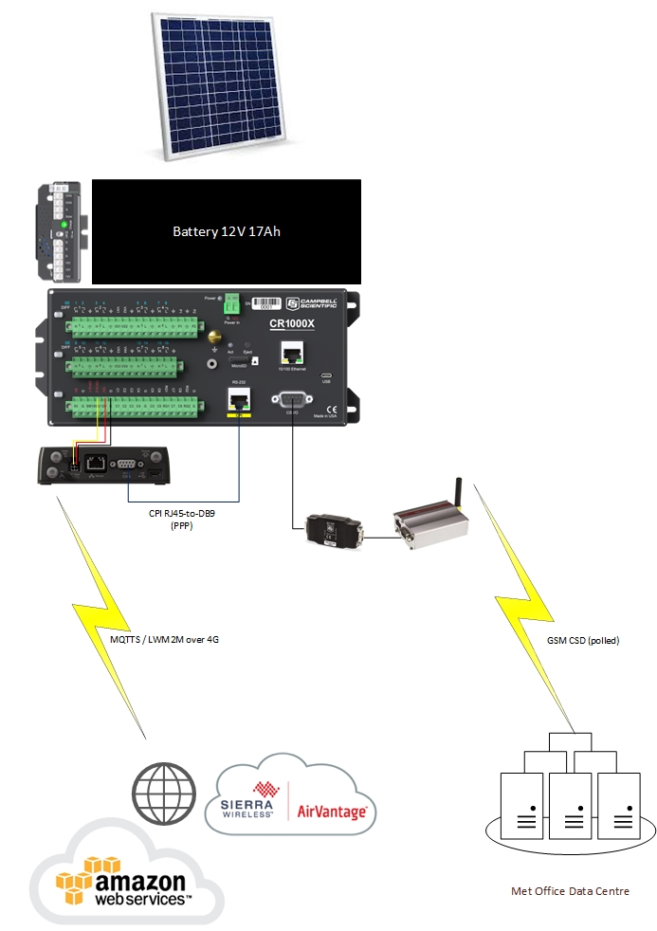

**1.5 Conditions of Submission**

1. You are hereby invited to participate in the following capability assessment to evaluate whether or not you have the ability to supply a solution that is able to fully meet the Met Office’s needs, as detailed below in **2.0 Hardware Specification**.
2. This is not a request for quotation, and the Met Office will not require any form of pricing to be provided at this stage. The purpose of this assessment is simply to understand whether or not there is current capability within the market to meet the organisation’s needs.

By publishing this assessment the Met Office is not, in any way, providing any guarantee of any further action, of any type, against this requirement.

1. Please complete the table below, in full. Failure to do so may result in the rejection of your assessment and the award of a negative response against your organisation.

1. Suppliers **MUST** meet **each and** **every** aspect of the specification in **2.0 Hardware Specification**. Failure to meet any aspect of the specification could result in the failure of the assessment.
2. The deadline for all returns of this assessment is **19th Oct 2018 at 17:30**. Your return **must** be made on the Pro-Contract system. The Met Office reserves the right to reject any assessment returns that fail to meet the deadline as set out in this document. The Met Office reserves the right to unilaterally amend these timescales, provided notification is given to all parties involved.
3. All requests for clarification concerning this assessment **must** be conducted via the correspondence function within Pro-Contract. No other form of communication will be accepted.
4. By signing below, you hereby agree that all information provided, to the very best of your knowledge, is correct and true.

**Supplier Expressions of Interest**

If you believe your organisation can provide an alternative product that equals or exceeds the specifications detailed in this document please indicate in the table below

|  |  |
| --- | --- |
| **Supplier Name** | |
| **I believe my organisation can provide an alternative product which meets or exceeds the specification given below** | **YES**  **NO** |
| (**Insert name of proposed alternative product**) |  |

|  |  |
| --- | --- |
| **Signed** |  |
| **Date** |  |

**2.0 - Hardware Specification**

Please indicate, in the tick boxes below, whether your proposed device can meet the specification.

* Modem must fit in existing data logger enclosure with a maximum space available of 120 mm x 35 mm x 95 mm (please include your device’s specific dimensions)
* The Modem can be powered by a 12VDC battery.

**YES**

* The Modems power consumption is minimal and controllable (e.g. has a low power state controllable from attached data logger)

**YES**

* The Modem is compatible with UK mobile operators and respective frequencies.

**YES**

* The Modem can connect to the internet (and/or AWS) via the data logger (CR1000X) serial interface (CSIO and/or RS-232) using PPP.

**YES**

* The modem can connect to the internet (and/or AWS) via a LAN interface

**YES**

* The Modem can connect to a VPN

**YES**

* The Modem is compatible with a remote management platform that provides the minimum of the following features:
  + Communicate in a secure and cost efficient manner.
  + Centrally manage and perform firmware updates
  + Centrally manage and perform device configuration
  + Monitor and alert device connectivity
  + Monitor and alert data usage

**YES**

* Modem radio technology includes 4G

**YES**

* Modem has the ability to provide network diversity through dual SIM and dual aerials if required.

**YES**

* Modem and associated data logger settings are easy to setup and configure both locally and remotely.

**YES**

**Please provide a specification list detailing the specifications of your proposed product either as a bullet point list or as an attached PDF File**.

* **PLEASE NOTE:** Should it be found now, or at any future time, that any claims to meet the specification, in full, were in fact untrue and known to you at the time, then you will be rejected from taking any further part in this process.
* **If a genuine alternative product that meets or exceeds the described specification is offered, the Met Office will issue an ITT to potential suppliers** to ascertain which product will be ultimately purchased in relation to this project.

Yours Sincerely



Nicholas Taylor

**Sub-Category Manager**

**Met Office**