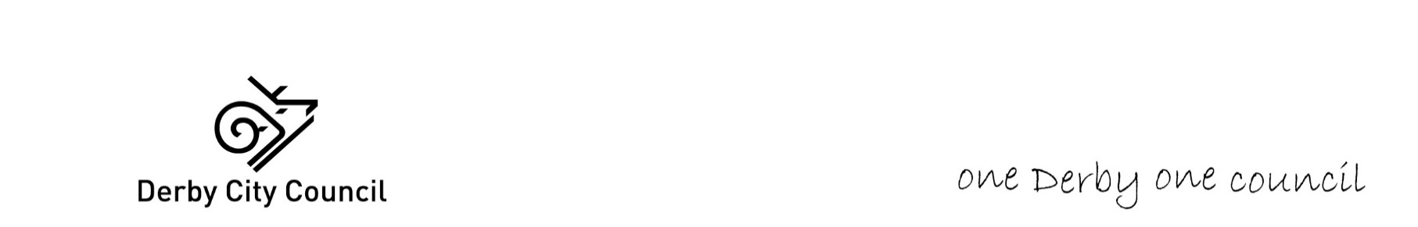

**Soft Market Testing – D2 & NHS ICB Specialist Homes Provision**

**Response Document**

**We would like to consult initially with the market on the feasibility of the model of delivery as outlined in the Overview Document with the following questions:**

**“D2” refers to Derby City Council and Derbyshire County Council**

**Please complete below and return this document by email to Catherine.young@derby.gov.uk** **no later than 5.00pm Friday 31st January 2025.**

|  |  |
| --- | --- |
| **Question** | **Response** |
| Would you be interested in bidding for this opportunity? |  |
| What are your thoughts about working with D2 on the above modelling, expressly the fact that one Local Authority (LA) is purchasing the property, and the other LA would expect you as a provider to bring a property on board?  Are there any issues with how this would be undertaken by yourselves, or considerations to be taken into account? |  |
| What is your preference?   1. Derby City Council contract with 1 home x 2 beds,   or   1. Derby City Council and Derbyshire County Council contract with 2 homes x 4 beds across the D2 footprint?   Which would be more financially viable? |  |
| What are your thoughts about working with D2 on the above modelling, expressly the fact that one LA is purchasing the property, and the other LA would expect you as a provider to bring a property on board?  Are there any issues with how this would be undertaken by yourselves, or considerations to be taken into account? |  |

**Many thanks for taking the time to respond.**