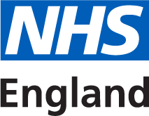

NHS England
Specialised Commissioning
Commercial Medicines Unit
Rutland House
Second Floor
Runcorn
Cheshire
WA7 2ES

01133 916904
tom.redfearn@nhs.net

Tuesday 5 September 2017
To Whom it May Concern:

Invitation to offer for NHS Framework Agreement for Proprietary Pharmaceuticals - Midlands and East Tranche A
Offer reference number: CM/PHR/15/5486/00
Period of framework agreement: 1 March 2018 to 29 February 2020 with an option to extend (at the Authority’s discretion) for a period or periods up to a total of 24 months

The NHS Commissioning Board (Operating under the Name of NHS England) (‘Authority’) invites offers for the above mentioned goods and/or services as defined in Document No.03 Framework Agreement and Terms and Conditions. Offers shall be made subject to the terms of:

Document No.01 This covering letter
Document No.02 Terms of offer
Document No.03 Framework Agreement and Terms and Conditions
Document No.04 Contract technical specification
Document No.05a Product listing and usage
Document No.05b Selectt offer schedule – CM_PHR_15_5486_00
Document No05c Offer Schedule - CM_PHR_15_5486
Document No.05d Selectt offer schedule instructions
Document No. 06 Instructions on completing the tender
Document No.07 Form of offer
Document No.08a Quality control technical sheet
Document No.08b Guidance for performing a pharmaceutical quality assessment of licensed medicines for the NHS
Document No.09 Confidential information schedule

all of which constitute this Invitation to offer.

If any of the documents constituting the Invitation to offer is missing please contact the undersigned immediately via the Bravosolution messaging portal.

The Authority does not bind itself to accept the lowest offer or any offer at all and reserves the right to accept an offer either in whole or in part, each item being for this purpose treated as offered separately. The Authority reserves the right to conclude a framework agreement for the supply of the goods and/or services with more than one Offeror.

I would like to draw your attention to the following important points when completing and submitting your offer:

1. All offers must be written in English.

2. All offers must be submitted subject to and in accordance with the documentation comprising the Invitation to offer. Save where the Offerors are instructed to provide information, the documentation comprising the Invitation to offer must not be amended in any way.

3. All offers must be loaded onto the Commercial Medicines Unit’s eTendering portal https://nhsengland.bravosolution.co.uk/web/login.html

4. Offers must be open for 90 days.

5. Offers must be fully completed and available on the designated website no later than 1 pm on Tuesday 10 October 2017.

I must also draw your attention to the enclosed Form of offer where all the requirements for completing and submitting an offer can be found. Failure to comply with these instructions may result in your offer being rejected.

I hope that the above instructions are clear but please contact the undersigned via the Bravosolution messaging portal if there is anything you wish to clarify.

Yours faithfully,

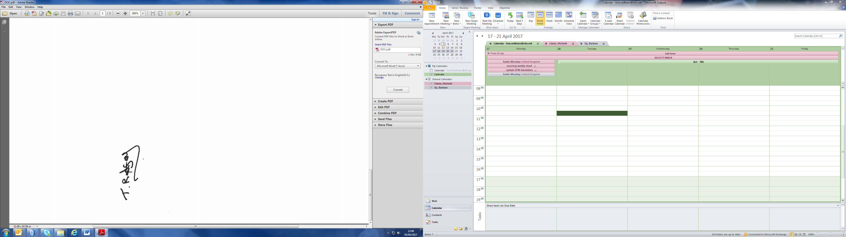

Tom Redfearn
Operations Adviser and Developing Commercial Practitioner

