DRAFT SCHEDULE 2 – THE SERVICES

- Service Specifications

This is a non-mandatory model template for local population. Commissioners may retain the structure below, or may determine their own in accordance with the NHS Standard Contract Technical Guidance.

Service Specification No.
Service | Advice, guidance and support service for families of children and young people aged 0-25 years with or without a diagnosis of Autism and /or ADHD
Commissioner Lead | Sally Murray Head of Children’s Commissioning
Provider Lead | TBA
Period | 1 January 2021 until 31 March 2023, with an option to extend the contract for any number of periods up to a further two years at the discretion of the Commissioner
Date of Review
Allocated funding | £60,000 per financial year

1. Population Needs
  - National/local context
Every person with autism and or ADHD will have unique talents; it is important that people are supported as early as possible and receive the appropriate support, so that they can truly tap into their potential and live independently.

As part of the Autism/ ADHD/ neurodiversity service review work undertaken in Berkshire West in 2019 and 2020, the CCG invited partners from across the system to participate in 2 planning workshops to explore and decide on actions to help improve and promote awareness of and access to health, education, social care and voluntary sector services to empower and help people with their emerging and actual needs.
The need for an accessible offer bringing together the support that is available to families and how to access it was identified. Partners agreed that this should comprise of
- a one stop shop where families and support workers/ voluntary sector partners can access up to date local advice and guidance including signposting to what help is available and where
- a clear service offer guide for families relating to children and young people aged 0-25 years who may have Autism, ADHD and comorbid presentations as well as those with a confirmed diagnosis
- support available in a range of formats to meet the needs of individuals including via telephone, face to face as well as online
- provision of advice and support as part of a wider stepped care approach
- promotion of consistent and up to date messages.
- promotion of resources

This service specification focuses on early support/ ongoing support/workshops for children and young people aged 0-25, parents and carers, to support children, young people with autism and/or ADHD (N.B. a diagnosis is not necessary to access this service). The service specification has been developed as a result of a number of co-production workshops and sessions where service and support gaps and needs have been identified.

There are a number of strategies and guidelines concerning autism and ADHD across health, education and social care. The national strategy has developed over the last 10 years and will continue to evolve over time, some strategies relate to children and young people and other adults. This service specification recognises the following legislation, national policies and guidelines:
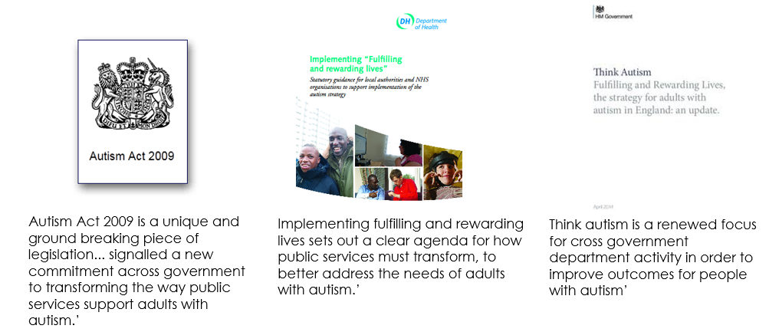
NHSE Autism Deep Dive May 2020
- NHS Long-Term Plan
- Five Year Forward View for Mental Health 2016
- Parity of Esteem (Health & Social Care Act 2012)
- The Transforming Care Programme
- The Children and Families Act 2014
- NICE Quality standards and guidance
- National Autistic Society (NAS) has led a number of high profile campaigns aimed at raising awareness and promoting positive change for people with
- Autism. These include:
  - Make School Make Sense (2006) – what families want from the education system
  - I Exist (2007) – understanding the needs of adults with autism.
  - You need to know (2009) – mental health for children with autism
  - Don’t write me off (2009) – support into employment
  - Supporting adults with autism (2009) – good practice guidance from NHS and local authorities
  - Great Expectations (2011) – developing and an education system that sets children up for life
  - Push for Action (2013) – getting the right services and support in place
  - Getting on (2013) – growing older with autism
- NHS England: Developing support and services for children and young people with a learning disability, autism or both
- NHS England Autism Diagnosis and Support Deep Dives May 2020

Building on the national context, there are a series of regional and local drivers that are important to consider, including:
- Each local area’s autism strategy
- Evolving work across the Integrated Care System and Partnership
- Each local area’s SEND strategy

  - The National Data
Prevalence figures for autism vary between 1 in a 100 and 1 in 68 (1-1.5%)
It is fair to say that prevalence studies vary but “indicate that 1.1% of the population in the UK may be on the autism spectrum. This means that over 695,000 people in the UK may be autistic, an estimate derived from the 1.1% prevalence rate applied to the 2011 UK census figures. The prevalence rate is based on two relatively recent studies, one of children and the other of adults. The prevalence study of children, (Baird G. et al., 2006) looked at a population in the South Thames area. The study of adults was published in two parts, Brugha et al (2009), and The NHS Information Centre, Community and Mental Health Team, Brugha et al (2012). This is the only known prevalence study to have been done of an adult population.”
Around 3-6 in every 100 school-aged children have ADHD. For about 1 in 7 children with ADHD, their ADHD will continue into adulthood. About half will have some issues as adults, although not full ADHD. In children, boys are more commonly diagnosed than girls.
70% of children and 80% of adults with autism will have at least one mental health condition which may include ADHD.
Around 66% of children and 92% of adults living with ADHD are undiagnosed.
Around 60% of adults aged 40+ living with autism are undiagnosed.
Autism is usually diagnosed from age 3-4 years.
ADHD is diagnosed from 6 years onwards.
3 times as many boys as girls are diagnosed with autism.
3 times as many boys as girls are diagnosed with ADHD. In adults, there are more equal numbers of men and women seen in clinics.
For every person with autism or ADHD, 3 more people are affected surrounding the individual
About one third of children with ADHD have a diagnosis. For adults this is 7-8% of the expected prevalent population.
1 in 10 children and 1 in 4 adults experience mental illness.
50% of all adults with mental ill-health experience their first symptoms by age 14 and 75% by age 24.
70% of children and 80% of adults with autism will have at least one mental health condition (including ADHD).

1.3 Local data
The estimated resident population of Berkshire West CCG was 488,286 in 2018/19. Children and young people aged 0 to 16 made up 26% of this population, compared to 21% in England.

Local EHCP data suggests that the prevalence of autism is greater in Berkshire West than national data would suggest.

Number of Children and Young People who have an EHC Plan
 | Total EHC Plan~ | Primary Need ASD (no.)~ | Primary Need ASD (%)~
Reading | 1414 | 493 | 35%
West Berkshire | 1031 | 465 | 45%
Wokingham | 1141 | 473 | 41%
Total Berkshire West | 3586 | 1431 | 40%

Source
~ Local Authority SEND data May 2020
There is no data for ADHD as this is not an area of primary need in SEND returns.
There is a further cohort of preschoolers, children and young people who do not have an EHCP who have ASD/ ADHD/ needs relating to neurodiversity.

Local EHCP data suggests that the prevalence of autism is greater in Berkshire West than national data would suggest.
Summary population and estimated prevalence Berkshire West based on national prevalence data
Local Authority | Segment | Population size (2018/19)^^ | Prevalence ASD |  | Prevalence ADHD
Local Authority | Segment | Population size (2018/19)^^ | % | No | % | No
Reading | Pre-school (<5) | 11289 | 1.1% | 124 | - | -
Reading | School (5-16) | 22525 | 1.1% | 248 | 4.5% | 1014
Reading | Adults (>16) | 127966 | 1.1% | 1408 | 3.5% | 4479
West Berkshire | Pre-school (<5) | 8980 | 1.1% | 99 | - | -
West Berkshire | School (5-16) | 22663 | 1.1% | 249 | 4.5% | 1020
West Berkshire | Adults (>16) | 126884 | 1.1% | 1396 | 3.5% | 4440
Wokingham | Pre-school (<5) | 9822 | 1.1% | 108 | - | -
Wokingham | School (5-16) | 25621 | 1.1% | 282 | 4.5% | 1153
Wokingham | Adults (>16) | 132536 | 1.1% | 1458 | 3.5% | 4639
Berkshire West Total | Pre-school (<5) | 30091 | 1.1% | 331 | - | -
Berkshire West Total | School (5-16) | 70809 | 1.1% | 779 | 4.5% | 3186
Berkshire West Total | Adults (>16) | 387386 | 1.1% | 4261 | 3.5% | 13558

Sources:
^^ LA ONS Population estimates 2018/19
* Estimate generally used in Literature and strategy papers
- https://www.rcpsych.ac.uk/mental-health/problems-disorders/adhd-in-adults
- https://www.nice.org.uk/guidance/ng87/evidence/full-guideline-pdf-4783651311
https://www.rcpsych.ac.uk/mental-health/parents-and-young-people/information-for-parents-and-carers/autism-for-parents-carers
- No prevalence found for ADHD in pre-school, since diagnosis takes place from 6 years old
2. Outcomes
2.1 NHS Outcomes Framework Domains & Indicators

Domain 1 | Preventing people from dying prematurely | $$√$$
Domain 2 | Enhancing quality of life for people with long-term conditions | $$√$$
Domain 3 | Helping people to recover from episodes of ill-health or following injury | $$√$$
Domain 4 | Ensuring people have a positive experience of care | $$√$$
Domain 5 | Treating and caring for people in safe environment and protecting them from avoidable harm | $$√$$

2.2 Local defined outcomes
Overall service outcomes:
Families and service users state that they feel supported and report that they
- know how to access local advice and guidance to enable them to support their child’s autism and/or ADHD and associated concerns such as sensory sensitivities
- know how to access appropriate services and support for their child
- have a greater understanding of what autism and/or ADHD is
- have understanding and strategies to support their child with anxiety, emotional and behavioural issues
- have strategies to support their child’s eating, toileting and sleeping
- have had the opportunity to access support for their own wellbeing before issues escalate
- children and young people who access the service report improved goal based outcomes
- know what a GP learning disability health check for people aged 14 years and over is, and how to request one
- feel informed and supported about the transition process for their young adult moving from Children’s Services into Adult Social Care and the CTPLD team

Families and service users state that they feel included and report that they have access to advice, guidance and support in their preferred medium- written, online (accessible by smartphone), via telephone, face to face, text.
3. Scope
3.1 Aims

The service will support the local cultural shift in moving away from the need for a diagnosis to meeting the person’s individual needs through appropriate support. The scope of this service is to provide a range of elements of support from the early signs through pre and post assessment of Autism and/or ADHD for children and young people age 0-25 as part of a stepped care approach with partners.

The service will provide a range of opportunities including a navigating/signposting role, support workshops for families/carers and contributing as required to the development and updating of any local autism resources.

This approach should enhance current provision and support with the purpose of improving the quality of life for children, young people, parents, carers and families with autism and/or ADHD within Berkshire West.

3.2 Objectives

To provide
3.2 A. Getting Advice – a navigator programme – initial advice and signposting across Berkshire West:
- Early support. Work with existing services including the early help hubs in each LA, to create a central point of contact (e.g. single telephone line) which will provide advice, information, signposting and navigation to access the most appropriate form of early support, for children and young people 0-25 who may have Autism and/ or ADHD.
- Provision of an initial point of contact offering advice and signposting to help support families to help access the right support based on their specific needs. This will include a central point of contact (e.g. single telephone line) which could include telephone, online and face to face contact.
- Signposting will include credible local and national organisations – e.g. the National Autistic Society.
- Signposting to neighbouring support hubs across the border (East Berkshire, Oxfordshire, North Hampshire and Wiltshire) when appropriate.
- Signposting to providers who can support the emotional health and wellbeing of the parent/carer
- Signposting to Special Educational Needs and Disabilities Information Advice and Support Service (SENDIASS) when appropriate

3.2B Getting help – Support sessions & workshops based on the needs of those living in Berkshire West.
These will take place in accessible locations in each locality- Reading, West Berkshire and Wokingham. Online resources including webinars will also be offered.
- A programme of introductory level support strategies:

-Understanding autism and ADHD and key strategies to support the child/ young person.
-Evidence based/ evidence informed workshops/ webinars on topics related to supporting neurodiverse children and young people with sleeping, eating, toileting; managing anxiety, emotional and behavioural needs, autism in girls. This list is not exhaustive and should reflect need in Berkshire West.
-Transition- equipping parents/ carers and the young person with knowledge, skills and confidence to support them with the transition to adulthood. There will be strong links with each local area transition team.

- A programme for children and young people age 5 -25 years, offering age appropriate small group workshops and groups to help them recognize their strengths and support as needed with social skills and confidence in a supported setting. e.g. life skills group sessions, friendship skills, reducing their own anxiety. Goal based outcomes for children and young people will be collated and reported on.

- A network for peer to peer support for parents and carers.

Where possible the provider should deliver programmes informed by the current evidence based and aligned to local approaches. The programme of delivery must be developed in partnership with key local autism and ADHD services/leads from Local Authorities (Autism leads/Education Psychology services) and from health (Berkshire Healthcare NHS Foundation Trust, Royal Berkshire Foundation Trust) linked to credible local and national organizations.

Relationship building and communication:

- The provider will provide a fully integrated service, through building strong working relationships with: Berkshire Healthcare NHS Foundation Trust; Autism, ADHD and SEND support teams in each local area; SENCO networks and parent/carer forums
- The programme of delivery must be developed in partnership with key local leads from Local Authorities (Autism leads, ADHD leads, Education Psychology services) and from health (Berkshire Healthcare NHS Foundation Trust, Royal Berkshire Foundation Trust)
- The service will operate in close partnership with other services including LAs early help systems, the respective Autism and ADHD support teams in each local area, education, social care and the voluntary sector.
- The service will offer a range of local promotion opportunities to a range of key stakeholders such as schools/ social care and a range of resources to facilitate awareness, engagement, uptake and evaluation. The provider will need to develop a communications and engagement plan in collaboration with the CCG and local authorities.
- The provider will ensure pathways to all relevant local services are identified and followed, with clear lines of communication established and ensuring that relevant staff in those organisations are aware of the service
  - The provider will ensure a prompt and efficient response to concerns raised by the commissioner, young person or other local stakeholder within 2 working days
- The provider will ensure a prompt and efficient response to queries raised by the commissioner, young person or other local stakeholder within 5 working days
  - The provider will demonstrate how service user feedback is used to inform continuous service development and practice, and how children, young people and families are involved in coproduction and wider decision making across the organisation from governance to design.
- There is an expectation that the provider will provide a range of opportunities including a navigating/signposting role, support workshops for families/carers and contributing as required to the development and updating of any local autism / ADHD resources.

3.3 Service description/Pathway

Key to achieving a fulfilling life with Autism and or ADHD is having easy access to information and advice about the support that is available. This is important regardless of whether someone wishes to stay at school, leave home and go to university, apply for a new job or maintain a new tenancy. Later in life, it may be important for to have consistent caring arrangements in place for themselves or a loved one, and to have clear information about accessing welfare, benefits or other welfare rights information. Those involved in our local workshops said that it can sometimes be hard to know where to go for advice and information locally.

As part of our Future In Mind work, partners, agreed have adopted the THRIVE model in service provision. 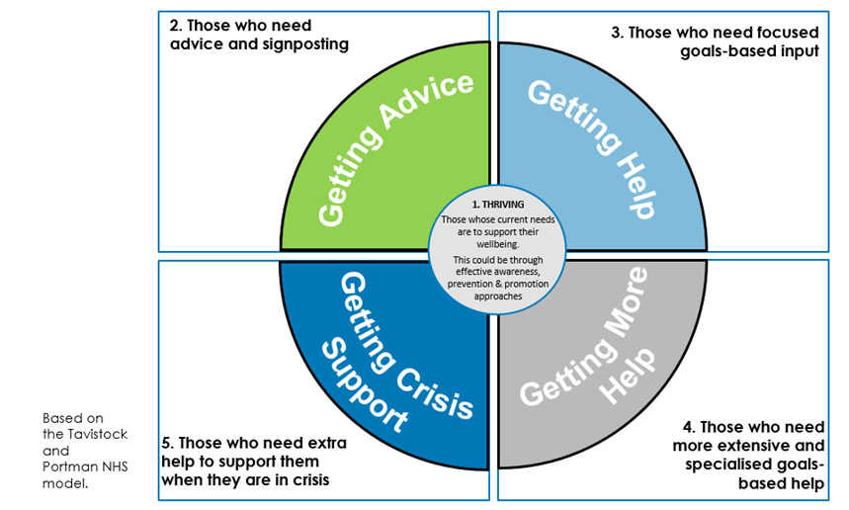

There are many models upon which we could base our proposed blueprint for Berkshire, however, long-term, quantifiable evidence is limited in this area. Having considered the models that are available, the evidence about where they have been used successfully and the needs of our community, our model of care is based on the THRIVE framework.

The framework is needs-led, meaning that people’s needs are defined by them and their families, alongside professionals, through shared decision making. Needs are not based on severity, assessment, or healthcare pathways. This resonates with the feedback received from stakeholders in the engagement process.

The framework balances the needs to provide good quality early intervention and resilience-building to tackle issues early, with the need for some people to access more specialist care.

The THRIVE framework was developed by the Tavistock & Portman NHS Foundation Trust and the Anna Freud Centre, in consultation with children, families and service provider - see here for more information http://www.implementingthrive.org/

Whilst the framework is based on children and young people, the key features are easily transferable across children and young people 0-25:
- it outlines groups of people and the sort of support they may need, drawing a clear distinction between support and treatment (services).
- it focuses on a wish to build on individual and community strengths wherever possible and to ensure people are active decision makers in the process of choosing the right interventions.
- it has been successfully used in other parts of England to shape a positive culture and support and services for children and young people’s emotional wellbeing and mental health.
- its structure is closely aligned with what we are trying to achieve in Berkshire West.

To support the delivery of the new model of care and the developing Autism and ADHD pathway in Berkshire West, there will be increased co-ordination of providing advice and information and standardisation of the support currently provided for children/young people/adults, parents, carers and families.

Where possible, support workshops and group sessions should be based on identified evidenced need and should be co-designed with service users and families/partners. Sessions should be accessible and reasonable adjustments need to be made to be as inclusive as possible.
Core, evidence-based, autism/ADHD-specific support (including online support), workshops and strategies which can also be provided through face to face and home visits will be provided to enable and empower children/young people/adults and families to make progress towards the goals they have identified as important to them. The provider will need to develop a support programme jointly with children/young people/adults and parents/families and this will require annual review.

The support and workshops that will be delivered will be designed and tailored according the needs of those living in Berkshire West and will achieve the outcomes listed in section 2 of this specification. The provider will work with the CCG and partners e.g educational psychologists, SENCO networks and with Berkshire Healthcare Foundation Trust, Royal Berkshire Foundation Trust autism/ADHD services for children and young people aged 0-25, to agree the final support programme offer. The support programme offer will be located within the Local Offer in Reading, Wokingham and West Berkshire as well as promoted through partner agencies.

3.4 Referral mechanism
There is an open referral policy for this service.

3.5 Any acceptance and exclusion criteria and thresholds
The service is open to children and young people aged 0-25 years and their families who are registered with a Berkshire West GP who have a presenting need relating to Autism and /or ADHD. This could be at the early identification of needs or pre-assessment stage or post assessment stage where a diagnosis of autism/ ADHD has been made.
The service is not open to people who do not meet these criteria.

3.6 Monitoring and Evaluation:

- All attendees of the workshops and courses will be asked to complete a pre-intervention and immediate post-intervention questionnaire. The questionnaires should use a combination of validated quantitative rating scales and qualitative free text questions.

- 5% of parent/carers who have attended more than one of the interventions via this service will be invited to take part in a semi-structured phone interview.

Reporting:
- Data must be reported in line with the requirements of the Mental Health Service Data Set, this is to ensure the work contributes to the national access standards and reporting of routine outcome measures.
- Provider(s) will need to play a full and active part in the evaluation of the service, including the production of;-
- An annual summary report no later than four weeks following the end of the last quarter (and if the optional contract extensions are used), as well as quarterly reports.
- Both reports should summarise quantitative activity and outcomes data and qualitative data from young people and stakeholders, such as schools and Early Help teams.
- Quarterly reports will be submitted to the lead commissioner with a follow up visit to discuss progress and issues. The quarterly reports will provide details of key data on project progress, risks and issues.

The KPI reporting tool will be developed with partners and the service provider within the first month following contract award.

3.5 Interdependence with other services/provider

  - Berkshire Healthcare NHS Foundation Trust
  - Royal Berkshire Foundation Trust
  - Autism Teams in Reading, Wokingham and West Berkshire including but not limited to ASSIST in Wokingham, West Berkshire Autism Team, and Reading Autism Advisor.
  - Emerging ADHD support teams in Reading, Wokingham and West Berkshire
  - Early Help teams in Reading, Wokingham and West Berkshire
  - Voluntary sector organisations
  - Educational psychologist teams
  - SENCO networks
  - Parent/carer forums
  - Family Information Services

4. Applicable Service standards
4.1 Applicable national standards (e.g. NICE)

It is considered best practice for all health-related services to young people to meet the quality criteria specified in “Quality Criteria For Young People Friendly Health Services” (DH, 2011); which include accessibility, confidentiality and consent, staff support and attitudes and involvement of young people in monitoring and evaluating their experiences. Fraser Guidelines (1985)

In addition the Service is expected to be provided in line with all relevant statutory policies and frameworks and work together with the Authority Commissioner to ensure compliance, monitoring of standards and work towards continuous improvement.

The evidence base for the treatment of Autism and ADHD and for providing support is based on the following NICE guidance:

Autism spectrum disorder in under 19s: recognition, referral and assessment: https://www.nice.org.uk/guidance/cg128/resources

Autism spectrum disorder in adults: assessment and management:
https://www.nice.org.uk/guidance/cg142/resources

Attention deficit hyperactivity disorder: assessment and management:
https://www.nice.org.uk/guidance/ng87

4.2 Applicable local standards

The service will be compliant with Section 11 of the Children and Families Act 2004.
Safeguarding Children Procedures for Reading, West Berkshire and Wokingham https://proceduresonline.com/berks/

5. Location of Provider Premises
The Provider’s Premises are located at: XXXXX

6. Appendices

