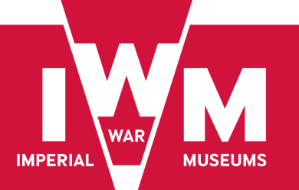
Contract No: IWM/ASA/1709
Legal Services – All Saints Development

Question & Answer Sheet No. 2

- Paragraph 2.5. of the Brief refers to the PDP developing the All Saints building "to the specification required". We assume that is a specification required by IWM, but please confirm.

This will be developed following the appointment of a developer, but with the assistance of our property advisor

- We also assume that IWM is looking to control the development of the All Saints building due to its proximity to the existing retained estate, the new office block to be built and the surrounding residential properties. Please confirm if this is correct or if there is an alternate objective. In the latter case, please specify what the objective is.

We will need to be clear about the demise of the new build and the leased building.

- You refer in paragraph 5.1 of the Brief to heads of terms. Are there any draft HoT at this stage and, if so, can we please have a copy?

Not at this stage. This will be the initial task of the legal appointment

- Paragraph 5.3 of the Brief refers to IWM's property adviser. Has one been appointed yet and, if so, can you please confirm who it is?

In the process of appointing

- Section 3 of the Brief mentions that interviews will be held on 30 May. This falls during the half term holiday. Is there any flexibility as to the date of the interview?

No. Unfortunately we need to move forward as per the programme, so currently the 30 May date will be the interview date

- Can you please provide a brief description of the contemplated works likely to be carried out?

No development yet approved so this is subject to discussions with the prospective developer

- Can you please provide us with the Appendix A attachment?

Please find below the floor plans for the current All Saints building

All Saints Level A current.pdf
All Saints Level B current.pdf
All Saints Level C current.pdf
All Saints Level D current.pdf
All Saints Level E current.pdf

Simon Bourne
Head of Procurement & Compliance
10 May 2017

