

Programme Evaluation
Invitation to Tender

ROAD: Reaching Out Across Durham

Building Better Opportunities for residents of County Durham aged 25+

Providing One–to-One intensive support that encourages and enables participants to achieve their goals as they move towards and into education, job search and training
Reference: BBO

Address: Groundwork NE & Cumbria
Grosvenor House
29 Market Place
Bishop Auckland
DL14 7NP
north.east@groundwork.org.uk

Website: Interested parties may wish to visit our website at: www.groundwork.org.uk/sites/northeast

Commissioning Body: Groundwork NE & Cumbria

Company limited by guarantee and registered in England No. 2702815

Charity Registration No: 1017706

Registered Office: Groundwork NE & Cumbria
Grosvenor House
29 Market Place
Bishop Auckland
DL14 7NP

Commissioning Officer: Craig Drummond: ROAD Partnership Lead

Contents
Opportunity and Context 5
The Opportunity 5
Context 5
About ‘ROAD’ – Reaching Out Across Durham 6
Programme Overview 6
Delivery Model 7
Locations 8
Outcomes & Results 8
Participant Outcome 1 8
Participant Outcome 2 9
Target Outcome 3 9
Target Outcome 4 9
Cross Cutting Themes 9
About Groundwork North East & Cumbria 9
Our Vision 9
Tender Details 10
The Successful Tenderer 10
Key Aims 11
Expectations 11
Key Outputs 11
Research Questions and Indicative Methods 12
Effectiveness of the Programme Model 12
Measuring Impact 12
Indicative Methods 13
Copyright and Intellectual Outputs 13
Data Protection 14
Budget 14
Responding to the Tender 14
Format of Response 14
Queries 14
Procurement Process 14
Further Information 16
Appendices 17
Appendix A: Selection Criteria 17
Appendix B: Customer Journey Diagram 18
Appendix C: Project Outcomes 19
Participant Outputs 19
Participant Results 19
Participant Outcomes 20

Opportunity and Context

The Opportunity

Groundwork NE & Cumbria is seeking a partner to undertake a mixed methods programme evaluation of ROAD: Reaching Out Across Durham.

Context
Building Better Opportunities sees the Big Lottery Fund matching funds from European Social Fund (ESF) 2014-2020, to provide joint investment in local projects that tackle poverty and promote social inclusion and drive local jobs and growth.

ESIF strategy for the North East LEP area

The North East LEP area’s European Structural and Investment Fund Strategy for 2014 – 2020 identifies strategic weaknesses for the region to address.

Amongst them are:

- Employment and inclusion
- Skills
- Enterprise rates
- Digital connectivity
The strategy recognises that ‘employment is the key route to combating poverty and exclusion’ and points out the relatively high levels of unemployment and economic inactivity
Groundwork NE & Cumbria is the lead partner for BBO in County Durham. Working with 11 voluntary and community sector delivery partners Reaching Out Across Durham (ROAD) will target 625 of the hardest to reach and provide them with intensive support and advice to help them move towards employment and or training. ROAD will also develop new services that our participant’s will be able to access including health, financial and digital inclusion activities as well as supporting them to access existing services
The Programme will run until July 2019.

About ‘ROAD’ – Reaching Out Across Durham

Programme Overview

Reaching Out Across Durham’ (ROAD) brings together twelve well respected voluntary and community sector organisations who want to make a real difference to the lives of 625 people in County Durham. We will achieve this by providing 1:1 intensive support that encourages and enables participants to achieve their goals as they move towards and into education, training, job search and employment.

We know that the needs of many people in County Durham are still not being met, making it increasingly difficult for them to overcome the challenges they face preventing them from entering employment. ROAD has been developed to add value to, and address the gaps within, existing provision by aligning and working with the excellent range of services that are currently being delivered. Through ROAD, we want to ensure that all our participants have a positive experience and access the right support for them in a way that breaks down barriers and challenges perceptions.

We are confident that ROAD will make this a reality through:

- Our enthusiastic partners who are passionate about making a difference to the lives of those they work with in County Durham.
- Learning from our existing service users and co-designing ROAD to address their needs.
- Adding value to and joining up with, rather than duplicating, existing services.
- Offering 1:1 support for individuals over a longer time frame and providing them with help to improve their health and wellbeing.
- Combining digital capabilities with financial advice as these skills complement each other.
- Providing individuals with the self believe and confidence to achieve their goals.
- Raising awareness of the range of employment opportunities in County Durham and by working with considerate employers and local businesses.
- Being flexible, learning from each other and our participants so we truly believe ‘Reaching Out Across Durham’ will help those who need our support most.

In order to achieve these aims we have developed a partnership that brings together organisations who are capable of providing specialist support for those with complex needs. Together, our focus will be on identifying and helping those most in need of support.

Our approach will be to work closely together and collaboratively with local stakeholders, to provide an accessible and responsive service that encourages participants to succeed and provides clear pathways into positive progressions.

Delivery Model

Our delivery model has been designed in consultation with participants and local stakeholders, and draws on a range of successful interventions delivered previously by partners. Central to our model is the deployment of Navigators who will build trust with participants, encouraging them to set positive goals and helping them navigate a tailored path towards improving their lives which may include education, training, employment and job search.

We will support participants through: a team of dedicated Navigators - Working with at least 30 people per annum. Our team of 8 Navigators will provide intensive 1:1 advice, support and encouragement to individuals to help overcome barriers and progress towards work by:

- Targeting and engaging participants facing multiple/complex barriers
- Undertaking asset-based assessments and co-producing action plans identifying goals, barriers and appropriate support activities, regularly reviewing progress
- Working with participants to build essential soft skills, utilising the existing services or ROAD provision to address barriers, and offering health, financial and digital support
- Facilitating participant forums and recruiting volunteers and Peer Mentors to support delivery
- Providing one-to-one and group training in team work, problem solving, self-management and work ethics, to include job search, applications, cv and interview support
- Sustaining positive outcomes by continuing to provide low-level support to participants progressing into work, training or learning

Specialist Support will include:

- Health & Wellbeing - Provide activities that focus on health barriers to employment and address health-related behaviours. Promote healthy lifestyles to enable individuals to become fit for work and support people with mental health issues. Group activities in art and sport
- Financial Inclusion - Activities to support people to improve their financial capability (the knowledge, skills, confidence and motivation to be able to manage their money well) and improve their awareness of and use of appropriate financial products and services
- Digital Inclusion - Improving basic digital skills (managing information, communicating, transacting and problem solving) with an emphasis on progression into economic activity and addressing the challenges people face to going online. We will also support those in crisis situations

Locations

ROAD will support participants across County Durham. ROAD partners will operate from a range of accessible local delivery hubs, including community buildings giving us capacity in urban centres and reach into more rural areas.

Although all residents of County Durham will be eligible, ROAD will support participants from the most deprived Lower Super Output Areas as set out below; these are communities with low levels of employment, income and educational achievement:

- Bishop Auckland and Shildon
- Seaham, Peterlee and outlying areas in East Durham - Thornley, Trimdon, Blackhall
- Crook, Willington and Tow Law
- Newton Aycliffe and Spennymoor
- Cornforth and Ferryhill
- Consett and Stanley
- Chester le Street - Pelton Fell, Grange Villa, Pelaw
- Areas surrounding Durham City - Brandon, Gilesgate, Bowburn, Sherburn Village

Outcomes & Results

ROAD will achieve the following results

- 100 participants will move into education or training on leaving
- 100 participants will progress into employment (including self-employment)
- The above figures will be split 50:50 between male and female
- 110 participants who were economically inactive when joining ROAD will be job searching when leaving

We will work with 625 people and of those:

- 312 will be men
- 313 will be women
- 312 will be unemployed
- 313 will be economically inactive
- 94 will be aged 50+
- 125 will have a disability
- 13 will be from an ethnic minority

Participant Outcome 1

- 470 participants will report increased aspiration and motivation
- 470 participants will report increased job specific skills and experience
- 470 participants will report increased job search skills
- 370 will report reduced financial and digital barriers to employment

Participant Outcome 2

- 300 participants will report a healthier lifestyle
- 300 participants will report improved well-being
- 300 will report feeling more positive

Target Outcome 3

- 50 employers will have employed a participant
- 25 employers will report improved perceptions of people who have been long term unemployed or economically inactive
- 25 employers will be more willing to employ people who have been long term unemployed or economically inactive

Target Outcome 4

- 24 Voluntary & Community Sector organisations will report improved ability in working with the hardest to reach
- 24 Voluntary & Community Sector organisations will report improved ways of delivering activity whilst working with the hardest to reach clients
- 24 Voluntary & Community Sector organisations will report improved learning across different specialisms relating to employability, health & wellbeing, digital and financial inclusion

Cross Cutting Themes

There are two cross-cutting themes for ESF which must be fully integrated in the delivery of our project. These are: sustainable development and gender equality and equal opportunities.

About Groundwork North East & Cumbria

Our Vision

A society made up of vibrant, healthy and green communities

Our Mission

To enable communities and individuals to realise their potential by:

- Creating better places
- Improving people's prospects
- Promoting greener living and working

We work across the North East and Cumbria helping communities find practical sustainable solutions to the challenges they face. We provide training and create jobs, reduce energy and waste, reconnect people with nature and transform whole neighbourhoods.
Groundwork NE & Cumbria is environmentally aware and focused on communities in need. We aim to be collaborative, show integrity and strive for quality in everything we do.

Tender Details

The Successful Tenderer

The successful tenderer is likely to have experience in, or be:

- Active, ‘in the field’ assessment of employability style interventions

  - Working with third sector organisations and understanding the specific challenges faced by this sector

  - Working with a wide range of stakeholders, including local authorities, employers, Local Enterprise Partnerships and statutory services

- an understanding of and sympathy with Groundwork’s mission and objectives¹

- embedding evaluations within relevant policy context

- researching and understanding relevant commissioning landscapes

  - Writing clear and impactful reports and case studies for a variety of audiences working flexibly and in close partnership with a commissioning organisation

¹ http://www.groundwork.org.uk/Sites/northeast/Pages/our-vision-northeast

Experience in evaluating person-focussed interventions concentrating on one or more of the following areas would be advantageous:

- transitional periods (for example moving from education to employment) employability skills

- coaching and mentoring models

- vulnerable and/or high needs participants

Joint or consortium bids with academic bodies or other third party evaluators are acceptable but not necessarily preferred, and encouraged from agencies with complementary capabilities, with the proviso that they must show they meet the criteria and all agencies must not be subject to any exclusions or disqualifications stated below. Joint bids must designate a lead bidder and contact to act as the key contractor for Groundwork North East & Cumbria’s purposes.

In order to ensure that this research is impartial and relevant, Groundwork NE & Cumbria will not award the contract to any party who has:

- canvassed any Groundwork North East & Cumbria’s or Groundwork Trust personnel or Board Members a personal relationship of any kind to any person employed by or on the Local and Federation Boards of Groundwork

- previously undertaken work for Groundwork NE & Cumbria which has not been completed to our satisfaction

Contracts awarded where the above criteria are later declared will be declared null and void, and any payments made must be repaid to Groundwork NE & Cumbria as per the contract conditions.

Key Aims

Groundwork NE & Cumbria key aims for the evaluation are to:

- Measure the progress of individuals during the programme
- Evidence the impact of the programme on participants’ outcomes, including:

  - Increased, wellbeing confidence and self-esteem;
  - Positive attitudes towards employment and prospects;
  - Personal, social and employability skills

- Measure the performance of the programme against key performance indicators

- Identify the critical success factors and/or limitations of the delivery model and make recommendations for in-programme changes

- Understand how the programme has been implemented within the local context and any additional impact(s) at the community level

- Contribute to the evidence base on delivery practice and design of effective programmes

Expectations

It is expected that the successful tenderer will:

- Work closely, flexibly & collaboratively with the Groundwork NE & Cumbria`s ROAD’s Programme Team, partners and participants

- Attend key meetings and events throughout the programme to form relationships with partners and disseminate learning

- To regularly disseminate findings in relation to programme design in order to inform ongoing planning activities
- To attend regular contract review and catch-up meetings (in person and by telephone) with Groundwork NE & Cumbria

Key Outputs

- A number of Evaluation Reports covering all key areas – including the cross cutting themes of Sustainable development and gender equality and equal opportunities - suitable for external dissemination with summary reports suitable for wider dissemination. We would expect the first report to be produced in July 2017, with an annual report in July 2018 and a final report soon after programme completion in July 2019.

- A minimum of 5 Participant Case Studies suitable for external use, including quotes and photographs demonstrating the impact of the programme

- Regular Findings and Update Reports

Research Questions and Indicative Methods

The following framework is intended to act as a guide for prospective evaluators. Providers are invited to design additional or alternative research questions and methods if they add value to or deepen our understanding of what works and why.

It is essential that the evaluation team has experience in using interactive research tools and methods to successfully engage vulnerable people.

Effectiveness of the Programme Model

How effective is the delivery model at achieving ‘hard’ and ‘soft’ outcomes for Participants (both pre-agreed programme outcomes and additional outcomes)?

How well does the delivery model (including the qualifications and abilities of the Navigators) meet the needs of participants?

How successful is the partnership in achieving programme outcomes, and what are its key factors for success / challenges that need to be overcome?

***

To what extent is the programme able to identify appropriate employment opportunities and support participants to access them?

How effectively have partners worked with local employers, and what could improve relationships and approaches?

***

To what extent does the delivery model add value to existing local provision, and what opportunities are there for it to do more?

How effectively does the programme integrate with other local services, and how could it integrate better?

What benefit has the programme brought to the local area?

***

How successfully has the programme worked closely with key stakeholders (including local authorities and district council, education providers, employers and the LEP)?

How and why have these relationships worked with stakeholders, and how can they be improved?

***

To what extent could this programme be replicated or scaled across other regions?

Measuring Impact

What has been the impact (consider hard and soft skills, physical and mental wellbeing, employability, resilience, self-esteem, life outlook etc.) of the programme on participants?

Including:

- Immediate impact achieved whilst on programme
- Longer term impact outside of the scope of the programme

How has this varied according to demographics and level of need?

How has location, provider and types of provision/activity/support accessed affected the outcomes achieved?

What are the Participant’s personal experience of the programme and the impact it has had on their lives?

Has the over-arching cross cutting themes been achieved and realised, and how have these positively impacted the programme?

Indicative Methods

We anticipate that the provider will use data collected by Navigators through the

Outcome Star and via additional quantitative data collection and in-depth qualitative methods. You are encouraged to state which methods and approach will be most effective to achieve the research questions.

We anticipate mixture of quantitative and qualitative methods, including:

In Depth interviews

Group workshops, interactive sessions, observations of interventions

Surveys (to link to Groundwork NE & Cumbria satisfaction/feedback surveys where possible to reduce demand on stakeholders and beneficiaries)

Analysis of core data (collected and collated by programme staff), including needs assessment and distance travelled tools

Analysis of management information data (collected and collated by programme staff) Analysis of pre-post Outcomes Star data (collected and collated by
programme staff)

Detailed case studies of participants journeys through the programme

Longitudinal tracking of participants throughout and beyond programme involvement

We would also be interested in the potential for benchmarking progress against similar programmes of activity, including other Building Better Opportunity Programmes.

Copyright and Intellectual Outputs

Copyright in the final report will be vested in Groundwork NE & Cumbria and a declaration to this effect will be required on award of contract. A confidentiality agreement will also be required on award of contract, which will specify that:

- Authors will be deemed to have asserted Moral Right pursuant to the Copyright, Designs and Patents Act 1988

- Authors may use, on final sign-off of the report, Groundwork NE & Cumbria as a reference for further work

- Authors will be expected to obtain and provide copies of licences, copyright releases or other permissions needed for any images used within the report

Data Protection

The successful organisation will be required to adhere to agreed Data Protection and Data Security requirements on the handling, storage and processing of sensitive data.

Budget

A total budget of £30,000.00 (to include VAT) is available to successful tenderers. Please give a detailed breakdown of how you intend to allocate the budget across the lifetime of the programme within your response.

Responding to the Tender

Format of Response

Please provide a response to this tender specification in no more than 6000 words in Word or PDF format.

Please ensure you include:

- Details of your organisation
- Your understanding of the brief (including Groundwork, the partnership and the programme objectives)

- Details of your staff team who will be working directly on this evaluation. A detailed methodology clearly linked to relevant research questions

- Any additional or alternative research questions or approaches you feel appropriate.

- Evidence of recent (within the last two years) and relevant experience conducting similar evaluations

- A detailed budget

- Details of 2 recent referees who are willing to be contacted regarding work you have completed on their behalf

You may also attach examples of relevant CVs, reports or case studies to support your tender, which do not count towards the overall word count.

Queries

Any queries regarding this tender should be directed to Craig Drummond at craig.drummond@groundwork.org.uk stating “BBO Evaluation Tender Query” in the subject line, or 01207 524832 by no later than midday, Friday 10th February 2017.

Procurement Process

- Please send tender submissions to Rachel Vickers, Groundwork North East & Cumbria, The Greenhouse, 1 Amos Drive, Stanley, County Durham, DH9 7XN to arrive no later than noon Friday 17th February 2017.

- Groundwork will assess tenders and respond to all tenderers by Thursday 23rd^{th} February 2017.

- The completed templates will be assessed, and the highest scoring tenderers will be invited to interview at Groundwork NE & Cumbria during week commencing 27th February 2017.

- The outcome of the interviews will be communicated by Friday 24^{h} March 2017.

- The successful tenderer(s) to meet with Groundwork UK during week commencing 20th March 2017.

- Delivery to begin late March 2017

Further Information

Full details of the Building Better Opportunities programme can be found on the Big Lottery Fund website https://www.biglotteryfund.org.uk/esf

Full guidance documents from the Big Lottery Fund can be found here: https://www.biglotteryfund.org.uk/global-content/programmes/england/building-better- opportunities/building-better-opportunities-resources

Appendices

Appendix A: Selection Criteria

Please note that organisations failing one or both of the selection criteria listed below will not be assessed for or invited to interview.

 | Criteria Type | Scoring Guide | Max. Score
Word Count | Selection | Pass – within word count maximum | Pass / Fail
Word Count | Selection | Fail – over 6000 words | Pass / Fail
Context and Understanding | Assessment | 0 – no understanding of the context nor requirements of the tender demonstrated | 4
Context and Understanding | Assessment | 1 – limited demonstration of the tender requirements and/or its context | 4
Context and Understanding | Assessment | 2 – reasonable demonstration of the tender requirements and its context, Includes reference to how the organisation meets the characteristics and expectations set out in the tender and some understanding of the political and social context of the programme. | 4
Context and Understanding | Assessment | 3 – good demonstration of the tender requirements, the programme structure and its context. Includes detailed reference to how the organisation meets the characteristics and expectations set out in the tender and a clear understanding of the political and social context of the programme. | 4
Context and Understanding | Assessment | 4 - excellent demonstration of the tender requirements, the programme structure and its context. Includes very detailed reference to how the organisation meets the characteristics and expectations set out in the tender, and a strong demonstration of an understanding of the political and social context of the programme | 4
Methodology | Assessment | 0 – no methodology given | 5
Methodology | Assessment | 1 - limited methodology; no or limited timescales; little indication of methods to be used; very limited linking of methodology to research questions | 5
Methodology | Assessment | 2 - adequate methodology; some timescales given; indication of broad methods to be used; some linking of methodology to relevant research | 5
Methodology | Assessment | 3 - good methodology; clear timescales given; clear methods set out along with strong links to relevant research questions | 5
Methodology | Assessment | 4 - excellent methodology; clear and practical timescales given; method set out in detail with definite links to relevant research questions and named staff members | 5
Methodology | Assessment | 5 - excellent methodology; clear and practical timescales given; methods set out in detail with definite links to relevant research questions and named staff members; organisation proposes innovative and / or tailored methodology to ensure vulnerable participants are able to participate | 5
Experience | Assessment | 0 – no relevant experience and/or examples given | 3
Experience | Assessment | 1 - limited experience and / or examples given | 3
Experience | Assessment | 2 - moderate experience and / or examples given | 3
Experience | Assessment | 3 - detailed experience and / or examples given | 3
Resources | Assessment | 0 – no detail of resource allocation given | 3
Resources | Assessment | 1 - limited detail of resource allocation given | 3
Resources | Assessment | 2 - adequate detail of resource allocation given, including named staff | 3
Resources | Assessment | 3 - good or excellent detail of resource allocation given, including named staff, experience, their role within the proposal and copies of CVs where relevant | 3
Budget – Amount | Selection | Pass – tender is within budget, including VAT | Pass / Fail
Budget – Amount | Selection | Fail – tender is over budget / does not include VAT | Pass / Fail
Budget – Detail | Assessment | 0 – no budget detail given | 3
Budget – Detail | Assessment | 1 - budget detail limited to headline cots | 3
Budget – Detail | Assessment | 2 - fair level of budget detail given, including resource costs | 3
Budget – Detail | Assessment | 3 - detailed breakdown of expected budget expenditure with clear reference to programme outputs | 3
TOTAL |  |  | 18

Appendix B: Customer Journey Diagram

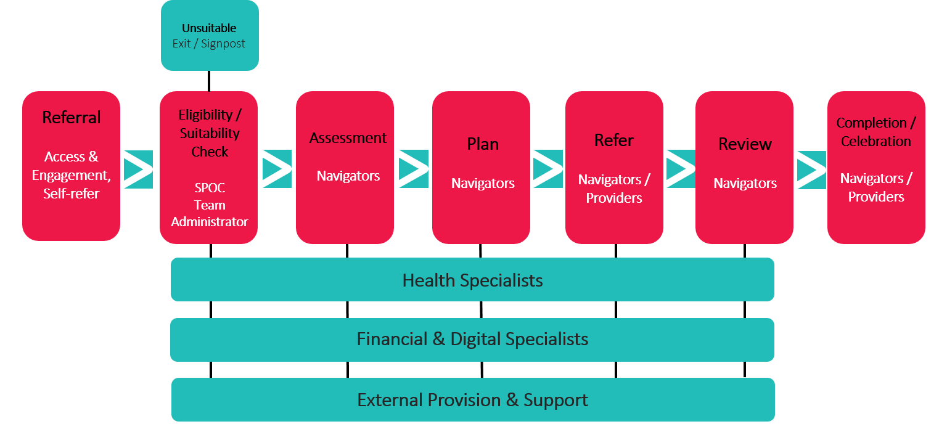

Appendix C: Project Outcomes

Participant Outputs

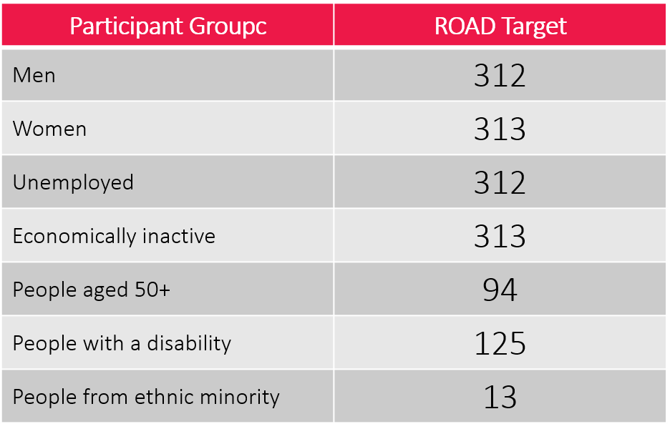

Participant Results

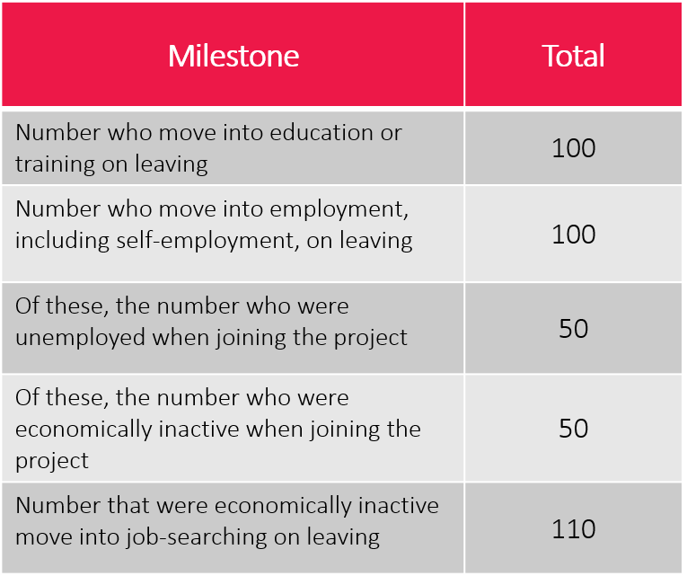

Participant Outcomes

