

**Invitation to Tender for Grounds Maintenance Contract: 2022 – 2025**

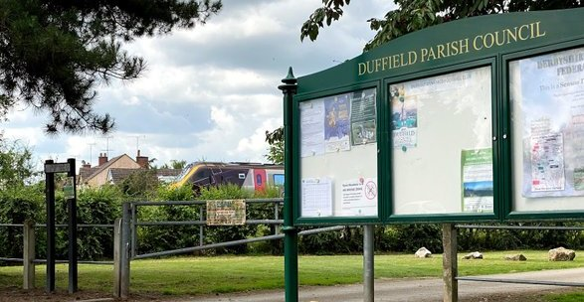

Duffield Parish Council is situated within Amber Valley, Derbyshire and is seeking tender submissions for its 3-year Grounds Maintenance contract of open-spaces.

The contract runs for a three-year period from April 2022 to Mar 2025, with a possible extension period of up to two years.

**Timetable for Tendering**

* Invitation to Tender notice; 1st March 2022
* Closing date for tenders; 28th March 2022
* Award of Contract; 7th April 2022
* Contract commencement; 25th April 2022

Full details of the Invitation to Tender (ITT) and instructions on submitting tenders can be found by visiting Duffield Parish Council’s website; <https://www.duffieldparishcouncil.gov.uk/>

The website provides links to download all ITT documents (including ITT Brief, Specification, Plans and Terms & Conditions) and tender forms for submission.

**Jane Terry**

**Duffield Parish Clerk**

**Tel: 07719 103015**