Request for Information

Ophthalmology – triage, tier 2 and minor surgery

For Midlands and Lancashire Commissioning Support Unit

On behalf of West Lancashire Clinical Commissioning Group

Reference – L16/25

Table of Contents
Section Content
- Commissioner requirements
- Procurement process
- Appendices
- Appendix A – Draft Service Specification
- Appendix B – Draft Financial and activity model
- Appendix C- RFI questions

Section 1 – Commissioner requirements
  - NHS West Lancashire Clinical Commissioning Group (CCG) commissions local health services for a diverse population of c. 110,685 residents across Ormskirk, Skelmersdale, Burscough, Rufford, Tarleton and surrounding areas as indicated below. They receive a budget from the Department of Health to plan and pay for most local NHS services.
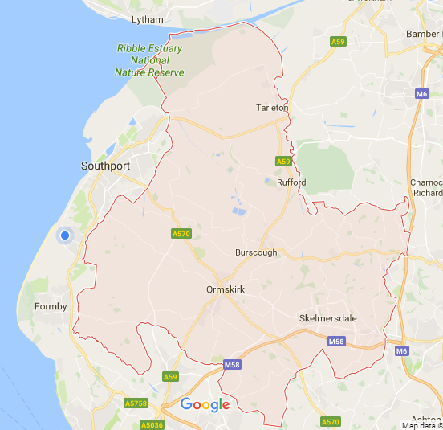
1.2 They commission planned hospital care, rehabilitative care, emergency and urgent care, most community health services, mental health and learning disability services. They do not manage local hospitals (which are independent trusts), however they do procure services from local hospitals.
1.3 They aim to buy high quality, safe and effective health services that meet the needs of residents in ophthalmology care To do this they use clinical expertise, evidence of good practice and the experience of patients who use the services they procurement.
1.4 Clinical Commissioning Groups have taken on delegated responsibility for the commissioning of services.
1.5 Details of the CCG’s scope of service, vision and values can be found at http://www.westlancashireccg.nhs.uk/about-us/our-vision-and-values/
1.6 The current main providers of these services are as follows

Supplier | Service provided
Community Health and Eye Care | Tier 2 Ophthalmology services
Southport and Ormskirk Hospital NHS Trust | Ophthalmology services
ISight | Ophthalmology Services
Aintree University Hospital | Ophthalmology Service
Royal Liverpool and Broadgreen Hospital | Ophthalmology Service

1.7 The key objective of this procurement process is to ensure, in line with the National Health Service (Procurement, Patient Choice and Competition No. 2) Regulations 2013 that the following objectives are met:
- Regulation 2 (a) securing the needs of the people who use the service.
- Regulation 2 (b) improving efficiency in the provision of the service – The Contract will feature national Key Performance Indicators (KPIs) to ensure that the requiste level of service quality is maintained and where necessary improved.
- Regulation 2 (c) improving efficiency in the provision of the services – The Service Specification will require the suppliers(s) to work to a set of Key Performance Indicators (KPIs) which will focus supplier attention and measure their performance in relation to efficiency
1.8 The CCG wishes to create a new triage, tier 2 and minor surgery service for residents across West Lancashire. They key aim of the services to deliver care to the heart of the community and in many cases outside of the acute hospital setting.
1.10 The CCG spends approximately £4.3m per annum on all Ophthalmology services. The CCG is looking to reduce the activity going through secondary care by increasing the scope of the Tier 2 service. Please see financial and activity model for further details.
  - The CCG is likely to consider a Contract duration of 36 months which a break clause provision after 24 months.
1.12 At present wet AMD and Cataract services are out of scope and these areas maybe subject to procurements in the future.
1.13 Objectives of this Request for Information
- To stimulate interest in the opportunity from potential Suppliers
- To ascertain if the draft Service Specification is fit for purpose.
- To understand if the financial data is sufficient to encourage bidders
- To gauge the level of savings which are achievable.
- To understand opportunities for innovation in delivery of the Service.

Section 2 – Procurement process

1.0. Contact details
1.1 All communication for this RFI should be directed to James Aldred, Senior Procurement Office, Midlands and Lancashire Commissioning Support Unit (MLCSU), email MLCSU.tenders@nhs.net telephone 07701 293729.
1.2 Following the completion of the RFI process the intention is to proceed to a formal tender with interested Potential Suppliers. The tender process will be conducted using the MLCSU e-sourcing portal – full details of how to access the tender will be provided to interested Potential Suppliers.

2.0 Timescales
2.1 The outline timescales for the Request for Information and Tender are as follows, please the tender dates are currently provisional.
Date of posting of Contract advert to Contracts Finder | 22nd May 2017
Potential dates for Suppliers to meet the evaluation team | 30th May 2017 and 31st May 2017
Date to formally submit RFI feedback | 1st June 2017 2.00pm
Proposed Invitation to Tender period | TBC
Target Contract award date | TBC
Target service commencement date | 29th September 2017

3.0 Expressing interest in the Tender opportunity
3.1 To express interest in the tender opportunity please contact James Aldred, email MLCSU.tenders@nhs.net providing the details of your Supplier name, address, telephone and email contact details.
3.2 In the event that the MLCSU proceed to Invitation to Tender stage all suppliers who expressed interest in the tender will be invited into the procurement process which will be conducted through MLCSU’s e-sourcing portal Bravo https://mlcsu.bravosolution.co.uk
4.0 Supplier engagement
4.1 As part of the RFI process we encourage suppliers to engage with the CCG and MLCSU to provide face to face feedback on the proposed approach.
4.2 Potential Suppliers will be offered a one hour meeting with project team members, the purpose of this meeting will be to provide verbal feedback on the questions detailed in Section 3 and to ask questions about the commissioner’s aspirations for the service.
4.3 Potential suppliers are encouraged to contact James Aldred, email MLCSU.tenders@nhs.net providing the details of your Supplier name, address, telephone and email contact details and your preferred date and time for the meeting.
4.4 The available timeslots are as followed and will be offered on a first come first served basis.
Date | Time slots available
30th May 2017 | 9.00am – 10.00am  10.15am – 11.15am  11.30am – 12.30pm
31th May 2017 | 1.30pm – 2.30pm  2.30pm – 3.30pm  3.30pm – 4.30pm

4.5 All meetings will take place at West Lancashire CCG, Hilldale, Wigan Road, Ormskirk, L39 2JW, provision for chargeable parking is available within the campus. Directions to the CCG offices are detailed in the embedded document below.
4.6 The proposed agenda for the meeting will be
  - Introductions (5 minutes)
  - Overview of the current and future service (10 minutes)
  - Supplier feedback on Service Specification (10 minutes)
  - Supplier feedback on the Finance model (15 minutes)
  - Supplier opportunities for innovation (10 minutes)
  - Supplier questions (10 minutes)
4.7 On arrival Suppliers shall report to Hilldale reception and ask for James Aldred
4.8 It is not a mandatory requirement for interested Suppliers to meet with the project team.
5.0 RFI response
5.1 All potential suppliers are encouraged to read the questions in Appendix ‘C’ and to provide written feedback as directed to MLCSU.
5.2 Feedback should be submitted by email to MLCSU.tenders@nhs.net in alignment with the timescales shown in section 2.1.
5.3 It is not a mandatory requirement for interested Suppliers to submit a response to the RFI with the project team.

Section 3 - Appendices
The following appendices are available to Potential Suppliers.
Appendix A - Draft Service Specification
Appendix B -Draft Finance Model and activity model
Appendix C – RFI response questions

Appendix A – Draft Service Specification

Appendix B – Draft Finance and Activity model

Appendix C – RFI questions
1.0 RFI questions
1.1 Suppliers are requested to provide a response to the attached questions.
2.0 Contact details
2.1 The Supplier shall complete the attached contact details
Feedback may include but not be limited to:
Supplier name
Supplier address
Supplier contact
Contact email address
Contact telephone number

3.0 Specification
3.1 The draft Service Specification for this requirement is included in Appendix A. Please can you review the Service Specification and provide feedback.
Feedback may include but not be limited to:
  - Clarity of the Service Specification
  - Areas where additional information are required
  - Quality of the data provided
  - Credibility of the Key Performance Indicators
  - Track changes suggestions of enhancements to the Service Specification
Supplier response

4.0 Finance model
4.1 The draft Finance model for this requirement is included in Appendix B. Please can you review the Service Specification and provide feedback.
Feedback may include but not be limited to:
  - Clarity of the Finance model
  - Areas where additional information are required
  - Quality of the data provided
  - Potential pricing model proposed
  - Commonality between services where pricing could be grouped together
Supplier response

5.0 Opportunities for innovation
5.1 Potential suppliers are encouraged to provide feedback on opportunities to provide innovation and creativity to improve the service or provide increased value for money.
Supplier response

2011 Census

