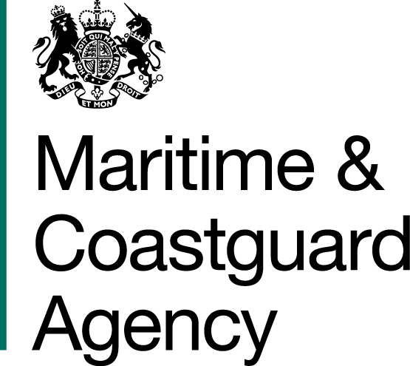 |  |  | Bay 3/17  Spring Place  105 Commercial Road  Southampton  SO15 1EG
 | To whom it may concern, |  | Tel:  E-mail: | +44 (0)20 381 72476  contracts@mcga.gov.uk
 |  |  | Your ref:  Our ref: |  | TCA 3/7/706
 |  |  | 16th March 2018

INVITATION TO TENDER FOR CONTRACT FOR HYDROGRAPHIC SURVEY SERVICES IN UK AND EUROPEAN WATERS

You are invited by the Secretary of State for Transport (from now on referred to as "the Authority") to submit a tender for the above contract.

One original and one copy (so marked) in hard copy format and one electronic copy on an USB 3.0 hard drive (or equivalent) of your tender and proposals, including any covering letter, will be required. Your Tender Price should be entered onto the Price Schedule included within the documentation.

Tenders must be delivered by 11am Thursday 3rd May 2018.

Late tenders will not be accepted, and it is your responsibility to ensure that your tender is received on time.

Tenderers are welcome to ask questions about any aspect of the procurement process. Such queries should be addressed to the Procurement Team at contracts@mcga.gov.uk, and should contain the reference number or title of the contract. The deadline for submission of queries is 17:00 Friday 20th April 2018.

As part of your tender you should supply the following:-

- The MCA’s Form of Tender, signed and dated by an authorised representative of the tendering organisation;
- The MCA’s provided Price Schedule;
- An outline description of how the tenderer will meet the requirements of the MCA.

SHOULD YOU BE SUCCESSFUL, THESE DOCUMENTS AND ANY SUBSEQUENT CORRESPONDENCE BETWEEN YOU AND THE DEPARTMENT WILL FORM A BINDING CONTRACT BETWEEN YOU AND THE AUTHORITY.

Please read all the documents listed in the Form of Tender. To ensure that all tenderers have access to the same information you can only obtain further information about contractual issues and Technical Information from me (The Contract Officer). All requests must be submitted in writing to me at the above e-mail address.

Yours sincerely,

Richard Skeats MCIPS
MCA Procurement Team

