Barking, Havering & Redbridge University Hospitals Trust
TFM Procurement
Market Engagement Briefing Paper
VERSION 1.1
September, 2024

Barking, Havering & Redbridge University Hospitals’ (the Trust’s) is one of London’s largest and highest profile healthcare organisations – in April 2024, the combined attendances at the Trust’s A&E departments were the 5th highest in London with almost 26,000 visits.
Total Facilities Management (TFM) services represent one of the most important non-clinical activities that the Trust undertakes and successful delivery of these services underpins a range of statutory obligations as well as supporting efficient and effective clinical service delivery.
On 1st October, 2018, the Trust entered into a Total Facilities Management (TFM) contract at King George Hospital (KGH) with Interserve (Facilities Management) Ltd who were subsequently acquired by Mitie Facilities Services (Mitie) in December 2020.
The contract provided for an Initial Term of five years with an option to extend for a further two years. The extension to the Mitie contract – until 30/09/2025 – was approved by the Trust Board in May, 2023.
Based on the Trust’s overarching objectives, we have developed the following requirements from the new delivery model.
Trust Goal | TFM Delivery Requirement
Deliver high quality, patient centred care | - Ensure the availability of high quality, clean and compliant space from which Clinical teams deliver these services  - Ensure high levels of customer care from the FM community and recognise roles as Trust ambassadors
Create a diverse and inclusive workplace | - Provide effective way-finding in different languages  - Embed inclusive recruitment practices within the new delivery model and work with partners to deliver this
Maximise capacity utilisation and improve performance | - High levels of stakeholder satisfaction  - Compliance with legislative requirements around FM outcomes  - Delivery of FM outcomes that actively support clinical services  - A relevant and navigable performance regime
Make better use of resource to get financially fit | - Appropriate risk transfer within the new model  - Effective financial benchmarking to ensure transparent value for money  - A clear and simple governance model that can be easily understood by all
Be a good partner and proactive contributor in our local economy | - Relevant and tangible ESG commitments embedded within service delivery  - Support to local SME organisations either through Trust contracts or our partners’ supply chains
Address the inequalities experienced by staff and patients | - Ensure a fair pay deal for service delivery colleagues

The Opportunity
Recognising that there has been a number of fundamental shifts in the market since 2018 caused by macro-economic factors, the new delivery model for TFM services is different from the existing model and an opportunity to build on the transformational successes of the current service model In July 2024, the Trust Board approved the following model.0
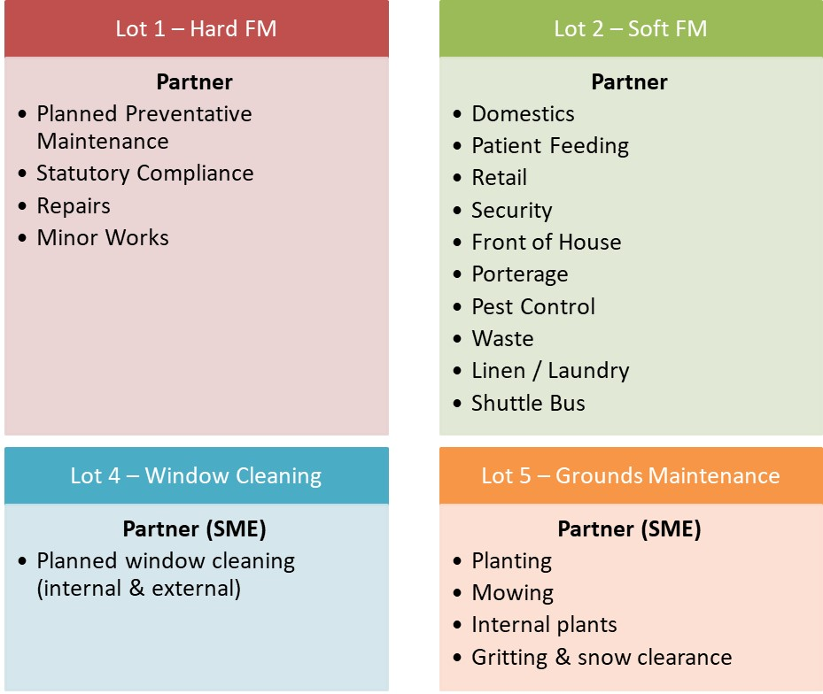
The new delivery model will have the following attributes:
- Each Lot will be evaluated in its own terms and must be capable of being standalone. There will be no opportunity for bidders to submit variant bids where they are awarded multiple Lots although we are not restricting bidders to only securing one Lot.
- The new contracts will go-live on 01/10/2025
- The Trust reserves the right to amend the constitution of any of the Lots described above by removing and / or changing service lines included
- The Trust have a responsibility to achieve value for money from the new model to protect front line healthcare as much as possible. However, there is no explicit requirement for the new model to achieve specific revenue savings
- Across the new delivery model, staff pay must align, as a minimum, to the London Living Wage and that staff absence pay and provisions are aligned to Agenda for Change provisions.

Timescales
The Trust are working alongside colleagues and NHS England and the Cabinet Office to ensure comprehensive probity around the process. Accordingly, we have developed the following high level timetable for the procurement exercise.
Activity | Date
Soft Market Testing | October 2024
Procurement Launch (Conditions of Participation) | 13/01/2025 – 07/02/2025
ITT | 21/02/2025 – 28/03/2025
Evaluation & Trust Governance | 29/03/2025 – 24/06/2025
Mobilisation | 01/07/2025 – 30/09/2025
Contracts Commencement | 01/10/2025
Dates include approvals process for Trust, NHS England and Cabinet Office.
Specific timings are subject to change.

Market Engagement
In accordance with the Chapter 2, Section 20 of the New Procurement Act (2023), the Trust intend to run this process as a ‘Competitive Flexible Procedure’.
This exercise is not part of the procurement process and will not influence the decision of the Trust to continue with the processes themselves or to award contracts to any organisations.
The objectives of the Soft Market Engagement sessions are:
- Openly and transparently discuss the current situation and successes and challenges of the current delivery model (including macro-level challenges with the sector) with suppliers
- Enable the Trust to write clearer specifications
- Ensure that the commercial details of the contracts meet all parties’ objectives
- Encourage competition and a good level of market interest
- Explore any opportunities for delivering innovation within the contracts
To be clear, this process is not:
- Any form of commitment to any organisation to provide these services
- Any commitment from the Trust that a contract will be let
- A way for potential bidders to seek a competitive advantage within the formal procurement process
- A pre-cursor for any organisation to be included in the procurement process. This will be done purely in accordance with the PCR and as set out in the Contract Notice once published.
We now invite potential suppliers to a face to face meeting at King George Hospital on 8th October, 2024 or 11th October, 2024 to discuss the Trust’s requirements and the market more generally. To support the sessions, meetings will be based around the following agenda. It will be necessary (in the interests of fairness and time) to restrict each session to 45 minutes.
- All – Introductions
- BHRUT – Background and opportunity
- Supplier – Can you provide a brief background to your organisation and which of the Lots you would be interested in bidding for
- Supplier – What pressures are you currently facing in the sector that it would be useful for us to consider in terms of how we structure the procurement / contract
- Supplier – What commercial terms (including KPIs / performance mechanism) we should avoid / be aware of and why
- BHRUT – Next steps and wrap-up
Meeting slots will be allocated on a first come, first served basis. We have 12 slots available across the two dates indicated.
There is no need to prepare presentation material – we would much rather have a discussion about the Trust, services and the procurement more generally – but if there is anything specific, presentation facilities are available.

