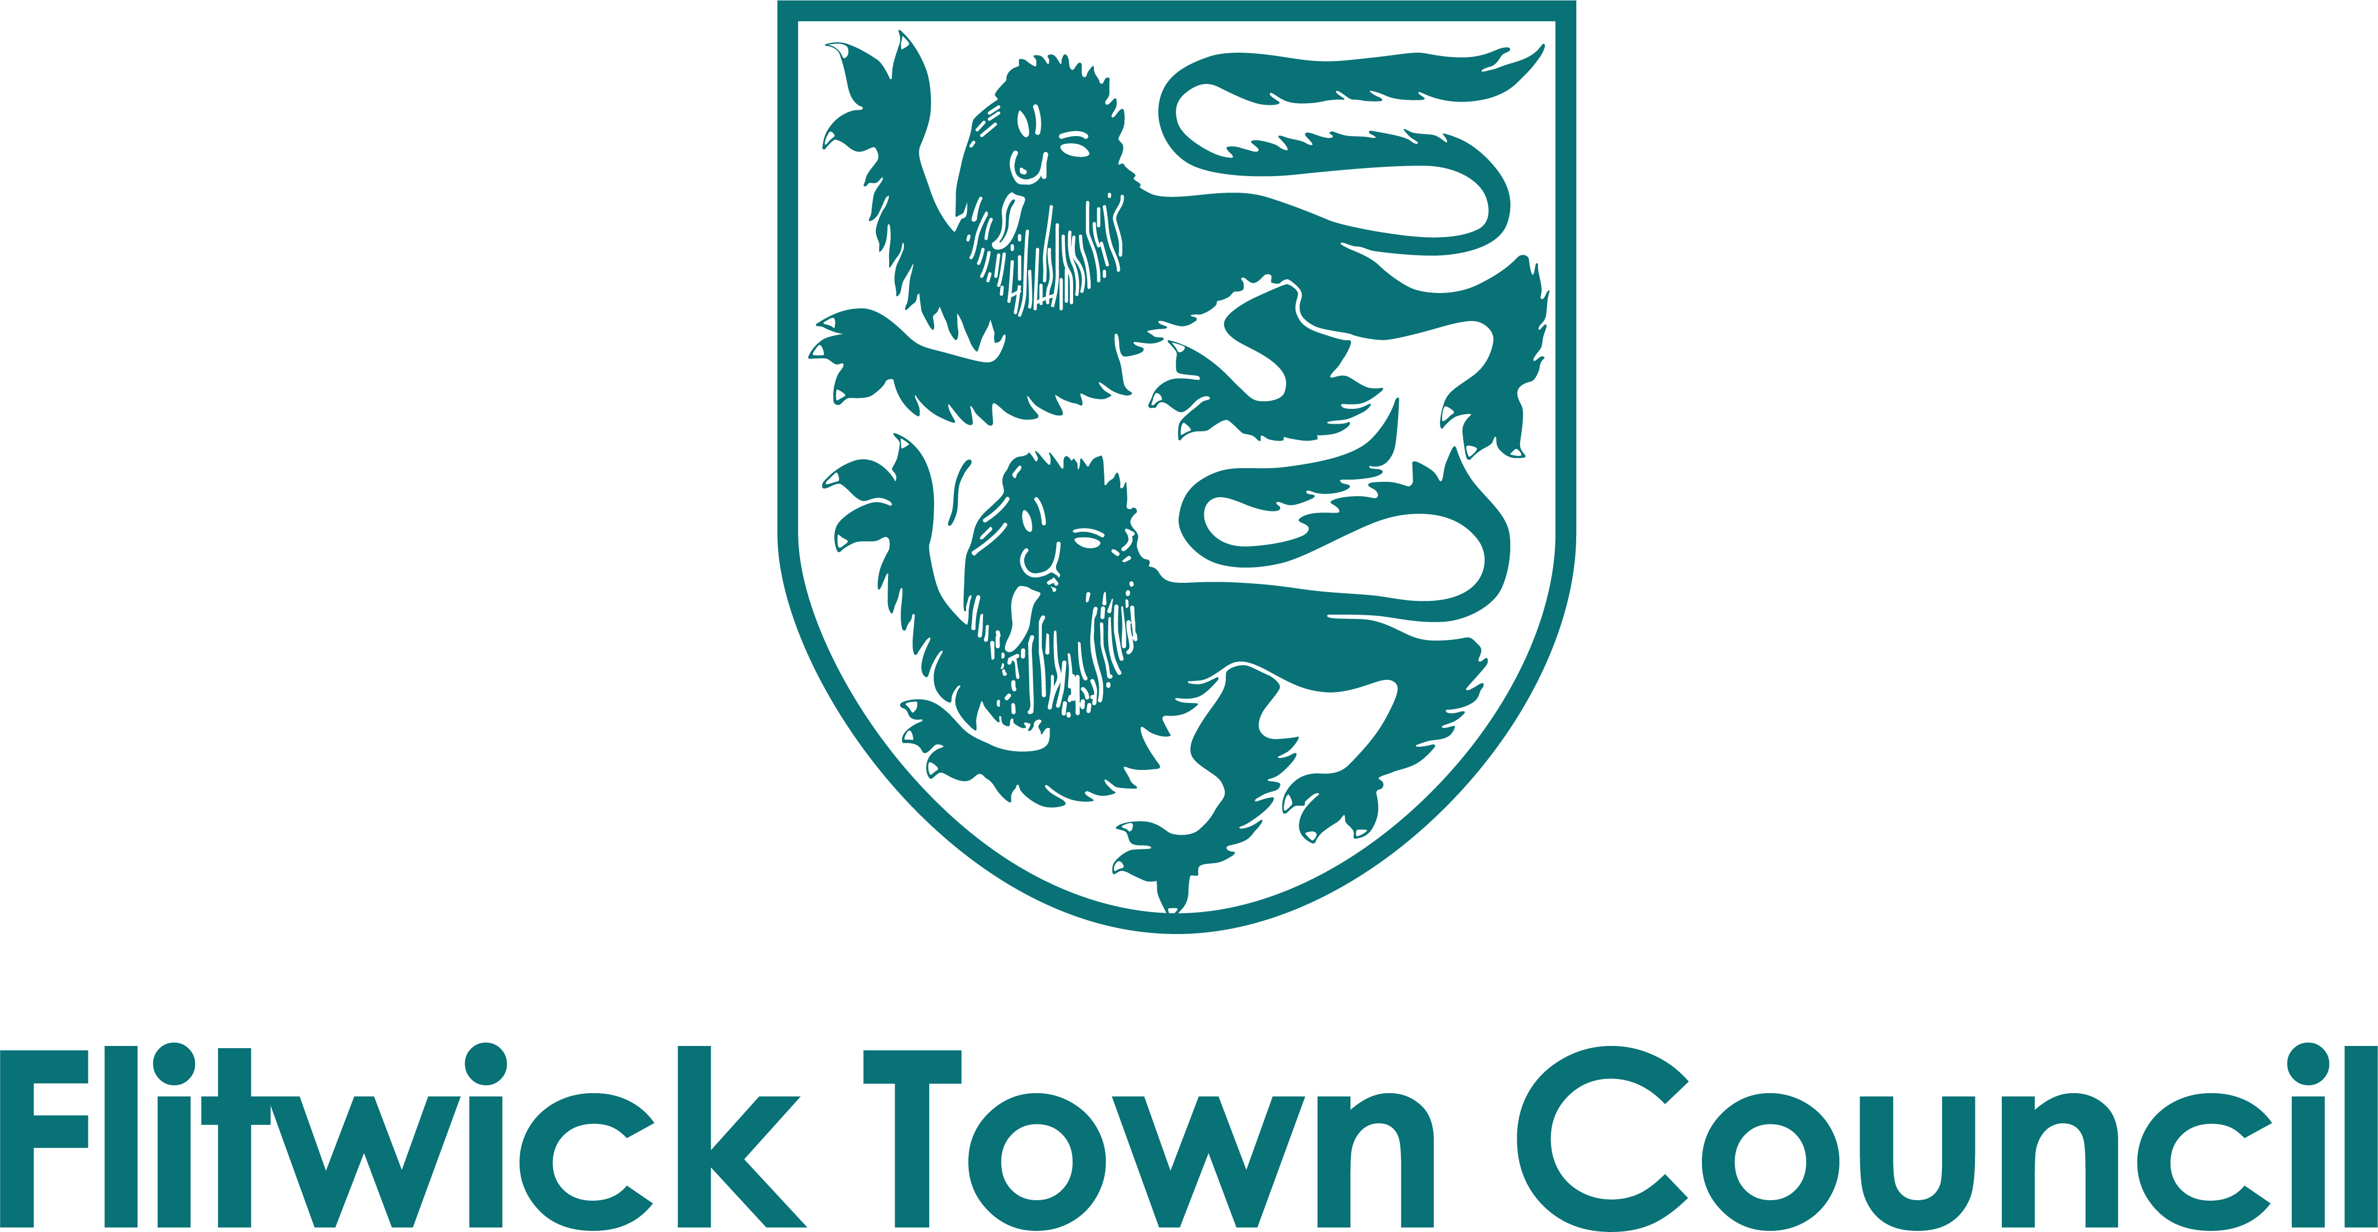

Form of Tender
Rufus Centre Heating System upgrade

Contractor/Consultant Name ………………………………………………………………

Please complete the following information:

Total cost proposed

I declare that the proposals presented are valid for 90 days:

Signed ……………………………………………………….. Date ………………………..

Certificate of Non-collusion and Non-canvassing

Rufus Centre Heating System upgrade

To: Flitwick Town Council

Date: ………………………… [please insert date]
For the attention of: Stacie Lockey
Note to Organisation: As a public body it is important that the Council receives genuine competitive offers from Tenderers, and that all Tenderers act in a manner that is honest and reflects best practices. Tenderers are therefore required to sign this document to certify that they have not and will not undertake any acts of canvassing or collusion.
Statement of Non-canvassing

I/We certify the following.
I/we hereby certify that I/we have not canvassed any member, director, employee or adviser of the Council in connection with this Tender and the proposed award of the Contract by the Council and that no person employed by me/us or acting on my/our behalf, or advising me/us, has done any such act.
I/we further hereby undertake that I/we will not canvass any member, director, employee or adviser of the Council in connection with this Tender and the proposed award of the Contract and that no person employed by me/us or acting on my behalf, or advising me/us, will do any such act. I/we agree that the Council may, in consideration of this bid, and in any subsequent actions, rely upon the statements made in this Certificate.
Statement of Non-collusion
The essence of the public procurement process for selective tendering for the Contract is that the Council shall receive bona fide competitive Tenders from all Tenderers.
In recognition of this principle, I/we hereby certify that this is a bona fide offer, intended to be competitive, and that I/we have not fixed or adjusted the amount of the offer or the price in accordance with any agreement or arrangement with any person (except any sub-contractor identified in this offer).
I/we also certify that I/we have not done, and undertake that I/we will not do, at any time during the tender process or in the event of my/our Tender being successful while the resulting Contract is in force, any of the following acts:
- enter into any agreement or agreements with any other person that they shall refrain from tendering to the Council or as to the amount of any offer submitted by them; or
- inform any person, other than the Council of the details of the Tender or the amount or the approximate amount of my/our offer except where the disclosure was in confidence and was essential to obtain insurance premium quotations required for the preparation of the Tender; or
- cause or induce any person to enter into such an agreement as is mentioned in paragraph 1 and 2 above or to inform us of the amount or the approximate amount of any rival Tender for the Contract; or
- commit any offence under the Public Bodies Corrupt Practices Act 1889, the Prevention of Corruption Acts 1889 to 1916 nor under Section 117 of the Local Government Act 1972; or
- offer or agree to pay or give or actually pay or give any sum of money, inducement or valuable consideration directly or indirectly to any person for doing or having done or causing or having caused to be done in relation to any other Tender or proposed Tender for the performance of the Project covered by the Tender any act or omission.
In this Certificate, the word ’person’ includes any person, body or association, corporate or incorporate and ‘agreement’ includes any arrangement whether formal or informal and whether legally binding or not.
I/we agree that the Council may, in its consideration of the offer, and in any subsequent actions, rely upon the statements made in this certificate.

Signed
Name
Position
For and on behalf of

