

***To Be Advised (TBA)  
TBA***

Attn: TBA

By email to: TBA

Date: TBA

Your ref: TBA

Our ref: **RE19213**

Dear Sirs,

**Award of contract for the supply of WFM Chopper Disc Assemblies**

Following your tender/ proposal for the supply of WFM Chopper Disc Assemblies to UKRI, we are pleased to award this contract to you.

This letter (“**Award Letter**”) and its Schedule(s) set out the terms of the Contract between:

1. **United Kingdom Research and Innovation**, a statutory corporation whose registered office is at Polaris House, North Star Avenue, Swindon, England, SN2 1FL (“**UKRI**”); and
2. **TBA**, a business with its trading address at TBA (the “**Supplier**”).

Unless the context otherwise requires, capitalised expressions used in this Award Letter have the same meanings as in the terms and conditions of contract set out in Schedule 1 to this Award Letter (the “**Conditions**”). Please do not attach any Supplier terms and conditions to this Award Letter as they will not be accepted by UKRI and may delay conclusion of the Contract.

For the purposes of the Contract, UKRI and the Supplier agree as follows:

**Term**

1. Commencement Date: 19/11/2019
2. Expiry Date: 18/11/2019

**Description of Goods and/or Services**

1. The Specification of the Goods and/or Services to be delivered is as set out in Schedule 2.

**Charges & Payment**

1. The Charges for the Goods and/or Services shall be as set out in Schedule 3.
2. All invoices should be sent, quoting a valid purchase order number (PO Number) provided by UKRI, to: Finance@uksbs.co.uk.
3. To avoid delay in payment it is important that the invoice is compliant and that it includes a valid PO Number, PO Number item number (if applicable) and the details (name and telephone number) of your UKRI contact (i.e. Contract Manager). Non-compliant invoices will be sent back to you, which may lead to a delay in payment. If you have a query regarding an outstanding payment please contact our Accounts Payable section either by email to Finance@uksbs.co.uk or by telephone 01793 867 004 between 09:00-17:00 Monday to Friday.

**Supplier’s Liability**

1. Pursuant to clause 20.4, the Supplier’s Limit of Liability under this Contract shall be: 125% of the total Charges paid and payable to the Supplier under this Contract.

**Insurances**

1. The Supplier is not required to maintain the following insurance policies referred to in clause 19.1 of the Conditions:

N/A

**Notices**

1. The address for notices of the Parties are:

|  |  |
| --- | --- |
| **UKRI** | **Supplier** |
| Polaris House, North Star Avenue, Swindon, England, SN2 1FL  Attention: TBA  Email: TBA | TBA  Attention: ***TBA***  Email: TBA |

**Liaison & Disputes**

1. For general liaison your contact will continue to be TBA or, in their absence, scientificresearch@uksbs.co.uk
2. Pursuant to Clause 32.3, Disputes shall be escalated to the following individuals:
   * 1. Stage 1 escalation:

UKRI: UKRI - STFC

Supplier: TBA

* + 1. Stage 2 escalation:

UKRI: UKRI Head of Commercial

Supplier: TBA

We thank you for your co-operation to date, and look forward to forging a successful working relationship resulting in a smooth and successful supply of the Goods and/or Services. Please confirm your acceptance of the award of this contract by signing and returning the enclosed copy of this letter to TBA at the above address. No other form of acknowledgement will be accepted. Please remember to quote the reference number above in any future communications relating to this contract.

Yours faithfully,

|  |  |
| --- | --- |
| Signed for and on behalf of **United Kingdom Research and Innovation** | |
| Signature: | ……………………………………………… |
| Name: | ……………………………………………… |
| Position: | ……………………………………………… |
| Date: | ……………………………………………… |

We accept the terms set out in this Award Letter and the Schedule(s).

|  |  |
| --- | --- |
| Signed for and on behalf of **TBA** | |
| Signature: | ……………………………………………… |
| Name: | ……………………………………………… |
| Position: | ……………………………………………… |
| Date: | ……………………………………………… |

1. - The Conditions

|  |
| --- |
| 1. Interpretation |
| * 1. Definitions. In the Contract (as defined below), the following definitions apply: |
| **Award Letter:** means the letter from UKRI to the Supplier printed above these terms and conditions; |
| **Change in Law:** any change in Law which impacts on the performance of the Goods and/or Services which comes into force after the Commencement Date; |
| **Charges:** the charges payable by UKRI for the supply of the Goods and/or Services as specified in Schedule 3; |
| **Commencement Date**: means the date for the start of the Contract as set out in the Award Letter; |
| **Confidential Information:** means:   * + 1. all confidential information and data which is acquired from or made available (directly or indirectly) by the Disclosing Party or the Disclosing Party's representatives however conveyed or presented, including but not limited to any information or document relating to the Disclosing Party’s business, affairs, operations, budgets, policies, processes, initiatives, plans, product information, pricing information, technical or commercial know-how, trade secrets, specifications, strategies, inventions, designs, software, market opportunities, personnel, customers or suppliers (whether relating to this Contract or otherwise) either orally, in writing, or in whatever form obtained or maintained;     2. any information or analysis derived from the Confidential Information;     3. anything marked as confidential and any other information notified by or on behalf of the Disclosing Party to the Receiving Party as being confidential;     4. the existence and terms of this Contract and of any subsequent agreement entered into in relation to this Contract;     5. the fact that discussions and negotiations are taking place concerning this Contract and the status of those discussions and negotiations; and     6. any copy of any of the information described in (a), (b), (c), (d), or (e) above, which shall be deemed to become Confidential Information when it is made. For the purposes of this definition, a copy shall include, without limitation, any notes or recordings of the information described in (a), (b), (c), (d), or (e) above (howsoever made);   but not including any information which:   * + - 1. was in the possession of the Receiving Party without a breach of an obligation of confidentiality prior to its disclosure by the Disclosing Party;       2. the Receiving Party obtained on a non-confidential basis from a third party who is not, to the Receiving Party’s knowledge or belief, bound by a confidentiality agreement with the Disclosing Party or otherwise prohibited from disclosing the information to the Receiving Party;       3. was already generally available and in the public domain at the time of disclosure otherwise than by a breach of this Contract or breach of a duty of confidentiality;       4. was independently developed without access to the Confidential Information; or       5. relates to the Supplier’s performance under this Contract or failure to pay any sub-contractor as required pursuant to clause 10.9; |
| **Contract:** means the contract between UKRI and the Supplier constituted by the Supplier’s countersignature of the Award Letter and includes the Award Letter and Schedules; |
| **Cyber Essentials Questionnaire:** UKRI’s questionnaire for suppliers regarding their cyber security arrangements, a copy of which is available from UKRI on request; |
| **Data Protection Legislation:** means, for the periods in which they are in force, all laws giving effect or purporting to give effect to the GDPR, the Data Protection Act 2018, or otherwise relating to Data Protection, including the Regulation of Investigatory Powers Act 2000, the Telecommunications (Lawful Business Practice) (Interception of Communications) Regulations 2000 (SI 2000/2699), the Electronic Communications Data Protection Directive (2002/58/EC), the Privacy and Electronic Communications (EC Directive) Regulations 2003 (SI 2426/2003), the GDPR and all applicable laws and regulations relating to the processing of personal data and privacy, including where applicable the guidance and codes of practice issued by the Information Commissioner, in each case as amended or substituted from time to time; |
| **Declaration of Ineffectiveness:** a declaration made by a Court under regulation 98 which has any of the consequences described in regulation 101 of the Public Contracts Regulations 2015 (as amended) or which is made under an equivalent provision implementing Directive 2014/23/EU in England, Wales & Northern Ireland and which has consequences which are similar to any of the consequences described in regulation 101 of the Public Contracts Regulations 2015 (as amended); |
| **Deliver:** means hand over of the Goods to UKRI at the address(es) specified in the Specification (or otherwise agreed in writing by the Parties) and on the Delivery Date, which shall include unloading and any other specific arrangement agreed in accordance with clause 6. “Delivered”, “Delivery” and “Deliveries” shall be construed accordingly; |
| **Deliverables:** all Documents, products and materials developed by the Supplier or its agents, contractors and employees as part of, or in relation to, the Services in any form, including computer programs, data, reports and specifications (including drafts); |
| **Delivery Date:** the date for delivery of the Goods specified by UKRI in writing and if no such date is specified, within 28 days of the date of UKRI’s written request; |
| **Delivery Note:** means a note produced by the Supplier accompanying each delivery of the Goods which shows the date of the order, the order number (if any), the type and quantity of the Goods (including the code number of the Goods, where applicable), special storage instructions (if any) and, if the Goods are being delivered by instalments, the outstanding balance of Goods remaining to be delivered; |
| **Disclosing Party:** means a Party that makes a disclosure of Confidential Information to another Party; |
| **Dispute**: means any dispute, conflict or disagreement arising out of or in connection with this Contract; |
| **Document:** includes, in addition to any document in writing, any drawing, map, plan, diagram, design, picture or other image, tape, disk or other device or record embodying information in any form. |
| **EIR:** the Environmental Information Regulations 2004 (or if applicable the Environmental Information Regulations (Scotland) 2004) together with any guidance and/or codes of practice issued by the Information Commissioner or relevant government department in relation to such regulations; |
| **Expiry Date**: means the date for expiry of the Contract as set out in the Award Letter; |
| **FOIA:** the Freedom of Information Act 2000 (or if applicable the Freedom of Information (Scotland) Act 2002) and any subordinate legislation made under the Act from time to time, together with any guidance and/or codes of practice issued by the Information Commissioner or relevant government department in relation to such legislation; |
| **Force Majeure Event:** shall be limited to one or more of the following events: hurricanes, tempest, acts of state or public enemy, wars, revolutions, uprisings, hostilities, civil disturbances, riots, civil war, insurrection and invasion. For the avoidance of doubt, strikes, lockouts and shutdowns of a Party (or of any person engaged by any of them) shall not be a force majeure event for that Party; |
| **GDPR:** means:   * + 1. the General Data Protection Regulations (Regulation (EU) 2016/679) which came into force on 25 May 2018; or     2. any equivalent legislation amending or replacing the General Data Protection Regulations (Regulation (EU) 2016/679); |
| **General Change in Law:** a Change in Law where the change is of a general legislative nature (including taxation or duties of any sort affecting the Supplier) or which affects or relates to the supply of goods and/or services to another customer of the Supplier that are the same or similar to any of the Goods and/or Services; |
| **Good Industry Practice**: means all relevant practices and professional standards that would be expected of a well-managed, expert service provider performing services substantially similar to the Services or supplies substantially similar to the Goods to customers of a substantially similar size and nature to UKRI; |
| **Goods:** means the goods to be supplied by the Supplier to UKRI, under the Contract as set out in the Specification; |
| **Information:** has the meaning given under section 84 of FOIA; |
| **Intellectual Property Rights:** all patents, rights to inventions, utility models, copyright and related rights (including moral rights), trademarks, service marks, trade, business and domain names, rights in trade dress or get-up, rights in goodwill or to sue for passing off, unfair competition rights, rights in designs, rights in computer software, database right, topography rights, rights in confidential information (including know-how and trade secrets) and any other intellectual property rights, in each case whether registered or unregistered and including all applications for and renewals or extensions of such rights, and all similar or equivalent rights or forms of protection in any part of the world; |
| **Key Personnel**: means any persons specified as such in Schedule 3 or otherwise notified as such by UKRI to the Supplier in writing; |
| **Law**: means any law, statute, subordinate legislation within the meaning of section 21(1) of the Interpretation Act 1978, bye-law, enforceable right within the meaning of section 2 of the European Communities Act 1972 and section 4 of the European Union (Withdrawal Act 2018, regulation, order, mandatory guidance or code of practice, judgment of a relevant court of law, or directives or requirements of any regulatory body, with which UKRI and the Supplier (as the context requires) is bound to comply; |
| **Limit of Liability:** means the Supplier’s limit of liability identified in the Award Letter; |
| **Notifiable Breach:** has the meaning set out at clause 8.3; |
| **Party:** the Supplier or UKRI (as appropriate) and “Parties” shall mean both of them; |
| **Personal Data:** has the meaning given to this term by the Data Protection Legislation; |
| **Personal Data Breach:** shall have the same meaning as in the Data Protection Legislation; |
| **PO Number:** means UKRI’s unique number relating to the supply of the Goods and/or Services; |
| **Public Body:** any part of the government of the United Kingdom including but not limited to the Northern Ireland Assembly and Executive Committee, the Scottish Executive and the National Assembly for Wales, local authorities, government ministers and government departments and government agencies; |
| **Public Procurement Termination Event:** UKRI exercises its right to terminate the Contract in one or more of the circumstances described in either regulation 73(1) of the Public Contracts Regulations 2015 (as amended from time to time), or equivalent provisions implementing Directive 2014/23/EU in England, Wales & Northern Ireland (as amended from time to time); |
| **Receiving Party:** means a Party to which a disclosure of Confidential Information is made by another Party; |
| **Remediation Plan:** means a report identifying:   1. the nature of the Notifiable Breach described at clause 8.3, its cause and its anticipated duration and impact on the Contract; and 2. the procedures and resources the Supplier proposes to apply to overcome and rectify the Notifiable Breach and to ensure the impact of the Notifiable Breach is minimised and future performance of the Contract is not adversely affected; |
| **Request for Information:** a request for Information or an apparent request under FOIA or EIR; |
| **Services:** the services, including without limitation any Deliverables, to be provided by the Supplier to UKRI under the Contract as set out in the Specification; |
| **SME:** as defined by EU recommendation 2003/361/EC; |
| **Specification:** the description of the Goods and / or Services to be provided under this Contract as set out in Schedule 2; |
| **Specific Change in Law**: a Change in Law that relates specifically to the business of UKRI and which would not affect the supply of goods and/or services to another customer of the Supplier that are the same or similar to any of the Goods and/or Services; |
| **Supplier's Associate:** any individual or entity associated with the Supplier including, without limitation, the Supplier's subsidiary, affiliated or holding companies and any employees, agents or contractors of the Supplier and / or its subsidiary, affiliated or holding companies or any entity that provides Goods and or Services for or on behalf of the Supplier; |
| **Supplier Dispute:** means any disputes, claims, litigation, mediation or arbitration whether threatened or pending in relation to any incident involving the Supplier's, or another party’s, provision of the Goods and/or Services; |
| **Staff**: means all directors, officers, employees, agents, consultants and contractors of the Supplier and/or of any sub-contractor of the Supplier engaged in the performance of the Supplier’s obligations under the Contract; |
| **Staff Vetting Procedures**: means vetting procedures that accord with good industry practice or, where requested by UKRI, UKRI’s procedures for the vetting of personnel as provided to the Supplier from time to time; |
| **Term**: means the period from the Commencement Date to the Expiry Date as such period may be extended or terminated in accordance with the terms and conditions of the Contract; |
| **TUPE:** the Transfer of Undertakings (Protection of Employment) Regulations 2006 as amended or replaced from time to time; |
| **Working Day:** a day (other than a Saturday, Sunday, public holiday or 27, 28, 29, 30 and 31 December) when banks in London are open for business. |
| * 1. In this Contract, unless the context requires otherwise, the following rules apply: |
| * + 1. A person includes a natural person, corporate or unincorporated body (whether or not having separate legal personality). |
| * + 1. A reference to a party includes its personal representatives, successors or permitted assigns. |
| * + 1. A reference to any Law is a reference to Law as amended or re-enacted. A reference to a Law includes any subordinate legislation made under that Law, as amended or re-enacted. |
| * + 1. Any phrase introduced by the terms including, include, in particular or any similar expression shall be construed as illustrative and shall not limit the sense of the words preceding those terms. |
| * + 1. The headings in the Contract are for ease of reference only and do not affect the interpretation or construction of the Contract. |
| * + 1. A reference to writing or written includes e-mails. |
| * + 1. A reference to numbered clauses are references to the relevant clause in this Contract. |
| * + 1. Any obligation on any Party not to do or omit to do anything shall include an obligation not to allow that thing to be done or omitted to be done. |
| 1. Basis of Contract |
| * 1. The Contract comprises of the Award Letter and its Schedules, to the exclusion of all other terms and conditions, including any other terms that the Supplier seeks to impose or incorporate (whether in any quotation, confirmation of order, invoice, in correspondence or in any other context), or which are implied by trade, custom, practice or course of dealing. |
| * 1. If there is any conflict or inconsistency between the Award Letter and its Schedules, the provisions of the Award Letter will prevail followed by the Conditions in this Schedule 1 to the extent necessary to resolve that conflict or inconsistency. |
| 1. Term |
| * 1. This Contract shall take effect on the Commencement Date and shall expire on the Expiry Date, unless it is otherwise extended or terminated in accordance with the terms and conditions of this Contract. |
| 1. Supply of Services |
| * 1. In consideration of UKRI’s agreement to pay the Charges, the Supplier shall for the Term provide the Services to UKRI in accordance with the terms of this Contract. |
| * 1. The Supplier shall meet any performance dates for the Services (including the delivery of Deliverables) specified in the Specification or notified to the Supplier by UKRI. |
| * 1. In providing the Services, the Supplier shall: |
| * + 1. co-operate with UKRI in all matters relating to the Services, and comply with all instructions of UKRI using reasonable endeavours to promote UKRI’s interests; |
| * + 1. perform the Services with reasonable skill, care and diligence in accordance with Good Industry Practice in the Supplier’s industry, profession or trade; |
| * + 1. use Staff who are suitably skilled and experienced to perform tasks assigned to them, and in sufficient number to ensure that the Supplier's obligations are fulfilled in accordance with this Contract; |
| * + 1. ensure that the Services and Deliverables will conform with the Specifications and that the Deliverables shall be fit for any purpose expressly or impliedly made known to the Supplier by UKRI; |
| * + 1. provide all equipment, tools and vehicles and such other items as are required to provide the Services; |
| * + 1. use goods, materials, standards and techniques, and ensure that the Deliverables, and all goods and materials supplied and used in the Services or transferred to UKRI are of a quality in line with Good Industry Practice and are free from defects in workmanship, installation and design; |
| * + 1. obtain and at all times maintain all necessary licences and consents, and comply with all applicable laws and regulations; |
| * + 1. not do or allow anything to be done that would, or would be likely to, bring UKRI into disrepute or adversely affect its reputation in any way; |
| * + 1. observe all health and safety rules and regulations and any other security requirements that apply at any of UKRI’s premises; and |
| * + 1. not do or omit to do anything which may cause UKRI to lose any licence, authority, consent or permission on which it relies for the purposes of conducting its business, and the Supplier acknowledges that UKRI may rely or act on the Services. |
| * 1. UKRI’s rights under this Contract are without prejudice to and in addition to the statutory terms implied in favour of UKRI under the Supply of Goods and Services Act 1982 and any other applicable legislation as amended. |
| 1. Supply of GOods |
| * 1. In consideration of UKRI’s agreement to pay the Charges, the Supplier shall supply all Goods in accordance with the Contract. In particular, the Supplier warrants that the Goods shall: |
| * + 1. conform with their description in the specifications (including the Specification), drawings, descriptions given in quotations, estimates, brochures, sales, marketing and technical literature or material (in whatever format made available by the Supplier) supplied by, or on behalf of, the Supplier; |
| * + 1. be of satisfactory quality (within the meaning of the Sale of Goods Act 1979) and fit for any purpose held out by the Supplier or made known to the Supplier by UKRI, expressly or by implication, and in this respect UKRI relies on the Supplier's skill and judgement. The Supplier acknowledges and agrees that the approval by UKRI shall not relieve the Supplier of any of its obligations under this sub-clause; |
| * + 1. where applicable, be free from defects (manifest or latent), in materials and workmanship and remain so for 12 months after Delivery; |
| * + 1. be free from design defects; |
| * + 1. comply with all applicable statutory and regulatory requirements relating to the manufacture, labelling, packaging, storage, handling and delivery of the Goods; |
| * + 1. be supplied in accordance with all applicable legislation in force from time to time; and |
| * + 1. be destined for supply into, and fully compliant for use in, the United Kingdom (unless specifically stated otherwise in the Specification). |
| * 1. In supplying the Goods, the Supplier shall co-operate with UKRI in all matters relating to the supply of the Goods and comply with all of UKRI’s instructions. |
| * 1. The Supplier shall ensure that at all times it has and maintains all the licences, permissions, authorisations, consents and permits that it needs to carry out its obligations under the Contract. |
| * 1. UKRI and its representatives shall have the right to inspect and test the Goods at any time before Delivery. |
| * 1. If following such inspection or testing UKRI considers that the Goods do not conform or are unlikely to comply with the Supplier's undertakings at clause 5.1, UKRI shall inform the Supplier and the Supplier shall immediately take such remedial action as is necessary to ensure compliance. |
| * 1. Notwithstanding any such inspection or testing, the Supplier shall remain fully responsible for the Goods and any such inspection or testing shall not reduce or otherwise affect the Supplier's obligations under this Contract, and UKRI shall have the right to conduct further inspections and tests after the Supplier has carried out its remedial actions. |
| * 1. UKRI’s rights under the Contract are without prejudice to and in addition to the statutory terms implied in favour of UKRI under the Sale of Goods Act 1979, the Supply of Goods and Services Act 1982 and any other applicable legislation as amended. |
| 1. Delivery |
| * 1. Unless otherwise agreed in writing by UKRI, the Supplier shall Deliver the Goods to UKRI on the Delivery Date (with the carriage paid) to the address(es) specified in the Specification and in accordance with any other Delivery instructions provided to the Supplier.   2. Delivery of the Goods shall be completed once the completion of unloading the Goods from the transporting vehicle at the Delivery address has taken place (as well as any other specific arrangement agreed by the Parties has taken place) and UKRI has signed for the Delivery. The Supplier will unload the Goods at its own risk as directed by UKRI. The Goods will remain at the risk of the Supplier until Delivery to UKRI (including unloading) is complete and the Supplier has obtained sign-off of the Delivery Note by or on behalf of UKRI.   3. Unless otherwise stipulated by UKRI in writing to the Supplier, Deliveries shall only be accepted by UKRI on Working Days and during normal business hours.   4. The Supplier shall ensure that: |
| * + 1. the Goods are properly packed and secured in such manner as to enable them to reach their destination in good condition: |
| * + 1. each delivery of the Goods is accompanied by a Delivery Note; and |
| * + 1. if the Supplier requires UKRI to return any packaging material to the Supplier, that fact is clearly stated on the Delivery Note. Any such packaging material shall be returned to the Supplier at the Supplier's cost. |
| * 1. If the Supplier delivers to UKRI more than the quantity of Goods ordered, UKRI will not be bound to pay for the excess and any excess will remain at the Supplier's risk and will be returnable to the Supplier at the Supplier's expense. |
| * 1. If the Supplier delivers less than the quantity of Goods ordered, and UKRI accepts the delivery, a pro rata adjustment shall be made to the invoice for the Goods. |
| * 1. The Supplier shall not deliver the Goods in instalments without prior written consent from UKRI. Where it is agreed that the Goods are to be delivered in instalments, they may be invoiced and paid for separately. |
| * 1. The Supplier shall: |
| * + 1. obtain, at its risk and expense, any export and import licences or other authorisations necessary for the export and import of the Goods and their transit through any country or territory; and |
| * + 1. deal with all customs formalities necessary for the export, import and transit of the Goods, and will bear the costs of complying with those formalities and all duties, taxes and other charges payable for export, import and transit. |
| * 1. Without prejudice to UKRI’s statutory rights, UKRI will not be deemed to have accepted any Goods until it has had at least 14 Working Days after Delivery to inspect them and UKRI also has the right to reject any Goods as though they had not been accepted for 14 Working Days after any latent defect in the Goods has become apparent. |
| * 1. Without prejudice to clause 13.1, any access to UKRI’s premises and any labour and equipment that may be provided by UKRI in connection with Delivery of the Goods shall be provided without acceptance by UKRI of any liability in respect of any actions, claims, costs and expenses incurred by third parties for any loss or damages to the extent that such loss or damage is not attributable to the negligence or other wrongful act of UKRI, its servant or agent. The Supplier shall indemnify UKRI in respect of any actions, suits, claims, demands, losses, charges, costs and expenses, which UKRI may suffer or incur as a result of or in connection with any damage or injury (whether fatal or otherwise) occurring in the course of Delivery or installation to the extent that any such damage or injury is attributable to any act or omission of the Supplier or the Staff. |
| 1. Title, Risk and Use |
| * 1. Without prejudice to any other rights or remedies of UKRI, title and risk in the Goods shall pass to UKRI on completion of Delivery. |
| * 1. The Supplier warrants that: |
| * + 1. it has full clear and unencumbered title to the Goods; |
| * + 1. at the Delivery Date of any of the Goods it shall have full have unrestricted right, power and authority to sell, transfer and deliver all of the Goods to UKRI; and |
| * + 1. on Delivery, UKRI shall acquire a valid and unencumbered title to the Goods. |
| 1. remedies |
| * 1. UKRI’s rights and remedies under the Contract are in addition to its rights and remedies implied by statute and common law.   2. Where (i) the Supplier fails to Deliver the Goods or part of the Goods including any instalment(s) or (ii) the Goods or part of the Goods do not comply with the provisions of clause 5 then without limiting any of its other rights or remedies in this Contract or implied by statute or common law, UKRI shall be entitled to:      1. terminate the Contract in whole or in part without liability to the Supplier;      2. accept late delivery of the Goods;      3. require the Supplier, free of charge, to deliver substitute Goods within the timescales specified by UKRI;      4. require the Supplier, free of charge, to repair or replace the rejected Goods, or to provide a full refund of the price of the rejected Goods (if paid);      5. reject the Goods (in whole or part) and return them to the Supplier at the Supplier’s own risk and expense and UKRI shall be entitled to a full refund on those Goods or part of Goods duly returned;      6. buy the same or similar goods from another supplier; and      7. recover any expenses incurred in respect of buying the Goods from another supplier which shall include but not be limited to administration costs, chargeable staff time and extra delivery costs.   3. Without prejudice to any of its other rights or remedies in this Contract or implied by statute or common law, in the event that:      1. UKRI considers the Supplier is in breach of, or is likely to breach, clause 4.2 and the breach is capable of remedy; or      2. the Supplier commits a breach of clause 4.3 which is capable of remedy,   (each a “**Notifiable Breach**”), the Supplier must as soon as practicable but in any event within 5 Working Days (or as otherwise agreed by UKRI) of being notified by UKRI of the Notifiable Breach, submit a draft Remediation Plan to UKRI for approval. UKRI may, acting reasonably, consider the draft Remediation Plan as inadequate to rectify the Notifiable Breach and reject the draft, in which case the Supplier shall submit a revised Remediation Plan to UKRI for review within 3 Working Days (or as otherwise agreed by UKRI) of UKRI's notice rejecting the draft. Once the Remediation Plan is approved, the Supplier shall immediately start work on the actions set out in the approved Remediation Plan.   * 1. Where the Supplier fails to provide a Remediation Plan in accordance with the timescales specified in clause 8.3 or fails to comply with any approved Rectification Plan, UKRI shall be entitled to:      1. terminate the Contract with immediate effect by giving written notice to the Supplier;      2. recover from the Supplier any costs incurred by UKRI in performing the Services itself or obtaining substitute services from a third party;      3. a refund of the Charges paid in advance for Services that have not been provided by the Supplier; and      4. claim damages for any additional costs, loss or expenses incurred by UKRI which are in any way attributable to the Notifiable Breach and the Supplier’s failure as described in this clause 8.4.   2. This Contract shall apply to any repaired or replacement Goods and any substituted or remedial Services provided by the Supplier. |
| 1. UKRI Obligations |
| * 1. UKRI shall: |
| * + 1. provide the Supplier with reasonable access at reasonable times to UKRI’s premises for the purpose of providing the Goods and/or Services; and |
| * + 1. provide such information to the Supplier as the Supplier may reasonably request and UKRI considers reasonably necessary for the purpose of providing the Goods and/or Services. |
| 1. Charges and Payment |
| * 1. The Charges for the Goods and/or Services are set out in Schedule 3, and shall be the full and exclusive remuneration of the Supplier in respect of the supply of the Goods and/or Services. Unless otherwise agreed in writing by UKRI, the Charges shall include every cost and expense of the Supplier directly or indirectly incurred in connection with the provision of the Goods and/or performance of the Services. |
| * 1. All amounts stated are exclusive of VAT which shall be charged at the prevailing rate where applicable. UKRI shall, where applicable and following the receipt of a valid VAT invoice, pay to the Supplier a sum equal to the VAT chargeable in respect of the Goods and/or Services. |
| * 1. The Supplier shall invoice UKRI at the times specified in Schedule 3 and in accordance with this clause 10. If an invoicing schedule is not specified in Schedule 3, the Supplier shall invoice UKRI on or after the Delivery of the Goods or completion of the Services.   2. Each invoice shall include such supporting information required by UKRI to verify the accuracy of the invoice, including the relevant PO Number and a breakdown of the Goods and/or Services supplied in the invoice period as well as appropriate details in order to allow for payment via BACS transfer (sort code and bank account details). |
| * 1. In consideration of the supply of the Goods and/or Services by the Supplier, UKRI shall pay the invoiced amounts within 30 days of the date of a correctly rendered invoice after verifying that the invoice is valid and undisputed. Payment shall be made to the bank account nominated in writing by the Supplier unless UKRI agrees in writing to another payment method. |
| * 1. If UKRI fails to consider and verify an invoice in a timely fashion the invoice shall be regarded as valid and undisputed for the purpose of clause 10.5 after a reasonable time has passed (which shall be no less than 14 calendar days). |
| * 1. If there is a dispute between the Parties as to the amount invoiced, UKRI may reject the invoice in its entirety. The Supplier shall not suspend the supply of the Goods and/or Services unless the Supplier is entitled to terminate this Contract for a failure to pay undisputed invoice in accordance with clause 21.5. Any disputed invoices shall be resolved through the dispute resolution procedure detailed in Clause 32. |
| * 1. If a payment of an undisputed invoice is not made by UKRI by the due date, then UKRI shall pay the Supplier interest at the interest rate specified in the Late Payment of Commercial Debts (Interest) Act 1998, accruing on a daily basis from the due date up to the date of actual payment, whether before or after judgment. |
| * 1. Where the Supplier enters into a sub-contract, the Supplier shall include in that sub-contract: |
| * + 1. provisions having the same effects as clauses 10.3 to 10.8 of this Contract; and |
| * + 1. a provision requiring the counterparty to that sub-contract to include in any sub-contract which it awards provisions having the same effect as 10.3 to 10.9 of this Contract. |
| * + 1. In this clause 10.9, “sub-contract” means a contract between two or more suppliers, at any stage of remoteness from UKRI in a subcontracting chain, made wholly or substantially for the purpose of performing (or contributing to the performance of) the whole or any part of this Contract. |
| * 1. The Supplier shall not be entitled to assert any credit, set-off or counterclaim against UKRI in order to justify withholding payment of any such amount in whole or in part. If any sum of money is recoverable from or payable by the Supplier under the Contract (including any sum which the Supplier is liable to pay to UKRI in respect of any breach of the Contract), that sum may be deducted unilaterally by UKRI from any sum then due, or which may come due, to the Supplier under the Contract or under any other agreement or contract with UKRI. |
| 1. Taxation Obligations of the Supplier |
| * 1. The Supplier shall be fully responsible for all its own tax including any national insurance contributions arising from supplying the Goods and/or Services. |
| * 1. The Supplier shall indemnify, and shall keep indemnified, UKRI in full against all costs, claims, expenses, damages and losses, including any interest, penalties, fines, legal and other professional fees and expenses awarded against or incurred or paid by UKRI as a result of the Supplier’s failure to account for or pay any taxes including any national insurance contributions. |
| 1. UKRI Property |
| * 1. The Supplier acknowledges that all information (including UKRI’s Confidential Information), equipment and tools, drawings, specifications, data, software and any other materials supplied by UKRI (or its agents on behalf of UKRI) to the Supplier (“UKRI’s Materials”) and all rights in UKRI’s Materials are and shall remain at all times the exclusive property of UKRI. The Supplier shall keep UKRI’s Materials in safe custody at its own risk, maintain them in good condition until returned to UKRI, and not dispose or use the same other than for the sole purpose of performing the Supplier's obligations under the Contract and in accordance with written instructions or authorisation from UKRI. |
| * 1. UKRI's Materials shall be returned promptly to UKRI on expiry or termination of the Contract. |
| * 1. The Supplier shall reimburse UKRI for any loss or damage to UKRI’s Materials (other than deterioration resulting from normal and proper use) caused by the Supplier or any Staff. UKRI’s Materials supplied by UKRI (or its agents on behalf of UKRI) shall be deemed to be in a good condition when received by the Supplier or relevant Staff unless UKRI is notified otherwise in writing within 5 Working Days. |
| 1. Premises |
| * 1. If, in connection with the supply of the Goods and/or Services, UKRI permits any Staff to have access to any of UKRI’s premises, the Supplier will ensure that, whilst on UKRI’s premises, the Staff comply with: |
| * + 1. all applicable health and safety, security, environmental and other legislation which may be in force from time to time; and |
| * + 1. any UKRI policy, regulation, code of practice or instruction relating to health and safety, security, the environment or access to and use of any UKRI laboratory, facility or equipment which is brought to their attention or given to them whilst they are on UKRI’s premises by any employee or representative of UKRI. |
| * 1. All equipment, tools and vehicles brought onto UKRI’s premises by the Supplier or the Staff shall be at the Supplier’s risk. |
| * 1. If the Supplier supplies all or any of the Goods and/or Services at or from UKRI’s premises, on completion of the Goods and/or Services or termination or expiry of the Contract (whichever is the earlier) the Supplier shall vacate UKRI’s premises, remove the Supplier’s plant, equipment and unused materials and all rubbish arising out of the provision of the Goods and/or Services and leave UKRI’s premises in a clean, safe and tidy condition. The Supplier shall be solely responsible for making good any damage to UKRI’s premises or any objects contained on UKRI’s premises which is caused by the Supplier or any Staff, other than fair wear and tear. |
| * 1. If the Supplier supplies all or any of the Goods and/or Services at or from its premises or the premises of a third party, UKRI may, during normal business hours and on reasonable notice, inspect and examine the manner in which the relevant Goods and/or Services are supplied at or from the relevant premises. |
| 1. Staff and Key Personnel |
| * 1. If UKRI believes that any of the Staff are unsuitable to undertake work in respect of the Contract, it may, by giving written notice to the Supplier: |
| * + 1. refuse admission to the relevant person(s) to UKRI's premises; |
| * + 1. direct the Supplier to end the involvement in the provision of the Goods and/or Services of the relevant person(s); and/or |
| * + 1. require that the Supplier replace any person removed under this clause with another suitably qualified person and procure that any security pass issued by UKRI to the person removed is surrendered, |
| and the Supplier shall comply with any such notice. |
| * 1. The Supplier shall: |
| * + 1. ensure that all Staff are vetted in accordance with the Staff Vetting Procedures; |
| * + 1. ensure that no person who discloses that he/she has a conviction that is relevant to the nature of the Contract, relevant to the work of UKRI, or is of a type otherwise advised by UKRI (each such conviction a “**Relevant Conviction**”), or is found by the Supplier to have a Relevant Conviction (whether as a result of a police check, the Staff Vetting Procedures or otherwise) is employed or engaged in the provision of any part of the supply of the Goods and/or Services; |
| * + 1. if requested, provide UKRI with a list of names and addresses (and any other relevant information) of all persons who may require admission to UKRI’s premises in connection with the Contract; and |
| * + 1. procure that all Staff comply with any rules, regulations and requirements reasonably specified by UKRI. |
| * 1. Any Key Personnel shall not be released from supplying the Goods and/or Services without the agreement of UKRI, except by reason of long-term sickness, maternity leave, paternity leave, termination of employment or other extenuating circumstances. |
| * 1. Any replacement to the Key Personnel shall be subject to the prior written agreement of UKRI (not to be unreasonably withheld). Such replacements shall be of at least equal status or of equivalent experience and skills to the Key Personnel being replaced and be suitable for the responsibilities of that person in relation to the Goods and/or Services. |
| 1. **TUPE**    1. The Supplier warrants that the provision of the Goods and/or Services shall not give rise to a transfer of any employees of the Supplier or any third party to UKRI pursuant to TUPE. |
| 1. Assignment and sub-contracting    1. The Supplier shall not without the written consent of UKRI assign, sub-contract, novate or in any way dispose of the benefit and/or the burden of the Contract or any part of the Contract. UKRI may, in the granting of such consent, provide for additional terms and conditions relating to such assignment, sub-contract, novation or disposal. The Supplier shall be responsible for the acts and omissions of its sub-contractors as though those acts and omissions were its own.    2. Where UKRI has consented to the placing of sub-contracts, the Supplier shall, at the request of UKRI, send copies of each sub-contract, to UKRI as soon as is reasonably practicable.    3. UKRI may (without any cost to or liability of UKRI) require the Supplier to replace any subcontractor where in the reasonable opinion of UKRI any mandatory or discretionary grounds for exclusion referred to in Regulation 57 of the Public Contracts Regulations 2015 (as amended) apply to the subcontractors.    4. UKRI may assign, novate, or otherwise dispose of its rights and obligations under the Contract without the consent of the Supplier provided that such assignment, novation or disposal shall not increase the burden of the Supplier’s obligations under the Contract. |
| 1. Intellectual Property Rights |
| * 1. All Intellectual Property Rights in any materials created or developed by the Supplier pursuant to this Contract or arising as a result of the supply of the Goods and/or Services, including the Deliverables, shall vest in UKRI. If, and to the extent, that the ownership of any Intellectual Property Rights in such materials vest in the Supplier by operation of law, the Supplier hereby assigns ownership of such Intellectual Property Rights to UKRI by way of a present assignment of future rights that shall take place immediately on the coming into existence of any such Intellectual Property Rights, all its Intellectual Property Rights in such materials (with full title guarantee and free from all third party rights). |
| * 1. The Supplier shall obtain waivers of all moral rights in the products, including for the avoidance of doubt the Deliverables, of the Services to which any individual is now or may be at any future time entitled under Chapter IV of Part I of the Copyright Designs and Patents Act 1988 or any similar provisions of law in any jurisdiction. |
| * 1. The Supplier shall, promptly at the request of UKRI, do (or procure to be done) all such further acts and things and execute all such other documents as UKRI may from time to time require for the purpose of securing for UKRI the full benefit of the Contract, including all rights, title and interest in and to the Intellectual Property Rights assigned to UKRI in accordance with clause 17.1. |
| * 1. All Intellectual Property Rights in any materials provided by UKRI to the Supplier shall remain the property of UKRI. UKRI hereby grants the Supplier a royalty-free, non-exclusive and non-transferable licence to use:      1. any Intellectual Property Rights in the materials provided by UKRI to the Supplier;      2. any Intellectual Property Rights in the materials created or developed by the Supplier pursuant to this Contract and any Intellectual Property Rights arising as a result of the provision of the Goods and/or Services,   as required until termination or expiry of this Contract for the sole purpose of enabling the Supplier to perform its obligations under the Contract.   * 1. Without prejudice to clause 17.1, the Supplier hereby grants UKRI a perpetual, royalty-free, irrevocable and non-exclusive licence (with a right to sub-license) to use:      1. any Intellectual Property Rights vested in or licensed to the Supplier on the date of this Contract to the extent not falling within clause 17.1; and      2. any Intellectual Property Rights created during the Term to the extent not falling within clause 17.1,   including any modifications to or derivative versions of any such Intellectual Property Rights, which UKRI reasonably requires in order to exercise its rights and take the benefit of the Contract including the Goods and/or Services provided. |
| 1. Indemnity |
| * 1. The Supplier shall indemnify, and shall keep indemnified, UKRI in full against all costs, claims, expenses, damages and losses (whether direct or indirect to include loss of profits, loss of business, depletion of good will and similar losses), including any interest, penalties, fines, legal and other professional fees and expenses awarded against or incurred or paid by UKRI as a result of or in connection with: |
| * + 1. the Supplier’s breach or negligent performance or non-performance of this Contract; |
| * + 1. any claim brought against UKRI for actual or alleged infringement of a third party's Intellectual Property Rights arising out of, or in connection with, the manufacture, receipt, use or supply of the Goods and/or Services, to the extent that the claim is attributable to the acts or omissions of the Supplier or any Staff; |
| * + 1. any claim made against UKRI by a third party for death, personal injury or damage to property arising out of, or in connection with, defects in Goods and/or Services, to the extent that the defect in the Goods and/or Services is attributable to the acts or omissions of the Supplier and the Staff; and |
| * + 1. any claim whether in tort, contract, statutory or otherwise, demands, actions, proceedings and any awards arising from a breach by the Supplier of clause 9 of the Contract. |
| * 1. This clause 18 shall survive termination or expiry of the Contract. |
| 1. Insurance |
| * 1. Unless otherwise specified in the Award Letter, during the Term of the Contract and for a period of 6 years thereafter, the Supplier shall maintain in force the following insurance policies with reputable insurance companies to insure the Supplier against all manner of risks that might arise out of the acts or omissions of the Supplier or otherwise in connection with the Supplier’s performance of its obligations under this Contract. |
| * + 1. Professional indemnity insurance for not less than £2million per claim; |
| * + 1. loss, damage or destruction of any of UKRI’s property under the custody and control of the Supplier, with a minimum sum insured of £5 million per claim; |
| * + 1. public liability insurance for not less than £5million per claim; |
| * + 1. employer liability insurance for not less than £5million per claim; and |
| * + 1. product liability insurance for not less than £5million for claims arising from any single event. |
| The Supplier shall ensure that UKRI’s interest is noted on each insurance policy, or that a generic interest clause has been included. |
| * 1. On request from UKRI, the Supplier shall provide UKRI with copies of the insurance policy certificates and details of the cover provided. |
| * 1. From the Commencement Date, the Supplier shall notify UKRI in writing of any employer's liability or public liability incident arising out of or in connection with this Contract which: |
| * + 1. has the potential to exceed £25,000 (twenty-five thousand pounds sterling) (excluding costs); and/or |
| * + 1. irrespective of the claim’s value, which may reasonably be considered to have the potential to adversely affect the reputation of UKRI,   within five (5) days of such an incident occurring. |
| * 1. The Supplier shall keep UKRI informed and up-to-date on the progress of any incident referred to in clause 19.3 and related claims, decisions taken in respect of liability and any movement of reserves with respect thereto. |
| * 1. The Supplier shall ensure that any subcontractors also maintain adequate insurance having regard to the obligations under the Contract which they are contracted to fulfil. |
| * 1. The Supplier shall: |
| * + 1. do nothing to invalidate any insurance policy or to prejudice UKRI’s entitlement under it; and |
| * + 1. notify UKRI if any policy is (or will be) cancelled or its terms are (or will be) subject to any material change. |
| * 1. The Supplier's liabilities under the Contract shall not be deemed to be released or limited by the Supplier taking out the insurance policies referred to in clause 19.1. |
| * 1. If the Supplier fails or is unable to maintain insurance in accordance with clause 19.1, UKRI may, so far as it is able, purchase such alternative insurance cover as it deems to be reasonably necessary and shall be entitled to recover all reasonable costs and expenses it incurs in doing so from the Supplier. |
| 1. Liability |
| * 1. UKRI shall not be responsible for any injury, loss, damage, cost or expense suffered by the Supplier if and to the extent that it is caused by the negligence or wilful misconduct of the Supplier or the Staff or breach by the Supplier of its obligations under the Contract. The Supplier shall not be responsible for any injury, loss, damage, cost or expense suffered by UKRI if and to the extent that it is caused by the negligence or wilful misconduct of UKRI or by breach by UKRI of its obligations under the Contract. |
| * 1. Subject to clause 20.6, UKRI shall not have any liability for: |
| * + 1. any indirect or consequential loss or damage; |
| * + 1. any loss of business, rent, profit or anticipated savings; |
| * + 1. any damage to goodwill or reputation; |
| * + 1. loss, theft, damage or destruction to any equipment, tools, machinery, vehicles or other equipment brought onto UKRI’s premises by or on behalf of the Supplier; or |
| * + 1. any loss, damage, costs or expenses suffered or incurred by any third party. |
| * 1. Subject to clause 20.6, the aggregate liability of UKRI in respect of all defaults, claims, losses or damages howsoever caused, whether arising from breach of the Contract, misrepresentation (whether tortuous or statutory), tort (including negligence), breach of statutory duty or otherwise shall in no event exceed 100% of the Charges paid or payable to the Supplier. |
| * 1. Subject always to clause 20.5 and 20.6, the Supplier's aggregate liability in respect of all defaults, claims, losses or damages howsoever caused, whether arising from breach of the Contract, the supply or failure to supply of the Goods and/or Services, misrepresentation (whether tortuous or statutory), tort (including negligence), breach of statutory duty or otherwise shall in no event exceed the Limit of Liability. |
| * 1. The Supplier’s liability under the indemnity in clause 18.1(b), 29.1 and 27.7 shall be unlimited. |
| * 1. Nothing in the Contract restricts either Party's liability for: |
| * + 1. death or personal injury resulting from its negligence or that of its Staff; or |
| * + 1. its fraud (including fraudulent misrepresentation) by it or that of its Staff; or |
| * + 1. breach of any obligations as to title implied by Section 12 of the Sale of Goods Act 1979 or Section 2 of the Supply of Goods and Services Act 1982; or |
| * + 1. any other matter which, by law, may not be excluded or limited. |
| 1. Termination |
| * 1. UKRI may terminate the Contract in whole or in part at any time before the Goods and/or Services are provided with immediate effect by giving the Supplier written notice, whereupon the Supplier shall discontinue the provision of the Goods and/or Services (in whole or in part as applicable). UKRI shall pay to the Supplier:      1. such Charges or that part of the Charges for Goods which have been Delivered to UKRI or, on the deemed date of service of the notice of cancellation, are already in transit and the costs of materials which the Supplier has purchased to fulfil the order for the Goods and which cannot be used for other orders or be returned to the supplier of those materials for a refund; and/or      2. such Charges or that part of the Charges for Services provided and a fair and reasonable portion of the Charges for work-in-progress in performing the Services at the time of termination,   but UKRI shall not be liable for any loss of anticipated profits or any consequential loss and the Supplier shall have a duty to mitigate its costs and shall on request provide proof of work-in-progress claimed.   * 1. UKRI may terminate the Contract at any time by notice in writing to the Supplier to take effect on any date falling at least 3 months (or, if the Contract is less than 3 months in duration, at least 10 Working Days) later than the date of service of the relevant notice. |
| * 1. UKRI may terminate the Contract with immediate effect by giving written notice to the Supplier if: |
| * + 1. the circumstances set out in clauses 8.2, 8.4 or 29.1 apply; or |
| * + 1. the Supplier is in material breach of any obligation under the Contract which is not capable of remedy; or |
| * + 1. the Supplier breaches any term of the Contract and (if such breach is remediable) fails to remedy that breach within 30 days of being notified in writing of the breach; or |
| * + 1. the Supplier repeatedly breaches any of the terms and conditions of this Contract in such a manner as to reasonably justify the opinion that its conduct is inconsistent with it having the intention or ability to give effect to the terms and conditions of this Contract; or |
| * + 1. the Supplier suspends, or threatens to suspend, payment of its debts or is unable to pay its debts as they fall due or admits inability to pay its debts or (being a company) is deemed unable to pay its debts within the meaning of section 123 of the Insolvency Act 1986, or (being an individual) is deemed either unable to pay its debts or as having no reasonable prospect of so doing, in either case, within the meaning of section 268 of the Insolvency Act 1986, or (being a partnership) has any partner to whom any of the foregoing apply; or |
| * + 1. the Supplier commences negotiations with all or any class of its creditors with a view to rescheduling any of its debts, or makes a proposal for or enters into any compromise or arrangement with its creditors; or |
| * + 1. (being a company) a petition is filed, a notice is given, a resolution is passed, or an order is made, for or in connection with the winding up of the Supplier; or |
| * + 1. (being an individual) the Supplier is the subject of a bankruptcy petition or order; or |
| * + 1. a creditor or encumbrancer of the Supplier attaches or takes possession of, or a distress, execution, sequestration or other such process is levied or enforced on or sued against, the whole or any part of its assets and such attachment or process is not discharged within 14 days; or |
| * + 1. (being a company) an application is made to court, or an order is made, for the appointment of an administrator or if a notice of intention to appoint an administrator is given or if an administrator is appointed over the Supplier; or |
| * + 1. a person becomes entitled to appoint a receiver over the Supplier's assets or a receiver is appointed over the Supplier's assets; or |
| * + 1. any event occurs, or proceeding is taken, with respect to the Supplier in any jurisdiction to which it is subject that has an effect equivalent or similar to any of the events mentioned in clause 21.3(e) to clause 21.3(k) inclusive; or |
| * + 1. there is a change of control of the Supplier (within the meaning of section 1124 of the Corporation Tax Act 2010); or |
| * + 1. the Supplier suspends, or threatens to suspend, or ceases or threatens to cease to carry on, all or substantially the whole of its business; or |
| * + 1. the Supplier's financial position deteriorates to such an extent that in UKRI’s opinion the Supplier's capability to adequately fulfil its obligations under the Contract has been placed in jeopardy; or |
| * + 1. (being an individual) the Supplier dies or, by reason of illness or incapacity (whether mental or physical), is incapable of managing his or her own affairs or becomes a patient under any mental health legislation. |
| * 1. The Supplier shall notify UKRI as soon as practicable of any change of control as referred to in clause 21.3(m) or any potential such change of control. |
| * 1. The Supplier may terminate the Contract by written notice to UKRI if UKRI has not paid any undisputed invoice within 90 days of it falling due. |
| * 1. Termination or expiry of the Contract shall be without prejudice to the rights of either Party accrued prior to termination or expiry and shall not affect the continuing rights of the Parties under this clause and clauses 4, 5, 6, 7, 11, 12, 15, 17, 18, 19, 20, 24, 25, 26, 27, 28, 29, 34, 36, 37 or any other provision of the Contract that either expressly or by implication has effect after termination. |
| * 1. Upon termination or expiry of the Contract, the Supplier shall immediately: |
| * + 1. cease all work on the Contract; |
| * + 1. deliver to UKRI all Deliverables and all work-in-progress whether or not then complete. If the Supplier fails to do so, UKRI and/or its representatives shall have the right to enter the Supplier's premises (which the Supplier shall not refuse) in order to take possession of all Deliverables and all work-in-progress. The Supplier shall allow UKRI and its representatives such access and assistance as required by UKRI and its representatives to take possession of the Deliverables and the work-in-progress. Until the Deliverables and the work-in-progress have been returned to UKRI, the Supplier shall be solely responsible for their safe keeping and will not use them for any purpose not connected with this Contract; |
| * + 1. cease use of and return (or, at UKRI’s election, destroy) all of UKRI’s Materials in the Supplier's possession or control; and |
| * + 1. give all reasonable assistance to UKRI and any incoming supplier of the Goods and/or Services (as applicable); and |
| * + 1. return or destroy UKRI’s Confidential Information in accordance with clause 24.3. |
| 1. Declaration of INeffectiveness and PUblic Procurement Termination EVent    1. In the event that a Court makes a Declaration of Ineffectiveness, UKRI will promptly notify the Supplier in writing. The Parties agree that the provisions of clause 21.7 and this clause 22 will continue to apply as from the time when the Declaration of Ineffectiveness is made.    2. The Declaration of Ineffectiveness will not prejudice or affect any right, liability or remedy which has accrued or will accrue to either Party prior to or after such Declaration of Ineffectiveness in respect of the period prior to the Declaration of Ineffectiveness.    3. Consistent with UKRI’s rights of termination implied into the Contract by Public Contracts Regulations 2015 (as amended), in the event of a Public Procurement Termination Event, UKRI shall promptly notify the Supplier and the provisions of clause 21.7 and this clause 22 shall apply as from the date of receipt by the Supplier of the notification of the Public Procurement Termination Event.    4. The Public Procurement Termination Event shall not prejudice or affect any right, liability or remedy which has accrued or shall accrue to either Party prior to or after such Public Procurement Termination Event in respect of the period prior to the Public Procurement Termination Event.    5. During any Court proceedings seeking a Declaration of Ineffectiveness or following notification of a Public Procurement Termination Event, UKRI may require the Supplier to prepare a contingency plan with the effect of achieving:       1. An orderly and efficient cessation of the Contract or a transition of the provisions of the Goods and/or Services to UKRI or such other entity as UKRI may specify; and       2. Minimal disruption or inconvenience to UKRI or to UKRI’s supported organisations or clients,   and the Parties agree that this shall have effect in the event a Declaration of Ineffectiveness is made or a Public Procurement Termination Event occurs.   * 1. Where there is any conflict between the provisions of clause 21.7 and this clause 22 and the contingency plan then the clauses of this Contract shall take precedence.   2. The Parties will comply with their respective obligations under any contingency plan (as agreed by the Parties, or where agreement cannot be reached, as reasonably determined by UKRI) in the event that a Declaration of Ineffectiveness is made or a Public Procurement Termination Event occurs. |
| 1. Governance and Records |
| * 1. The Supplier shall: |
| * + 1. attend progress meetings with UKRI at the frequency and times specified by UKRI and shall ensure that its representatives are suitably qualified to attend such meetings; and |
| * + 1. submit progress reports to UKRI at the times and in the format specified by UKRI . |
| * 1. The Supplier shall keep and maintain until 6 years after the expiry or termination of the Contract, or as long a period as may be agreed between the Parties, full and accurate records of the Contract including the Goods and/or Services supplied under it and all payments made by UKRI. The Supplier shall on request afford UKRI and its representatives such access to those records as may be reasonably requested by UKRI in connection with the Contract. |
| * 1. UKRI may from time to time require the Supplier to complete the Cyber Essentials Questionnaire. The Supplier shall submit a completed Cyber Essentials Questionnaire to UKRI within 10 Working Days of a request from UKRI. UKRI shall not be liable for the Supplier’s or the Staff’s costs in complying with this clause 23.3. |
| * 1. The Supplier shall keep and maintain records of sub-contractors it uses to supply the Goods and/or Services, including whether the sub-contractor is an SME and the payments it has made to the sub-contractor as a result of the sub-contractor’s work under this Contract. The Supplier shall provide such records to UKRI within 10 Working Days of a request from UKRI.   2. Where the estimated annual Charges are above £5 million, the Supplier shall:      1. advertise on the UK Government’s Contracts Finder website all sub-contractor opportunities above £25,000 arising from and in connection with this Contract. Each advert shall provide a full and detailed description of the sub-contract opportunity with each of the mandatory fields on Contracts Finder being completed.      2. within 90 days of awarding a sub-contract, update the notice on Contracts Finder with details of the successful sub-contractor;      3. monitor the number, type and value of the sub-contract opportunities placed on Contracts Finder in its supply chain during the Term;      4. provide reports on the information at clause 23.5(c) to UKRI in the format and frequency reasonably requested by UKRI; and      5. promote Contracts Finder to its suppliers and encourage those organisations to register on Contracts Finder.   3. Clause 23.5 shall only apply to sub-contractor opportunities arising after the Commencement Date and UKRI may by giving its prior written approval decide to waive the obligations under Clause 23.5 in respect of any sub-contractor opportunity. |
| 1. Confidential Information |
| * 1. Subject to clause 24.2, each Party shall:      1. treat all Confidential Information it receives as confidential, safeguard it accordingly and not disclose it to any other person without the prior written permission of the Disclosing Party; and      2. not use or exploit the Disclosing Party’s Confidential Information in any way except for the purposes anticipated under the Contract.   2. Notwithstanding clause 24.1, a Receiving Party may disclose Confidential Information:      1. where disclosure is required by applicable law or by a court of competent jurisdiction;      2. to its auditors or for the purposes of regulatory requirements;      3. on a confidential basis, to its professional advisers;      4. to the Serious Fraud Office where the Receiving Party has reasonable grounds to believe that the Disclosing Party is involved in activity that may constitute a criminal offence under the Bribery Act 2010;      5. where the Receiving Party is the Supplier, to the Staff on a need to know basis to enable performance of the Supplier’s obligations under the Contract provided that the Supplier shall procure that any Staff to whom it discloses Confidential Information pursuant to this clause (e) shall observe the Supplier’s confidentiality obligations under the Contract; and      6. where the Receiving Party is UKRI:         1. on a confidential basis to the employees, agents, consultants and contractors of UKRI;         2. on a confidential basis to any other Central Government Body, any successor body to a Central Government Body or any company to which UKRI transfers or proposes to transfer all or any part of its business;         3. to the extent that UKRI (acting reasonably) deems disclosure necessary or appropriate in the course of carrying out its public functions; or         4. in accordance with clause 28;         5. and for the purposes of the foregoing, references to disclosure on a confidential basis shall mean disclosure subject to a confidentiality agreement or arrangement containing terms no less stringent than those placed on UKRI under this clause 24. |
| * 1. All documents and other records (in whatever form) containing Confidential Information supplied to or acquired by the Receiving Party from the Disclosing Party or its representatives shall be returned promptly to the Disclosing Party (or, at the election of the Disclosing Party, destroyed promptly) on expiry or termination of the Contract, and no copies shall be kept. |
| 1. Transparency |
| * 1. The Parties acknowledge that, except for any information which is exempt from disclosure in accordance with the provisions of the FOIA or EIR, the content of the Contract is not Confidential Information and the Supplier hereby gives its consent for UKRI to publish this Contract in its entirety to the general public (but with any information that is exempt from disclosure in accordance with the FOIA or EIR (as applicable) redacted) including any changes to the Contract agreed from time to time. UKRI may consult with the Supplier to inform its decision regarding any redactions but shall have the final decision in its absolute discretion whether any of the content of the Contract is exempt from disclosure in accordance with the provisions of the FOIA or EIR. |
| 1. Publicity |
| * 1. The Supplier shall not make any press announcements or publicise this Contract in any way without prior written consent from UKRI. |
| * 1. UKRI shall be entitled to publicise this Contract in accordance with any legal obligation upon UKRI, including any examination of this Contract by the National Audit Office pursuant to the National Audit Act 1983 or otherwise. |
| * 1. The Supplier shall not do anything or cause anything to be done, which may damage the reputation of UKRI. |
| 1. Data protection |
| * 1. In this clause 27, the terms, “processes”, “data controller” and “data processor” shall have the same meanings given to them under Data Protection Legislation. |
| * 1. The Parties acknowledge that for the purposes of Data Protection Legislation, UKRI is the data controller and the Supplier is the data processor of any UKRI Personal Data. |
| * 1. The Supplier shall itself, and shall procure that the Staff, comply with all Data Protection Legislation in relation to any Personal Data processed. |
| * 1. Without limiting clauses 27.2 and 27.3, the Supplier shall at all times (and shall ensure that at all times its Staff): |
| * + 1. process Personal Data only in accordance with the documented instructions received from UKRI and during the Term of this Contract the Supplier shall immediately inform UKRI if, in the Supplier’s opinion, an instruction from UKRI infringes the Data Protection Legislation or any other applicable Law; |
| * + 1. ensure that any person to whom it provides the Personal Data is subject to appropriate confidentiality obligations; |
| * + 1. have in place a suitably qualified data protection representative to manage the Personal Data; |
| * + 1. disclose any Personal Data only on a need to know basis to Staff directly concerned with the provision of the Goods and/or Services; |
| * + 1. not transfer or direct the transfer of any Personal Data to any third party or process or direct the processing of Personal Data outside of the European Economic Area in each case without UKRI’s prior written consent (which consent may be subject to conditions as directed by UKRI); |
| * + 1. keep all Personal Data confidential, and have in place now and shall on a continuing basis take all reasonable appropriate technical and organisational measures to keep all Personal Data confidential and secure and to protect against unauthorised or unlawful processing, accidental loss, destruction, damage, alteration, disclosure or access; |
| * + 1. keep records of their data processing activities performed under this Contract in order to be able to provide information included in those records to the data protection authorities, upon request, including but not limited to the Information Commissioner. Records should include: |
| * + - 1. details of the data controller and data processor and their representatives; |
| * + - 1. the categories of processing activities that are performed; |
| * + - 1. information regarding cross-border data transfers; and |
| * + - 1. a general description of the security measures that are implemented; |
| * + 1. upon request by UKRI, promptly do such other acts in relation to the Personal Data, or any part thereof, as UKRI shall request to enable UKRI to comply with its obligations under the Data Protection Legislation; |
| * + 1. notify UKRI promptly (and at least within 24 hours) if it receives a request from a Data Subject or a complaint relating to a Data Subject and promptly provide UKRI with all such data, information, cooperation and assistance as is required by UKRI in order to respond to and resolve the request or complaint within any applicable time frames; |
| * + 1. provide such information and allow for and contribute to audits, including inspections, conducted by UKRI or an auditor mandated by UKRI, as is reasonably necessary to enable UKRI to satisfy itself of the Supplier’s compliance with this clause 27 and the Data Protection Legislation; |
| * + 1. on termination or expiry of this Contract, and at any other time on UKRI’s request, either return or destroy (as elected by UKRI) the Personal Data (including all copies of it) and confirm in writing that it has complied with this obligation; and |
| * + 1. notify UKRI without undue delay on becoming aware of any Personal Data Breach and promptly following notification, provide such data, information and assistance as is required by UKRI in order for UKRI to notify the Personal Data Breach to the Information Commissioner and/or Data Subject(s) and otherwise fulfil its obligations under Data Protection Legislation. |
| * 1. The Supplier shall only use a sub-processor with UKRI’s formal written consent (specific or general, although where general consent is obtained processors must notify all and any changes to UKRI, giving them an opportunity to object). |
| * 1. To the extent that UKRI provides its consent pursuant to clause 27.5, the Supplier shall flow down the contractual obligations contained in clause 27.4 to sub-processors. |
| * 1. Notwithstanding any other remedies available to UKRI, fully indemnify UKRI as a result of any such breach of the GDPR, by the Supplier or any other party used by the Supplier in its performance of the Contract that results in UKRI suffering fines, loss or damages. |
| 1. Freedom of Information |
| * 1. The Supplier acknowledges that UKRI is subject to the requirements of FOIA and EIR and shall:      1. provide all necessary assistance and co-operation as reasonably requested by UKRI to enable UKRI to comply with its obligations under FOIA and EIR in relation to any Requests for Information relating to this Contract;      2. transfer to UKRI all Requests for Information relating to this Contract that it receives as soon as practicable and in any event within 2 Working Days of receipt;      3. provide UKRI with a copy of all Information belonging to UKRI requested in the Request for Information which is in its possession or control in the form that UKRI requires within 5 Working Days (or such other period as UKRI may reasonably specify) of UKRI 's request for such Information; and      4. not respond directly to a Request for Information unless authorised in writing to do so by UKRI. |
| * 1. UKRI shall be responsible for determining (in its absolute discretion) whether any Information: |
| * + 1. is exempt from disclosure in accordance with the provisions of FOIA or EIR; |
| * + 1. is to be disclosed in response to a Request for Information, |
| * 1. The Supplier acknowledges that UKRI may be obliged under the FOIA or EIR to disclose Information, in some cases even where that Information is commercially sensitive: |
| * + 1. without consulting with the Supplier, or |
| * + 1. following consultation with the Supplier and having taken its views into account. |
| * 1. Where clause 28.3(a) applies UKRI shall, in accordance with any recommendations issued under any code of practice issued under section 45 of FOIA, take reasonable steps, where appropriate, to give the Supplier advanced notice, or failing that, to draw the disclosure to the Supplier's attention as soon as practicable after any such disclosure. |
| * 1. Where the Supplier is subject to the requirements of the FOIA and EIR, UKRI shall assist and co-operate with the Supplier to enable the Supplier to comply with its obligations under the FOIA and EIR in relation to any Requests for Information received by the Supplier relating to this Contract. |
| 1. Corruption |
| * 1. Without prejudice to any other rights or remedies available to UKRI, UKRI shall be entitled to terminate the Contract immediately and to recover from the Supplier the amount of any loss resulting from such termination if the Supplier or the Supplier’s Associate: |
| * + 1. offers or agrees to give any person working for or engaged by UKRI, UKRI’s staff and agents, or any Public Body any favour, gift or other consideration, which could act as an inducement or a reward for any act or failure to act connected to the Contract, or any other agreement with UKRI or any Public Body; |
| * + 1. has entered into the Contract if it has knowledge that, in connection with it, any money has been, or will be, paid to any person working for or engaged by UKRI, or any Public Body by or for the Supplier, or that an agreement has been reached to that effect, unless details of any such arrangement have been disclosed in writing to UKRI before the Contract is entered into; |
| * + 1. breaches the provisions of the Prevention of Corruption Acts 1889 to 1916, or the Bribery Act 2010; or |
| * + 1. gives any fee or reward the receipt of which is an offence under Section 117(2) of the Local Government Act 1972. |
| * 1. The Supplier shall take all reasonable steps, in accordance with Good Industry Practice, to prevent fraud by the Supplier and the Supplier’s Associates in connection with the Contract and shall notify UKRI immediately if it has reason to suspect that any fraud has occurred or is occurring or is likely to occur. |
| * 1. For the purposes of clause 29.1, “loss” shall include, but shall not be limited to: |
| * + 1. UKRI’s costs in finding a replacement supplier; |
| * + 1. direct, indirect and consequential losses; and |
| * + 1. any loss suffered by UKRI as a result of a delay in the performance of the Services or its receipt of the Goods (as applicable). |
| 1. Modern Slavery Act 2015 |
| * 1. In performing its obligations under this Contract, the Supplier shall and shall ensure that any permitted sub-contractors shall comply with: |
| * + 1. all applicable laws, statutes and regulations from time to time in force, including but not limited to the Modern Slavery Act 2015; and |
| * + 1. Any anti-slavery policy adopted by UKRI from time to time. |
| * 1. UKRI may from time to time require the Supplier to provide information and evidence to demonstrate its and its sub-contractors’ compliance with clause 30.1. The Supplier shall provide such information with 10 Working Days of a request from UKRI for the same. A breach of this clause 30.1 shall be deemed a material breach for the purpose of clause 21.3(b). |
| 1. Force Majeure |
| * 1. Neither Party to this Contract shall in any circumstances be liable to the other for any delay or non-performance of its obligations under this Contract to the extent that such delay or non-performance is due to a Force Majeure Event. Subject to Clause 31.3, the date for performance of any affected obligations will be suspended for a period equal to the delay caused by the Force Majeure Event.   2. If a Party is delayed in or prevented from performing its obligations under this Contract by a Force Majeure Event, such Party shall:      1. give notice in writing of such delay or prevention to the other Party specifying the nature and extent of the Force Majeure Event immediately on becoming aware of it; and      2. use all reasonable endeavours to mitigate the effects of the Force Majeure Event on the performance of its obligations.   3. If the Force Majeure Event continues for a period of 30 (thirty) days or more following notification, then either Party may terminate this Contract by giving not less than 10 (ten) days’ prior written notice to the other Party.   4. UKRI shall not be liable to pay the Charges in relation to any Goods and/or Services that are not provided by the Supplier due to a Force Majeure Event. |
| 1. Dispute Resolution |
| * 1. The Parties agree to co-operate with each other in an amicable manner with a view to achieving the successful implementation of this Contract. |
| * 1. If a Dispute arises between UKRI and the Supplier during the Term in relation to any matter which cannot be resolved by local operational management either Party may refer the matter for determination in accordance with the procedure set out in Clause 32.3. |
| * 1. A Dispute referred for determination under clause 32.2 shall be resolved as follows: |
| * + 1. by referral in the first instance to the decision of the individuals for each Party referred to in the Award Letter for stage 1 escalations; and |
| * + 1. if a Dispute is not resolved within 21 days of its referral pursuant to Clause 32.3(a) such Dispute shall be referred to the individuals for each Party referred to in the Award Letter for stage 2 escalations. |
| * 1. If the dispute cannot be resolved by the Parties within one month of being escalated as referred to in Clause 32.3(b), the dispute may by agreement between the Parties be referred to a neutral adviser or mediator (the “**Mediator**”) chosen by agreement between the Parties. All negotiations connected with the dispute shall be conducted in confidence and without prejudice to the rights of the Parties in any further proceedings. |
| * 1. If the Parties fail to appoint a Mediator within one month, or fail to enter into a written agreement resolving the dispute within one month of the Mediator being appointed, either Party may exercise any remedy it has under applicable law. |
| * 1. Neither Party shall be prevented from, or delayed in, seeking orders for specific performance or interlocutory or final injunctive relief on an ex parte basis or otherwise as a result of the terms of this Clause 32, such clause not applying in respect of any circumstances where such remedies are sought. |
| 1. Change Control Procedure |
| * 1. In the event that either party desires to change the terms of this Contract, the following procedures will apply: |
| * + 1. the Party requesting the change will deliver a “Change Request” (in the form (or substantially in the same form) contained in Schedule 5 to this Contract) which describes: |
| * + - 1. the nature of the change; |
| * + - 1. the reason for the change; |
| * + - 1. the effect that the requested change will have on the scope or Specification for the Services; and |
| * + - 1. any change to the Charges and the Term. |
| * + 1. Upon receipt of a Change Request, the receiving Party’s authorised representative will contact his/ her counterpart within 5 working days to discuss and agree the Change Request. The parties will negotiate the proposed changes to the Contract in good faith and agree a timeline in which to finalise the Change Notice. |
| * + 1. Neither party is obliged to agree to a Change Request, but if the parties do agree to implement such a Change Request, the appropriate authorised representatives of both parties will sign the Change Request which will be effective from the date set out in the Change Request. |
| * + 1. If there is any conflict between the terms and conditions set out in the Contract and the Change Request, then the terms and conditions set out in the most recent fully executed Change Request will apply. |
| * + 1. The Supplier shall neither be relieved of its obligations to supply the Goods and/or Services in accordance with the terms and conditions of this Contract nor be entitled to an increase in the Charges as the result of:        1. a General Change in Law; or        2. a Specific Change in Law where the effect of that Specific Change in Law on the Goods and/or Services is reasonably foreseeable at the Commencement Date. |
| 1. Entire Agreement |
| * 1. The Contract constitutes the entire agreement between UKRI and the Supplier in relation to the supply of the Services and/or Goods and the Contract supersedes and replaces any prior written or oral agreements, representations or understandings between them relating to that subject matter. The Parties confirm that they have not entered into the Contract on the basis of any representation that is not expressly incorporated into the Contract. Nothing in this clause shall exclude liability for fraud or fraudulent misrepresentation. |
| 1. Notices |
| * 1. Any notice to be given under the Contract shall be in writing and may be served by personal delivery, first class or recorded post or, subject to clause 35.3, e-mail to the address of the relevant Party set out in the Award Letter, or such other address as that Party may from time to time notify to the other Party in writing.   2. Notices served as above shall be deemed served on the Working Day of delivery provided delivery is before 5.00pm on a Working Day. Otherwise delivery shall be deemed to occur on the next Working Day. An email shall be deemed delivered when sent unless an error message is received.   3. Notices under clauses 21, 22 and 31 may be served by email only if the original notice is then sent to the recipient by personal delivery or recorded delivery in the manner set out in clause 35.1. |
| 1. General |
| * 1. If any court or competent authority finds that any provision of the Contract (or part of any provision) is invalid, illegal or unenforceable, that provision or part-provision shall, to the extent required, be deemed to be deleted, and the validity and enforceability of the other provisions of the Contract shall not be affected. |
| * 1. If any invalid, unenforceable or illegal provision of the Contract would be valid, enforceable and legal if some part of it were deleted, the provision shall apply with the minimum modification necessary to make it legal, valid and enforceable. |
| * 1. A waiver of any right or remedy under the Contract is only effective if given in writing and shall not be deemed a waiver of any subsequent breach or default. No failure or delay by a party to exercise any right or remedy provided under the Contract or by law shall constitute a waiver of that or any other right or remedy, nor shall it preclude or restrict the further exercise of that or any other right or remedy. No single or partial exercise of such right or remedy shall preclude or restrict the further exercise of that or any other right or remedy. |
| * 1. The Contract shall not constitute or imply any partnership, joint venture, agency, fiduciary relationship or other relationship between the Parties other than the contractual relationship expressly provided for in the Contract. Neither Party shall have, nor represent that it has, any authority to make any commitments on the other Party’s behalf. |
| * 1. A person who is not a Party to this Contract shall have no right to enforce any of its provisions, which expressly or by implication, confer a benefit on him or her, without the prior written agreement of the Parties. |
| * 1. The Contract cannot be varied except in writing signed by a duly authorised representative of both the Parties. |
| 1. Governing Law and Jurisdiction. |
| * 1. The Contract, and any dispute or claim arising out of or in connection with it or its subject matter or formation (including non-contractual disputes or claims), shall be governed by, and construed in accordance with, English law, and the parties irrevocably submit to the exclusive jurisdiction of the courts of England and Wales. |

1. - Specification
2. The Suppliers shall provide the Goods and/or Services in accordance with this Schedule

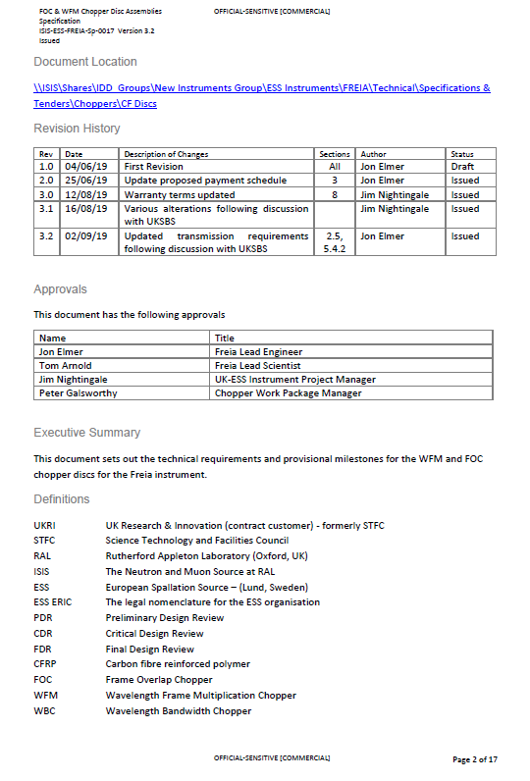



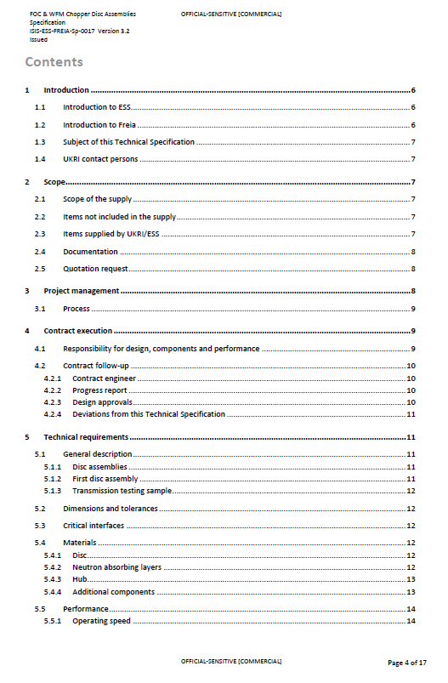

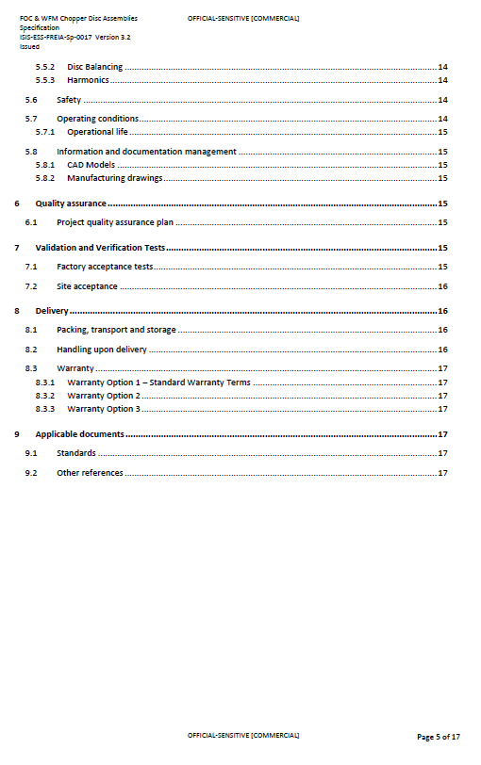

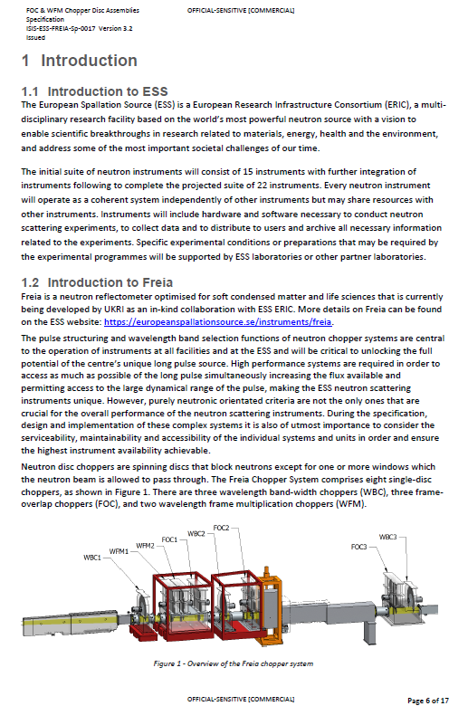

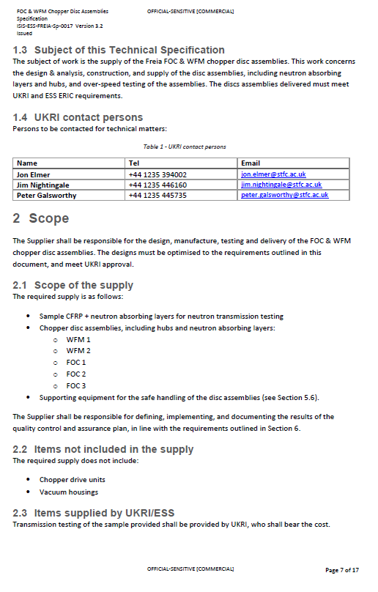

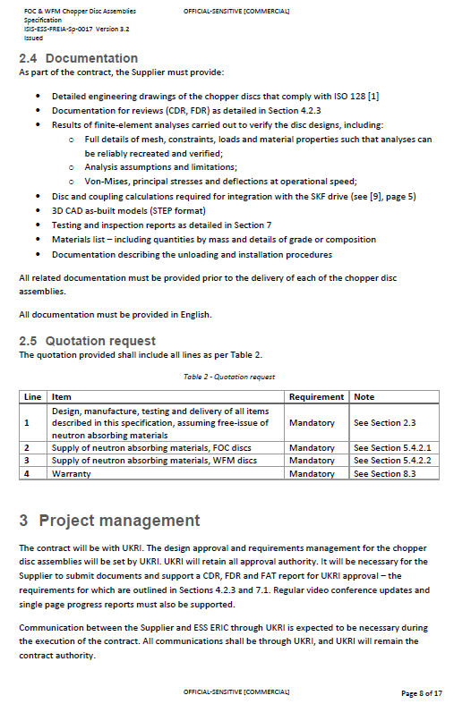

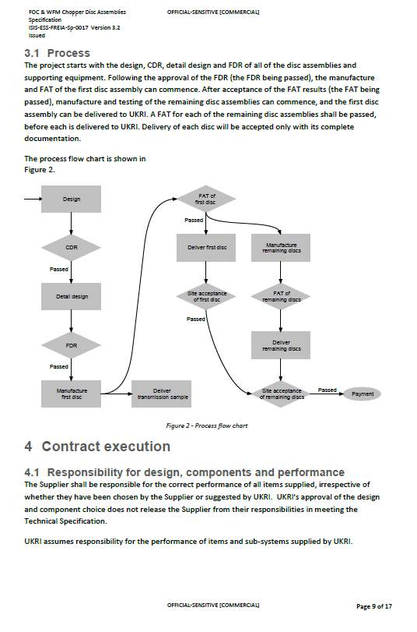

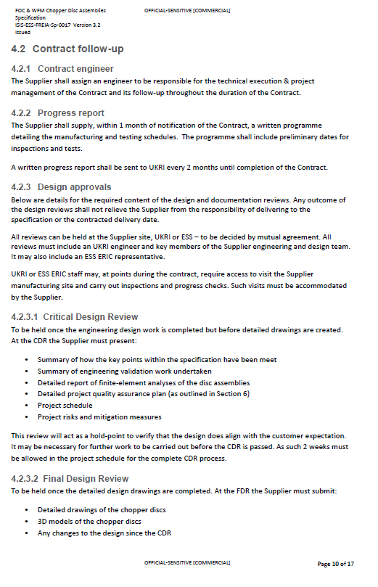

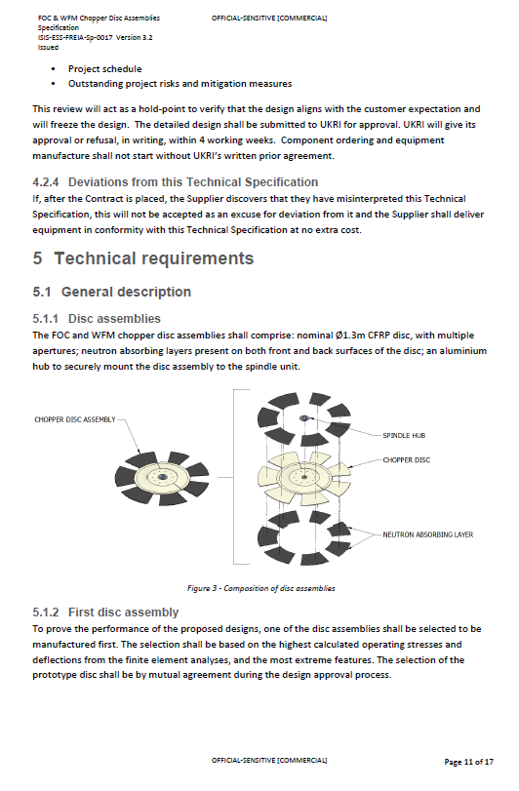

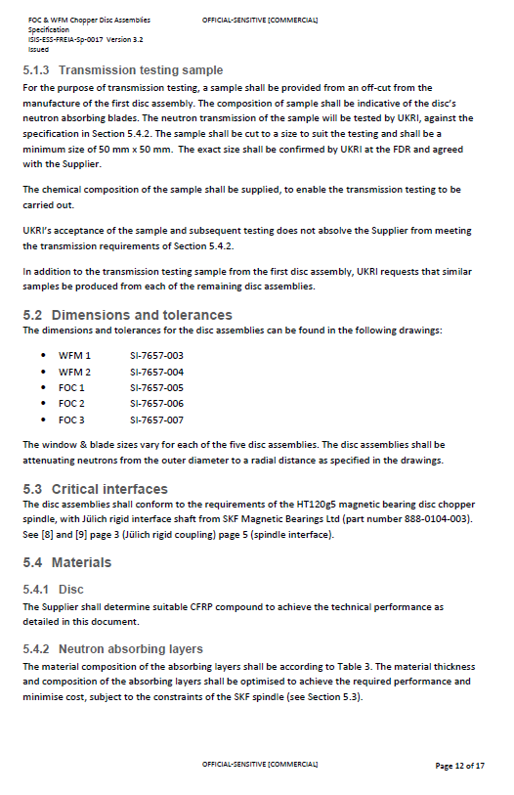

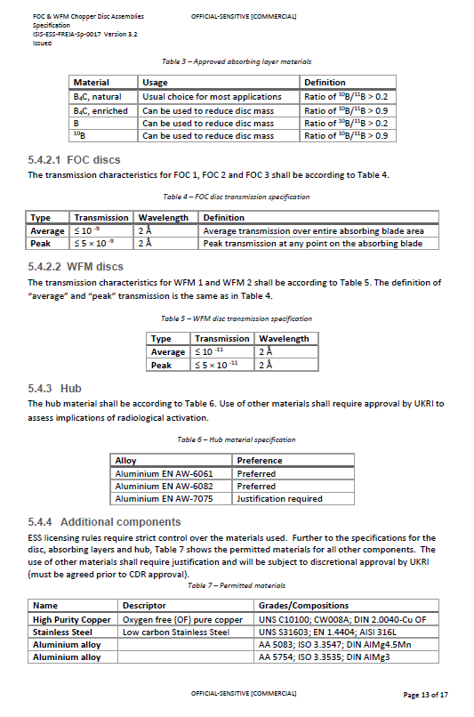

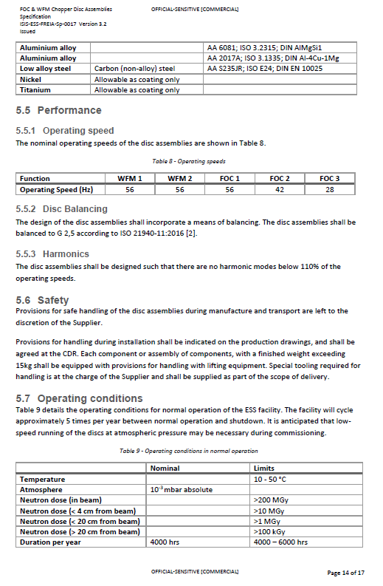

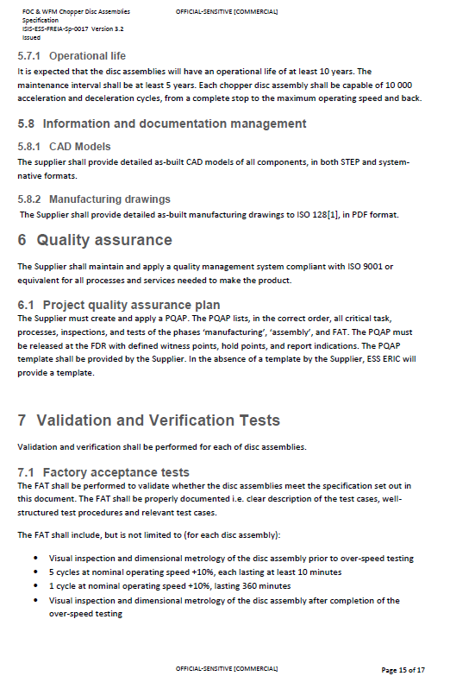

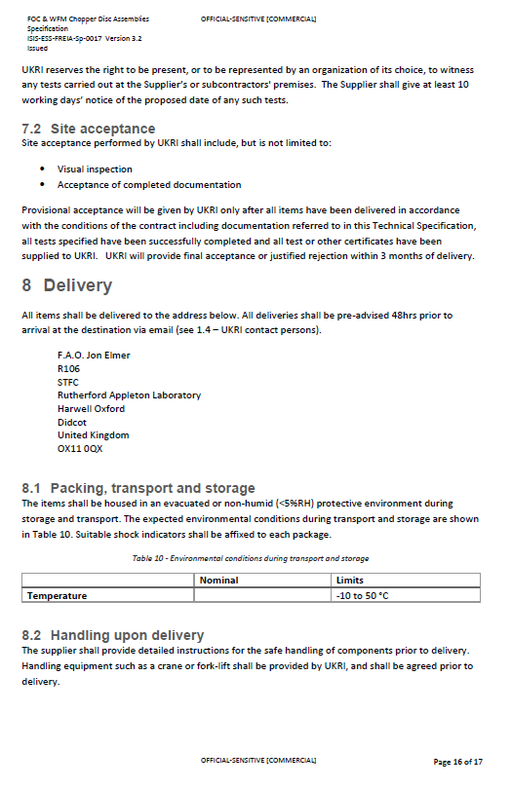

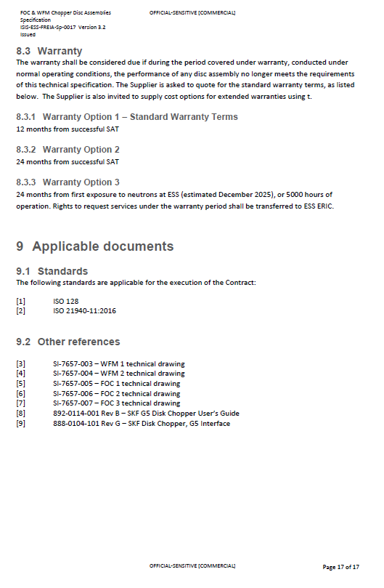

1. 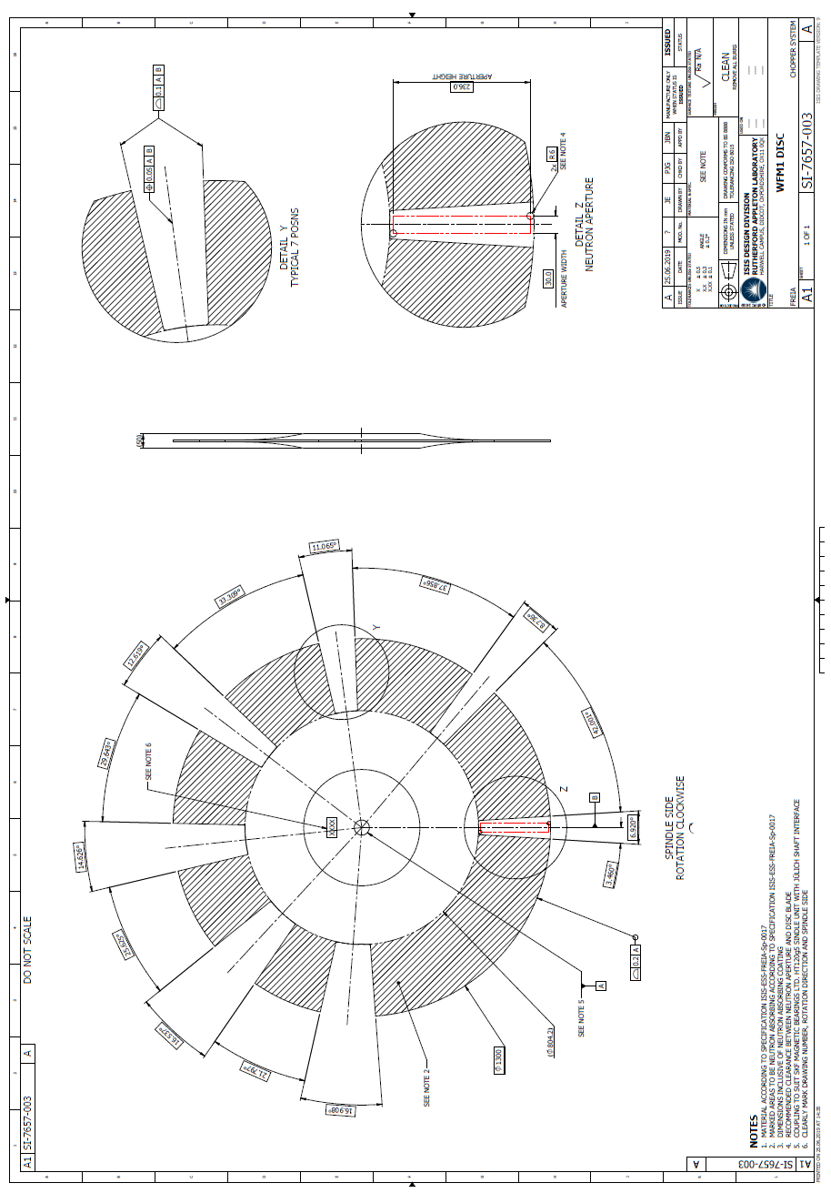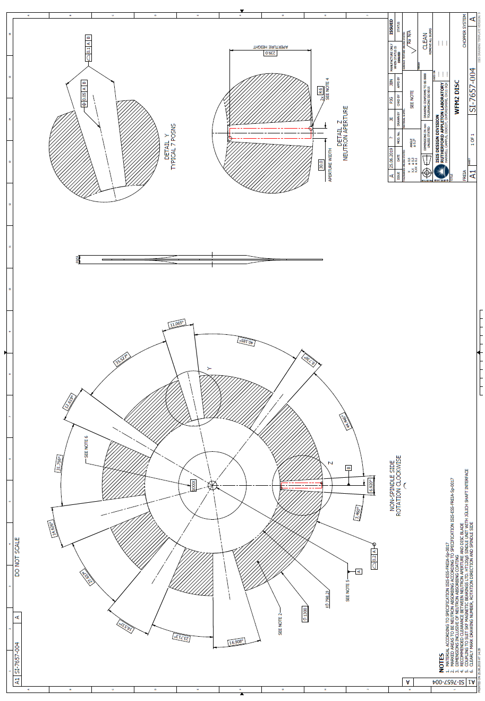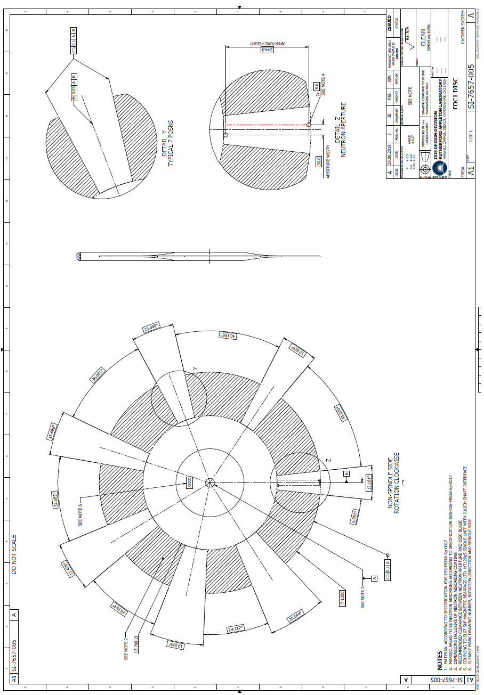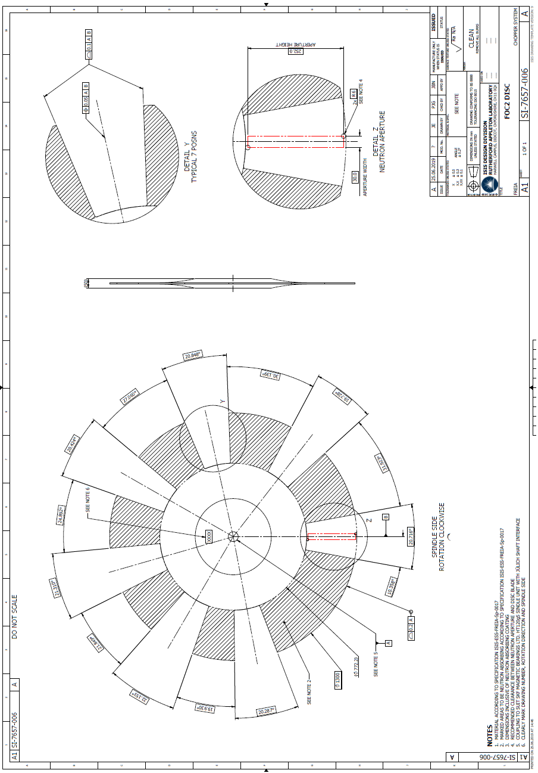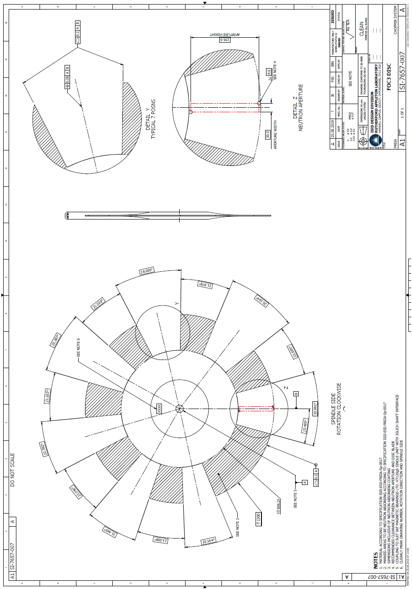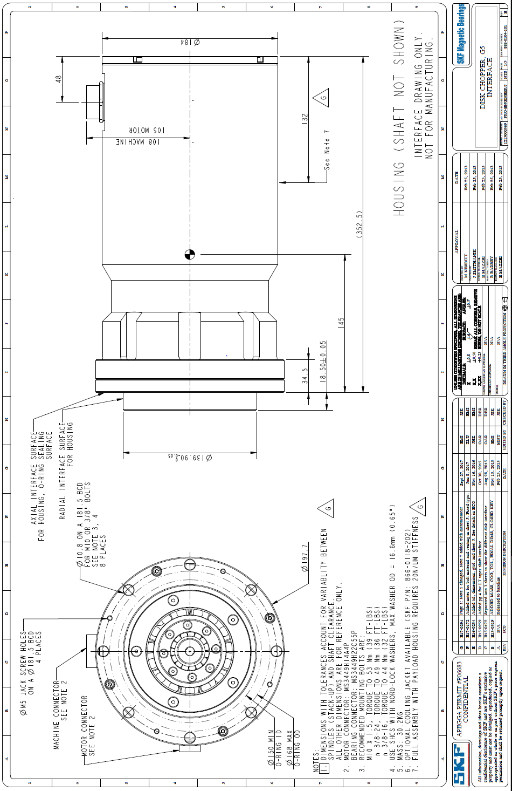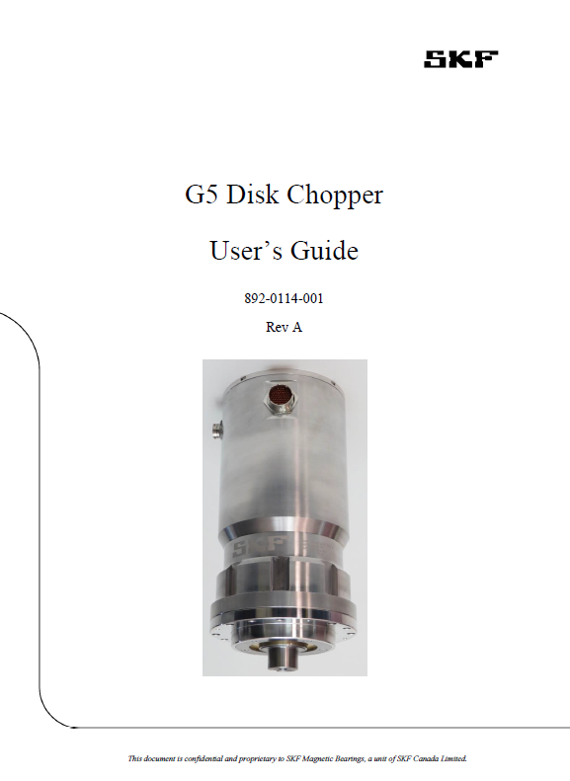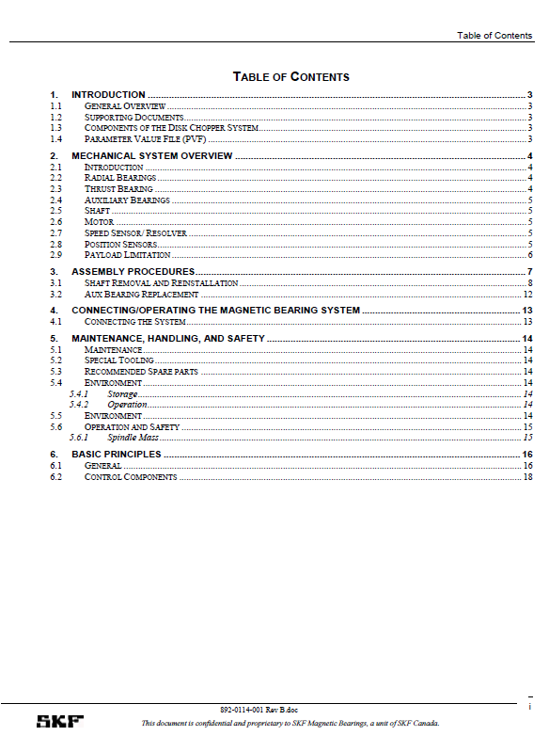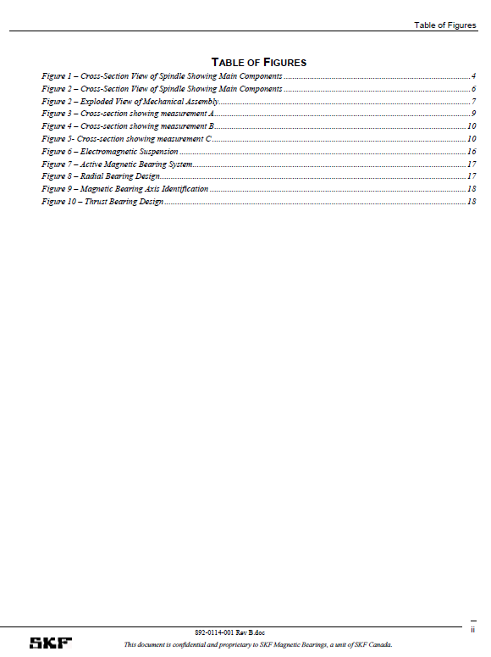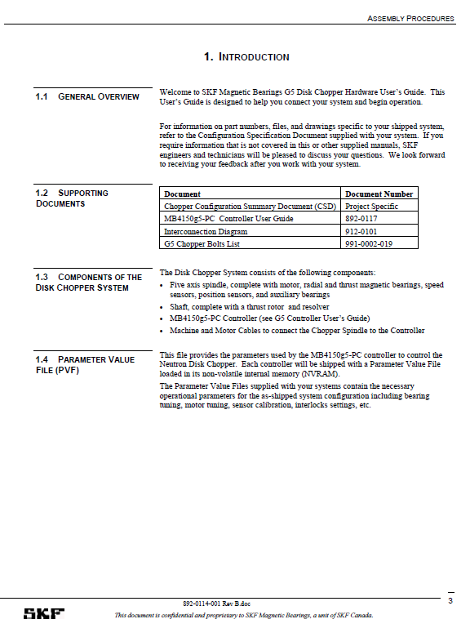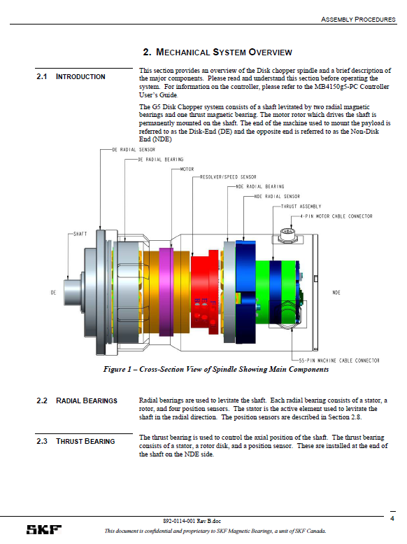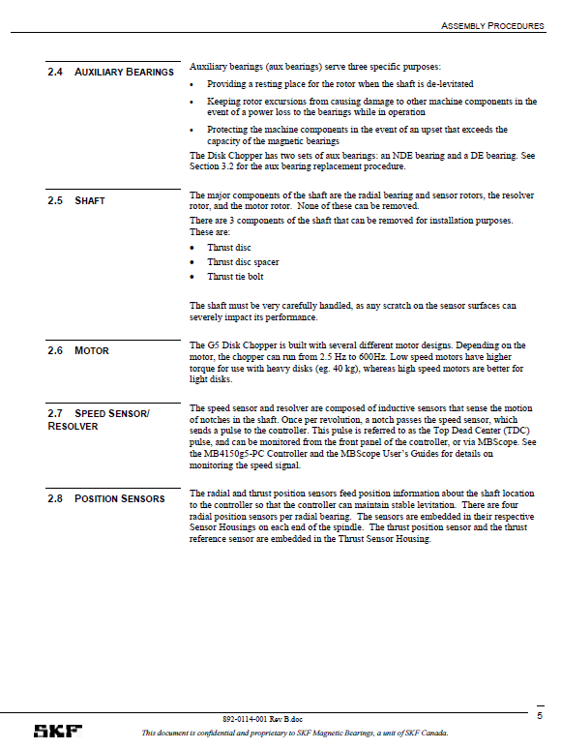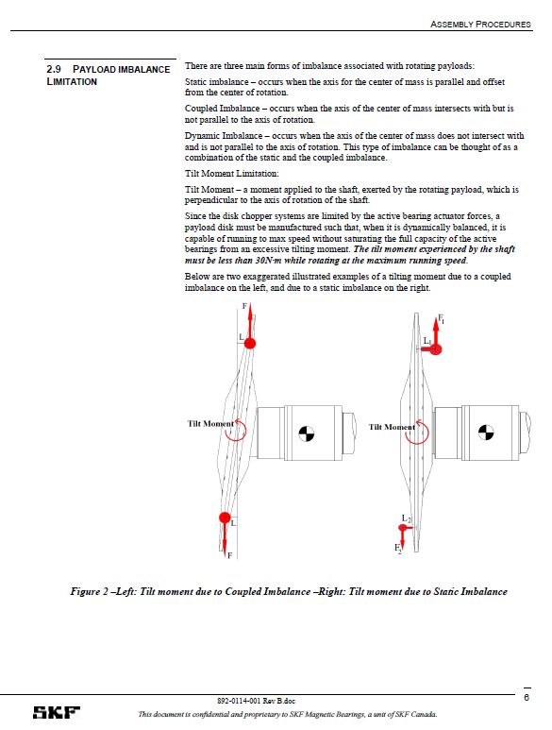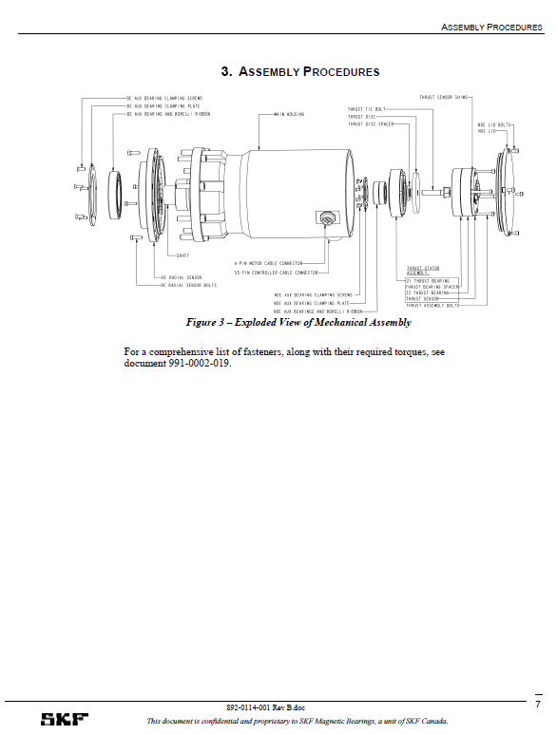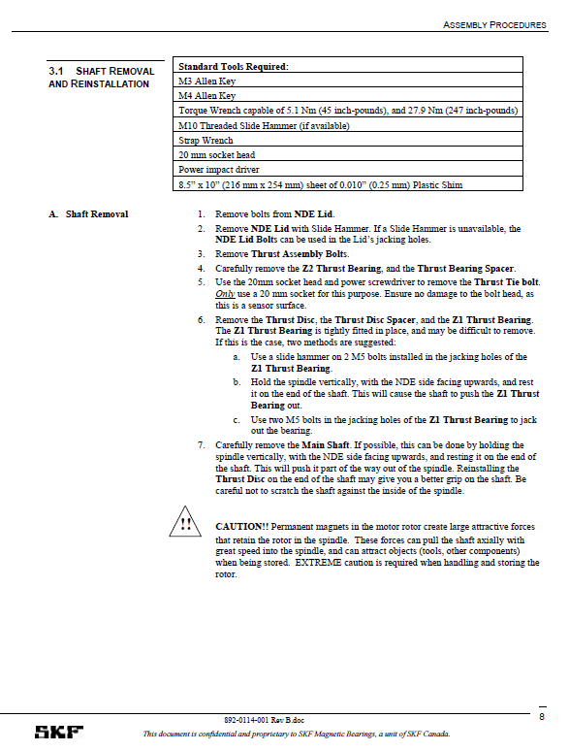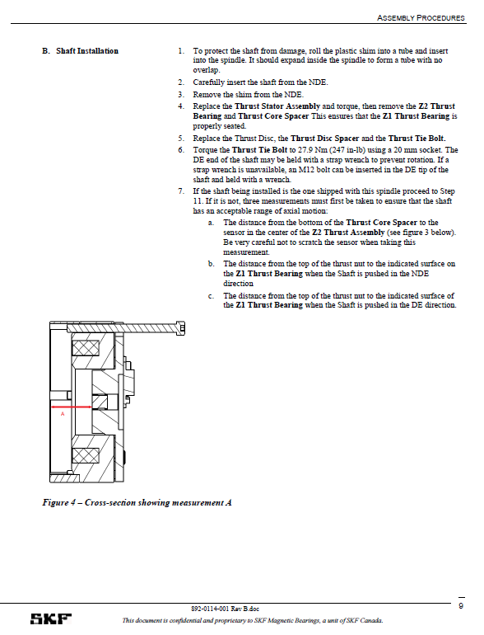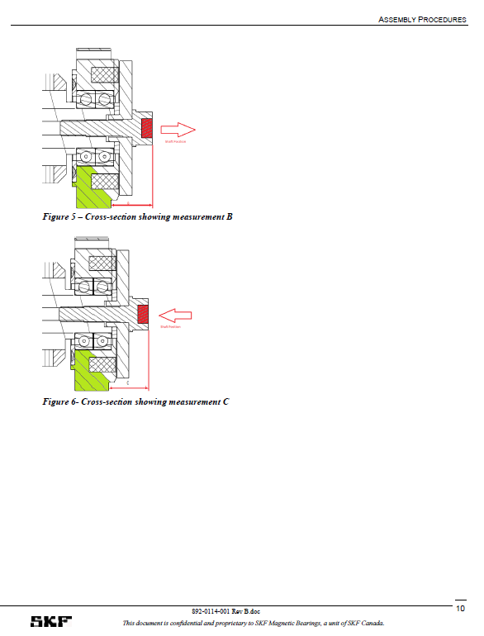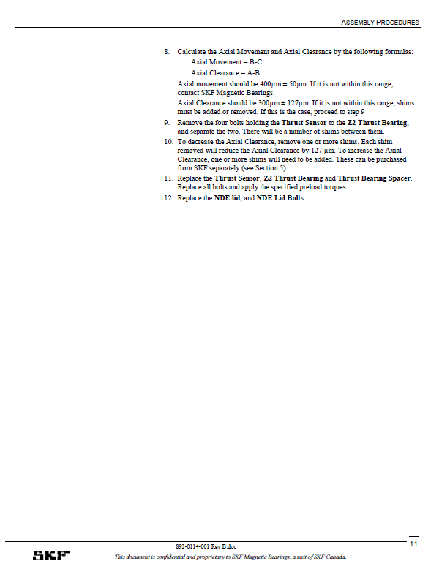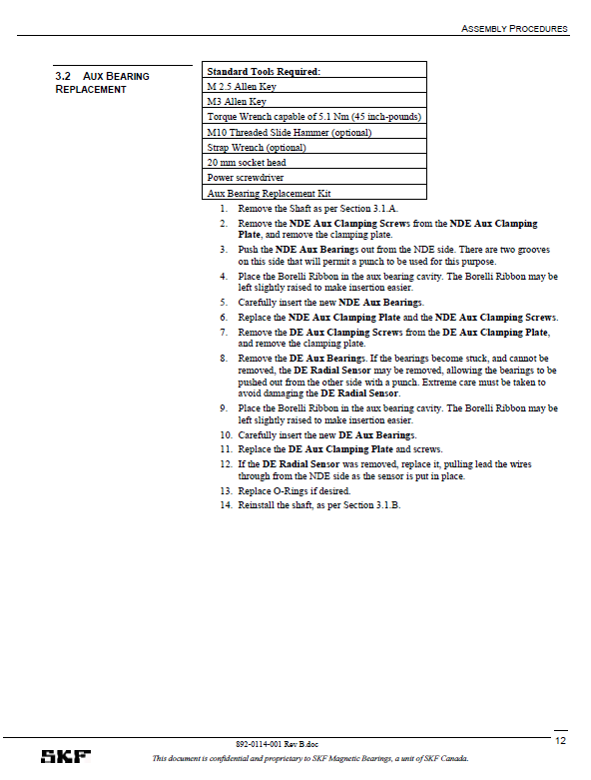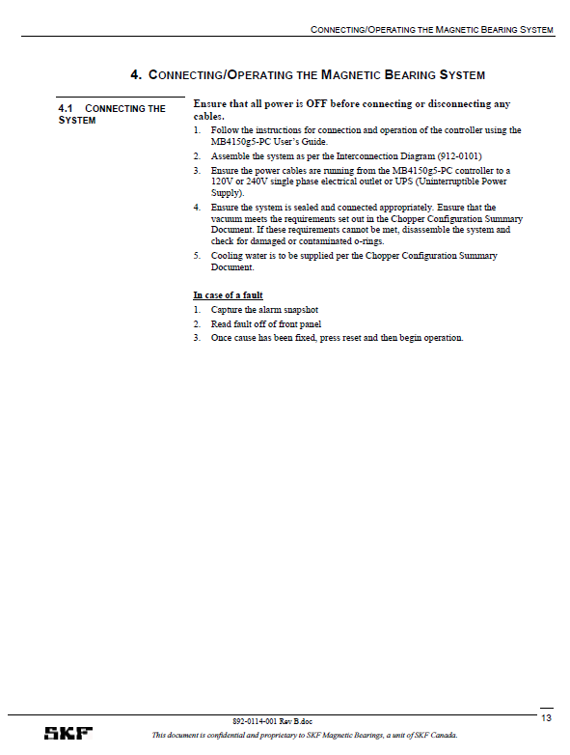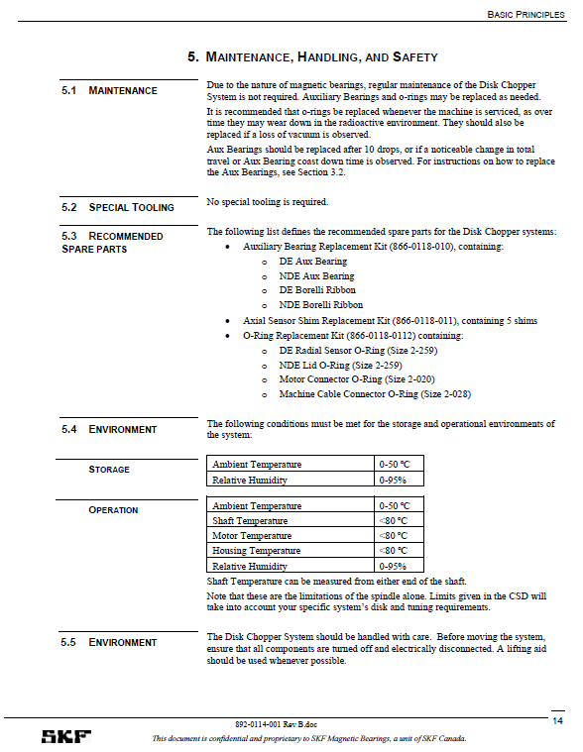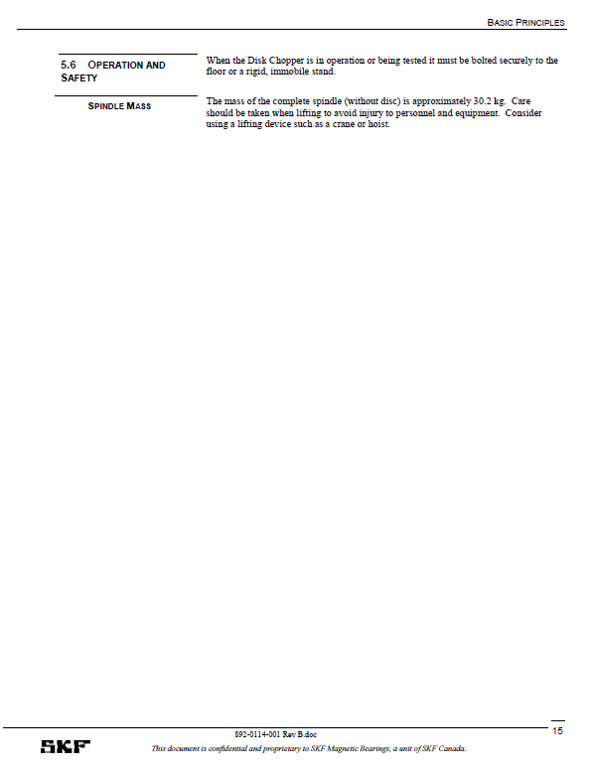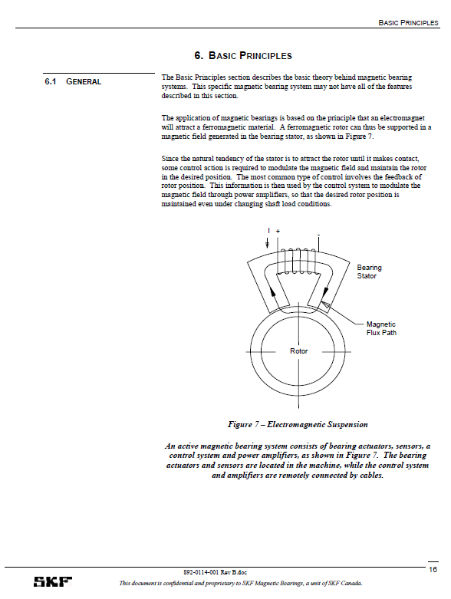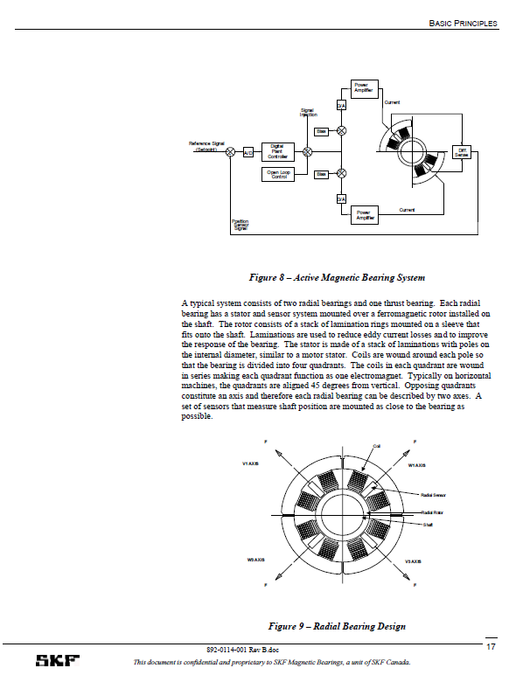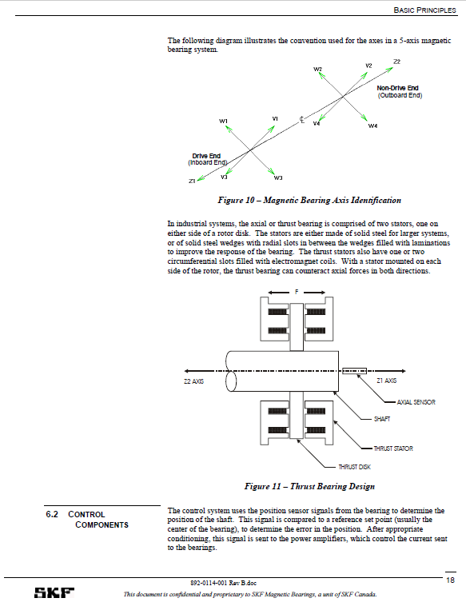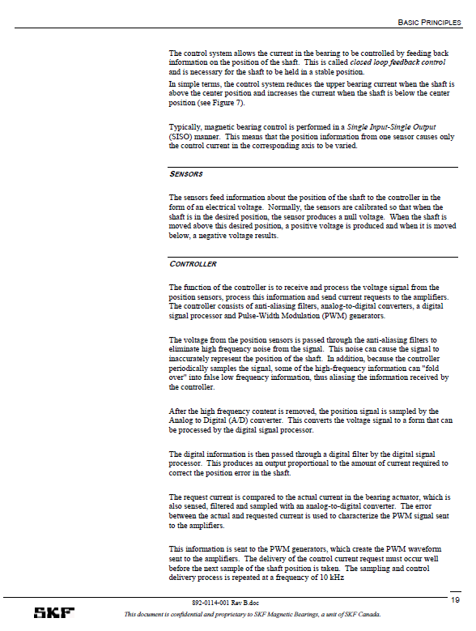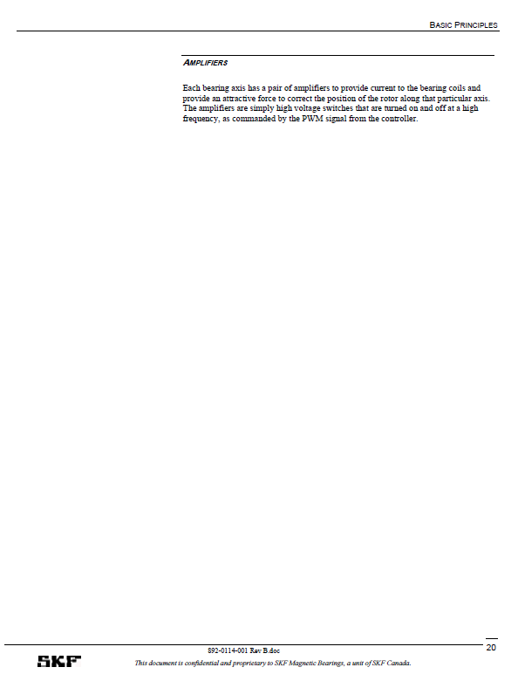

1. - Charges
2. The Charges for the Goods and/or Services shall be as set out in this Schedule 3.
3. Charges for the Goods TBA