

**Request for Information 1 (RfI)**

**PHOENIX III**

**MOD WHITE FLEET MANAGEMENT SERVICE**

11/05/2023

Contents

1. Notice to Reader and Disclaimer 3

2. Background 3

2.1. Overview of User Need 4

2.2. Single Statement of User Need (SSUN) 5

2.3. Candidate Key User Requirements (KUR) and High Level Characteristics (HLC) 5

3. Request for Information Questions 7

3.1. Responding to this RFI 9

3.2. Clarification Questions 9

4. MOD Commercial Notice – Subject to Contract 9

# Notice to Reader and Disclaimer

This RFI forms part of market engagement and is not part of any competitive procedure. Any information you submit will be considered solely for the purposes of building a greater understanding of the marketplace, and industry’s ability to provide Fleet Management Services to the Ministry of Defence. Should the decision be made to formally compete the Fleet Services requirement, any information provided must be resubmitted as part of the formal bid process.

None of the content of this document describing the Fleet Management Service or requirements should be construed as accurate or precise at this stage – it is for the purposes of assessing the market’s capability in the broader field and precedes any completed user requirements or tender evaluation criteria.

Information specific to Industry participants provided through this process will not be shared or distributed directly to other participants but will inform the discussions that MOD will have with Industry, and may subsequently be used to inform the terms on which the formal procurement process is conducted.

Any participation in this industry market engagement and any response to this RFI is entirely at your cost and risk. The MOD is under no obligation to proceed with a formal procurement or in any other way proceed with the Fleet Services project and shall not be liable to any participants for any costs arising from participation in this process.

The information contained in this RFI and any further information (whether written, electronic or oral) supplied by the Secretary of State and/or any of its representatives in respect of this RFI is, and will be, supplied on the condition that neither the Secretary of State, any of its representatives nor any agents, servants, officers or affiliates of the Secretary of State or its representatives whatsoever is liable for any error, omission, or inaccuracy therein nor for any loss or damage sustained by any party arising as a result of reliance on such information or any subsequent communication. This includes any error or omission or inaccuracy resulting from any negligent act or omission of any of the Secretary of State, its representatives or any other person (other than in respect of fraudulent misrepresentation). No party accepts any responsibility or gives any undertaking to provide further information, including any information required to correct any earlier inaccuracy or error.

# Background

There is a need for the continuation of ‘White Fleet’ management across Defence to enable continuity of service for those vehicles in the White Fleet category, a reduction in operating costs, and to ensure achievement of Central Government Sustainability Targets.

White Fleet management is currently delivered through an arrangement which is due to expire in the medium term. The current project addressing the replacement of this arrangement will deliver a future White Fleet Management provision to ensure seamless delivery in capability.

An objective for the replacement contract is for the Industry Partner to support the Authority in achieving the Greening Government Commitment (GGC) targets. The Authority are committed to achieving the GGC target for 100% of government owned or leased M1 car and N1 van fleets to be Zero Emissions Vehicles (ZEV) by 31 Dec 27. The replacement contract must support future Government mandated sustainability targets.

The pan-Defence requirement for the follow-on White Fleet contract to replace the current will need to be delivered to Defence, Equipment & Support (DE&S) in sufficient time to allow for a seamless transition from one contract to the next.

The new agreement will enable the Authority to achieve an optimised future White Fleet, which reflects reduced demand through New Ways of Working (NWOW), a reduction in long-term operating costs, reputational enhancement in the eyes of the public, and a clear demonstration that the MOD are meeting the expectations of our future workforce.

Currently vehicles are sourced via the Crown Commercial Service (CCS) frameworks on behalf of MOD.

## Overview of User Need

The MOD (‘the Authority’) requires the provision and management of suitable and appropriate non-warlike operational and administrative vehicles for whoever has a business need to travel, move materiel, carry out specified tasks within the British Isles and overseas, across Defence, and assisting in transitioning to zero emissions (at point of use) vehicles.

As well as the provision of vehicles, the MOD has a requirement for the Fleet Manager to manage the fleet on Defence’s behalf. This includes the provision of a Fleet Management Information System (FMIS); a Booking System (BS); Telematics; Service, Maintenance, Repair, and Inspection (SMRI); a recovery service; and managing fines and charges.

The MOD as the Contracting Authority will require an Arrangement which can provide:

A smooth transition and continuation of the capability of the services provided under predecessor ‘Phoenix II’ contract.

Appropriate assets (vehicles) to deliver the service availability required by end users to meet Defence needs (via purchase, lease, or VRS)

An affordable service demonstrating the best Value for Money (VfM) solutions

Quick and effective adaption to changes in requirements from the Authority to meet its objectives.

A sustainable service promoting and implementing government sustainable targets.

Expansion of Scope as required.

Continuous improvement of safety for end users.

Effective and timely adaption to changes in infrastructure.

Effective and timely adaption with alternative fuels and sources of energy.

## Single Statement of User Need (SSUN)

The Authority requires the provision and management of suitable and appropriate non-warlike operational and administrative vehicles for whoever has a business need to travel, move materiel, carry out specified tasks within the British Isles and overseas, across Defence, and assisting in transitioning to zero emissions (at the tailpipe) vehicles.

## Candidate Key User Requirements (KUR) and High Level Characteristics (HLC)

The full user requirements document (URD) will be released with any competitive procurement process which follows the market engagement activity. The candidate Key User Requirements (KURs) and High Level Characteristics (HLC) are included below. Please note that, like with all other content within the RfI, these are subject to change ahead of any competitive procurement which may take place:

**Key User Requirements**

|  |  |
| --- | --- |
| **Candidate KUR ID** | **Requirement** |
| 1.1.1 | The Authority shall be provided with self-drive vehicles for non-warlike operational and administrative tasks. Vehicles are to be available at the point of use and provide the capability required by each end user. |
| 1.1.3 | The Authority shall be able to move people at normal notice. |
| 1.2.1 | The Authority shall be able to move materiel at normal notice to enable end users to move varying amounts of stores, munitions, and equipment in non-warlike operational and administrative support of MOD tasks. |
| 1.4.1 | The Authority shall be provided with special to role vehicles that are available ‘commercially-off-the-shelf’ to enable the Authority to conduct its mandated tasks. |
| 2.1 | The Authority shall be provided the agreed service in key locations. |
| 3.1.1 | The Authority shall be delivered an available fleet management service, access to Short Term Rental vehicles and access to Industry Partner helpline. A Business Continuity Plan will be provided to cover outages of service. |
| 3.2.1 | The Authority requires a through life fleet management service to manage the White Fleet capability. |
| 4.2 | The Authority requires the Fleet Manager Provider to provide management information relating to finance, safety, usage, efficiency, contract, performance, legal and booking; and to recommend efficiencies based on the analysis of that management information. |
| 4.5 | The Authority requires an efficient booking service that enables authority personnel to book and manage bookings. |
| 9.1 | The Authority requires the capability to be delivered to best economic advantage to Defence whilst not impacting the capability to operate. |

**High Level Characteristics**

|  |  |  |
| --- | --- | --- |
| **HLC Ref** | **High Level Characteristic** | **Description** |
| HLC 1 | Vehicle Provision | the capability required to move personnel and freight and to carry out Specified Tasks |
| HLC 2 | Geographical Location | where the User requires the capability to be  provided |
| HLC 3 | Fleet Management Service | describes the processes required by the user in order to ensure the capability is managed effectively and that all benefits are realised |
| HLC 4 | Information Systems | describes the information systems required by the User to operate and manage the capability |
| HLC 5 | Training | describes the training required by the User to operate the capability |
| HLC 6 | Security | describes the security required by the User to maintain the integrity of the capability and the safety of personnel |
| HLC 7 | Safety and Environmental | describes the Safety and Environmental requirements of the User. |
| HLC 8 | Documentation | describes the Safety and Environmental requirements of the User. |
| HLC 9 | Finance | describes the financial information the capability shall provide to the User |

# Request for Information Questions

To better understand the market capability and appetite towards Phoenix III, this RFI invites Industry recipients to provide information in response to the questions below. Please answer Part A and Part B:

**PART A – FLEET MANAGEMENT SERVICE & SYSTEM PROVISION**

**Fleet Management Service (FMS)**

Are you able to provide a Fleet Management Service as illustrated below? (The diagram is high-level and indicative only, and we are open to any views which you may have on the way the solution could potentially be designed and structured).

Please provide details of where you currently provide a Fleet Management service. What vehicle types do you manage, and in which geographic locations. How many vehicles in a typical month do you manage?

Could you operate the Fleet Management Service for vehicles on and from HM Ships, and describe any experience which you already have in this capability?

How *could* you expand this provision if necessary? i.e. maximum geographic reach and any limitations? Range of non-warlike vehicle types under management? Maximum volumes managed (by type)?

If required, could you provide a Fleet Management Service for specialist or modified non-warlike vehicles? Please provide details.

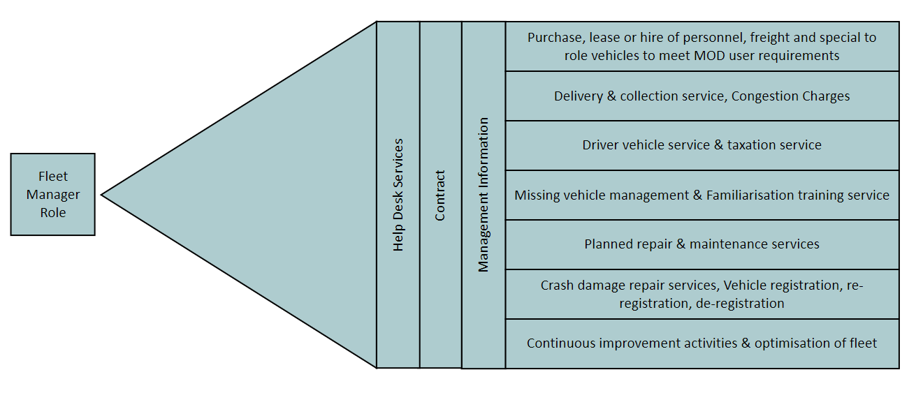

**Fleet Management Information System (FMIS)**

Can you provide a Fleet Management Information System to:

* consolidate and standardise fleet management across Defence;
* provide an intelligent booking and scheduling service;
* provide a Management Information System (MIS) which will collect, autonomously, accurate utilisation, safety and usage data.
* optimise fleet utilisation.
* improve driving standards / safety through a variety of methods including the use of a telematic system.
* utilise telemetry to collect accurate utilisation and safety data?

Do you have, and can you describe any experience of working within an MOD IT environment?

**PART B - VEHICLE SOURCING AND PROVISION**

As Fleet Manager, how would you manage the sourcing and provision of vehicles for the Fleet Management Service outlined?

As Fleet Manager, please describe what vehicle types you can source and provide.

Please provide information around:

* your plans and capabilities to meet the requirement to move to zero emissions vehicles (at the tailpipe) by December 2027 as defined by the Greening Government Commitment Targets.
* The volume of vehicles you could source and provide within any one month period (including lease and spot hire)
* The geographic locations you are able to source and provide vehicles to (e.g. UK including NI, Europe, Worldwide) and whether you provide the capability for vehicles to travel to, from and within other countries.
* A description of how you would deploy the vehicle provision capability on and from HM Ships, and any experience which you already have in this capability.
* The minimum notice periods you are able to adhere to for vehicle orders (with any differentiation by vehicle type).

## Responding to this RFI

For Part A and B – please provide any case studies or examples to support your answers.

Please respond to Part A & B by 1700 on 29/05/2023.

Please keep responses concise and relevant to the question, and do not exceed 1500 words for either Part A or Part B responses. Any directly-relevant diagrams, schematics or supporting documents are also welcomed outside of the main wordcount limit.

## Clarification Questions

All clarification questions regarding this RFI should be sent to the Defence Sourcing Portal by 1700 on 21/05/2023.

*Clarification questions and answers may be anonymised and shared with other RfI respondents.*

# MOD Commercial Notice – Subject to Contract

* This RFI is subject to contract.
* The Phoenix III project is at an early stage of development and UK MOD wishes to engage with Industry to gain a better understanding of current and planned capabilities.
* The existence of this RFI does not imply that UK MOD will make a purchase relating to the requirements within the indicated timescale, later, or at all.
* All information provided by UK MOD during discussions with industry is provided in good faith but is indicative only and does not constitute an invitation to tender or an offer of contract.
* Information received from Industry will be treated as commercially in confidence unless specifically and mutually agreed otherwise.

* * *