
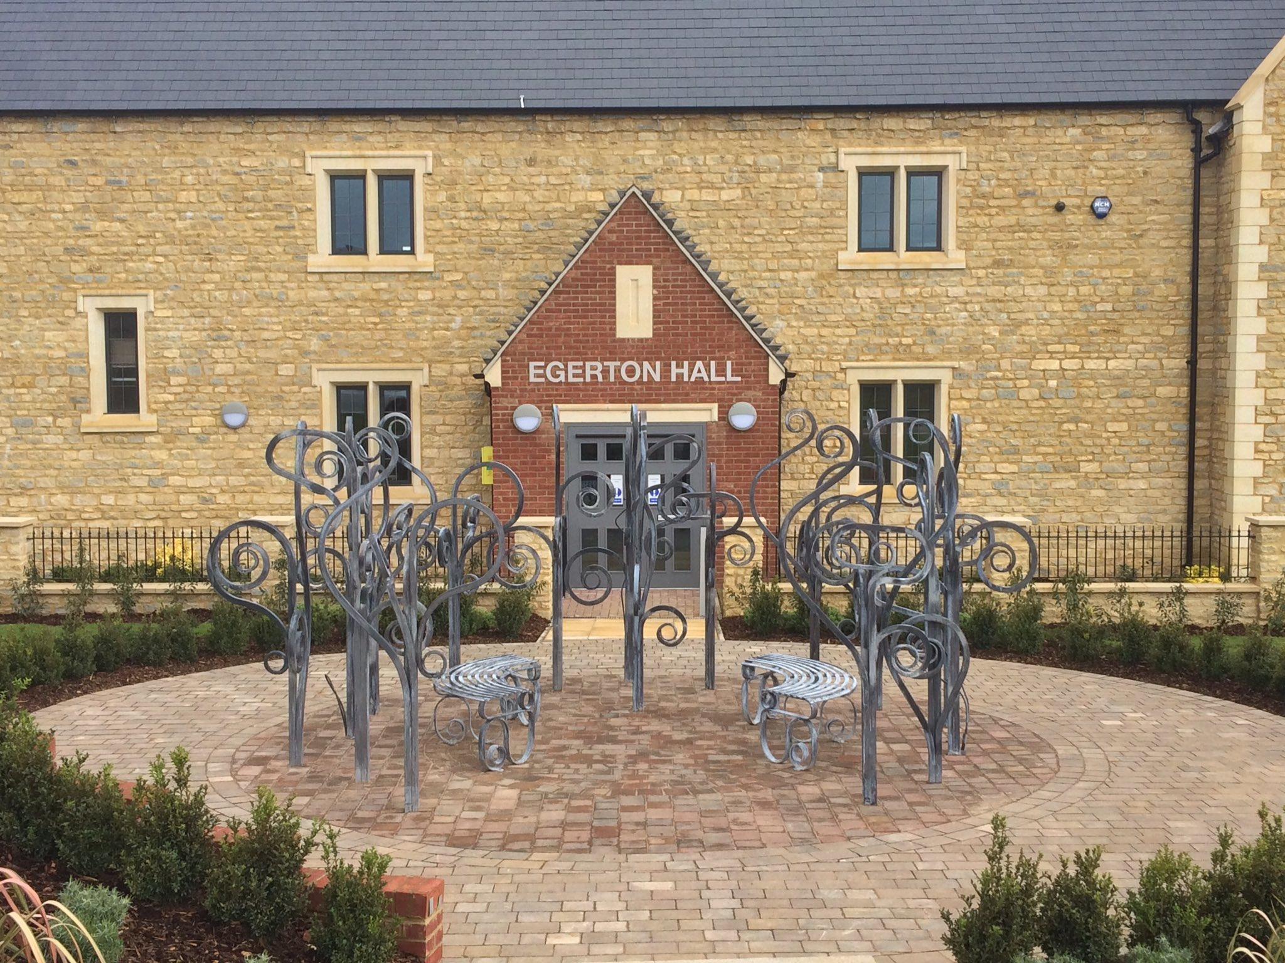
davidc
ITT Document
Document Details
Project Name | Egerton Hall Internal Alterations
Project Number | 026-23
Document Title | Invitation to Tender Document
Date Created | 08.11.2023
Revisions
Issue | Notes | Date | Signed
T01 | Tender Issue | 09.11.2023 | DC

Purpose 2
Background 2
Outline Timetable/Process 2
Instructions for Completion 2
ITT Queries 3
Contractors Contact Point 3
ITT Return Deadline 3
Approvals 3
Building Control 3
Planning Permission 3
Principal Contractor 3
ITT Evaluation 4
Scoring Guidelines 4
Award Questions 6
Form of Tender 8

Purpose
Brackley Town Council (the ‘Client) would like to invite you to take part in the tender for the project at Egerton Hall in Brackley.

The project involves the completion of the first floor fit out of Egerton Hall comprising of two function rooms a store, kitchen areas, three toilets and new staircase and platform lift with associated mechanical and electrical works. The building was originally designed with an additional floor level at First Floor, and it is understood provision for a future platform lift was incorporated into the original building structure.

The purpose and scope of this ITT and supporting documents is to explain in further detail the requirements of the Client Organisation and the procurement process for submitting a tender proposal. This document and the associated documents are an invitation to tender only and do not constitute an offer to trade and the Client is not bound to conduct business on the basis of any submission received.

Background
Egerton Hall is located in the North of Brackley in a relatively new housing development. It was built around 2013-2015 and is of brick/stone cavity wall construction with a pitched roof. The first floor is built to shell only. Adjacent the site is a school and local facilities. The local authority is West Northamptonshire South Area.

Outline Timetable/Process
The Client proposes the following indicative timetable for the procurement of this Service:

Invitation to Tender 07.11.2023
Tender Return 04.12.2023
Site Visits 08.11.2023 – 30.11.2023 see note below
Tender Evaluation 08.12.2023
Appoint Contractor 13.12.2023
Anticipated Start on Site 03.01.2024
Anticipated Contract Completion 30.04.2024

The Client reserves the right to change the above timetable.

Site visits can be arranged by contacting Brackley Town Council on 01280 702441

Instructions for Completion
Contractors should complete the Form of Tender and it is expected that all tenders will provide a breakdown of their itemised costs on the included Schedule of Works document, failure to do so may mean your tender will not be considered.

Contractors should complete the Award Questions and comply with other supporting information requirements of this document are to be submit as part of the overall package of information requested in the Invitation to Tender.

It is the responsibility of the Contractor to ensure safe receipt of submissions in accordance with the ITT requirements.

For the avoidance of doubt, the ITT should be completed and delivered by 11.00 pm on Monday 4th December 2023.
Late submissions, for any reason, will be disqualified from the selection process on grounds on basic non‐compliance.

Suppliers should answer all questions as accurately and concisely as possible.

Failure to provide the required information, make a satisfactory response to any question, or supply documentation referred to in responses, within the specified timescale will be taken into consideration of the ITT Evaluation.

Where a Contractor is not currently registered in the UK, the questions should still be answered, substituting any law, code of practice or appropriate professional, commercial or other register within their domestic jurisdiction.

ITT Queries
The Client will not enter into detailed discussion of the requirements at this stage.

Any questions about the ITT should be submitted in writing to Kathy Hale via e-mail to:
deputy@brackleynorthants-tc.gov.uk

If the Client considers any question or request for clarification to be of material significance, both the query and the response will be communicated, in a suitably anonymous form, to all Contractors who have responded.

All responses received and any communication from Contractors will be treated in confidence.

You should note that we are unable to respond to telephone queries other than those for site visits.

Contractors Contact Point
Contractors have been asked to include a single point of contact in their organisation for their response to the ITT.

The Client shall not be responsible for contacting the Contractor through any route other than the nominated contact.

The Contractor must therefore undertake to notify any changes relating to the contact promptly.

ITT Return Deadline
Responses must be received by 11.00 pm on Monday 4th December 2023. Responses received after this date will be disregarded.

Approvals

Building Control
HB Architects have made a Building Regulation application to West Northamptonshire Building Control for this development. An addendum to the tender will be submitted should full approval be issued from the local authority during the tender process.

Planning Permission
The project does not involve any external alterations and is not subject to any planning permission.

Principal Contractor
The contractor will be the Principal Contractor under the CDM (Construction Design and Management) Regulations and BSA (Building Safety Act) Regulations.

It is expected that the onsite H&S and welfare costs incurred by the main contractor to comply with CDM 2015 are allowed for within the tender price.

The existing building Health and Safety File can be seen by appointment and will be available for the awarded contractor to make an appendix for the proposed works.

ITT Evaluation
The following criteria and weightings will be applied in the evaluation of the questions asked of Contractors within this section 1 Award.

Evaluation Criteria Breakdown | Means of Evaluation
 | Sub Criteria | Main Criteria
Method Statements |  | 100%
Approach | 20%
Quality | 30%
Previous Project Experience | 15%
Management and Communication | 10%
Programme | 5%
Budget management | 20%

Scoring Guidelines

The questions asked of Contractors shall be scored using the marking system described in the table as follows. Contractor should refer to the Council’s minimum requirements to ensure that they meet or exceed the minimum requirements wherever possible.

Contractor should be aware that the responses provided to the questions will be evaluated in such a way that the highest scores will be awarded to Contractor who show innovation, creativity, further relevant details and information that could potentially enhance the Contractor’s proposal. It should be noted that to achieve the highest scores available the Contractor must not only meet but exceed the Council’s minimum requirements, where these are stated.

All scored question shall be evaluated in accordance with the guidelines below:

Score 0 | No response | No response
Score 1 | Extremely Weak | Very poor proposal/response; does not cover the associated requirements, major deficiencies in thinking or detail, significant detail missing, unrealistic or impossible to implement and manage | Weak
Score 2 | Very Weak | Poor proposal/response, only partially covers the requirements, deficiencies in thinking or detail apparent, difficult to implement and manage | Weak
Score 3 | Weak | Mediocre proposal/response, moderate coverage of the requirements, minor deficiencies either in thinking or detail, problematic to implement and manage | Weak
Score 4 | Fair - Below Average | Proposal/response partially satisfies the requirements, with small deficiencies apparent, needs some work to fully understand it | Fair - Good
Score 5 | Fair - Average | Satisfactory proposal/response, would work to deliver all of the Council's requirements to the minimum level | Fair - Good
Score 6 | Fair - Above Average | Satisfactory proposal/response, would work to deliver the majority of the Council's requirements to the minimum level with some evidence of where the Applicant could exceed the minimum requirements | Fair - Good
Score 7 | Good | Good proposal/response that convinces the Council of its suitability, response slightly exceeds the minimum requirements with a reasonable level of detail | Fair - Good
Score 8 | Strong | Robust proposal/response, exceeds minimum requirements, including a level of detail or evidence of original thinking which adds value to the bid and provides a great deal of detail | Strong - Excellent
Score 9 | Very Strong | Proposal/response well in excess of expectations, with a comprehensive level of detail given including a full description of techniques and measurements employed | Strong - Excellent
Score 10 | Outstanding/ Excellent | Fully thought through proposal/response, which is innovative and provides the reader with confidence of the suitability of the approach to be adopted due to the complete level of detail provided | Strong - Excellent

Award Questions

Question  Number |  | Question
Approach (20%)
1.1 |  | The Contractor shall provide a method statement detailing how it would plan, manage and deliver the Project
Council’s minimum requirements: Please note that the Council is looking for evidence of the Contractor’s previous experience in relation to managing and delivering projects of a similar nature to that required here, as well as detail of how that experience will be used during the delivery of this Contract. The Council is also looking for evidence of the Contractor’s previous experience of working collaboratively with key stakeholders and engaging in consultation with those stakeholders.

Response:

Quality (30%)
1.2 |  | The Contractor shall provide a method statement detailing how it proposes to deliver a high-quality project that delivers the aspirations on time, within budget, within any relevant constraints at competitive construction rates.
Council’s minimum requirements: Please note that the Council is looking for evidence that the Contractor has an understanding of managing key stakeholder’s expectations within a particular budget envelope.

Response:

Previous Project Experience (15%)
1.3 | The Contractor will provide examples of relevant projects that will be used to assess this question.
Council’s minimum requirements: The Council is looking for relevant project examples which demonstrate the Applicants’ track history of successful delivery.

Response:

Management and Communication (10%)
1.4 |  | The Contractor shall provide details of the project team that will be involved in the delivery of this Contract.
Council’s minimum requirements: Please note that the Council is looking for the appropriateness of the project team to meet the requirements of the Project, details of their previous experience of working together as a team, the project management structures that will be in place and the means by which they will communicate with the Council and key stakeholders throughout the life of the Contract.

Response:

Programme (5%)
1.5 |  | The Contractor shall provide an outline plan for delivering the requirements of the Project
Council’s minimum requirements: Please note that the Council is looking for the submission of a realistic programme and completeness of services offered.

Response:

Budget Management (20%)
1.6 |  | The Applicant shall describe its proposed approach to managing the budget, working with the Council to manage any potential cost overruns and reporting cost information to the Council. The Applicant must be mindful of the fact that the allocated budget for this Project is £200,000 excluding VAT which must not be exceeded.
Council’s minimum requirements: Please note that the Council is looking for a Contractor that is willing to work with the Council to manage the costs of the project within the allocated budget.
Response:

Form of Tender
Fit out of Egerton Hall
at
Brackley
for
Brackley Town Council

To:
Kathy Hale
Brackley Town Council
20 High Street
BRACKLEY
NN137DS

Dear Sir/Madam,

I/We, having read the Conditions of Contract and supporting information provided and having examined the Drawings referred to therein and visited the site do hereby offer to execute and complete the whole of the works described on a ‘FIXED PRICE’ basis for the sum (exclusive of VAT) as follows:-

For executing and completing the Works within a _______week period.
(Note: the contract period shall be deemed to include any holiday periods).

Project Total

…………………………………………………………………………………………………………………………………………

…………………………………………………………………………………………… £ ____________________________

I/We enclose with our tender our proposed outline programme for the Works and the Schedule of Works fully priced in ink in support of our tender.

I/We undertake in the event of your acceptance to execute with you a form of contract embodying all the conditions and terms contained in this offer.

I/We will undertake to commence the works within _______ weeks of acceptance of my/our tender and to complete the Works within the period of time stated from the date upon which I am/we are given possession of the site.

I/We agree that should obvious errors in pricing or errors in arithmetic be discovered before acceptance of this offer in the priced Specification submitted by me/us these errors will be corrected in accordance with The JCT Tendering Practice Note 2017.

I/We further agree that this Tender remains open for acceptance for 1 months and also understand that the Employer is not bound to accept this tender, or any tender, nor to refund any expenses in connection with the preparation of it.

Contractor’s signature ……………………………………………………………………………………………………………

Contractor ……………………………………………………………………………………………………………

Address ……………………………………………………………………………………………………………

……………………………………………………………………………………………………………

Telephone Number ……………………………………………………………………………………………………………

Date ……………………………………………………………………………………………………………

