New Forest National Park Authority

Invitation to Quote: NFNPA – 0049

CIL Viability Assessment and Affordable Housing Contributions

- Introduction

  - The New Forest National Park was designated in 2005 and covers 220 square miles in southern England within the counties of Hampshire and Wiltshire. The National Park is home to 35,000 people and has one of the highest population densities of any National Park in England. The largest villages in the National Park have around 3,000 residents. For planning purposes, the New Forest National Park has the highest status of protection in relation to landscape and scenic beauty and is recognised as an area where development is restricted. The Authority deals with around 900 planning applications per annum.

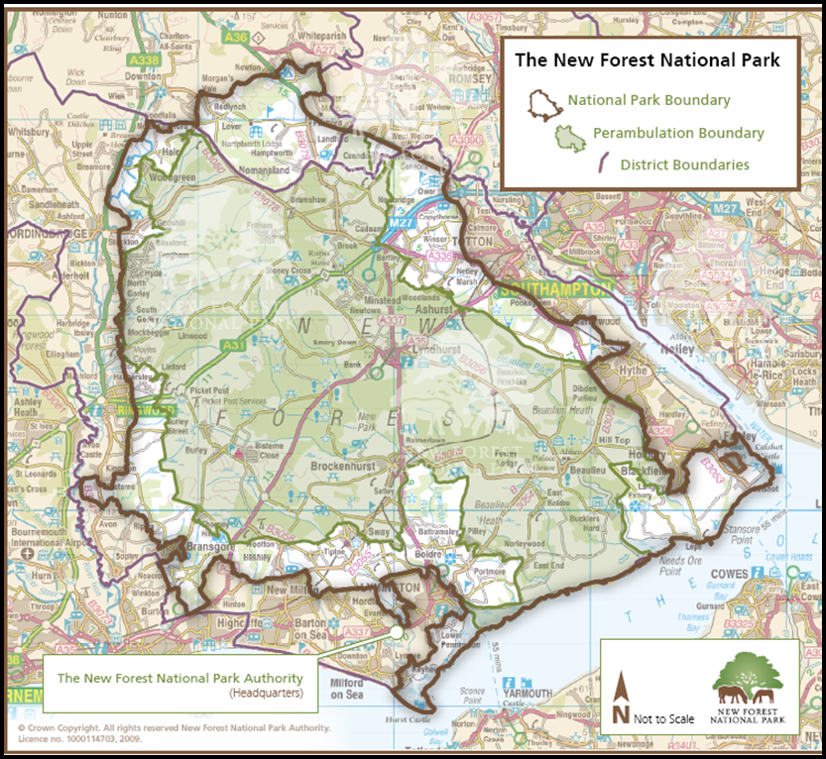

1.2 The National Park Authority is the sole statutory planning authority for the Park, covering the development management, planning policy, enforcement and minerals & waste planning functions. As guardians of a national park, the New Forest National Park Authority has statutory purposes and socio-economic responsibilities as specified in the Environment Act of 1995:

- To conserve and enhance the natural beauty, wildlife and cultural heritage of the area; and
- To promote opportunities for the understanding and enjoyment of the special qualities of the Park by the public.

1.3 Working in partnership with other organisations it is also the Authority's duty to seek to foster the economic and social well-being of the local communities within the National Park. We like to sum this up as Protect - Enjoy - Prosper.

1.4 Please visit www.newforestnpa.gov.uk for more information on the New Forest National Park Authority.

- The Brief

Part 1: The New Forest National Park Authority’s Local Plan and the Community Infrastructure Levy (CIL)

2.1 The New Forest National Park Authority’s recently adopted Local Plan 2016-2036 states in paragraph 7.84, “The National Park Authority is a charging authority under the relevant CIL Regulations, although it has not to date implemented CIL within the National Park. This remains an option for the Authority in the future.” This is further defined in Policy SP38 “Contributions will be secured through the appropriate mechanism – including the Community Infrastructure Levy…”

2.2 At the National Park Authority meeting on 11 July 2019 members endorsed the principle of developing a Community Infrastructure Levy (CIL) Charging Schedule (Report NFNPA 579/19). A key part of implementing CIL in the National Park is to commission updated viability evidence to determine whether CIL is viable in the National Park and, if so, to inform the charging level set.

2.3 The Authority had some initial CIL viability work undertaken as part of the Whole-Plan Viability Assessment (Three Dragons) in November 2017 and therefore baseline information is publicly available. This assessment concluded that there was ‘viability headroom’ for new development to support CIL. This report factored in the other planning policy requirements placed on new development in the National Park, including restrictions on the size of net new dwellings and the level of affordable housing sought.

Part 1 - Project Brief

2.6 As part of the required evidence base for determining whether CIL is viable and, if so, the production of a CIL Charging Schedule, the Authority invites submissions and quotes from suitably qualified consultants with an established track record and relevant experience in the production of the following outputs:

Undertake a viability assessment to:  (a) determine whether CIL is viable in the National Park (given the range of policy requirements placed on new development; and (b) if so, inform the preparation of a New Forest National Park CIL Charging Schedule | This assessment should consider different types and locations of development to provide the viability evidence for the setting of CIL rates, e.g. residential and commercial; and areas with higher land values (e.g. Brockenhurst).  It should include a technical paper comprising an evidence base, methodology, detailed assessment and conclusions.  The assessment should be compliant with the latest guidance on ‘Community Infrastructure Levy’ and ‘Viability’ contained within the National Planning Practice Guidance (NPPG) resource; and the most up to date regulations – including the Community Infrastructure Levy (Amendment) (England) Regulations 2019.
Examination | The appointed consultants will be expected to assist the Authority during the public examination of the CIL charging schedule and its evidence, should the decision to implement CIL be taken.
Advise on ongoing implementation of CIL charging | Provide an overview of the day-to-day tasks of CIL administration, including an estimate of administrative time per week or month, potential monitoring software with their pros and cons and other future work to be aware of.

2.7 The appointed consultants should also examine the type, extent and impact of CIL exemptions (e.g. affordable housing, self-build, etc.) within the specific context of the New Forest National Park.

2.8 As outlined in the table above, the Authority expects the CIL viability assessment to focus on the overall viability of CIL and to ensure that, if introduced, it will not prevent the delivery of development within the National Park. The CIL viability assessment must meet the requirements of the National Planning Policy Framework and the latest National Planning Practice Guidance on ‘Community Infrastructure Levy’ and ‘Viability’ (last updated September 2019), which state that,

“When deciding the levy rates, an authority must strike an appropriate balance between additional investment to support development and the potential effect on the viability of developments…Charging schedules should be consistent with, and support the implementation of, up-to-date relevant plans.”
– NPPG section on ‘Community Infrastructure Levy’, September 2019

2.9 The assessment should be proportionate and based on meeting the expectations of the CIL Examinations. The successful consultant is also requested to state if they will be able to represent the Authority at a future CIL Examination on any matters relating to the viability assessment evidence and provide an estimate of cost based on standard hourly/daily rates.

Background information on viability

2.10 A ‘Whole Plan, Affordable Housing and CIL Viability Assessment’ was undertaken in November 2017 as part of the evidence base for the Authority’s recently adopted Local Plan (August 2019). This assessment is in the public domain and provides useful information on the previous work undertaken.

2.11 By way of further context, Annex 1 of this document sets out the background to development within the New Forest National Park. This highlights the particular planning framework for new development in the New Forest National Park, based around the high level of protection for the landscape and habitats; the strong emphasis in national policy on the delivery of affordable housing to meet local needs; and high house prices. The Authority will be happy to provide further information at the inception meeting.

Methodology

2.12 The consultant should set out in their response to the invitation to quote their proposed methodology for an assessment of whether the introduction of CIL within the New Forest National Park is viable and, if so, the development of a Charging Schedule. Assessment methodologies should follow established industry best practice and meet the requirements of the NPPF and NPPG to demonstrate the deliverability of sites to ensure the CIL Charging Schedule is based on sound evidence.

Part 2: Updating the affordable housing financial contribution figures

2.13 As set out in Annex 1 to this document, the adopted Local Plan for the National Park (August 2019) confirms that financial contributions may be sought in lieu of off-site provision for smaller development (Policy SP27).

2.14 The current levels of financial contributions for off-site provision are set out in Annex 3 of the Authority’s Development Standards SPD. The financial contribution figures set out the unconstrained open market value of clean and serviced land for residential development within the four ‘Defined Villages’ of the National Park. These figures were derived from information provided by the District Valuation Service (DVS) based on 2011 land valuations and form the basis for negotiating affordable housing financial contributions.

2.15 There is a clear need to update the figures to reflect current land valuations within the National Park and ensure the level of financial contribution sought for off-site affordable housing provision under the new Local Plan is accurate and fair. The second part of this invitation to quote document therefore asks suitably qualified consultants to produce updated values for affordable housing contributions.

2.16 Financial contributions towards off-site affordable housing provision in lieu on on-site provision will continue to be secured through Section 106 legal agreements even if the Authority introduced CIL in the future. Therefore, although Part 2 of this invitation to quote is a separate area of work, the Authority believes there are benefits from progressing the CIL viability work and the updating of affordable housing contribution values in tandem, as the latter could impact on the former. In addition, if the decision is that ultimately the Authority does not implement CIL, there remains a need for updated affordable housing contribution values.

- Evaluation

3.1 Prospective suppliers:

- Are encouraged to be concise in explaining their suitability, experience and approach to the brief. Any further documentation supplied not strictly in support of your application is not encouraged (e.g. sales or marketing).
- Include their itemised costs for completion of Part 1 (CIL) and Part 2 (Affordable Housing Contributions), specifying hourly/daily rates where applicable. The fee proposal should be all inclusive, therefore including all travel, subsistence, disbursements and any other applicable expenses.
- If rates for follow up advice and/or attendance at examinations differ from the above, then these should be clearly stated.

3.2 The Contract will be awarded on the basis of the most economically advantageous tender to the Authority, based on an evaluation criteria of 70% price and 30% quality. The Authority has not placed an indicative budget on this work but would emphasise the need for a proportionate assessment that reflects the limited scale of future development planned within the New Forest National Park. The adopted Local Plan (August 2019) sets out a requirement for 800 new dwellings in the National Park over the period 2016 – 2036, an at annual average of 40 dwellings per annum. The adopted Local Plan includes 5 housing site allocations.

- Timeline (To be agreed at inception meeting)

Stage | Date
ITQ released | Thursday 24th October 2019
ITQ submission deadline | Midday Friday 15th November 2019
Evaluation of tenders & possible interviews | w/c 18th November 2019
Contract award | 22nd November 2019
Inception meeting | By Friday 6th December 2019
Draft reports | w/c 17th February 2020
Officer comments on draft reports | Within five working days
Completion of Contract | w/c 2nd March 2020
4.1 The successful consultants will be expected to attend an initial inception meeting within 2 weeks on the contract being awarded with Authority officers to agree the main inputs into the assessments. Further details of the work can be agreed in writing with the Authority during the course of the contract as required.
4.2 A copy of our Standard Conditions of Contract for Services can be found below (in particular please note Clause 10.4 re insurance levels required). Prospective suppliers should clearly indicate in their return submission if they have any issues with any of the stated terms:

4.3 All submissions can be made via our e-Procurement portal In-tend and must be submitted by 12 noon on Friday 15 November 2019.

4.4 Any queries must be made via the In-tend portal and any subsequent clarifications will be notified likewise (you will receive email notification from the In-tend system should this be the case).

4.5 The Authority reserves the right to withdraw this contract opportunity without notice and will not be liable for any costs incurred by suppliers during any stage of the process.

In case of content query, please contact:

David Illsley
Policy Manager
New Forest National Park Authority
david.illsley@newforestnpa.gov.uk
Direct Line: 01590 646672

For queries relating to the procurement process or any issues with our e-Procurement portal, In-tend, please contact:

Chris Pathmadeva
Finance and Procurement Officer
New Forest National Park Authority
chris.pathmadeva@newforestnpa.gov.uk
Direct Line: 01590 646678

Annex 1 – Background to development within the New Forest National Park

- Affordable Housing

1.1 Policy SP27 on affordable housing provision in the recently adopted New Forest National Park Local Plan 2016 – 2036 requires the following:

- On developments of 1 – 2 net new dwellings; no affordable housing will be sought;
- On developments of between 3 – 10 net new dwellings, a target of 50% affordable housing will be sought on site. Exceptionally, financial contributions in lieu of on-site provision will be accepted on smaller sites; and
- On development sites of 11 dwellings or more a target of 50% affordable housing will be sought on site.

1.2 As set out in (b) above, exceptionally the National Park may accept financial contributions in lieu of on-site affordable housing delivery and the second part of this invitation to tender document sets out more detail on this aspect. The current affordable housing financial contribution figures are set out in Annex 3 of the Authority’s adopted Development Standards SPD (2012).

1.3 The adopted Local Plan also includes five housing site allocations (Policies SP22 – SP26) and these policies set out the target for on-site affordable housing delivery on each of the site allocations.

- Public Open Space Provision

2.1 Policy DP10 in the adopted Local Plan (August 2019) Core Strategy seeks open space provision from new developments. In recognition of the typically small-scale of development within the Park, this is typically in the form of a financial contribution towards off-site open space, sport and recreation provision/ enhancements. Annex 4 of the Authority’s adopted Development Standards SPD (2012) sets out more detail on the financial contributions towards public open space enhancements required.

2.2 In light of the May 2016 High Court decision on contributions from small developments and subsequent amendments to the NPPG, the Authority can only seek financial contributions towards open space provision from developments of 6 dwellings or more.

- Transport Contributions

3.1 The Authority works in partnership with the statutory highways authorities within the National Park (Hampshire County Council for the majority of the Park, and Wiltshire Council) on transport matters. The Authority’s adopted Local Plan (August 2019) seeks financial contributions from new development to support transport projects. Section 2.5 and Annex 2 of the Authority’s adopted Development Standards SPD (2012) sets out more detail on the financial contributions currently required towards transport measures and includes a list of projects in the National Park that would be delivered by the highways authority.

2.2 In light of the May 2016 High Court decision on contributions from small developments and subsequent amendments to the NPPG, as a ‘tariff based contribution’, the Authority now only seeks financial contributions towards transport measures from developments of 6 dwellings or more.

- Habitat Mitigation measures

4.1 More than half of the New Forest National Park is designated as being of international importance for nature conservation. This includes the heathland habitats at the core of the Forest as well as significant parts of the National Parks Southampton Water and Solent coastline.

4.2 In line with the relevant legal requirements set out in the Habitats Regulations, all development is required to ensure that it will not affect the integrity of the New Forest’s Natura 2000 sites. Evidence that informed the Authority’s recently adopted Local Plan concluded that all net new residential development and visitor accommodation in the National Park requires mitigation. In terms of the scale of development that takes place within the National Park, this is typically achieved through financial contributions towards the agreed mitigation schemes development for the New Forest and Solent habitats. The current contribution levels are (i) £1,250 per dwellings toward mitigating impacts on the New Forest SPA; and (ii) a sliding scale of between £346 - £902 per dwelling (depending on the size of the dwelling) towards implementing the interim Solent Disturbance Mitigation project measures. The New Forest Habitat Mitigation Scheme is currently being reviewed and this is likely to result in an increase in the level of financial contribution sought in the future.

4.3 As these mitigation measures are a legal requirement, they remain unaffected by the Government’s amendments to the NPPG and the introduction in May 2016 of a national threshold below which financial contributions are not sought. Consequently these contributions continue to be sought from single dwelling developments within Park. In addition, as the majority of the habitat mitigation measures do not involve hard ‘infrastructure’, they are likely to remain outside the scope of CIL if it is implemented within the National Park

4.4 Both of the mitigation scheme outlined above for the New Forest and Solent sites focus on mitigating the recreational impacts of new development. Work undertaken as part of the Habitats Regulations Assessment of the Authority’s new Local Plan has also highlighted potential impacts from new development on air quality and elevated levels of phosphates and nitrates entering the River Avon and Solent systems. Work on mitigating these impacts is on-going; and in neighbouring planning authorities CIL funding is being identified to fund agreed mitigation measures.

Paragraphs 11 and 172 of the National Planning Policy Framework, 2019

