

www.gov.uk/naturalengland

Request for Quotation

## Request for Quotation

**Installation of non-return valves and access walkway to sluice at Woodwalton Fen**

You are invited to submit a quotation for the requirement described in the specification below.

Please confirm at your earliest convenience, by email, receipt of these documents and whether you intend to submit a quote.

After confirming receipt, your final quotation response should be returned to [Tristan.Colaco@naturalengland.org.uk](mailto:Tristan.Colaco@naturalengland.org.uk) by: 25.06.2023 at 09:00 BST. Ensure you state the request name and ‘Final Submission’ in the subject field when submitting your quote to make it clear that it is your response.

**Contact Details and Timeline**

Tristan Colaço will be your contact for any questions linked to the content of the quote pack or the process. Please submit any questions by email and note that, unless commercially sensitive, both the question and the response will be circulated to all tenderers.

|  |  |
| --- | --- |
| Action | Date |
| Date of issue of RFQ | 25-05-2023 |
| Deadline for clarifications questions | 18-06-2023 at 15:00 BST |
| Deadline for receipt of Quotation | 25-06-2023 at 09:00 BST |

### 

### Glossary

Unless the context otherwise requires the following words and expressions used within this Request for Quotation shall have the following meanings (to be interpreted in the singular or plural as the context requires):

|  |  |
| --- | --- |
| “Authority” | Means the Department for Environment, Food and Rural Affairs acting as part of Natural England |
| “RFQ” | Means this Request for Quotation and all related documents published by the Authority and made available to suppliers |
| “Contract” | Means the contract to be entered into by the Authority and the successful supplier. |

### 

### Conditions applying to the RFQ

You should examine your response to the RFQ and related documents ensuring it is complete prior to submitting your completed quotation.

Your quotation must contain sufficient information to enable the Authority to evaluate it fairly and effectively. You should ensure that you have prepared your quotation fully and accurately and that prices quoted are arithmetically correct for the units stated.

The supplier by submitting a quotation is deemed to accept the terms and conditions in the RFQ. Failure to comply with the instructions set out in the RFQ may result in the supplier’s exclusion from this procurement.

### Acceptance of Quotations

By issuing this RFQ the Authority does not bind itself to accept any quotation and reserves the right not to award a contract to any supplier who submits a quotation.

#### Costs

The Authority will not reimburse you for any costs and expenses which you incur preparing and submitting your quotation, even if the Authority amends or terminates the procurement process.

#### Self-Declaration and Mandatory Requirements

#### The RFQ includes a self-declaration response (Annex 1) which covers basic information about the supplier, as well as any grounds for exclusion. If you do not comply with them, your quotation will not be evaluated.

#### Any mandatory requirements will be set out in Section 2, Specification of Requirements and, if you do not comply with them, your quotation will not be evaluated.

**Clarifications**

Any request for clarification regarding the RFQ and supporting documentation must be submitted via email no later than the deadline for clarifications set out in the Timetable. The Authority shall be under no obligation to respond to queries raised after the clarification deadline.

The Authority will respond to all reasonable clarifications as soon as possible but cannot guarantee a minimum response time. The Authority will publish all clarifications and its responses to all suppliers via email unless deemed commercially sensitive.

If a supplier believes that a request for clarification is commercially sensitive, it should clearly state this when submitting the clarification request. However, if the Authority considers either that:

● the clarification and response are not commercially sensitive; and

● all suppliers may benefit from its disclosure,

then the Authority will notify the supplier (via email), and the supplier will have an opportunity to withdraw the request for clarification by sending a further message requesting the withdrawal of the clarification request. If not withdrawn by the supplier within 2 working days of the Authority’s notification, the Authority may publish the clarification request and its response to all suppliers and the Authority shall not be liable to the supplier for any consequences of such publication.

The Authority reserves the right to seek clarification of any aspect of a quotation and/or provide additional information during the evaluation phase to carry out a fair evaluation. Where the Authority seeks clarification on any aspect of the quotation, the supplier must respond within the timeframe requested by the Authority.

**Amendments**

The Authority may amend the RFQ at any time prior to the deadline for receipt. If it amends the RFQ the Authority will notify you via email.

Suppliers may modify their quotation prior to the deadline for Responses. No Responses may be modified after the deadline for Responses.

Suppliers may withdraw their quotations at any time by submitting a notice via the email to the named contact..

#### Conditions of Contract

The terms and conditions found here: [www.gov.uk/government/organisations/natural-england/about/procurement](http://www.gov.uk/government/organisations/natural-england/about/procurement) will be included in any contract awarded as a result of this RFQ process. The Authority will not accept any material changes to these terms and conditions proposed by a supplier.

**Prices**

Prices must be submitted in £ sterling, inclusive of VAT. Please itemised the quote per area as outlined above

**Quotation Submission**

We will award this contract in line with the most economically advantageous tender (MEAT) as set out in the following award criteria:

Price – 50%

Quality – 50%

|  |  |  |
| --- | --- | --- |
| **Criteria** | Weighting | **To include:** |
| **Experience of similar works** | 40 | To include:   * Examples of relevant work |
| **Proposed methodology** | 40 | To include:   * How you will work to allow for the sensitive ground conditions and habitat * Availability/timings |
| **Health and Safety** | 20 | * Ability to provide RAMS, work plans etc. |

|  |  |
| --- | --- |
| **Score** | **Justification** |
| For a score of hundred (100): | Excellent - Response is completely relevant and excellent overall.  The response is comprehensive, unambiguous and demonstrates a thorough understanding of the requirement and provides details of how the requirement will be met in full. |
| For a score of seventy (70): | Good - Response is relevant and good.  The response demonstrates a good understanding and provides details on how the requirements will be fulfilled. |
| For a score of fifty (50): | Acceptable - Response is relevant and acceptable.  The response provides sufficient evidence to fulfil basic requirements. |
| For a score of twenty (20): | Poor - Response is partially relevant and/or poor.  The response addresses some elements of the requirements but contains insufficient / limited detail or explanation to demonstrate how the requirement will be fulfilled. |
| For a score of zero (0): | Unacceptable - Nil or inadequate response.  Fails to demonstrate an ability to meet the requirement. |

**Bid format**

Please format your bid with a cost for each individual area of clearance work. If the cost for completing the entire works would differ from the sum of the individual areas (for example due to reduced transport costs if machinery stays on site), please also give a total combined cost all work areas.

If possible, please also provide a day-rate for clearance work and a day-rate for stump grinding in your quote as well as a total for the works outlined above. The reason for this being that, depending on costs relative to our budgets, we may be able to undertake more work than that outlined above.

**Contract Management**

This contract shall be managed on behalf of the Authority by Tristan Colaço through regular contact and occasional site meetings with Tristan and other NE staff.

We will raise purchase orders to cover the cost of the services and will issue to the awarded supplier following contract award. We envisage that we will be invoiced after works have been completed.

### Disclosure

All Central Government Departments, their Executive Agencies and Non Departmental Public Bodies are subject to control and reporting within Government. In particular, they report to the Cabinet Office and HM Treasury for all expenditure. Further the Cabinet Office has a cross-Government role delivering overall Government policy on public procurement, including ensuring value for money and related aspects of good procurement practice.

For these purposes, the Authority may disclose within Government any details contained in your quotation. The information will not be disclosed outside Government during the procurement.

In addition, the Authority is subject to the Freedom of Information Act 2000 and the Environmental Information Regulations 2004, which provide a public right of access to information held by public bodies. In accordance with these two statutes, the Authority may be required to disclose information contained in your quotation to any person who submits a request for information pursuant to those statutes.

By submitting a quotation you consent to these terms as part of the procurement.

### Disclaimers

Whilst the information in this RFQ and any supporting information referred to herein or provided to you by the Authority have been prepared in good faith the Authority does not warrant that this information is comprehensive or that it has been independently verified.

The Authority does not:

* make any representation or warranty (express or implied) as to the accuracy, reasonableness or completeness of the RFQ;
* accept any liability for the information contained in the RFQ or for the fairness, accuracy or completeness of that information; or
* accept any liability for any loss or damage (other than in respect of fraudulent misrepresentation or any other liability which cannot lawfully be excluded) arising as a result of reliance on such information or any subsequent communication.

Any supplier considering entering into contractual relationships with the Authority following receipt of the RFQ should make its own investigations and independent assessment of the Authority and its requirements for the goods and/or services and should seek its own professional financial and legal advice.

**Protection of Personal Data**

In order to comply with the General Data Protection Regulations 2018 the contractor must agree to the following:

* You must only process any personal data in strict accordance with instructions from the Authority
* You must ensure that all the personal data that we disclose to you or you collect on our behalf under this agreement are kept confidential.
* You must take reasonable steps to ensure the reliability of employees who have access to personal data.
* Only employees who may be required to assist in meeting the obligations under this agreement may have access to the personal data.
* Any disclosure of personal data must be made in confidence and extend only so far as that which is specifically necessary for the purposes of this agreement.
* You must ensure that there are appropriate security measures in place to safeguard against any unauthorised access or unlawful processing or accidental loss, destruction or damage or disclosure of the personal data.
* On termination of this agreement, for whatever reason, the personal data must be returned to us promptly and safely, together with all copies in your possession or control.

**General Data Protection Regulations 2018**

For the purposes of the Regulations the Authority is the data processor.

The personal information that we have asked you provide on individuals (data subjects) that will be working for you on this contract will be used in compiling the tender list and in assessing your offer. If you are unsuccessful the information will be **held and destroyed within two years** of the award of contracts. If you are awarded a contract it will be retained for the duration of the contract and destroyed within **seven years** of the contract’s expiry.

We may monitor the performance of the individuals during the execution of the contract, and the results of our monitoring, together with the information that you have provided, will be used in determining what work is allocated under the contract, and in any renewal of the contract or in the award of future contracts of a similar nature. The information will not be disclosed to anyone outside the Authority without the consent of the data subject, unless the Authority is required by law to make such disclosures.

Equality, Diversity & Inclusion (EDI)

The Client is striving to create a diverse and inclusive working environment where every individual has equality of opportunity to progress and to apply their unique insights to making the UK a great place for living. The Service Provider is expected to respect this commitment in all dealings with Natural England staff and service users.

Suppliers are expected to;

* support Defra group to achieve its Public Sector Equality Duty as defined by the Equality Act 2010, and to support delivery of [Defra group’s Equality & Diversity Strategy](https://www.gov.uk/government/publications/defra-group-equality-diversity-and-inclusion-strategy-2020-to-2024/defra-group-equality-diversity-and-inclusion-strategy-2020-to-2024).
* meet the standards set out in the [Government’s Supplier Code of Conduct](https://www.gov.uk/government/publications/supplier-code-of-conduct)
* work with Defra group to ensure equality, diversity and inclusion impacts are addressed (positive and negative) in the goods, services and works we procure, barriers are removed and opportunities realised.

Sustainable Procurement

Addressing global sustainability impacts and realising additional community benefits within commercial activity is core to Defra group’s approach, working with its supply chain is key to achieving sustainable outcomes. In addition to supporting Defra group to meet its outcomes we look to understand and reduce negative sustainability impacts associated with our commercial activity and realise benefits.

The Client encourages its suppliers to share these values, work to address negative impacts and realise opportunities, measure performance and success.

Suppliers are expected to have an understanding of the Sustainable Development Goals, the interconnections between them and the relevance to the Goods, Services and works procured on the Client’s behalf

Conflicts of Interest

The concept of a conflict of interest includes but is not limited to any situation where an Involved Person or Relevant Body has directly or indirectly, a financial, economic or other personal interest which might be perceived to compromise their impartiality and independence in the context of the procurement procedure and/or affect the integrity of the contract award.

We expect suppliers to mitigate appropriately against any real or perceived conflict of interest through their work with government. A supplier with a position of influence gained through a contract should not use that position to unfairly disadvantage any other supplier or reduce the potential for future competition

Where the supplier is aware of any circumstances giving rise to a conflict of interest or has any indication that a conflict of interest exists or may arise you should inform the Authority of this as soon as possible (whether before or after they have submitted a quotation). Tenderers should remain alert to the possibility of conflicts of interest arising at all stages of the procurement and should update the Authority if any new circumstances or information arises, or there are any changes to information already provided to the Authority. Failure to do so, and/or to properly manage any conflicts of interest may result in a quotation being rejected.

Provided that it has been carried out in an open, fair and transparent manner, routine pre-market engagement carried out by the Authority should not represent a conflict of interest for the supplier.

#### Specification

The Authority is Natural England. The Authority’s priorities are to secure a healthy natural environment; a sustainable, low-carbon economy; a thriving farming sector and a sustainable, healthy and secure food supply. Further information about the Authority can be found at: [Natural England](http://www.naturalengland.org.uk/)

Woodwalton Fen NNR is one of the oldest nature reserves in the UK and is of national importance to nature conservation. Being a wetland site, careful control of water levels is integral to the management of the site.

Part of the water level control is facilitated by a number of drop-board sluices in dykes around the site. These are constructed of corrugated piling driven into the dyke with a slot for inserting boards in the top to enable coarse control of water levels. Below the drop board slot is a short cylindrical pipe opening of around 50cm diameter, onto which non-return flap valves were previously installed. One sluice has a non-return flap valve on the reserve side of the sluice but none on the other site. We would a new non-return valve installed on the outside of the sluice to enable us to control water flow in either direction.

We would like you to quote for installing a new non-return valve to the sluice as outlined above. We would like to be able to operate the existing valve and new valve without having to enter the water- for example on other sluices we have chains attached to the flaps, with the end of the chain coming out of the water. The flaps and fixings must be resistant to corrosion and decay (for example plastic valves with stainless steel fixings). Also to enable us to operate the valves without entering the water, we would like you to quote for installing a walkway to enable operation of the valves on this sluice.

A second, nearby sluice had non-return valve flaps added recently and we would also like you to quote for installation of a walkway to enable operations of valves on this sluice. Both dykes are around 3m across. The sediment at the bottom of the dykes is very soft and deep, so this would need to be taken account of when designing the walkway (for example by sitting the walkway on top of the sluice pilings, thus avoiding the need to drive posts into the sediment). We anticipate that the works would require a preparatory scoping visit followed by another visit to carry out the installation.

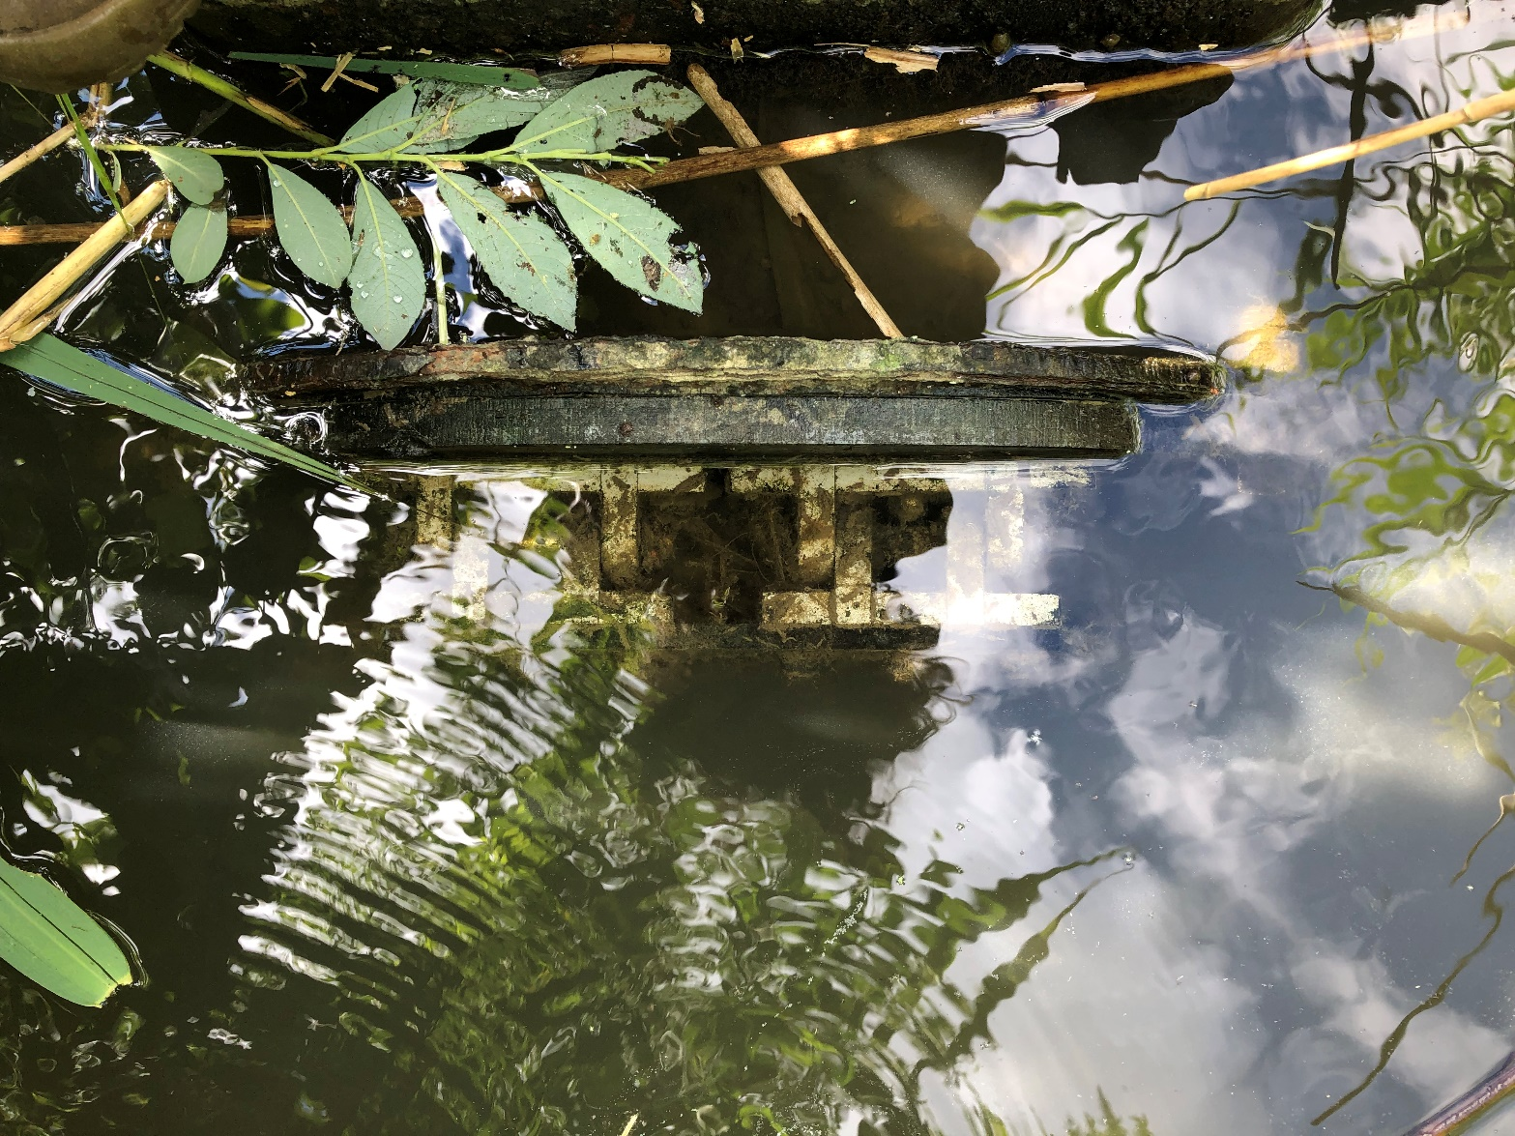

*Existing valve on reserve side of sluice. We would like a similar structure added to the non-reserve side.*

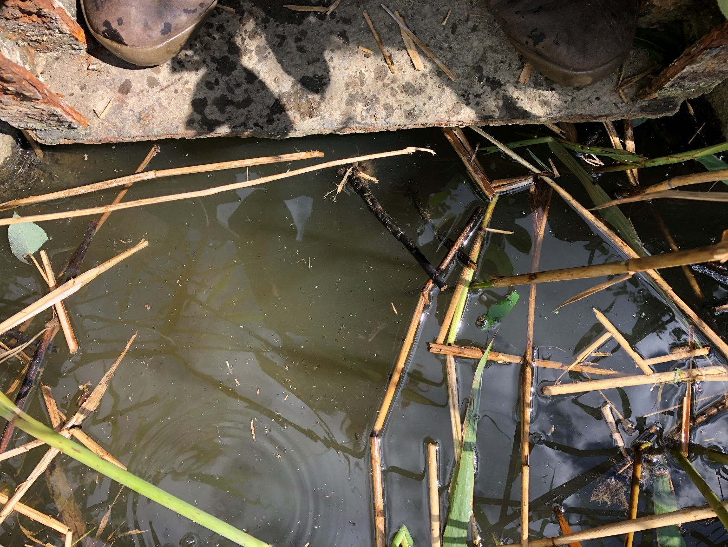

*Opposite side of sluice pictured above*

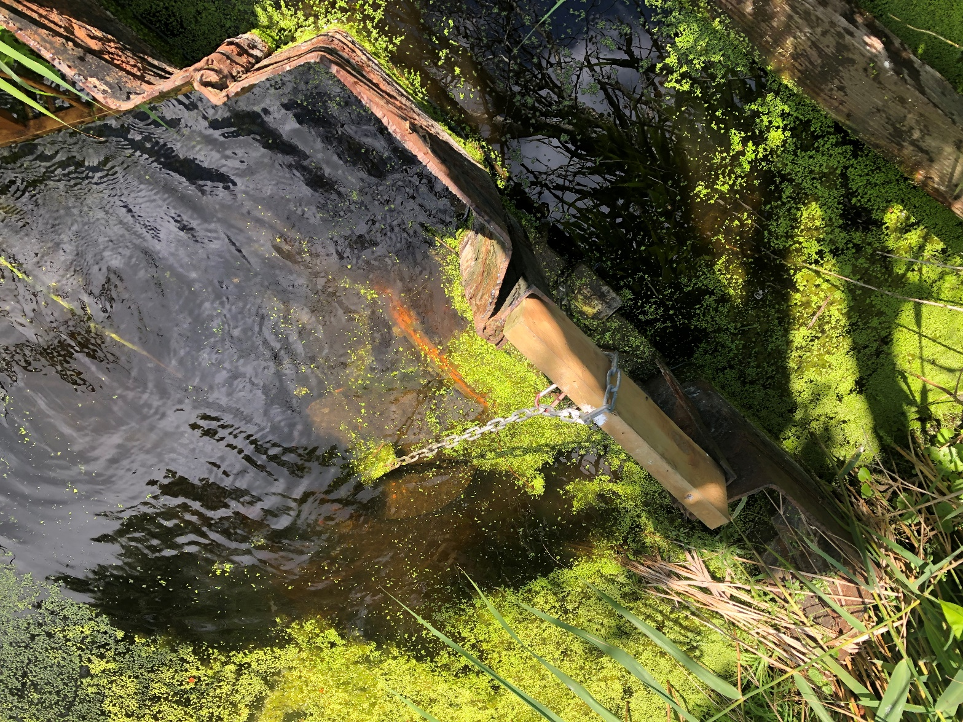

*Sluice with recently installed non-return valve flaps to give an illustration of what is anticipated. This is the sluice to which we also require a walkway installing*

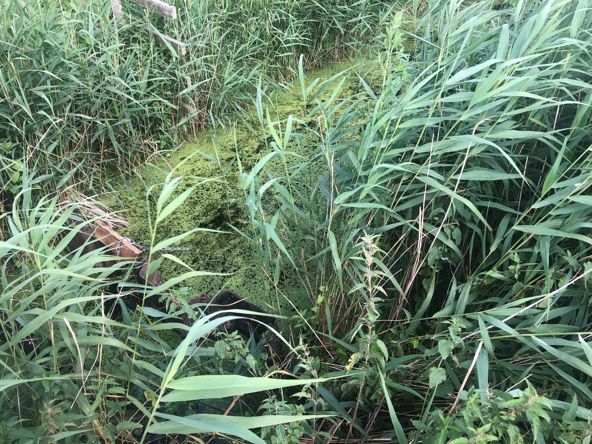

*Sluice with recently installed non-return valve flaps which we would like a walkway installed across to enable safe operation of the flaps.*

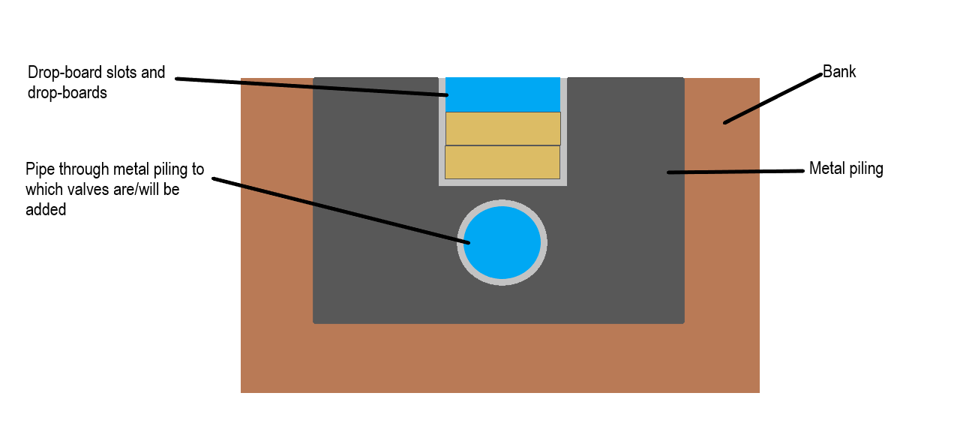

*Basic schematic cross-sectional diagram of the current sluice design*

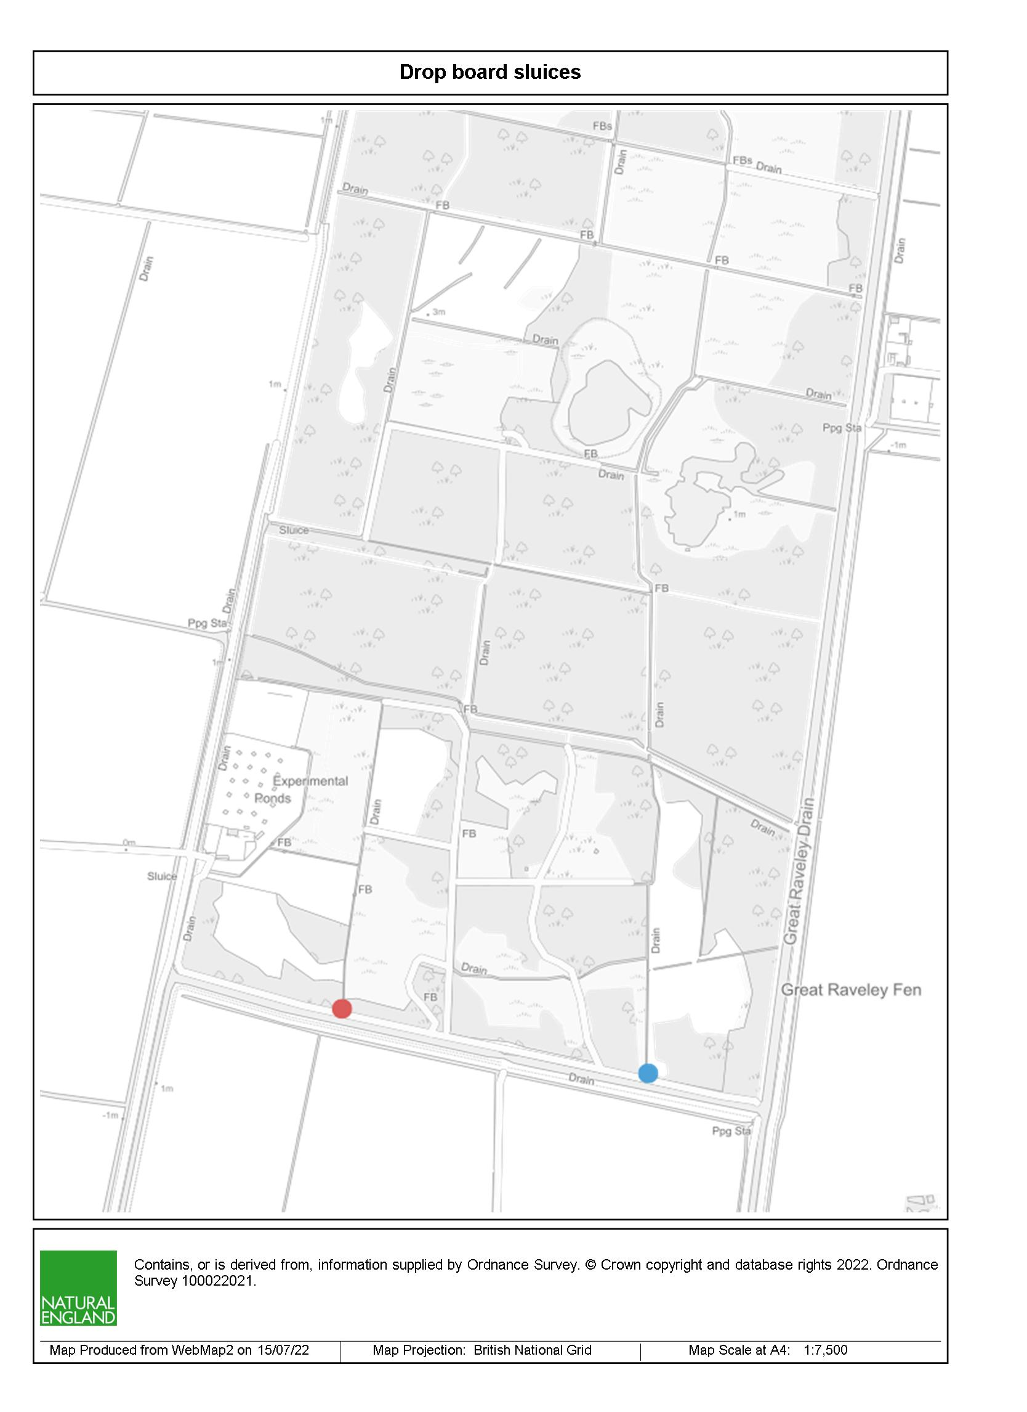

*Location of sluices. Red is the sluice which requires valve and walkway, blue is sluice which only requires walkway*

**

*Access route to Southwestern entrance of site*

**Other information**

Woodwalton Fen is a wetland and a SSSI. As such the ground is very sensitive to damage and can be very soft.

Work sites are accessed via a network of non-surfaced grass visitor/access paths and across bridges, some of which are narrow (3m).

Standard 4x4 vehicle access to the work sites is not possible at any time of year.

Any machinery used on site must be low ground pressure – e.g. wide tracked digger, ATV.

However, there is good access for standard vehicles and 4x4s into the reserve work base, which is a secure locked yard suitable for storing equipment and materials.

Please outline in your bid how your equipment and work methods will minimise ground disturbance.

Ditches being worked in are valuable habitats, home to rare plants and animals. The other habitats on site are also home to a number of important species. Please ensure that your bid outlines your environmental credentials and how your methodology will minimise risk to the natural environment.

Please also outline in your bid how the materials you will use in in the valves and walkways will not cause negative environmental impacts in the habitats they are being installed in. However, this must be balanced against durability, usability, and safety of future operators of the valves.

Due to the site’s biodiversity importance, we will require you to ensure that all equipment is properly cleaned before coming onto site to reduce the risk of spread of invasive species, disease etc. Please factor this into your quote.

The site is open to the public, so safety of visitors must be taken into consideration; please outline in your bid how visitor safety will be managed during works.

Before undertaking any work, we would be required to see risk assessments, work plans etc. to ensure we are satisfied it is safe for works to be carried out.

Ideally this work would be completed at some time from September-November; after bird breeding season is finished but prior to the site becoming too wet to access with vehicles without causing damage to the SSSI features.

**We would strongly recommend a site visit prior to submitting a quote.**

**Prices**

Prices must be submitted in £ sterling, inclusive of VAT.

**Quotation Submission**

We will award this contract in line with the most economically advantageous tender (MEAT) as set out in the following award criteria:

Price – 50%

Quality – 50%

|  |  |  |
| --- | --- | --- |
| **Criteria** | Weighting | **To include:** |
| **Experience of similar works** | 40 | To include:   * Examples of relevant work |
| **Proposed methodology** | 40 | To include:   * How you will work to allow for the sensitive ground conditions and habitat * Availability/timings |
| **Health and Safety** | 20 | * Ability to provide RAMS and Construction Plan covering CDM Regulations. |

|  |  |
| --- | --- |
| **Score** | **Justification** |
| For a score of hundred (100): | Excellent - Response is completely relevant and excellent overall.  The response is comprehensive, unambiguous and demonstrates a thorough understanding of the requirement and provides details of how the requirement will be met in full. |
| For a score of seventy (70): | Good - Response is relevant and good.  The response demonstrates a good understanding and provides details on how the requirements will be fulfilled. |
| For a score of fifty (50): | Acceptable - Response is relevant and acceptable.  The response provides sufficient evidence to fulfil basic requirements. |
| For a score of twenty (20): | Poor - Response is partially relevant and/or poor.  The response addresses some elements of the requirements but contains insufficient / limited detail or explanation to demonstrate how the requirement will be fulfilled. |
| For a score of zero (0): | Unacceptable - Nil or inadequate response.  Fails to demonstrate an ability to meet the requirement. |

**Contract Management**

This contract shall be managed on behalf of the Authority by Tristan Colaço through email/phone contact and site meetings with Tristan and other NE staff.

We will raise purchase orders to cover the cost of the services and will issue to the awarded supplier following contract award. We envisage that we will be invoiced after works have been completed.

### Disclosure

All Central Government Departments, their Executive Agencies and Non Departmental Public Bodies are subject to control and reporting within Government. In particular, they report to the Cabinet Office and HM Treasury for all expenditure. Further the Cabinet Office has a cross-Government role delivering overall Government policy on public procurement, including ensuring value for money and related aspects of good procurement practice.

For these purposes, the Authority may disclose within Government any details contained in your quotation. The information will not be disclosed outside Government during the procurement.

In addition, the Authority is subject to the Freedom of Information Act 2000 and the Environmental Information Regulations 2004, which provide a public right of access to information held by public bodies. In accordance with these two statutes, the Authority may be required to disclose information contained in your quotation to any person who submits a request for information pursuant to those statutes.

By submitting a quotation you consent to these terms as part of the procurement.

### Disclaimers

Whilst the information in this RFQ and any supporting information referred to herein or provided to you by the Authority have been prepared in good faith the Authority does not warrant that this information is comprehensive or that it has been independently verified.

The Authority does not:

* make any representation or warranty (express or implied) as to the accuracy, reasonableness or completeness of the RFQ;
* accept any liability for the information contained in the RFQ or for the fairness, accuracy or completeness of that information; or
* accept any liability for any loss or damage (other than in respect of fraudulent misrepresentation or any other liability which cannot lawfully be excluded) arising as a result of reliance on such information or any subsequent communication.

Any supplier considering entering into contractual relationships with the Authority following receipt of the RFQ should make its own investigations and independent assessment of the Authority and its requirements for the goods and/or services and should seek its own professional financial and legal advice.

**Protection of Personal Data**

In order to comply with the General Data Protection Regulations 2018 the contractor must agree to the following:

* You must only process any personal data in strict accordance with instructions from the Authority
* You must ensure that all the personal data that we disclose to you or you collect on our behalf under this agreement are kept confidential.
* You must take reasonable steps to ensure the reliability of employees who have access to personal data.
* Only employees who may be required to assist in meeting the obligations under this agreement may have access to the personal data.
* Any disclosure of personal data must be made in confidence and extend only so far as that which is specifically necessary for the purposes of this agreement.
* You must ensure that there are appropriate security measures in place to safeguard against any unauthorised access or unlawful processing or accidental loss, destruction or damage or disclosure of the personal data.
* On termination of this agreement, for whatever reason, the personal data must be returned to us promptly and safely, together with all copies in your possession or control.

**General Data Protection Regulations 2018**

For the purposes of the Regulations the Authority is the data processor.

The personal information that we have asked you provide on individuals (data subjects) that will be working for you on this contract will be used in compiling the tender list and in assessing your offer. If you are unsuccessful the information will be **held and destroyed within two years** of the award of contracts. If you are awarded a contract it will be retained for the duration of the contract and destroyed within **seven years** of the contract’s expiry.

We may monitor the performance of the individuals during the execution of the contract, and the results of our monitoring, together with the information that you have provided, will be used in determining what work is allocated under the contract, and in any renewal of the contract or in the award of future contracts of a similar nature. The information will not be disclosed to anyone outside the Authority without the consent of the data subject, unless the Authority is required by law to make such disclosures.

For any questions or to arrange a site visit to obtain a better understanding of the project please contact Tristan Colaço on [Tristan.Colaco@naturalengland.org.uk](mailto:Tristan.Colaco@naturalengland.org.uk) or 07880145755.

Yours faithfully,

Tristan Colaço

Natural England Reserve Manager, West Anglia