

“Building better lives”

GSA Background Information

Contents
About GreenSquareAccord 1
Our Strategy 2
Locality Model: our approach to delivering our strategy 3
Value for Money 5
Social Value 5
Sustainability 6
Historic Performance 7
Group Structure 8

About GreenSquareAccord
GreenSquareAccord Limited (GSA), is a leading developer and provider of high-quality housing, care and support across the Midlands and Southwest of England. We manage over 26,000 homes across our area of operation and provide care and support services to many of our customers.

In addition to the core housing association and care and support services, GSA carries out commercial activities in its commercial subsidiaries GreenSquare Homes Limited (GSH) and GreenSquare Estates Limited (GEL). The main activity of GSH is development of properties for open market sale. It also develops properties to be retained by the Registered Provider and provides development agency services to external clients. The principal activity of GEL is the management of public open spaces on housing developments, both for GSA properties but also for third parties. GreenSquare Construction Limited (GSC) provides internal construction services. LoCal Homes (our internal manufacturer of timber framed homes) is commercially focused to enable us to increase the level of this activity through supply to external third parties.

Our Purpose
GreenSquareAccord was created to deliver our purpose – ‘building better lives’. We believe that together we can deliver more for our customers and communities. As a charitable housing and care provider our focus is on those least able to meet their housing and related care needs in the open market. We exist to provide services for those in the greatest need. We believe that if we provide truly affordable homes and related services then people will be able to achieve their full potential without having to worry about the quality, affordability and safety of their housing and care services.

Locality Model: our approach to delivering our strategy
Customers tell us time and again that the most important thing we can do is to make sure they have a quality home and that our neighbourhood spaces are also maintained to a high quality. The Social Housing White Paper and building safety legislation will also support higher quality standards; we will focus our investment in building quality.

We want to ensure that our housing and care services are high quality. Our customer service should therefore ensure that customers do not have to contact us about problems with their property or tenancy, and that in the event they have to contact us, we should be able to deal with problems quickly and efficiently, resolving the vast majority of issues first time.

Frontline services should be as locally based as possible, so that we are visible and so that customers see us as a key part of their local community. We want to support customers to build effective communities so that people are proud of where they live. Our locality model will be the bedrock of our commitment to creating truly local and community-based services. We will focus on building relationships and trust with our customers by working with them and listening to their needs, whilst investing in initiatives that help to strengthen communities.

The map below shows the geographical spread of our housing assets.

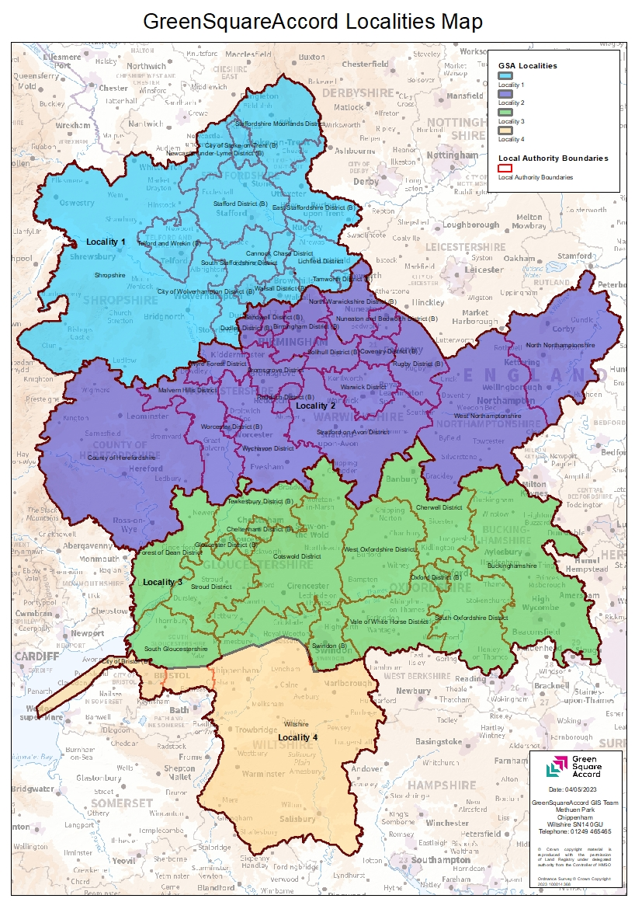

Our properties and services should be affordable. We aim to maintain our stock of social rent properties and to build new social rent and truly affordable rented properties, especially in areas where there is the greatest gap between social rents and market rent. We want customers to tell us that they are proud of their neighbourhood, and for it to be somewhere they actively choose to live and stay.

Value for Money
GSA is committed to delivering Value for Money (VfM) in all it does. Against the backdrop of a challenging economy in which rising inflation, materials shortages and interest rate rises, it is more important than ever that the Group optimises its use of assets and delivers cost effective and high-quality services to our customers. The group’s VfM strategy is based around two core pillars:

Doing things right | Fundamentally, ‘doing things right’ is a relative relationship between inputs, and outputs, outcomes and impact. It does not just mean doing things more cheaply. Therefore, as well as reduced cost of inputs, ‘doing things right’ also demands focus on how those inputs are managed, via our policies, processes and systems, to create better quality or broader impact. It is about economy, efficiency and effectiveness. Accordingly, our VfM activities focus on the delivery of both financial savings and qualitative benefits to customers and other stakeholders.
Doing the right things | We are committed to consistently reviewing the scope and scale of the Group’s activities:  - to ensure that they are consistent with our core purpose;  - to ensure that the Group is delivering a high quality and effective service to all its stakeholders;  - with the fundamental purpose of protecting social housing assets and customers e.g. from commercial risk and the risk that social housing returns are not invested back into social housing activities but instead into other activities (i.e. cross subsidy risk).

Social Value

Social Value
We are committed to the delivery of social value for the direct benefit of our customers, communities, and society. As part of our strategy procurement is committed to collaborating with our customer facing colleagues to develop a locality-based approach to directly address the needs of our customers and communities through our supply chain partners.

The Public Services (Social Value) Act 2012 requires GSA to consider, at pre-procurement stage, how what is being procured might improve the economic, social and environmental wellbeing of the relevant area and how we can secure such additional value through the procurement process.

When procuring goods and services - or the carrying out of works, the Public Services (Social Value) Act 2012, requires English and Welsh public authorities (housing providers, local authorities and other public bodies) to consider how what is being procured might improve the economic, social and environmental wellbeing of the relevant area; and how that improvement might be secured through the procurement process.

GSA sees the Act requirements as a responsibility and seeks to work with suppliers who share these principles and want to make a positive impact on people and places. GSA defines social value as: opportunities, in-kind or cash contributions from our appointed suppliers, that:
• are over and above the goods, services or works they are contractually obligated to provide
• produce a positive economic, social or environmental outcome
• benefit our customers, communities and society

Sustainability
The Group is committed to development of high-quality sustainable homes which are cost-effective for customers and positive for the environment. We deliver sustainability in development in the following ways:
- Under our grant-funded programmes, we are committed to a fabric first strategy that provides higher insulation standards than Building Regulations requires, to reduce the cost of heating to customers.
- Environmental factors relating to all key project investment decisions are considered by the Group’s Investment Committee.
- We are committed to increasing the number of high-quality, low-carbon homes developed through the Group’s timber frame factory, LoCal Homes.
- We are committed to the Government’s Carbon Neutral target to have net zero emissions by 2050.

Historic Performance

Comprehensive Income
£’m | 2018 | 2019 | 2020 | 2021 | 2022
Turnover | 199.8 | 200.9 | 209.9 | 221.9 | 227.5
Operating expenditure | -147.2 | -153.1 | -164.0 | -173.7 | -213.2
Disposal of assets | 3.2 | 2.6 | 7.4 | 2.8 | 3.8
Operating surplus | 55.9 | 50.4 | 53.3 | 50.9 | 18.0

Financial Performance
£’m | 2018 |  | 2019 | 2020 | 2021 | 2022
Housing properties net of depreciation and grant | 1,534.0 |  | 1,615.4 | 1,693.1 | 1,745.5 | 1,881.4
Other fixed assets net of depreciation | 15.7 |  | 16.3 | 16.7 | 15.7 | 16.3
Intangible fixed assets | 20.7 |  | 20.0 | 18.4 | 16.6 | 0.5
Investments | 5.5 |  | 2.7 | 1.6 | 1.6 | 1.8
Fixed assets net of depreciation and grant | 1,576.0 |  | 1,654.4 | 1,729.9 | 1,779.5 | 1,900.0
Current assets less current liabilities | 70.8 |  | 105.0 | 88.7 | 124.0 | 11.3
Total assets less current liabilities | 1,646.8 |  | 1,759.4 | 1,818.7 | 1,903.5 | 1,911.3
Long term liabilities | -1,133.1 |  | -1,243.4 | -1,275.1 | -1,366.4 | -1,342.4
Net assets | 513.7 |  | 516.0 | 543.6 | 537.2 | 568.9
Reserves | 513.7 |  | 516.0 | 543.6 | 537.2 | 568.9

Units
 | 2018 | 2019 | 2020 | 2021 | 2022
Units under management | 24,678 | 25,333 | 25,570 | 25,974 | 26,308

Group Structure
The diagram below illustrates the structure. Currently GSA is both the Group parent and the main asset owning entity within the Group, holding all the Group’s social housing assets. All other legal entities are then, either directly or indirectly, subsidiaries of GSA.

