Our ref:  Your ref:  Jacobs UK Limited  FAO REDACTED  Via Email | REDACTED  Procurement Delivery  Woodlands  Manton Lane  Bedford MK41 7LW  Direct Line: REDACTED  Date: 10 October 2019
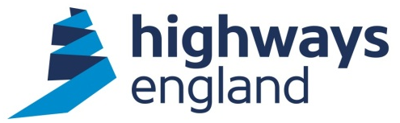
OFFICAL – SENSITIVE

Award Letter – Lower Thames Crossing Project Director – Secondment Agreement

Dear REDACTED

On behalf of Highways England, I am writing to accept your recent offer to carry out the above-mentioned Contract within the terms of the attached secondment agreement, as agreed with Highways England. A copy of the final signed secondment agreement is attached.

The commencement date is the 22 June 2019. The value of this contract is based on your monthly rate of £XXXXX plus expenses and the end date specified in the contract is 22 January 2020.

Invoices should be sent as a PDF file to FS Payments at Highways England via invoices@highwaysengland.co.uk. The invoice should quote the Project Manager’s name and Purchase Order number, which will be obtainable from the Project Manager.

Please note you must not make any public announcements and all media enquiries should be directed to the Highways England Press Office.

Please acknowledge receipt of this letter via email.

Yours sincerely,

REDACTED
Procurement Director
CIP.Procurement@highwaysengland.co.uk

