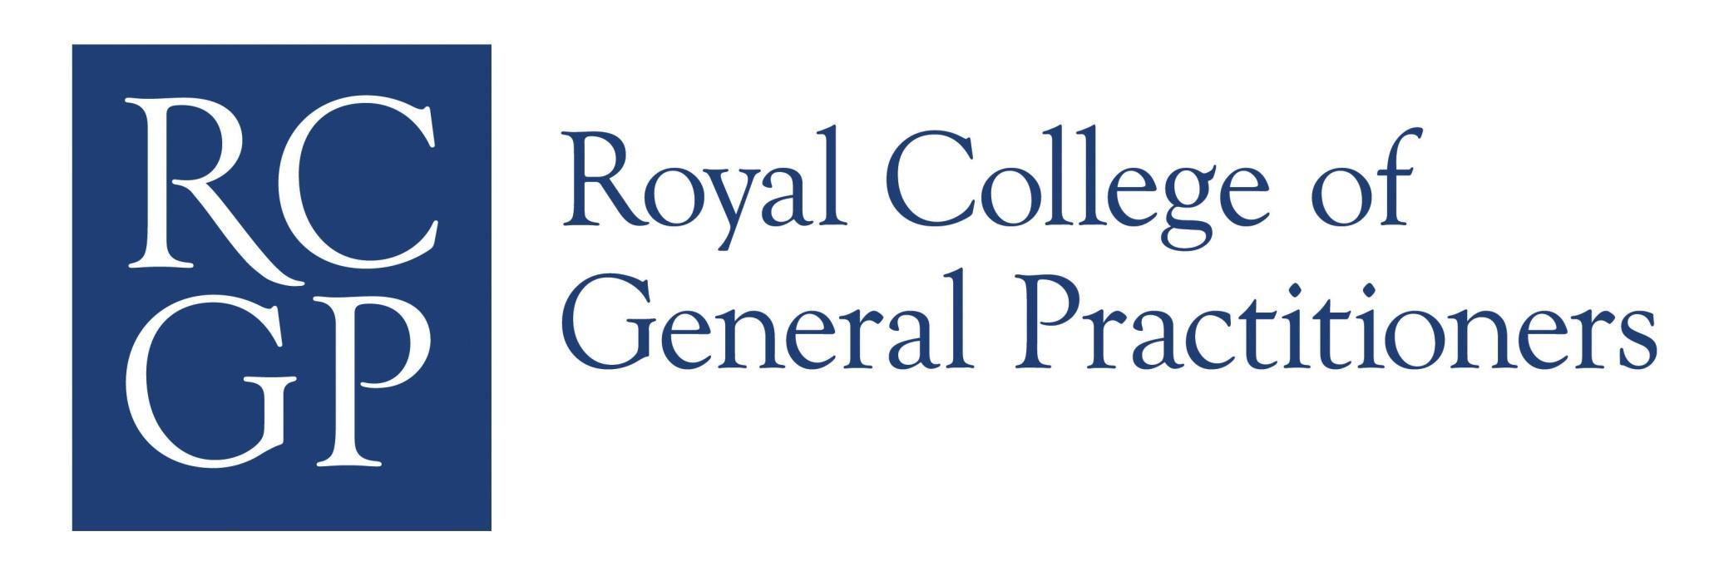

Schedule 4 - Supplier Company Information

Please complete and send back with your RFP response.

Commercial Information
Applicant Company Status | Public Private Other
Parent Company Name(s)
(% ownership to be included)
Parent Company Address(es)

Does the Applicant Company have Public Liability Insurance?  If yes, please provide one copy | Yes No
Does the Applicant Company have Employers Liability Insurance?  If yes, please provide one copy | Yes No
Does the Applicant Company have Professional Indemnity Insurance?  If yes, please provide one copy | Yes No
Does the Applicant Company have Contractors All Risk Insurance?  If yes, please provide one copy | Yes No
Will the Parent Company guarantee the contract performance of the Applicant Company (if applicable)? | Not Applicable Yes No  (enclose undertaking if applicable)

Financial Standing

Please provide the name and address of the Applicant Company's Bank

Please provide details of the Applicant Company's turnover over the last three years?

Please provide one copy of each of the last three years accounts | Enclosed Yes No
Does the Applicant Company have an Open Book Accounting Policy? | Enclosed Yes No

Company Operations and Experience

Please provide the Applicant Company organisational structure

Please provide details of:

- Name of Client
- Client Address/ Contract Location
- Value of Contract (£ p/a)
- Length of Contract Term
- Scope of Contract Services

For 3 recent clients with similar technical coverage
What are considered to be the key risks in the execution of the Applicant Company's services?
How does the Applicant Company manage and minimise the service risks?

How does the Applicant Company ensure the effectiveness, efficiency and competitiveness of the services provided are delivered and maintained?

Quality Assurance

Does the Applicant Company have an established and documented Quality system? | Yes No
Please provide evidence of any Quality System Registration | Enclosed Yes No

Environment

Does your Company have an Environmental Policy? (If yes please provide a copy) | Enclosed Yes No
Please detail your Company’s environmental management arrangements including the employee nominated as Responsible Officer for this contract, and details of their training and experience that makes them suitable. Do you comply or intend to comply with the standard defined in either ISO 14001 or Eco-Management and Audit Scheme?

Human Resources

Does the Applicant Company have a Training Policy?

If yes, please provide one copy
Has the Applicant Company or Group lost any legal cases arising out of legislation or equal opportunities in the last three years?

If yes, please provide details
Has the Applicant Company or Group lost any cases before Industrial Tribunals under employment legislation in the last three years?

If yes, please provide details

