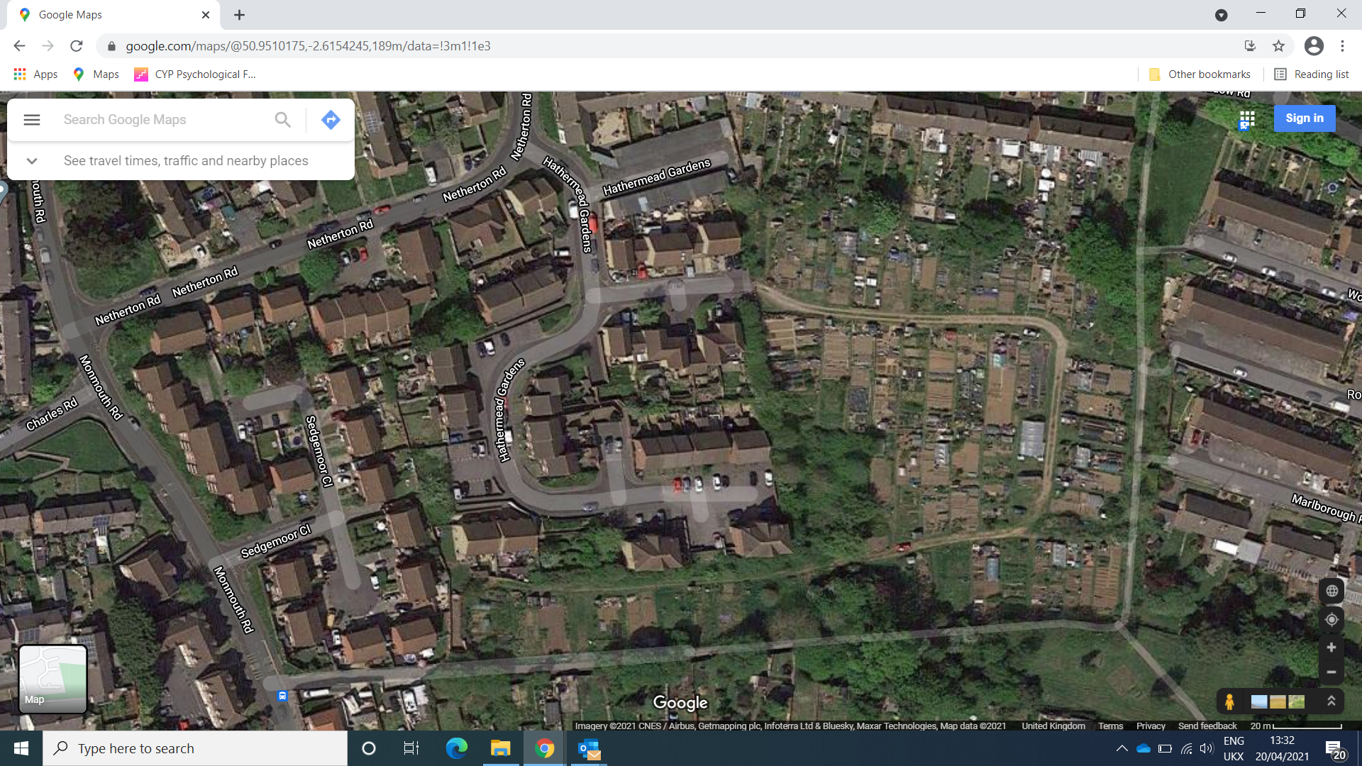

Sunningdale Allotment Site

Hathermead Gardens

Yeovil

BA21 5BX